SSW 810 – Homework 11

**select Name from** instructors **where CWID**=**'98763'**;

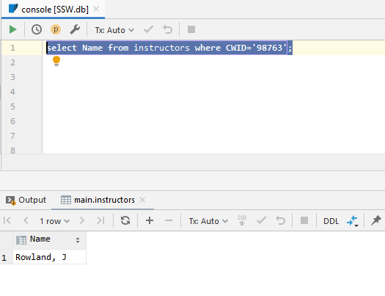

**select Dept**, *count*(*\**) **as** dep_count **from** instructors **group by Dept**;

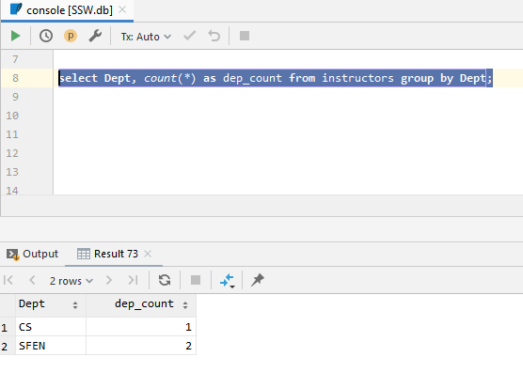

**select Grade**, *count*(**Grade**) **as** grade_count **from** grades **group by Grade order by Grade asc limit** 1;

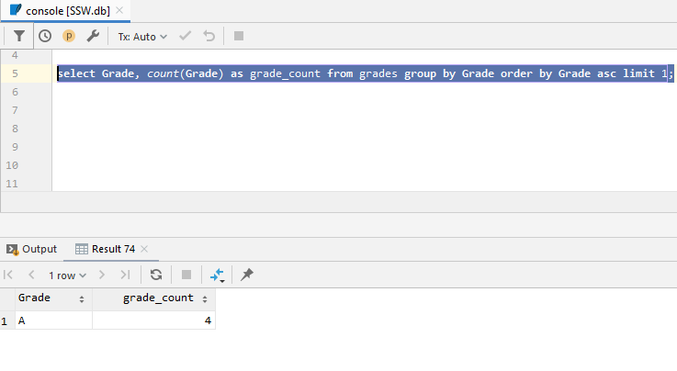

**select** a.**Name**, a.**CWID**, a.**Major**, b.**Course**, b.**Grade from** students **as** a  
**join** grades **as** b **on** a.**CWID** = b.**StudentCWID**;

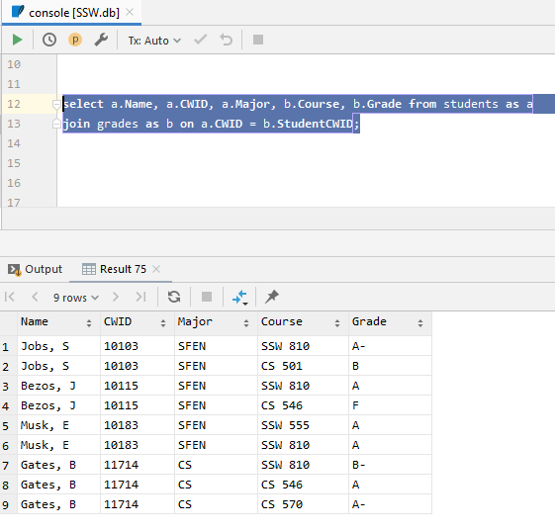

**select** a.**Name**, a.**CWID**, a.**Major**, b.**Course**, b.**Grade from** students **as** a  
**join** grades **as** b **on** a.**CWID** = b.**StudentCWID  
where** b.**Course**= **'SSW 810'**;

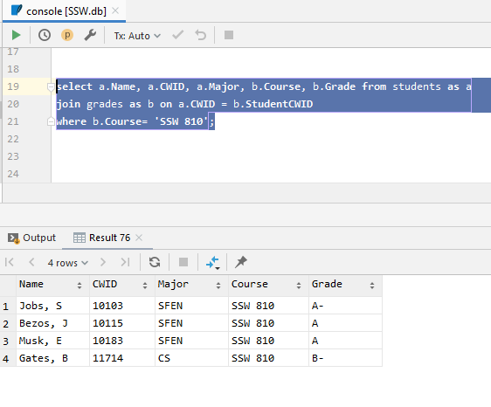  
  
**select** a.**CWID**, a.**Name**, a.**Dept**, b.**Course**, *count*(b.**Course**) **as** num_of_students **from** instructors **as** a  
**join** grades **as** b **on** a.**CWID** = b.**InstructorCWID  
group by** a.**CWID**, a.**Name**, a.**Dept**, b.**Course  
order by CWID desc**

