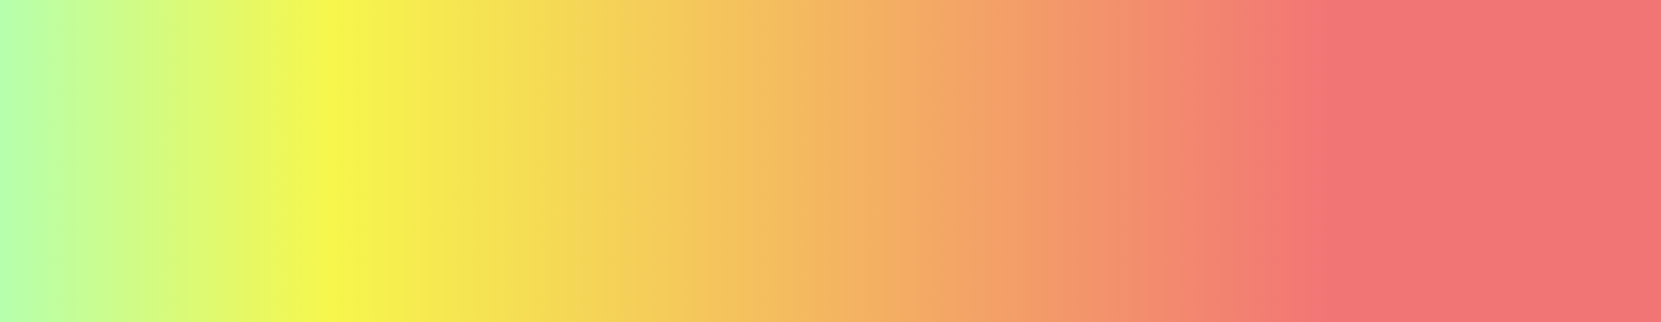

sidebar

#b5ffae嫩绿

#f6f64c正黄

#f27575粉红

background: linear-gradient(90deg, rgba(181,255,174,1) 0%, rgba(246,246,76,1) 20%, rgba(242,117,117,1) 80%);



background: linear-gradient(75deg, #b5ffae, #bffea9, #cafda3, #d7fb9e, #e5fa99, #f5f993, #f8ea8e, #f7d589, #f6bf84, #f4a87f, #f38f7a, #f27575);

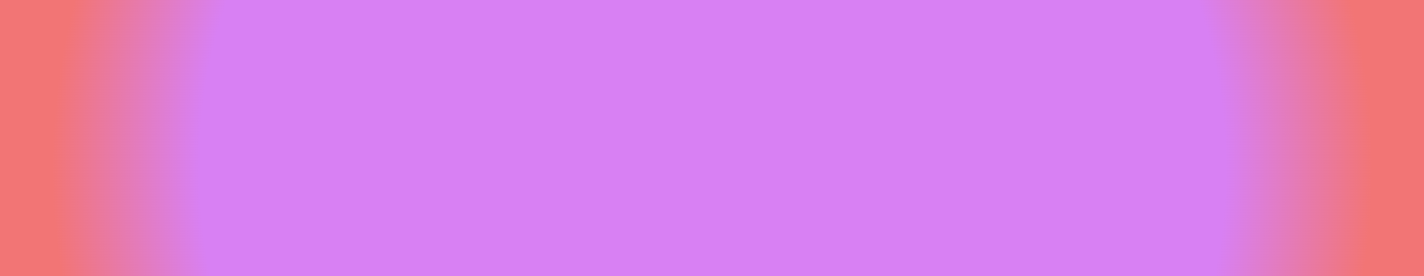

Button

#d880f3淡紫

#f27575粉红

background: radial-gradient(circle, rgba(216,128,243,1) 70%, rgba(242,117,117,1) 90%);