2019 Ham Radio Licensing Course Registration Available Now!
Mt. Diablo Amateur Radio Club
will be holding an 8 week course where you can learn everything you need to earn your 1st level Technician Class
and the 2nd level General class is 9 weeks.

The Technician Class license is your entry to the world-wide excitement of Amateur Radio and Emergency Communications… and now you do
NOT need to learn Morse code!
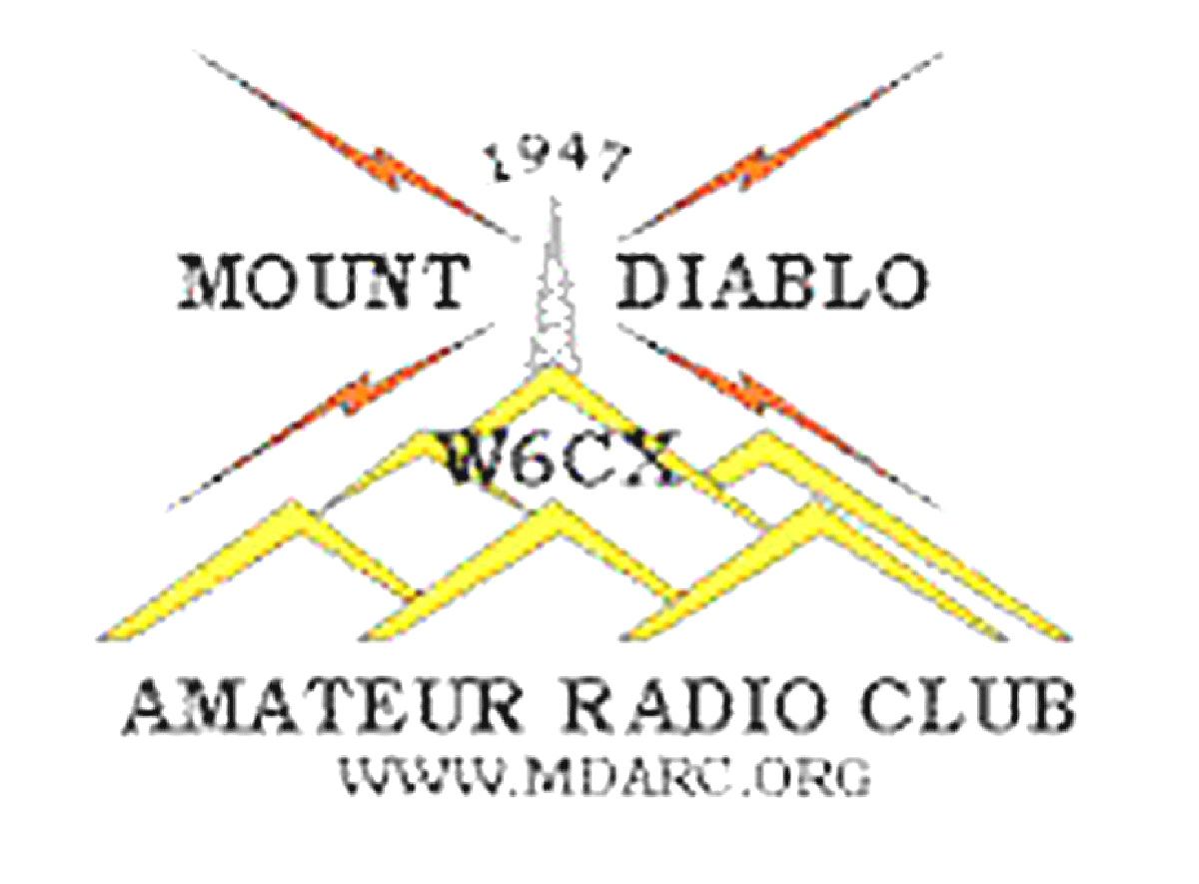
Technician Class Course begins on…
Thursday January 10, 2019
General Class begins March 28th, 2019
Thursday


First Class starts at 6:30 the rest are from 7-9pm
Trinity Lutheran Church, 2317 Buena Vista Ave.
Walnut Creek, CA 94597
Registration online is required. We use the current ARRL Textbooks – Text book details are part of the registration process.
Follow up training and License testing will also be available.

Complete class calendar and registration link: http://www.mdarc.org/activities/education/Classes

(If you are new to Ham Radio it is suggested you wait to buy your radio until after you take the TECH license class as some CHEAP radios advertised as Ham radios are out of compliance with FCC rules.)

The auto response at HamRadioClass@gmail.com will answer more class questions. Non License questions at info@mdarc.org

