Saturday, May 9, 2015 - Benicia, CA




AMATEUR RADIO
LICENSE CLASS

This session is conducted by the Benicia Amateur Radio Club – Member W5YI VEC

Study Session followed by Exam

When: Saturday May 9th, 2015
8:00 AM - 5:00 PM
Where: Benicia Senior Center
187 East L Street, Benicia
Fee: $30.00 at the door
(Includes exam fee)
Register: www.BeniciaARC.com

Conducted by:
Benicia Amateur Radio Club (BARC)
Serving the Benicia Fire Department and the Residents of the City of Benicia

Questions: HamRadioClass@BeniciaARC.com or Art at (707) 746-5858
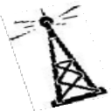

Class size is limited. Advance Registration is Required.
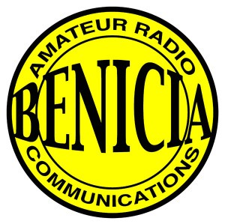

No prep or prior study required.

Prospective Hams should plan on attending a free Get-On-The-Air Class after passing their test, to become familiar with Amateur Radio operations

Reserve Your Space - Become a Ham!

Can’t make the class? We can notify you of the next date and location.... Contact us.
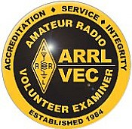

This is a Beginning Ham Radio Class Only. Successful students will earn a “Technician” License.

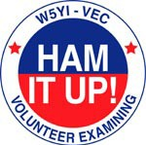

File: Ham Class May 2015 flyer

