David Goldfarb

ECE 449 HW #4

Motion Tracking

**Introduction**

The goal of this project was to track a moving object and to implement a kalman filter to predict its motion. The object was a tangle of paper that moved around on a desk as I blew on it.

**Procedure**

In order to track the object, background subtraction was performed. The first step is to take the difference of two frames. If the camera is stationary, anything that is in the background or not near the moving object will not change from frame to frame, and thus subtracting one frame from the other leaves only pixels that have changed – pixels around the moving object. In practice, since lighting conditions vary with time, a threshold is applied, such that the difference of pixels must be greater than the threshold to be acknowledged. Finally, a median filter was applied to filter out noise.

The result of this analysis finds the differences in the frames. Matlab’s built-in ‘regionprops’ command found the centroid and bounding box of the object.

Kalman filtering is done in two steps. The first step is to predict the location of the object in the next frame based on state variables such as velocity, position, and variance. The second step is to update the state variables in the model based on observation.

**Results**

Below are three consecutive frames from the moving object video.

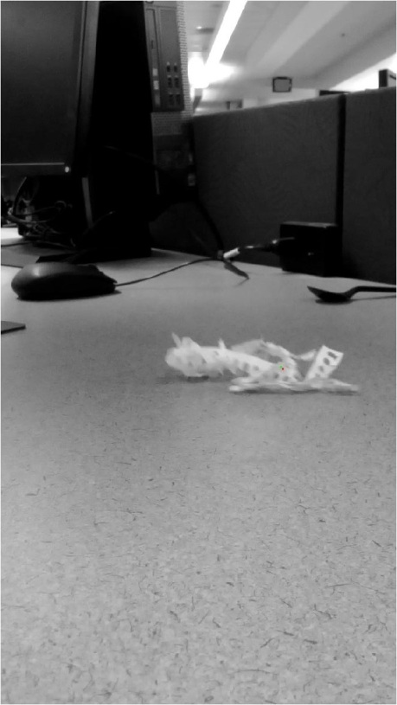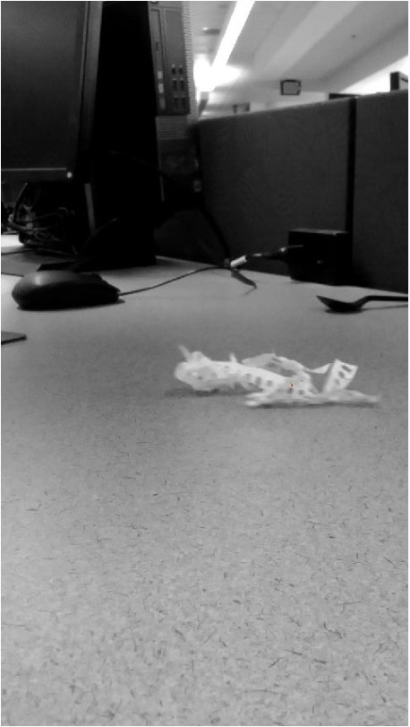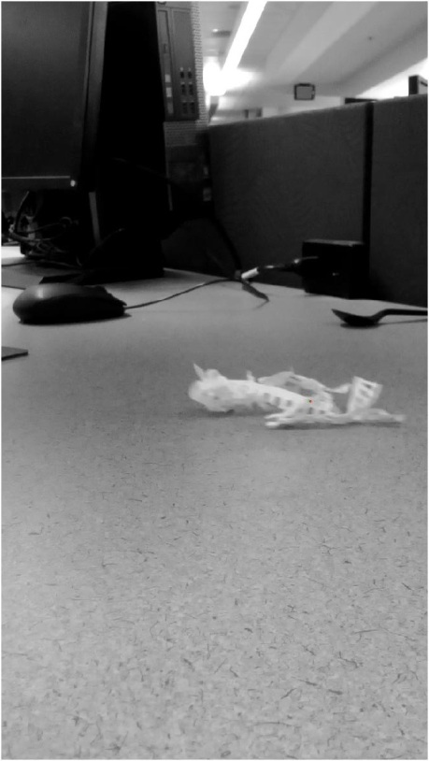

Zoomed in:

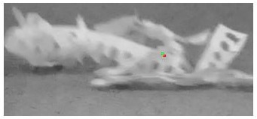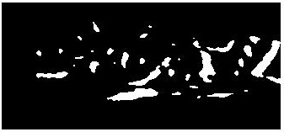

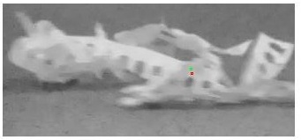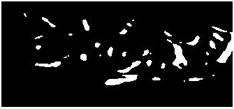

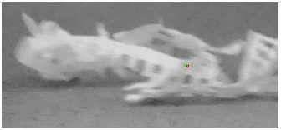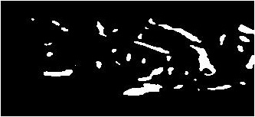

Left: Image overlaid with centroid and expected centroid.

Right: Image after background subtraction and filtering.

In this series of frames, the green dot is the predicted position and the red dot is the observed position. The expected position and observed position are quite close, and the expected position ‘follows’ the observed position.

**Conclusion**

There are a number of drawbacks to the background subtraction method. If the object to be tracked is uniform, background will only find the edges, and may misrepresent the centroid of the object. This could be solved by combining background subtraction with color segmentation.

The kalman filter was not perfect because the object did not move with constant velocity. It started and stopped and twice left the view of the camera. However, over a short enough time frame, the velocity is nearly constant, as is observed in the three frames shown above.

Kalman filtering can be done in real time, and thus the prediction can be used to help track the object by a voting procedure based on expectation and observation. This can help the robustness of object tracking models.