Topography

In the Permian period, all the continents were in solitary continent called Pangaea. After Pangaea,

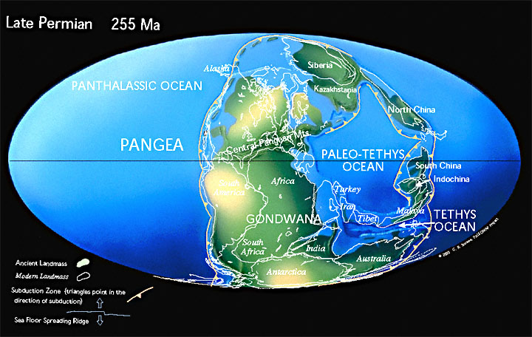

Also, the world was changing in numerous ways; the world was getting much dryer.

