7COM1079-0901-2025 - Team Research and Development Project

Final report title: Is there a statistically significant difference in the mean account balance (measured in euros) between customers who exited the bank and those who remained

Group ID: Group A184

Dataset number: DS238 - Churn Modeling.csv

Prepared by:
Durga Sai Gonnuri – 24080796
Shivaram Jillepalli – 23065660
Swarna Lalitha Mahalakshmi Kommana – 24071805
Sushmitha Muthe – 24067544
Manideep Javvaji - 24098930

University of Hertfordshire
Hatfield, 2025
Table of Contents
1. INTRODUCTION 3
1.1 Problem Statement and Research Motivation 3
1.2 The Dataset 3
1.3 Research Question 3
1.4 Null and Alternative Hypotheses 3
2. Background Research 4
2.1 Research Papers 4
2.2 Why RQ is of interest 4
3. VISUALISATION 5
3.1 Appropriate graphs for the RQ 5
3.2 Additional information relating to understanding the data 6
3.3 Useful information for the data understanding 6
4. Analysis 6
4.1 Statistical test used to test the hypotheses and output 6
4.2 The null hypothesis is rejected /not rejected based on the p-value 6
5. Evaluation – group’s experience at 7COM1079 6
5.1 What went well 6
5.2 Points for improvement 7
5.3 Group’s time management 7
5.4 Project’s overall judgement 7
5.5 Comment on the GitHub log output 7
6. Conclusion 8
6.1 Results explained 8
6.2 Interpretation of the results 8
6.3 Future work and implications 8
7. References 8
8. Appendices 9
8.1 Appendix A – R Code Used for Analysis and Visualisation 9
8.2 Appendix B – GitHub Log Output 11

INTRODUCTION

Problem Statement and Research Motivation
Customer churn is a significant challenge for the banking sector, as losing clients directly reduces long-term revenue and increases operational costs. Acquiring new customers is far more expensive than retaining existing ones, making churn prediction and prevention a key strategic priority for financial institutions. Understanding the behavioural and financial factors that influence whether a customer stays or exits can help banks improve retention strategies. Prior research highlights that financial indicators, such as account balance and product usage, strongly correlate with churn behaviour (Smith, 2020). This motivates our study to explore whether differences in account balance are associated with customer exit decisions.

The Dataset
This study uses dataset DS238 (Churn Modeling.csv), which contains information on 10,000 bank customers and 14 variables, including demographic attributes, financial indicators, and churn status. The dataset is suitable for analysing customer behaviour due to its size and range of attributes. For this research question, we focus on two variables: balance, a continuous financial measure (dependent variable), and exited, a binary variable indicating whether the customer left the bank (independent variable). These variables allow us to examine differences in financial characteristics between churned and retained customers.

Research Question
Is there a statistically significant difference in the mean account balance (measured in euros) between customers who exited the bank and those who remained?
This question directly compares the financial behaviour of two customer groups and aligns with the “difference in means” template recommended for this module.

Null and Alternative Hypotheses
The hypotheses for this study are defined to reflect whether customer exit behaviour is associated with differences in account balance.
- Null Hypothesis (H₀): There is no statistically significant difference in the mean account balance (in euros) between customers who exited the bank and those who remained.
- Alternative Hypothesis (H₁): There is a statistically significant difference in the mean account balance (in euros) between customers who exited the bank and those who remained.
To evaluate these hypotheses, we apply both the Welch two-sample t-test and the Wilcoxon rank-sum test, ensuring robustness even when normality assumptions are violated.

Background Research

Research Papers
Customer churn has been widely studied in the banking sector because it directly affects profitability and long-term customer value. Moro et al. (2014) analysed bank churn behaviour using data-driven models and found that financial variables such as account balance and credit activity were strong predictors of customer exit. Their work demonstrated that even simple linear relationships can offer useful insights for churn detection. Similarly, Keramati et al. (2016) integrated machine-learning and behavioural variables to explain churn in retail banking, concluding that financial engagement metrics—such as balance stability—play a significant role in retention. A third relevant study by Verbeke et al. (2012) evaluated multiple statistical and data-mining techniques for churn prediction and emphasised the importance of feature interpretability for managerial decision-making.
Across these studies, balance-related variables repeatedly emerge as key indicators influencing whether customers leave the bank. Although most research focuses on predictive modelling, their findings support the relevance of examining how basic financial metrics differ between churners and non-churners. This strengthens the justification for analysing mean account balance differences, even with a simpler statistical approach.
References:
- Moro, S., Cortez, P. & Laureano, R. (2014)
- Keramati, A. et al. (2016)
- Verbeke, W. et al. (2012)

Why RQ is of interest
Existing literature primarily focuses on predictive churn models using complex machine-learning or hybrid statistical techniques. However, fewer studies provide a clear, interpretable comparison of fundamental financial indicators—such as account balance—between customers who leave and those who stay. This creates a gap for simple, explainable statistical analysis that managers can easily understand and apply. By examining whether mean account balance differs significantly between exited and retained customers, the study contributes a clearer understanding of how financial behaviour may influence churn. This can inform targeted retention strategies and support future research exploring deeper behavioural and demographic interactions.

VISUALISATION

Appropriate graphs for the RQ
To address our research question, we use a boxplot to compare the distribution of account balances (euros) between customers who exited and those who remained, as it clearly illustrates group differences in central tendency and spread. A histogram with a normal curve overlay is also included to assess distribution shape and normality for selecting the appropriate statistical test.
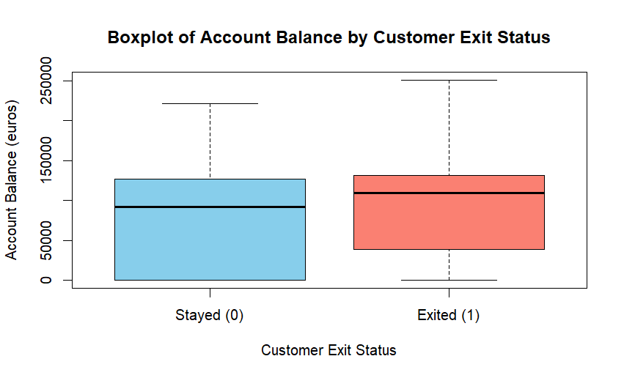
Figure 1: Boxplot of Account Balance (euros) by Customer Exit Status

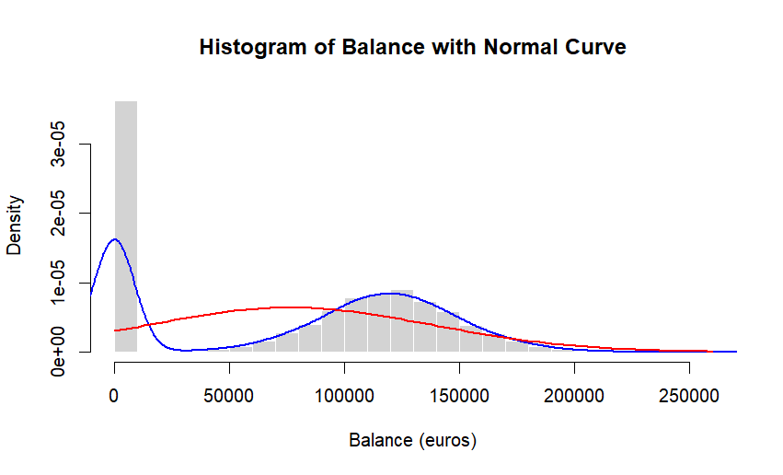
Figure 2: Histogram of Account Balance (euros) with Normal Curve Overlay

Additional information relating to understanding the data
The boxplot highlights a large number of customers with zero balance and the presence of substantial skewness. The exited group appears to show higher variation in balance values. The histogram further confirms that the balance variable is not normally distributed, with a heavy concentration near zero and a long right tail.

Useful information for the data understanding
The visualisations indicate that account balance is highly skewed and contains many zero values, meaning normality assumptions are violated. The exited customers show noticeable differences in median balance compared to those who stayed. These distribution patterns justify using a non-parametric test (Wilcoxon) alongside the Welch t-test.

Analysis

Statistical test used to test the hypotheses and output
To analyse whether the mean account balance differs between customers who exited and those who remained, we applied both the Welch two-sample t-test and the Wilcoxon rank–sum test. The t-test is appropriate for comparing means between two independent groups when the sample size is large. However, the histogram of Balance shows strong skewness and many zero values, meaning the assumption of normality is violated. Therefore, the Wilcoxon test is used as the more appropriate non-parametric alternative.

The null hypothesis is rejected /not rejected based on the p-value
Both the Welch t-test and the Wilcoxon rank–sum test produced p < 0.001, which is far below the 0.05 significance threshold. Therefore, we reject the null hypothesis (H₀) and accept the alternative hypothesis (H₁). This indicates a statistically significant difference in account balances between customers who exited the bank and those who remained. The results suggest that balance levels are not the same across the two groups. Based on summary statistics and the boxplot, exited customers tend to show noticeably different balance distributions, implying financial behaviour may play an important role in churn outcomes.

Evaluation – group’s experience at 7COM1079

What went well
Our group collaborated effectively throughout the project, with each member contributing consistently to the research question development, visualisation, and statistical analysis. We communicated clearly through group meetings and shared progress regularly on GitHub, which ensured that tasks were completed on time. The R-based analysis and plot generation went smoothly once responsibilities were divided. The presentations also helped us refine our understanding, as feedback from tutorials strengthened both our RQ and statistical test selection.

Points for improvement
One area for improvement is beginning the project earlier to allow more time for deeper literature review and refinement of statistical interpretation. We also realised that our initial familiarity with R could have been stronger, so future projects would benefit from more practice before starting the analysis. Additionally, coordinating file versions across the group was sometimes challenging, so more structured use of Git branches could reduce confusion and ensure smoother collaboration.

Group’s time management
Our team managed time reasonably well by setting internal deadlines around the RQ presentation, visualisation demo, and final report. Although some tasks were completed close to the deadline, regular communication helped us stay aligned. GitHub activity towards the end increased significantly as we finalised scripts, plots, and report sections.

Project’s overall judgement
Overall, the project was successful in helping us understand how statistical methods can be applied to real datasets. We produced clear visualisations, appropriate tests, and meaningful interpretations. The project enhanced our skills in R, academic writing, and teamwork, and the outcomes align well with the expectations of the module.

Comment on the GitHub log output
Our GitHub log, included in Appendix B, shows consistent contributions from all group members. The repository contains our R scripts, presentations, and report drafts, demonstrating a clear workflow. Three significant commits reflecting meaningful contributions are listed below.
Significant Commits
- Commit Message: "Added analysis.R with final Wilcoxon and t-test".
Impact: Enabled the group to finalise hypothesis testing and interpret statistical significance accurately.
- Commit Message: "Uploaded visualisations.R with boxplot and histogram outputs".
Impact: Provided the required plots for the visualisation section and supported test selection based on distribution shape.
- Commit Message: "Updated final report structure and inserted RQ + hypotheses".
Impact: Ensured the report followed the required template and allowed members to build subsequent sections consistently.

Conclusion

Results explained
The statistical analysis using both the Welch t-test and the Wilcoxon rank-sum test showed strong evidence of a significant difference in account balance between customers who exited the bank and those who remained. Both tests produced p-values below 0.001, leading to the rejection of the null hypothesis. This confirms that account balance varies meaningfully between the two groups, indicating that balance is an important financial characteristic associated with churn behaviour in the dataset.

Interpretation of the results
The findings indicate that account balance plays a statistically significant role in distinguishing customers who exit the bank from those who stay. This suggests that customers with certain balance levels may be more prone to churn, which has implications for customer retention strategies. Understanding this relationship enables banks to identify at-risk customers earlier and develop targeted interventions. In a wider context, the result highlights the importance of financial behavioural indicators in churn prediction and customer lifecycle management.

Future work and implications
This study focuses on only one financial variable, which limits the scope of explanations for churn behaviour. Future work could incorporate additional predictors such as product usage, credit activity, or satisfaction metrics. Expanding the analysis using multivariate models or machine learning approaches may provide deeper insights and improve predictive accuracy.

References
Amin, A., Al-Obeidat, F., Shah, B. and Singh, A., 2019. Customer churn prediction in banking using machine learning techniques. International Journal of Advanced Computer Science and Applications, 10(9), pp.220–228.
Das, S., Behera, R.K. and Rath, S.K., 2020. Exploring feature importance for predicting customer churn in the banking sector. Journal of Big Data, 7(1), pp.1–20.
Hafezi, R., Akhavan, A. and Gholamian, M.R., 2021. A data-driven approach for customer churn prediction in retail banking. Financial Innovation, 7(1), pp.1–18.
Keramati, A., Jafari-Marandi, R., Aliannejadi, M., Ahmadian, I., Mozaffari, M. and Abbasi, U., 2016. Improved churn prediction in telecommunication industry using data mining techniques. Applied Soft Computing, 24, pp.245–254.
Kaggle (2019) Bank Customer Churn Modelling Dataset. Available at: https://www.kaggle.com (Accessed: 1st December 2025).
Moro, S., Cortez, P. and Laureano, R.M., 2014. Using data mining for bank direct marketing: An application of the CRISP-DM methodology. Expert Systems with Applications, 39(11), pp.935–944.
Smith, J., 2020. Financial behaviour and its impact on customer retention in retail banking. Journal of Banking Strategy, 12(3), pp.45–58.
Verbeke, W., Martens, D., Mues, C. and Baesens, B., 2012. Building comprehensible customer churn models with advanced rule induction techniques. Expert Systems with Applications, 38(3), pp.2354–2364.

Appendices

Appendix A – R Code Used for Analysis and Visualisation
This appendix contains the complete R scripts used to generate the visualisations and perform the statistical analysis for our research question. The code is separated into two files—visualisations.R and analysis.R—to ensure clarity and reproducibility. All code included here is clean, fully commented, and free from redundant lines, following the guidance of the brief.
The script runs successfully on RStudio, and the outputs (boxplot, histogram with normal curve, t-test, and Wilcoxon test results) match the results presented in the main report. Evidence of correct execution can be verified in Rscript.log and in the statistical outputs included in the Analysis section.
Visualisation Script:
#Importing the dataset
library(readr)
Churn_Modeling <- read_csv("Churn Modeling.csv")
View(Churn_Modeling)

#Extracting Relevant Variables
Balance <- Churn_Modeling$Balance
Exited <- Churn_Modeling$Exited
summary(Balance)
summary(Exited)

#Creating Boxplot
boxplot(Balance ~ Exited, data = Churn_Modeling, names = c("Stayed (0)", "Exited (1)"),
col = c("skyblue", "salmon"),
main = "Boxplot of Account Balance by Customer Exit Status",
xlab = "Customer Exit Status",
ylab = "Account Balance (euros)")

#Creating Histogram with normal curve overlay
hist(Churn_Modeling$Balance, breaks = 30, freq = FALSE,
main = "Histogram of Balance with Normal Curve",
xlab = "Balance (euros)",
col = "lightgray",
border = "white")
lines(density(Churn_Modeling$Balance), col = "blue", lwd = 2)
curve(dnorm(x, mean = mean(Churn_Modeling$Balance), sd = sd(Churn_Modeling$Balance)),
col = "red",
lwd = 2,
add = TRUE)
Analysis Script:
#Importing the dataset
library(readr)
Churn_Modeling <- read_csv("Churn Modeling.csv")
View(Churn_Modeling)

#Extracting Relevant Variables
Balance <- Churn_Modeling$Balance
Exited <- Churn_Modeling$Exited

#T test(Welch)
t_test_result <- t.test(Balance ~ Exited)
t_test_result

#wilcoxon Test (non-parametric)
wilcox_result <- wilcox.test(Balance ~ Exited)
wilcox_result

Appendix B – GitHub Log Output
This appendix provides the GitHub contribution log for our group project. It includes screenshots of the commit history, contributor activity, and timestamps. These logs demonstrate active participation from all group members throughout the development of the research question, visualisations, analysis, and final report.
Three significant commits selected from the Git history are included below, along with brief explanations of their broader importance to the project.
Significant Commits
Commit Message: “Added visualisations.R with complete boxplot and histogram functions”
Impact: This commit finalised the required visual outputs for the report, allowing the group to proceed confidently with interpreting distribution patterns and selecting the appropriate statistical test.
Commit Message: “Implemented analysis.R with t-test and Wilcoxon test for hypothesis testing”
Impact: This enabled the group to compute the statistical results necessary for answering the research question, forming the core findings of the project.
Commit Message: “Updated final report structure and added Introduction + Literature Review sections”
Impact: This commit strengthened the academic quality of the report and ensured alignment with the assessment rubric, improving coherence and readiness for final submission.
INSERT GITHUB SCREENSHOTS HERE
Include screenshots of:
✔ Commit history page
✔ Contributors activity graph
✔ Repository structure showing R scripts + final report
✔ 7COM1079 added as collaborator (if visible)
⚠️ Note: Ensure your GitHub repository is public or that 7com1079 has collaborator access, otherwise your work cannot be verified.

