- Install Anaconda:
https://repo.anaconda.com/archive/Anaconda3-2020.07-Windows-x86_64.exe

- Install the necessary Python packages:

Open 
b) Go to Environments on the left:
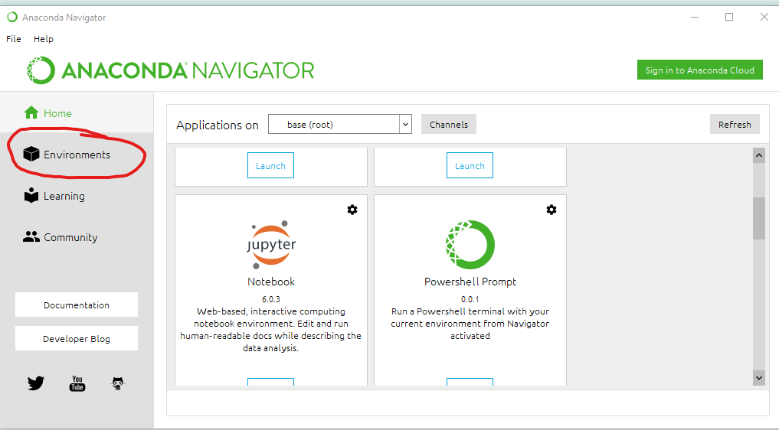
c) Click the green Play button and choose Open Terminal:
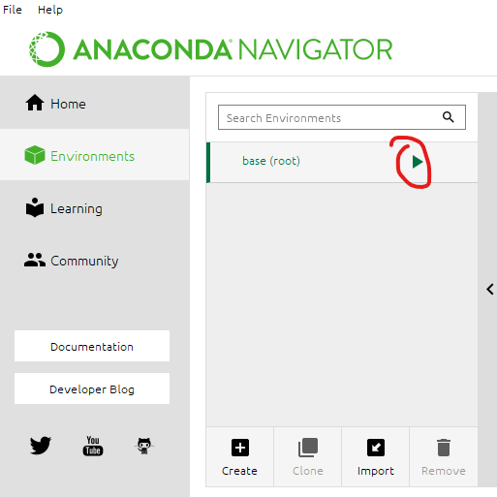
d) Copy and paste the following text into the Terminal and press Enter:
pip3 install -U matplotlib numpy pandas scipy jupyter ipython scikit-learn scikit-image openslide-python

3) Change the terminal location to where the program is located:
a) In Windows, go to the folder containing “slides_to_tiles.py” and open it:
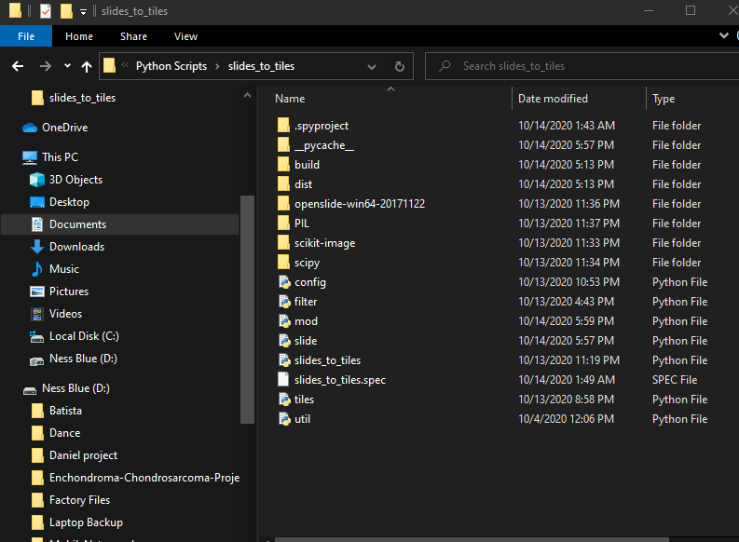
b) Right click any file or folder and choose “Properties”:
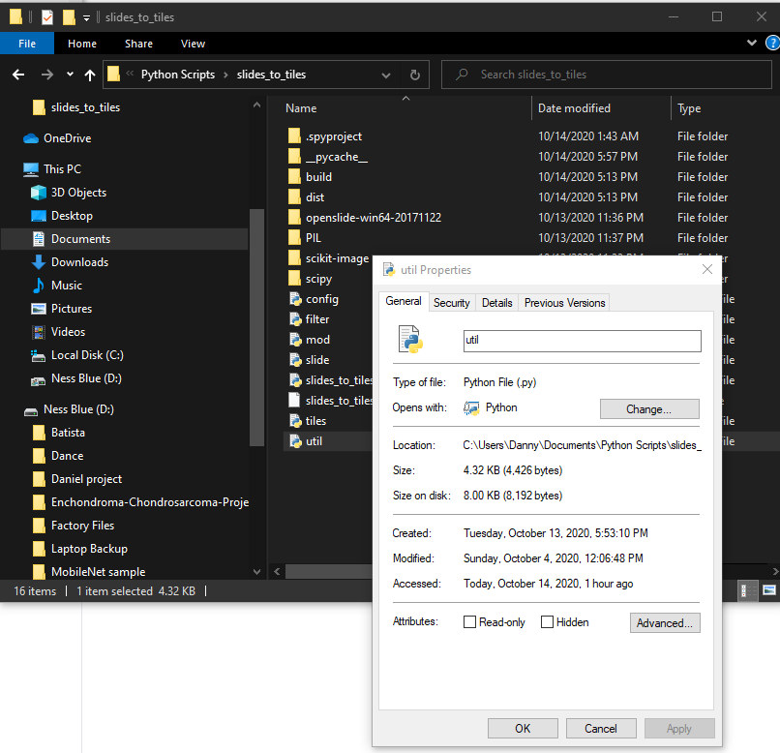

c) Copy the entire directory next to where it says “Location:”
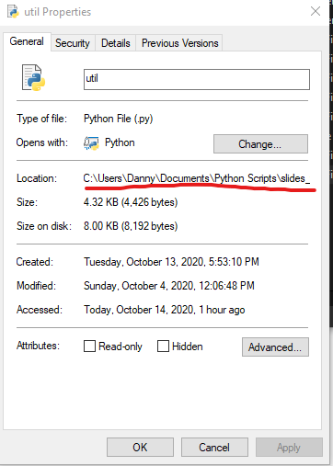
For example, mine is C:\Users\Danny\Documents\Python Scripts\slides_to_tiles
d) Go to the Terminal that was opened through Anaconda before, type “cd ” without the quotes, paste the directory right after, and press enter. Note the space after “cd”:
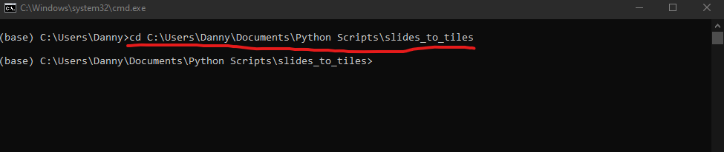

4) Run the python script by copying and pasting the following text:

python slides_to_tiles.py
5) Choose the location containing your whole slide images. The program will generate many different folders containing different statistics and metrics related to the WSI’s in the chosen directory. The tiles generated from the WSI are saved in the folder called tiles_jpg. The tile_summary_jpg folder is pretty neat because it shows which parts of the WSI were exported as tiles. The program does its best to filter out the background in order to reduce unnecessary computations later on.

