**Tutorial 01**

**TO DO IN CLASS- REMEMBER TO UPLOAD THE REPO LINK TO TEAMS**

**FIRST COMPLETE THE ENTIRE TUTORIAL (IGNORE THE ACTIVITES) – AT THE END, COMPLETE THE PROPOSED ACTIVITIES**

* **Before starting (create a new Django project):**

Open your Terminal, and in a location of your choice (it’s recommended to create a folder for each django project in this course), execute the following:

|  |
| --- |
| **Execute in Terminal** |

cd djangocourse  
mkdir && cd helloworld

|  |
| --- |
| **Execute in Terminal** |

django-admin startproject helloworld_project **.**

**Note: the dot (.) at the end of this command tells django to create the project in the current folder.**

The previous command creates a new django project inside the *djangolcourse/helloworld* folder. Next, in your Terminal, and run the application with the following:

|  |
| --- |
| **Execute in Terminal** |

python manage.py runserver

If the installation and setup were successful, you could open the django development server link in your browser (<http://127.0.0.1:8000/>). You should see your django application (in django 4).

Django 4 default page.

You can press CTRL+C (on Windows, CMD+C on Mac) on your Terminal to stop running the server, as we are not going to run it from here in the future.

1. **“Clean” hello world version**

* In your Terminal run the following command:

|  |
| --- |
| **Execute in Terminal** |

* code

This command should open the VS Code editor with your project in the Explorer tab. If not, you can go to File->Open Folder -> select the helloworld folder.

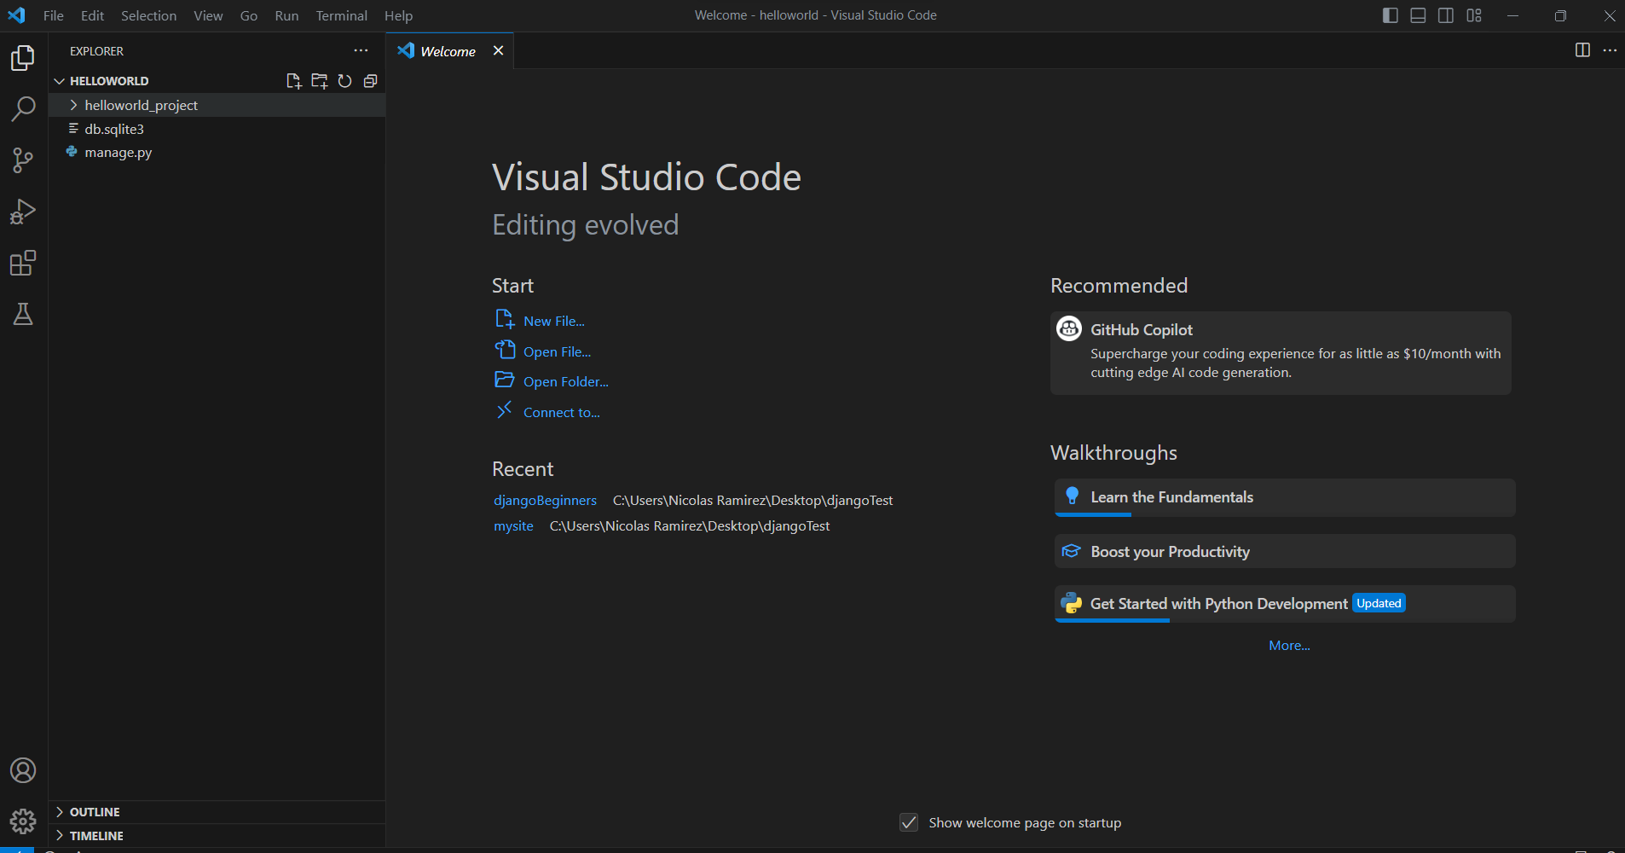

Additionally, in the Terminal tab, click on New Terminal to open a Terminal in VS Code from which we will run terminal commands for this project.

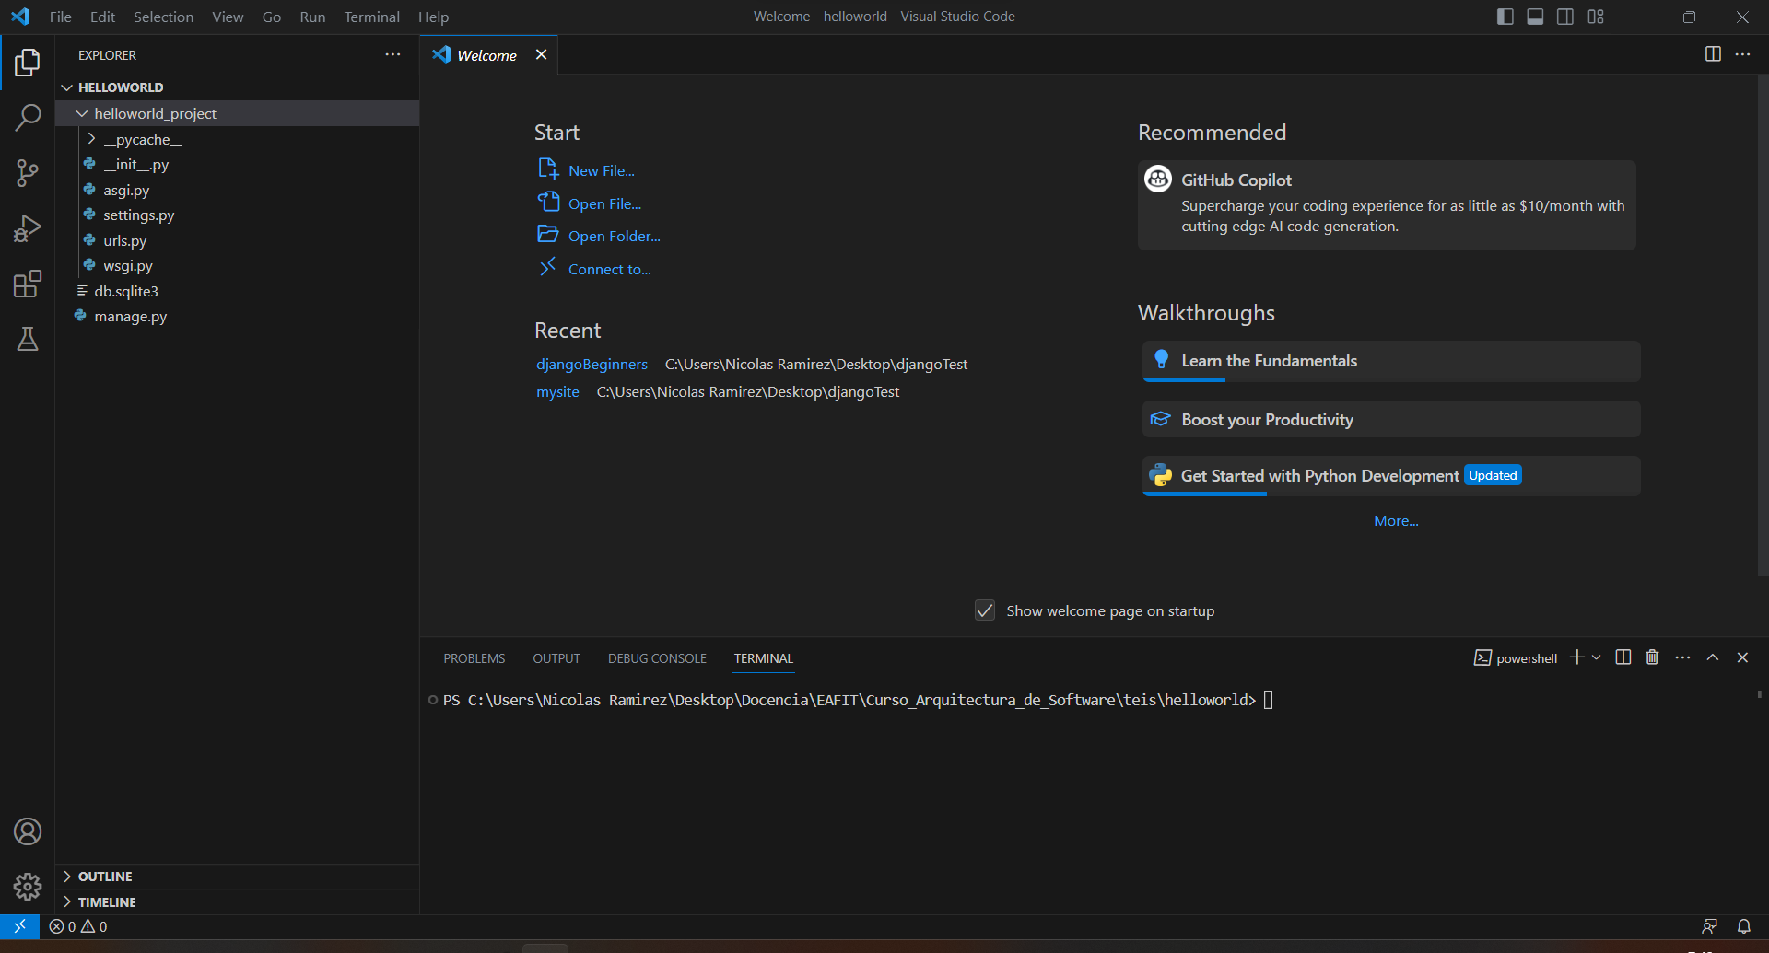

**Create your first app**

In your VS code Terminal run the following command:

|  |
| --- |
| **Execute in VS Terminal** |

* python manage.py startapp pages

The previous command should add a new directory named *pages* in your project:

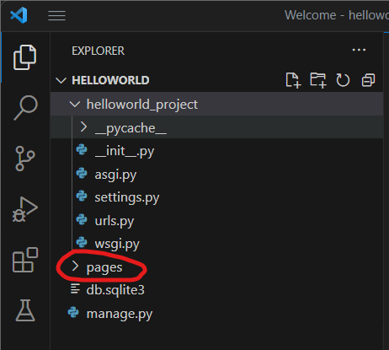

Go to *helloworld_project/settings.py* and add the following code in the INSTALLED_APPS list:

|  |
| --- |
| **Add Bold Code** |

* # Application definition
* INSTALLED_APPS = [
* 'django.contrib.admin', # here by default
* 'django.contrib.auth', # here by default
* 'django.contrib.contenttypes', # here by default
* 'django.contrib.sessions', # here by default
* 'django.contrib.messages', # here by default
* 'django.contrib.staticfiles', # here by default
* **'pages.apps.PagesConfig', # new**
* ]

**Controller/View**

* Go to *pages/views.py* and add the following content to it (do not remove any content already there):

|  |
| --- |
| **Add Bold Code** |

* from django.shortcuts import render # here by default
* **from django.http import HttpResponse # new**
* # Create your views here.
* **def homePageView(request): # new**
* **return HttpResponse('Hello World!') # new**
* Create a urls.py file in *pages*

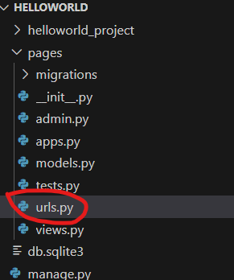

* Go to *pages/urls.py* and add the following content to it:

|  |
| --- |
| **Add Entire Code** |

* from django.urls import path
* from .views import homePageView
* urlpatterns = [
* path(“”, homePageView, name='home')
* ]
* Go to *helloworld_project/urls.py* and add the following content to it:

|  |
| --- |
| **Add Bold Code** |

* from django.contrib import admin
* from django.urls import path, **include**
* urlpatterns = [
* path('admin/', admin.site.urls),
* **path('', include('pages.urls')),**
* ]
* **Note:** it is recommended that you create a Github repository for your projects and push changes as you make them.

**Template/view**

* Go to *pages* and create a *templates* directory; then, inside this new directory create a *pages* directory inside, then create a *base.html* file. The layout should look like this:

* Go to *pages/templates/pages/base.html* with the following content:

|  |
| --- |
| **Add Entire Code** |

{% load static %}

<!doctype html>

<html lang="en">

<head>

<meta charset="utf-8" />

<meta name="viewport" content="width=device-width, initial-scale=1" />

<link href="https://cdn.jsdelivr.net/npm/bootstrap@5.3.0-alpha1/dist/css/bootstrap.min.css" rel="stylesheet" crossorigin="anonymous" />

<link href="{% static 'pages/app.css' %}" rel="stylesheet" />

<title>{% block title %}'Online Store'{% endblock %}</title>

</head>

<body>

<!-- header -->

<nav class="navbar navbar-expand-lg navbar-dark bg-secondary py-4">

<div class="container">

<a class="navbar-brand" href="#">Online Store</a>

<button class="navbar-toggler" type="button" data-bs-toggle="collapse" data-bs-target="#navbarNavAltMarkup"

aria-controls="navbarNavAltMarkup" aria-expanded="false" aria-label="Toggle navigation">

<span class="navbar-toggler-icon"></span>

</button>

<div class="collapse navbar-collapse" id="navbarNavAltMarkup">

<div class="navbar-nav ms-auto">

<a class="nav-link active" href="#">Home</a>

<a class="nav-link active" href="#">About</a>

</div>

</div>

</div>

</nav>

<header class="masthead bg-primary text-white text-center py-4">

<div class="container d-flex align-items-center flex-column">

<h2>{% block header_title %}'A Django EAFIT App'{% endblock %}</h2>

</div>

</header>

<!-- header -->

<div class="container my-4">

{% block content %}

{% endblock %}

</div>

<!-- footer -->

{% block footer %}

<div class="copyright py-4 text-center text-white">

<div class="container">

<small>

Copyright - <a class="text-reset fw-bold text-decoration-none" target="_blank"

href="https://twitter.com/danielgarax">

Daniel Correa

</a>

</small>

</div>

</div>

<!-- footer -->

{% endblock %}

**<script src="https://cdn.jsdelivr.net/npm/bootstrap@5.3.0-alpha1/dist/js/bootstrap.bundle.min.js" crossorigin="anonymous">**

</script>

</body>

</html>

* Go to *templates/pages/home.html* file with the following content:

|  |
| --- |
| **Add Entire Code** |

@extends('layouts.app')

{% extends 'pages/base.html' %}

{% block title %}'Home Page - Online Store'{% endblock %}

{% block content %}

<div class="text-center">

Welcome to the application

</div>

{% endblock %}

**CSS**

* Create a new directory *pages/static/pages*
* Go to *static/pages* and create a file *app.css* with the following content:

|  |
| --- |
| **Add Entire Code** |

.bg-secondary {

background-color: #2c3e50 !important;

}

.copyright {

background-color: #1a252f;

}

.bg-primary {

background-color: #1abc9c !important;

}

nav{

font-weight: 700;

}

.img-card{

height: 18vw;

object-fit: cover;

}

* The layout should look like this:

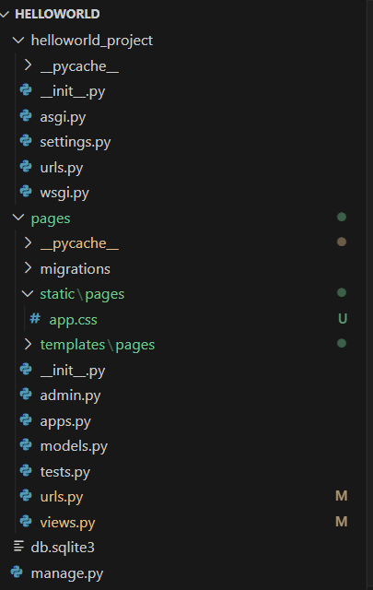

**Update View**

**Note:** in future projects you can create your Views here first rather than creating a function.

* In *pages/views.py*, make the following changes in **bold**.

|  |
| --- |
| **Modify Bold Code** |

* from django.shortcuts import render # here by default
* **~~from django.http import HttpResponse # new~~**
* **from django.views.generic import TemplateView**
* # Create your views here.
* **~~def homePageView(request): # new~~**
* **~~return HttpResponse('Hello World!') # new~~**
* **class HomePageView(TemplateView):**
* **template_name = ‘home.html**

**Run the application**

* Open a VS Terminal by going to the *Terminal* tab and clicking *New Terminal.*  The new Terminal should appear below your code :
* Texto

  Descripción generada automáticamente

|  |
| --- |
| **Execute in Terminal** |

python manage.py runserver

**You should see the application running.**

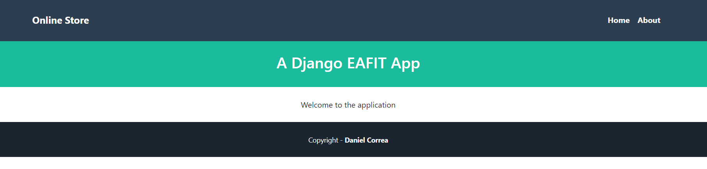

**B. An About page**

**Views**

* Go to *pages/templates/pages* and create a file *about.html* with the following content:

|  |
| --- |
| **Add Entire Code** |

{% extends 'pages/base.html' %}

{% block title %} {{title}} {% endblock %}

{% block header_title %} {{subtitle}} {% endblock %}

{% block content %}

<div class="container">

<div class="row">

<div class="col-lg-4 ms-auto">

<p class="lead">{{description}}</p>

</div>

<div class="col-lg-4 me-auto">

<p class="lead">{{author}}</p>

</div>

</div>

</div>

{% endblock %}

**Updating links in Header**

* Now that we have the proper routes, controller, and views, let’s include the links in the header. In *templates/pages/base.html*, make the following changes in **bold**.

|  |
| --- |
| **Modify Bold Code** |

<!doctype html>

...

<body>

<!-- header -->

<nav class="navbar navbar-expand-lg navbar-dark bg-secondary py-4">

<div class="container">

<a class="navbar-brand" **href="{% url 'home' %}">**Online Store</a>

<button class="navbar-toggler" type="button" data-bs-toggle="collapse" data-bs-target="#navbarNavAltMarkup"

aria-controls="navbarNavAltMarkup" aria-expanded="false" aria-label="Toggle navigation">

<span class="navbar-toggler-icon"></span>

</button>

<div class="collapse navbar-collapse" id="navbarNavAltMarkup">

<div class="navbar-nav ms-auto">

<a class="nav-link active**" href="{% url 'home' %}">**Home</a>

<a class="nav-link active**" href="{% url 'about' %}**">About</a>

</div>

</div>

</div>

</nav>...

**Routes**

* In *pages/views.py*, make the following changes in **bold**.

|  |
| --- |
| **Modify Bold Code** |

…

from django.shortcuts import render

from django.http import HttpResponse

from django.views.generic import TemplateView

# Create your views here.

class HomePageView(TemplateView):

template_name = 'pages/home.html'

**class AboutPageView(TemplateView):**

**template_name = 'pages/about.html'**

**def get_context_data(self, **kwargs):**

**context = super().get_context_data(**kwargs)**

**context.update({**

**"title": "About us - Online Store",**

**"subtitle": "About us",**

**"description": "This is an about page ...",**

**"author": "Developed by: Your Name",**

**})**

**return context**

* Go to *pages/urls.py* and make the following changes in **bold**

|  |
| --- |
| **Modify Bold Code** |

…

from django.urls import path

from .views import HomePageView, **AboutPageView**

urlpatterns = [

path('', HomePageView.as_view(), name='home'),

**path('about/', AboutPageView.as_view(), name='about')**

]

**Run the application**

* In the Terminal, execute the following:

|  |
| --- |
| **Execute in Terminal** |

python manage.py runserver

**Click the “about link” in the header, and you should see the application running.**

**Activity 1**

* Create a “/contact” section in which you display the application email, address, and phone number. Use fake information.

**C. Show products**

**View**

* Go to *pages/views.py* and add the following content:

|  |
| --- |
| **Add Entire Code** |

**from django.views import View**

class Product:

products = [

{"id":"1", "name":"TV", "description":"Best TV"},

{"id":"2", "name":"iPhone", "description":"Best iPhone"},

{"id":"3", "name":"Chromecast", "description":"Best Chromecast"},

{"id":"4", "name":"Glasses", "description":"Best Glasses"}

]

class ProductIndexView(View):

template_name = 'products/index.html'

def get(self, request):

viewData = {}

viewData["title"] = "Products - Online Store"

viewData["subtitle"] = "List of products"

viewData["products"] = Product.products

return render(request, self.template_name, viewData)

class ProductShowView(View):

template_name = 'products/show.html'

def get(self, request, id):

viewData = {}

product = Product.products[int(id)-1]

viewData["title"] = product["name"] + " - Online Store"

viewData["subtitle"] = product["name"] + " - Product information"

viewData["product"] = product

return render(request, self.template_name, viewData)}

***Product index template***

In *pages/templates*, create a subfolder *products*. Then, in *apges/templates/products*, create a new file *index.html* and fill it with the following code.

|  |
| --- |
| **Add Entire Code** |

@extends('layouts.app')

{% extends 'pages/base.html' %}

{% block title %} {{title}} {% endblock %}

{% block header_title %} {{subtitle}} {% endblock %}

{% block content %}

<div class="row">

{% for product in products %}

<div class="col-md-4 col-lg-3 mb-2">

<div class="card">

<img src="https://static.djangoproject.com/img/logos/django-logo-positive.svg" class="card-img-top img-card">

<div class="card-body text-center">

<a href="{% url 'show' id=product.id %}"

class="btn bg-primary text-white">{{product.name}}</a>

</div>

</div>

</div>

{% endfor %}

</div>

{% endblock %}

***Product show view***

In *pages/templates/products*, create a new file *show.html* and fill it with the following code.

|  |
| --- |
| **Add Entire Code** |

{% extends 'pages/base.html' %}

{% block title %} {{title}} {% endblock %}

{% block header_title %} {{subtitle}} {% endblock %}

{% block content %}

<div class="card mb-3">

<div class="row g-0">

<div class="col-md-4">

<img src="https://static.djangoproject.com/img/logos/django-logo-positive.svg" class="img-fluid rounded-start">

</div>

<div class="col-md-8">

<div class="card-body">

<h5 class="card-title">

{{product.name}}

</h5>

<p class="card-text">{{product.description}}</p>

</div>

</div>

</div>

</div>

{% endblock %}

**Modifying routes**

In *pages/urls.py*, add the following changes in **bold**.

|  |
| --- |
| **Modify Bold Code** |

…

urlpatterns = [

path('', HomePageView.as_view(), name='home'),

path('about/', AboutPageView.as_view(), name='about'),

**path('products/', ProductIndexView.as_view(), name='index'),**

**path('products/<str:id>', ProductShowView.as_view(), name='show'),**

**]**

**Run the application**

In the Terminal execute the following:

|  |
| --- |
| **Execute in Terminal** |

python manage.py runserver

**Go to the (“/products”) route and you should see the application running.**

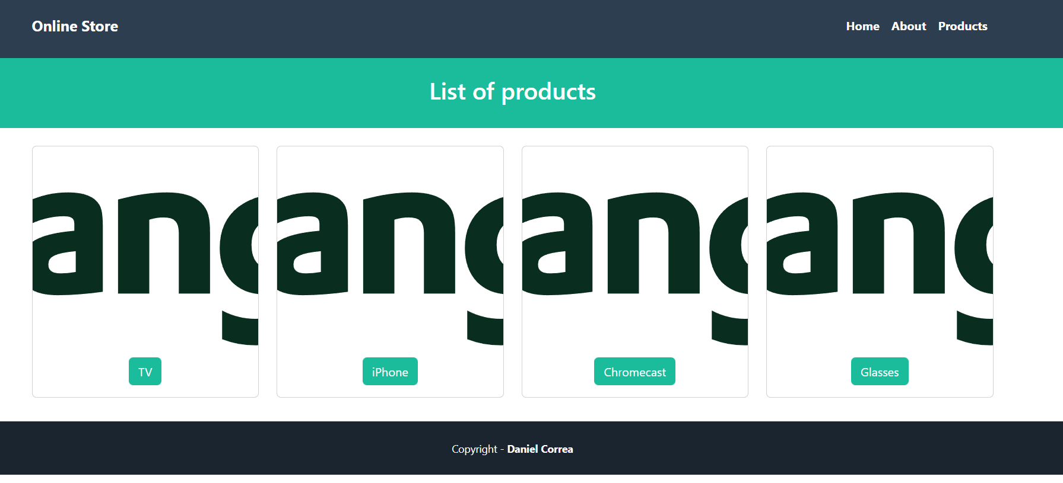

You can also click a specific product to see its information.

**Activity 2**

* Add the (“/products”) route as a new menu option (in the header navbar).

**Activity 3**

* Add prices for each product and display the information in the product.show view.

**Activity 4**

* Modify the show method. If the product number entered by the URL is not valid, redirect the user to the home page (“home”) route: <https://docs.djangoproject.com/en/4.2/intro/tutorial04/> .

Be careful, you should include this in the method response: *HttpResponseRedirect;*

**Activity 5**

* Add a conditional in the “show” template. If the price of a product is greater than 100, display the product name in red <https://docs.djangoproject.com/en/4.2/ref/templates/builtins/>

**D. Product creation (simulation)**

**Views**

* In *pages/views.py*, add the following content.

|  |
| --- |
| **Modify Bold Code** |

…

**from django import forms**

**from django.shortcuts import render, redirect**

**class ProductForm(forms.Form):**

**name = forms.CharField(required=True)**

**price = forms.FloatField(required=True)**

**class ProductCreateView(View):**

**template_name = 'products/create.html'**

**def get(self, request):**

**form = ProductForm()**

**viewData = {}**

**viewData["title"] = "Create product"**

**viewData["form"] = form**

**return render(request, self.template_name, viewData)**

**def post(self, request):**

**form = ProductForm(request.POST)**

**if form.is_valid():**

**return redirect(form)**

**else:**

**viewData = {}**

**viewData["title"] = "Create product"**

**viewData["form"] = form**

**return render(request, self.template_name, viewData)**}

**Routes**

* In *pages/urls.py*, make the following changes in **bold**. (check the route order, it matters).

|  |
| --- |
| **Modify Bold Code** |

…

from django.urls import path

from .views import HomePageView, AboutPageView, ProductIndexView, ProductShowView**, ProductCreateView**

**urlpatterns = [**

path('', HomePageView.as_view(), name='home'),

path('about/', AboutPageView.as_view(), name='about'),

path('products/', ProductIndexView.as_view(), name='index'),

**path('products/create', ProductCreateView.as_view(), name='form'),**

**path('products/<str:id>', ProductShowView.as_view(), name='show'),**

**]**

**Templates**

* Go to *templates/products*, create a file *create.html* with the next content:

|  |
| --- |
| **Add Entire Code** |

{% extends 'pages/base.html' %}

{% block title %} {{title}} {% endblock %}

{% block content %}

<div class="container">

<div class="row justify-content-center">

<div class="col-md-8">

<div class="card">

<div class="card-header">Create product</div>

<div class="card-body">

{% if form.errors %}

<ul id="errors" class="alert alert-danger list-unstyled">

{% for field, errors in form.errors.items %}

{% for error in errors %}

<li>{{ error }}</li>

{% endfor %}

{% endfor %}

</ul>

{% endif %}

<form method="POST" action="{% url 'form' %}">

{% csrf_token %}

<input type="text" class="form-control mb-2" placeholder="Enter name" name="name" value="{{form.data.name }}" />

<input type="text" class="form-control mb-2" placeholder="Enter price" name="price" value="{{form.data.price }}" />

<input type="submit" class="btn btn-primary" value="Send" />

</form>

</div>

</div>

</div>

</div>

</div>

</div>

{% endblock %}

**Run the application**

In the Terminal, go to the project directory, and execute the following:

|  |
| --- |
| **Execute in Terminal** |

python manage.py runserver

**Go to the (“/products/create”) route and you should see the application running.**

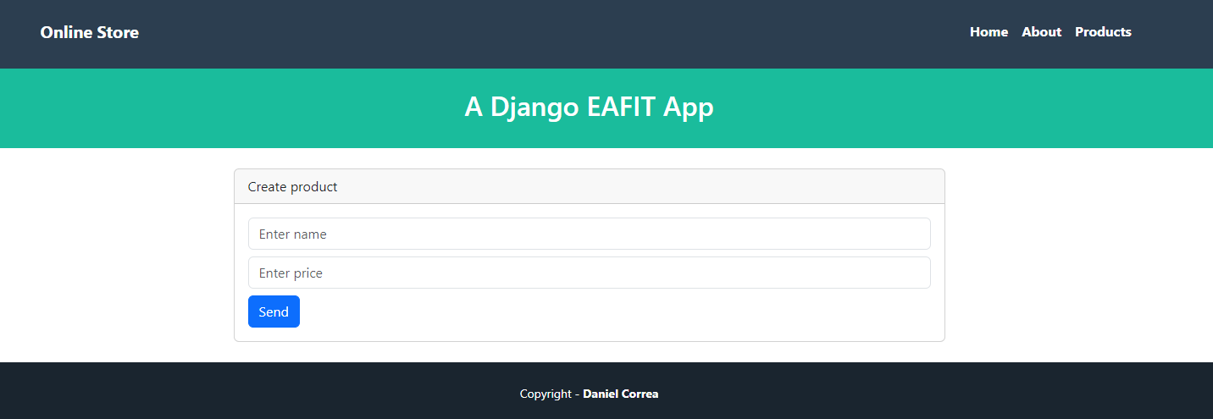

**Activity 6**

* Try to understand the previous code. Add a new product but leave the name empty (and click send). Then, leave the price empty. Then, enter the two fields.

**Activity 7**

* Modify the previous code to only allow numbers greater than zero for the prices. <https://docs.djangoproject.com/en/4.2/ref/forms/validation/> HINT: use clean_<field_name> methods.

**Activity 8**

* If the info entered by the form is valid. Then display a message saying, “Product created”. **Note:** create a new template (which uses the lbase template).

**Activity 9**

* Add a new menu option in the header (base.html), that links to the “/products/create” page.

**Activity 10**

* Create a Github repo with all this code (called DjangoTutorials) and upload the repo link to the corresponding Teams Assigment.