IT Service Desk Case INC-2401
Subject: VPN access intermittent
Category: Remote Access | Priority: P2 | Status: Resolved - monitoring

Service summary
Request INC-2401 concerns vpn access intermittent. The service desk confirmed impact, followed the standard support runbook, and recorded the resolution for audit and handoff.
Metric | Value
Opened | 2026-08-20 09:15 UTC
Assigned group | Remote Access Operations
SLA target | 4 business hours

Weekly service chart
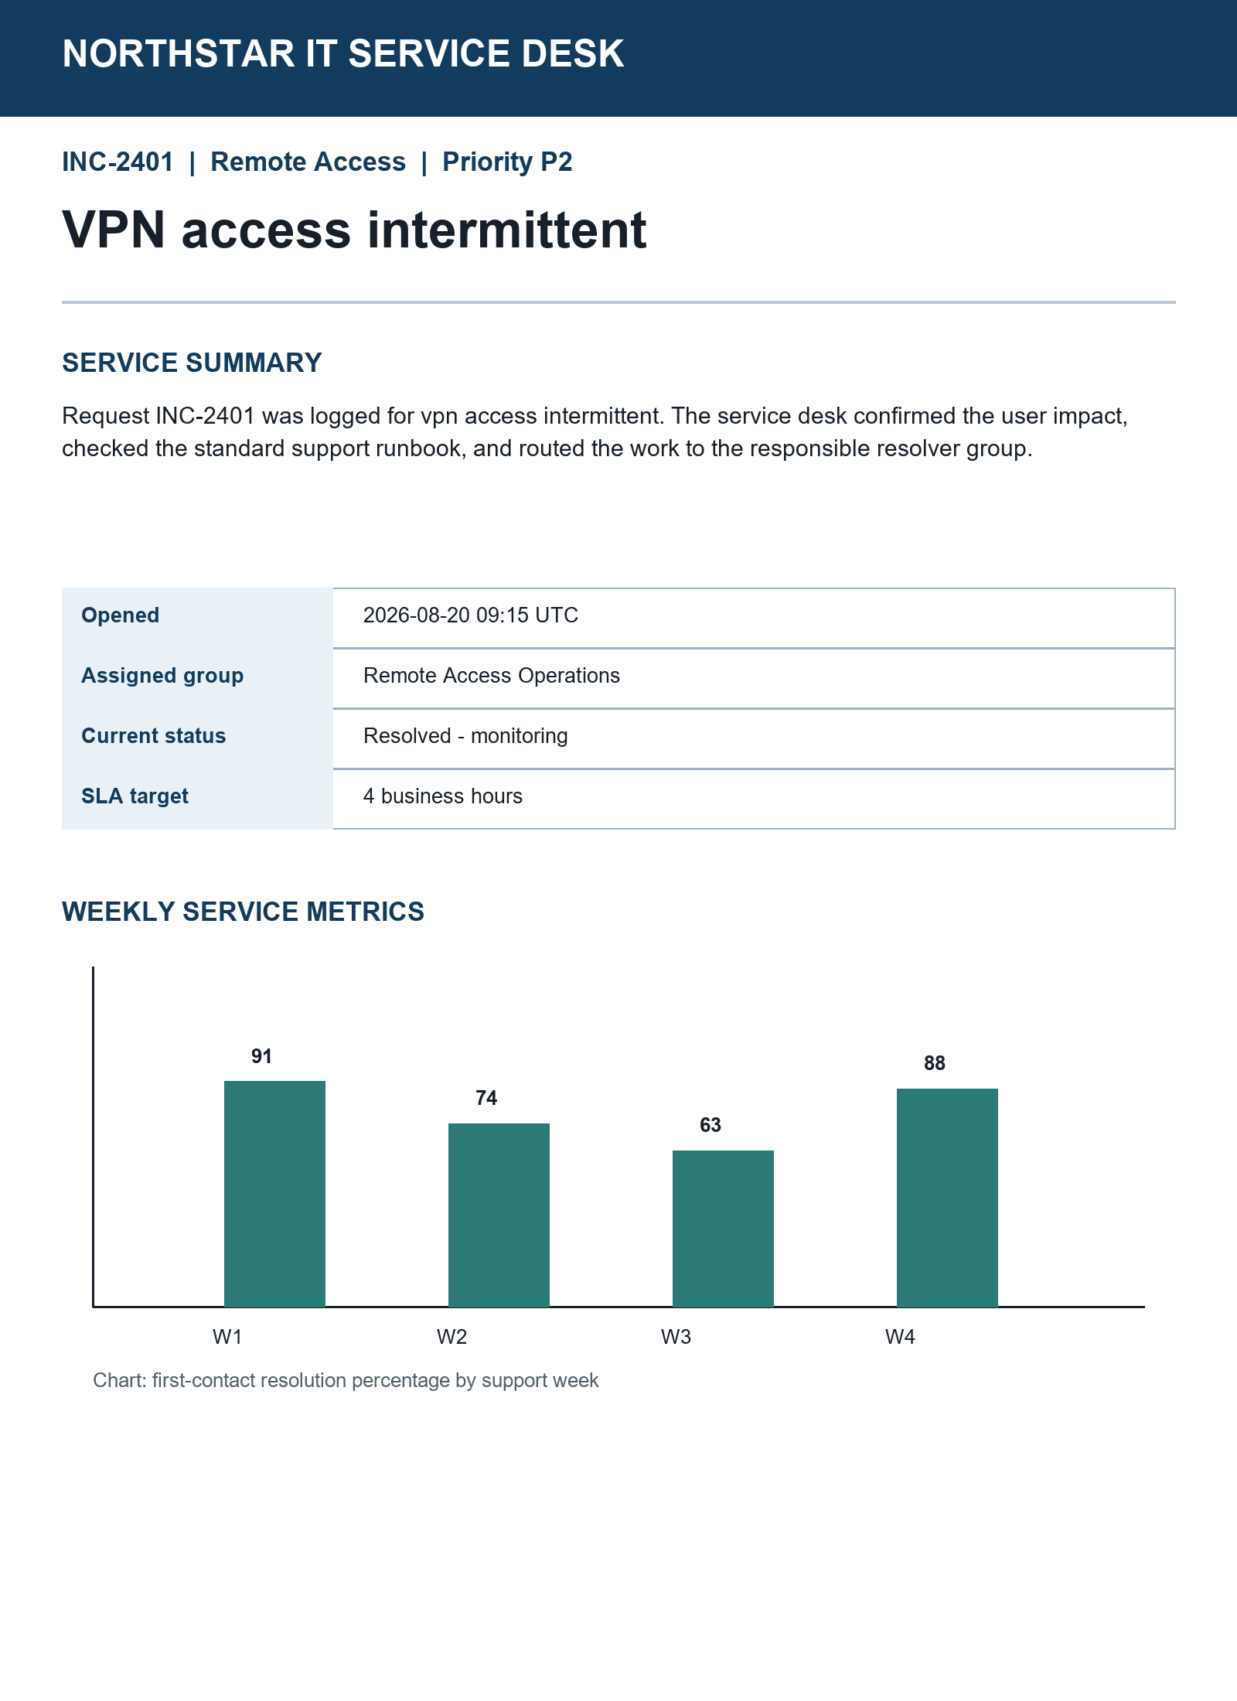

Agent workstation snapshot
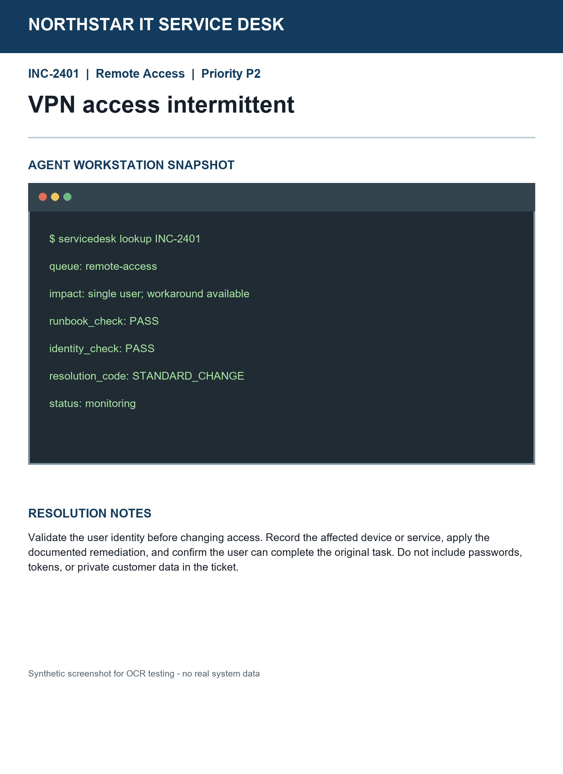

Resolution notes
Validate identity before changing access. Record the affected service, apply the documented remediation, and confirm the original task works. Never record passwords or tokens.

