IT Service Desk Case INC-2405
Subject: Email delivery delay
Category: Messaging | Priority: P2 | Status: Resolved - monitoring

Service summary
Request INC-2405 concerns email delivery delay. The service desk confirmed impact, followed the standard support runbook, and recorded the resolution for audit and handoff.
Metric | Value
Opened | 2026-08-20 09:15 UTC
Assigned group | Messaging Operations
SLA target | 4 business hours

Weekly service chart
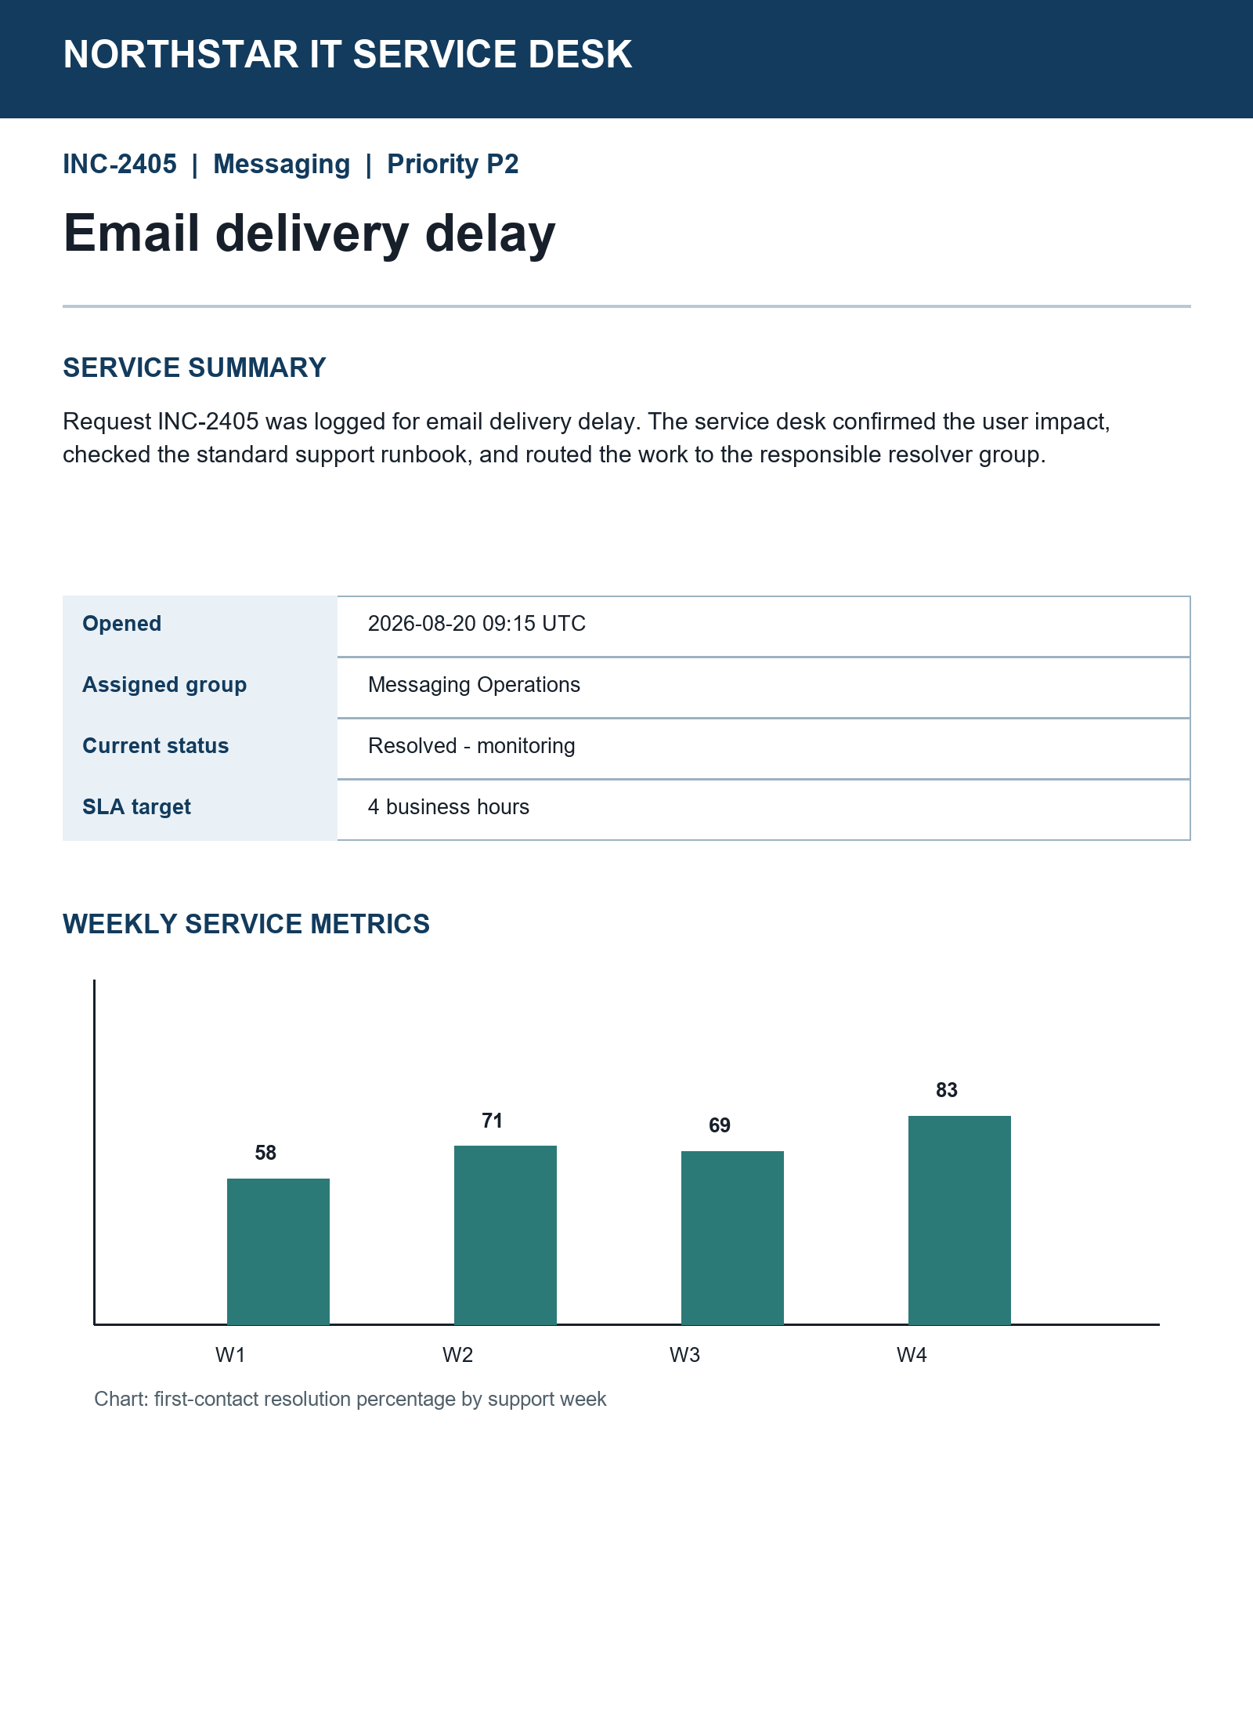

Agent workstation snapshot
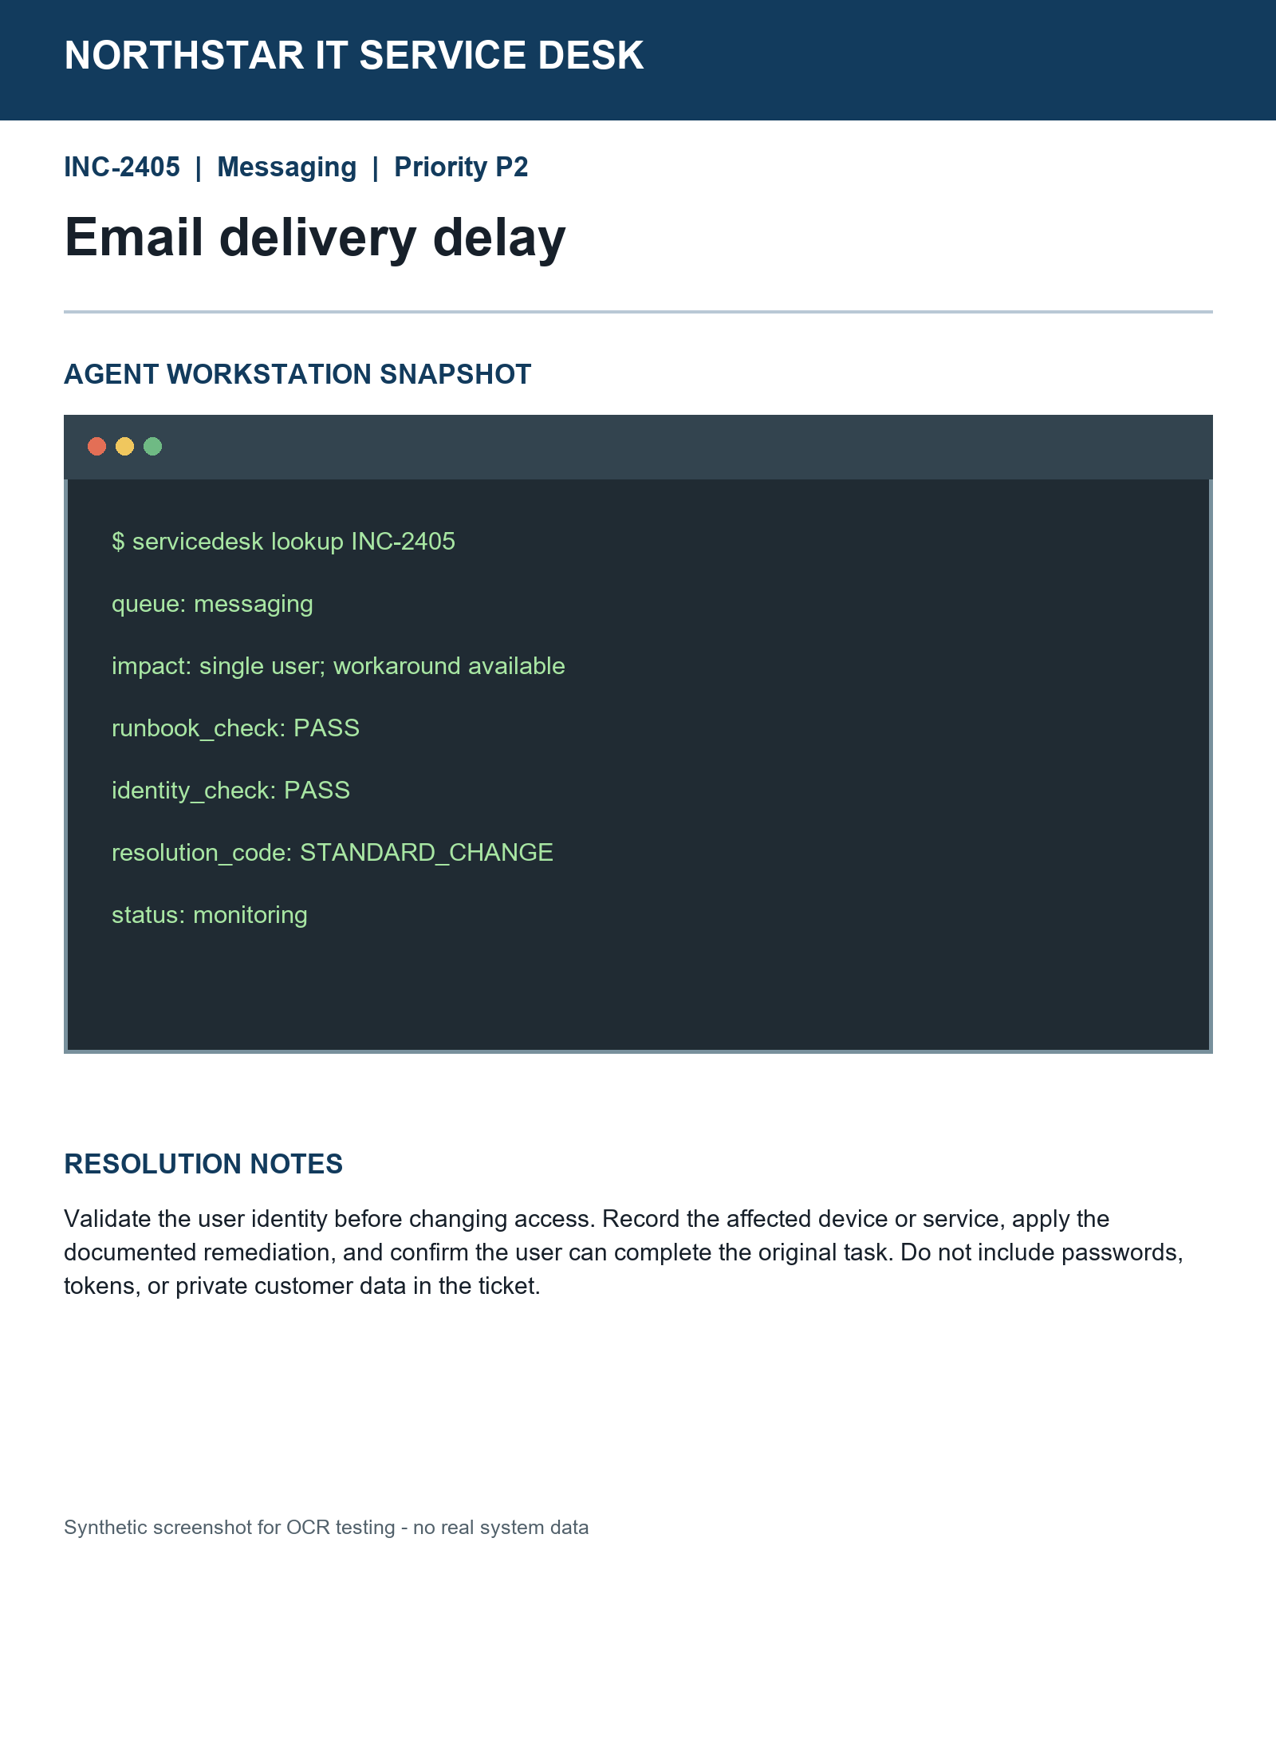

Resolution notes
Validate identity before changing access. Record the affected service, apply the documented remediation, and confirm the original task works. Never record passwords or tokens.

