IT Service Desk Case REQ-2402
Subject: Laptop battery replacement
Category: Hardware | Priority: P3 | Status: Resolved - monitoring

Service summary
Request REQ-2402 concerns laptop battery replacement. The service desk confirmed impact, followed the standard support runbook, and recorded the resolution for audit and handoff.
Metric | Value
Opened | 2026-08-20 09:15 UTC
Assigned group | Hardware Operations
SLA target | 4 business hours

Weekly service chart
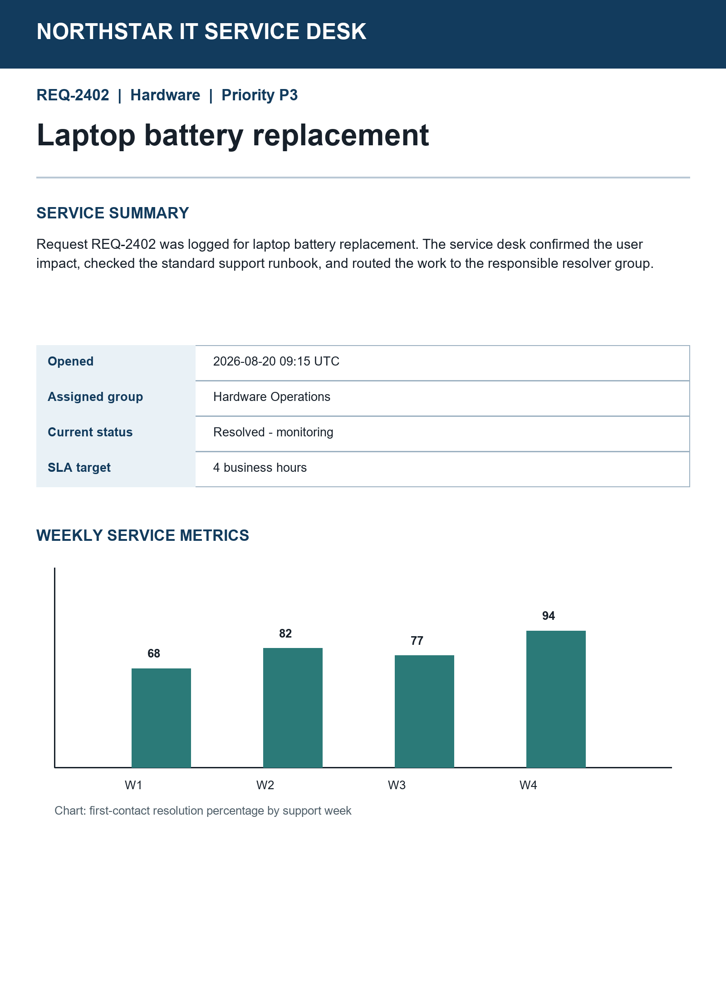

Agent workstation snapshot
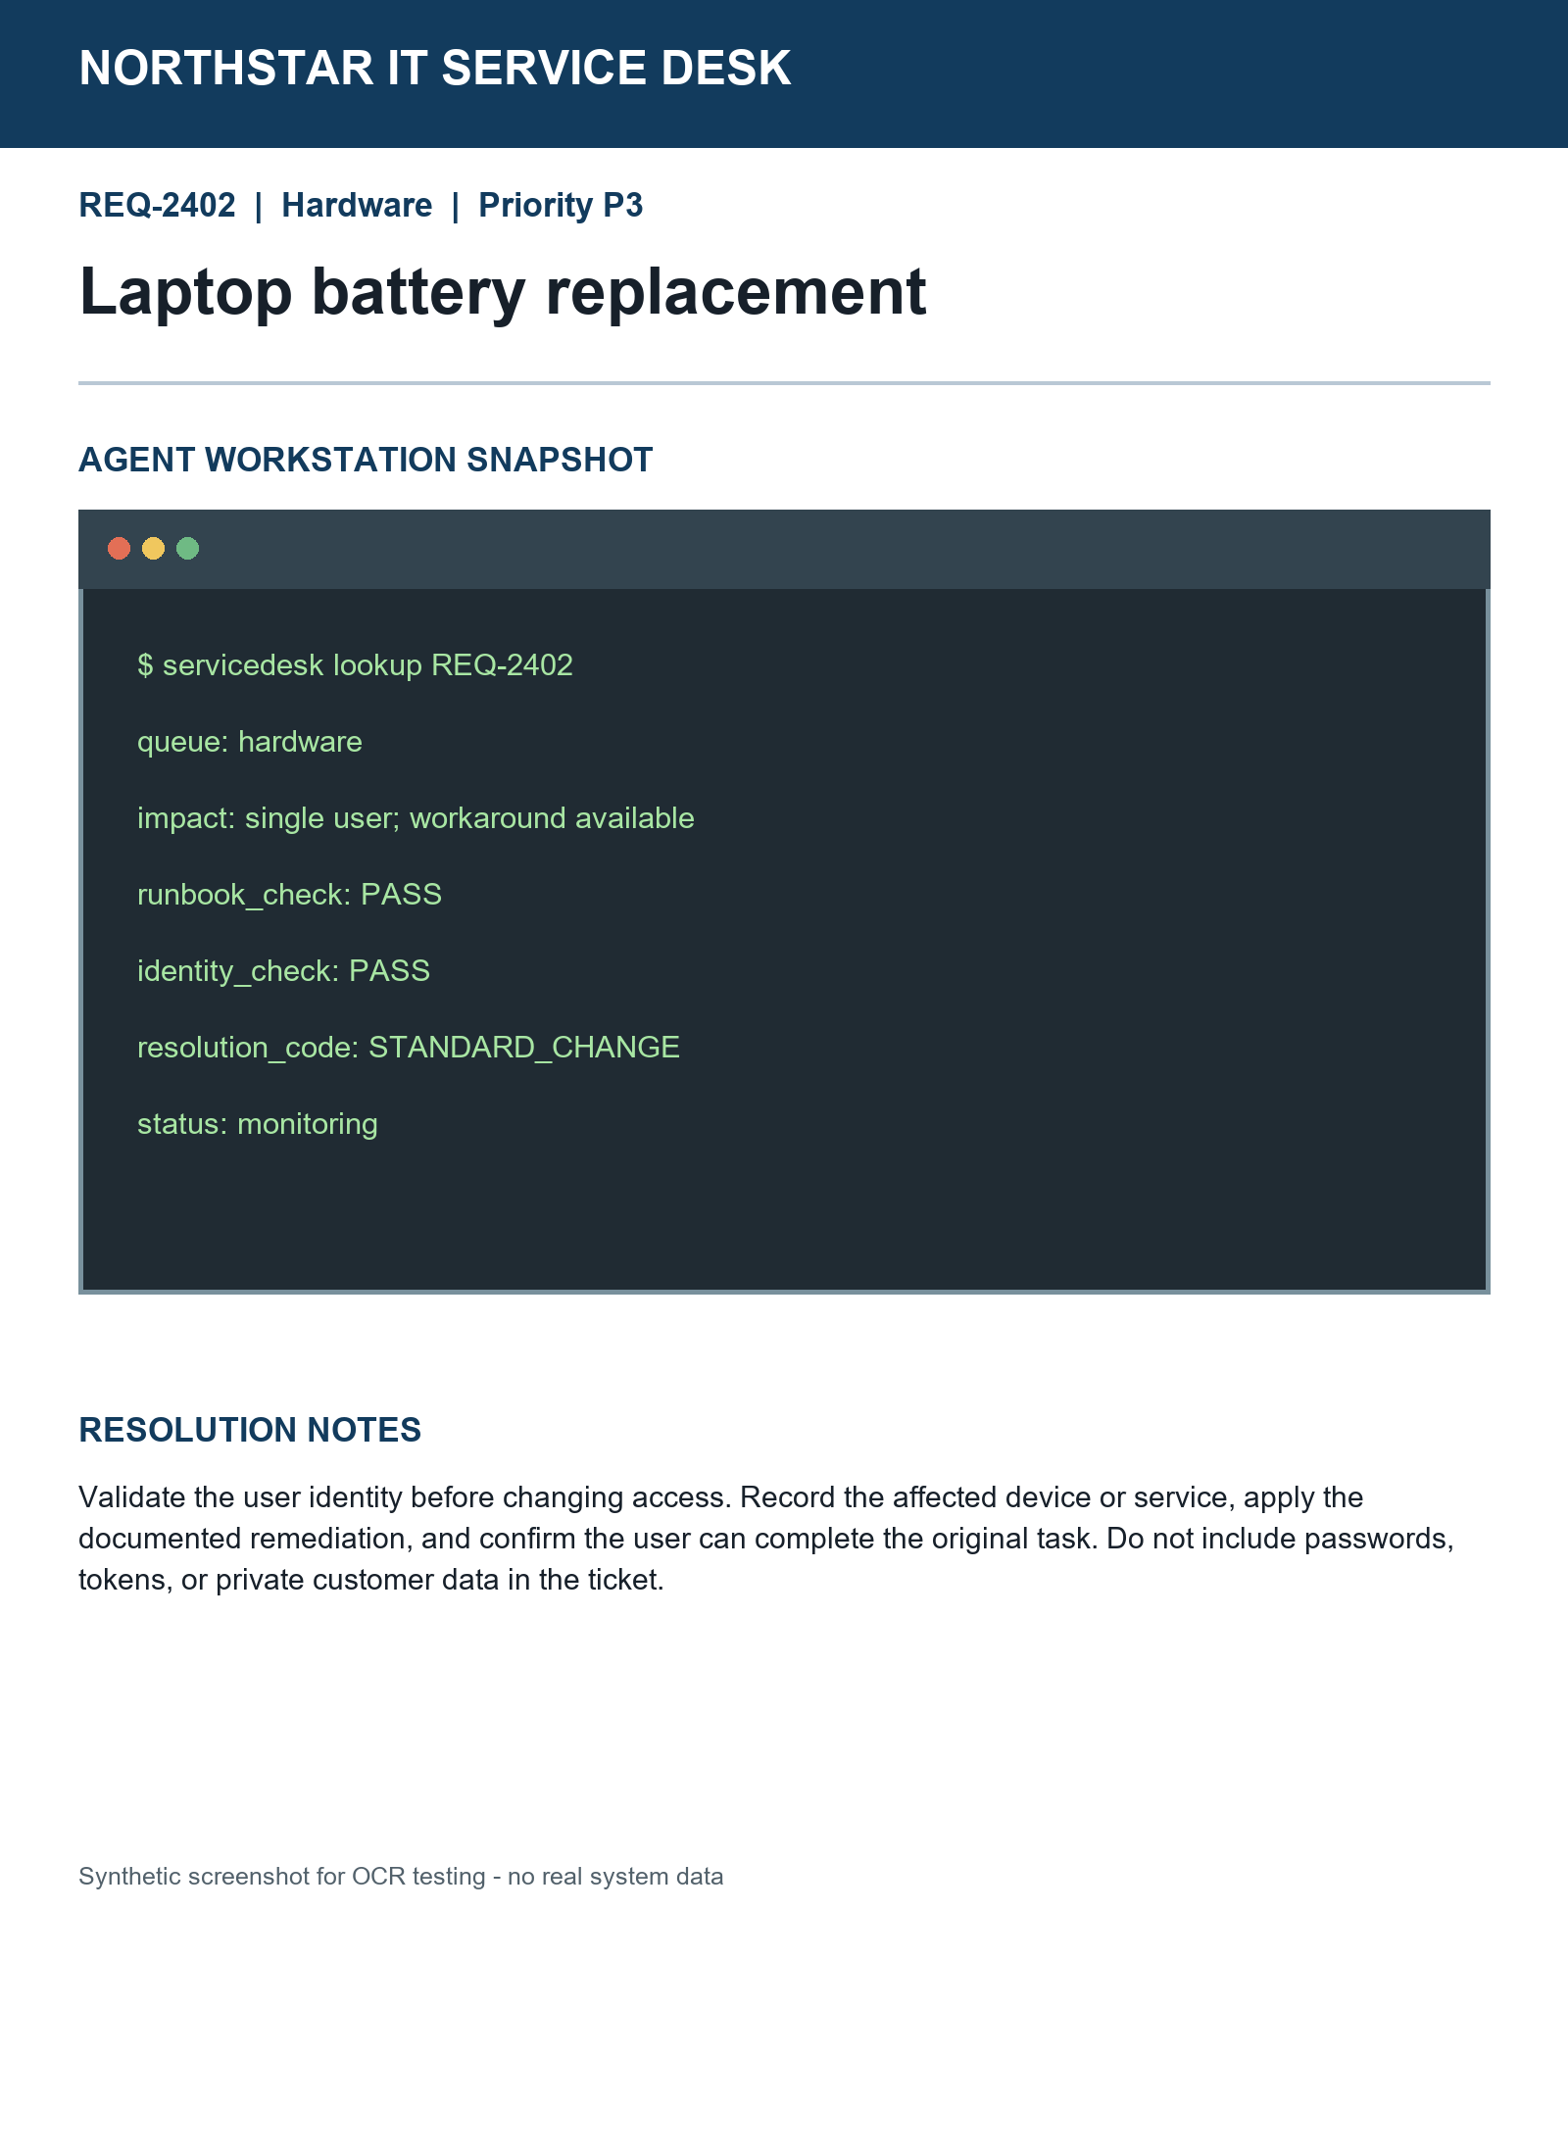

Resolution notes
Validate identity before changing access. Record the affected service, apply the documented remediation, and confirm the original task works. Never record passwords or tokens.

