IT Service Desk Case REQ-2403
Subject: MFA enrollment assistance
Category: Identity | Priority: P2 | Status: Resolved - monitoring

Service summary
Request REQ-2403 concerns mfa enrollment assistance. The service desk confirmed impact, followed the standard support runbook, and recorded the resolution for audit and handoff.
Metric | Value
Opened | 2026-08-20 09:15 UTC
Assigned group | Identity Operations
SLA target | 4 business hours

Weekly service chart
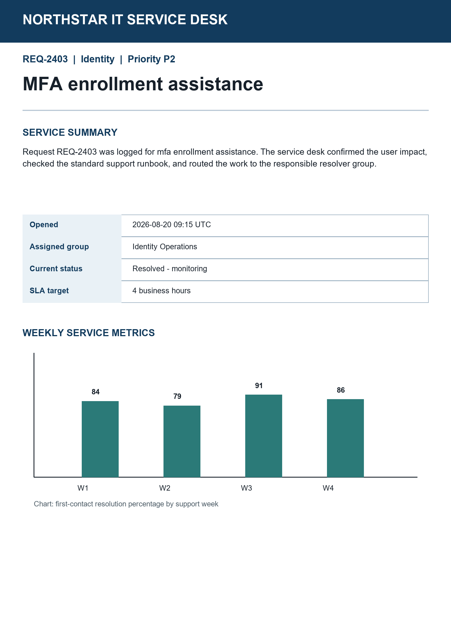

Agent workstation snapshot
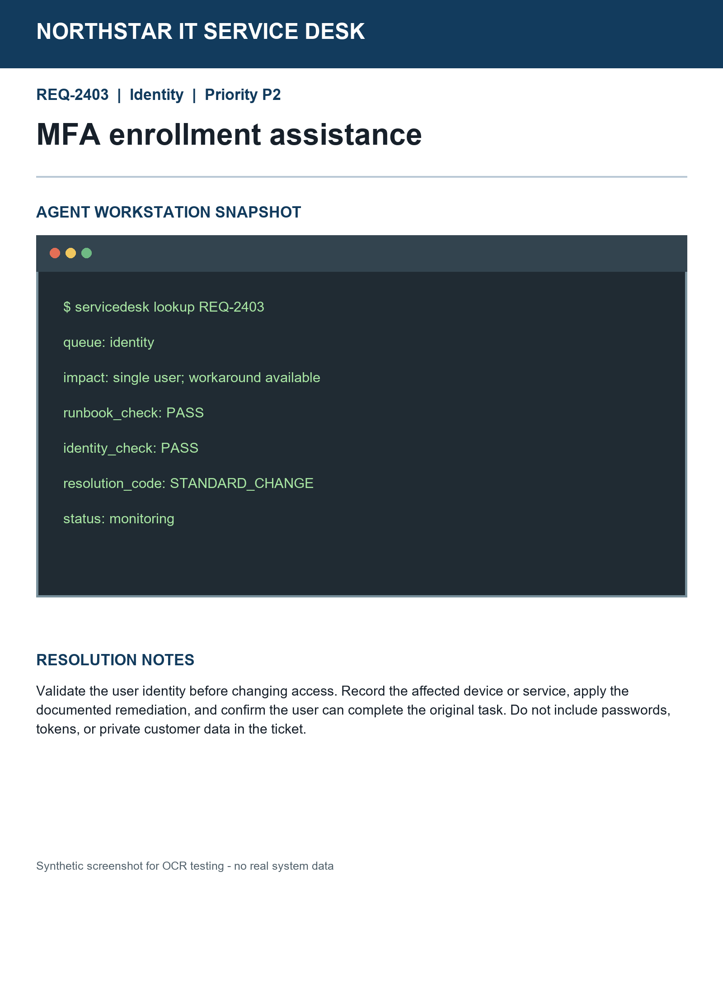

Resolution notes
Validate identity before changing access. Record the affected service, apply the documented remediation, and confirm the original task works. Never record passwords or tokens.

