IT Service Desk Case REQ-2404
Subject: Shared drive permissions
Category: Collaboration | Priority: P3 | Status: Resolved - monitoring

Service summary
Request REQ-2404 concerns shared drive permissions. The service desk confirmed impact, followed the standard support runbook, and recorded the resolution for audit and handoff.
Metric | Value
Opened | 2026-08-20 09:15 UTC
Assigned group | Collaboration Operations
SLA target | 4 business hours

Weekly service chart
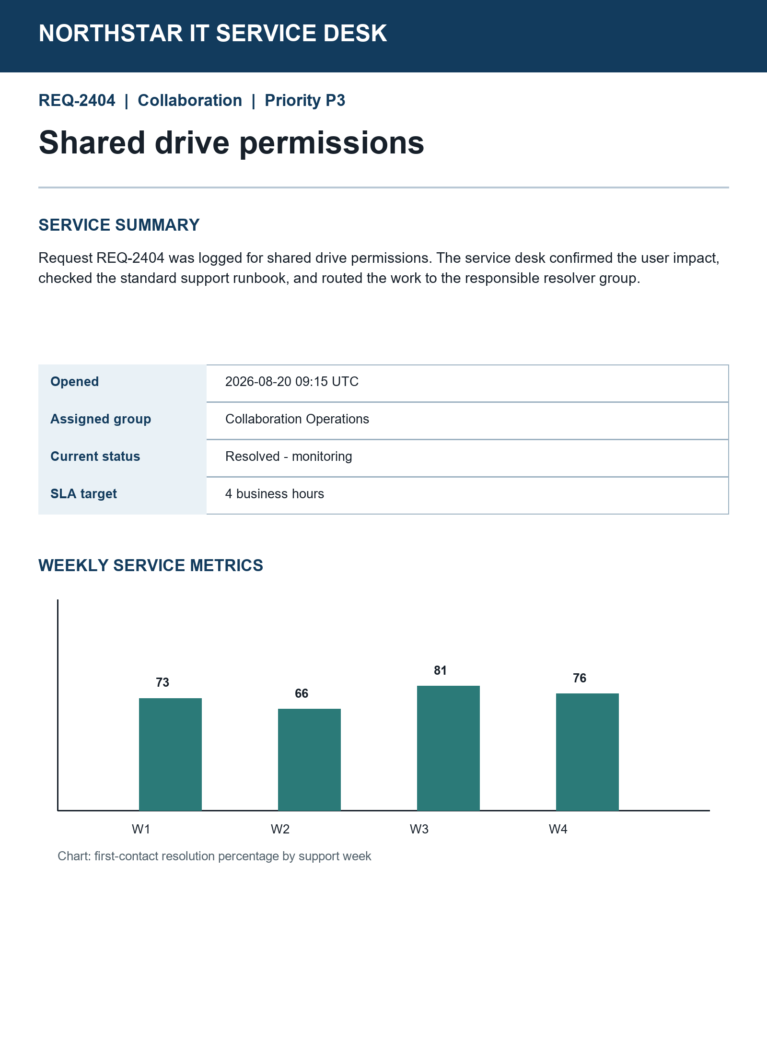

Agent workstation snapshot
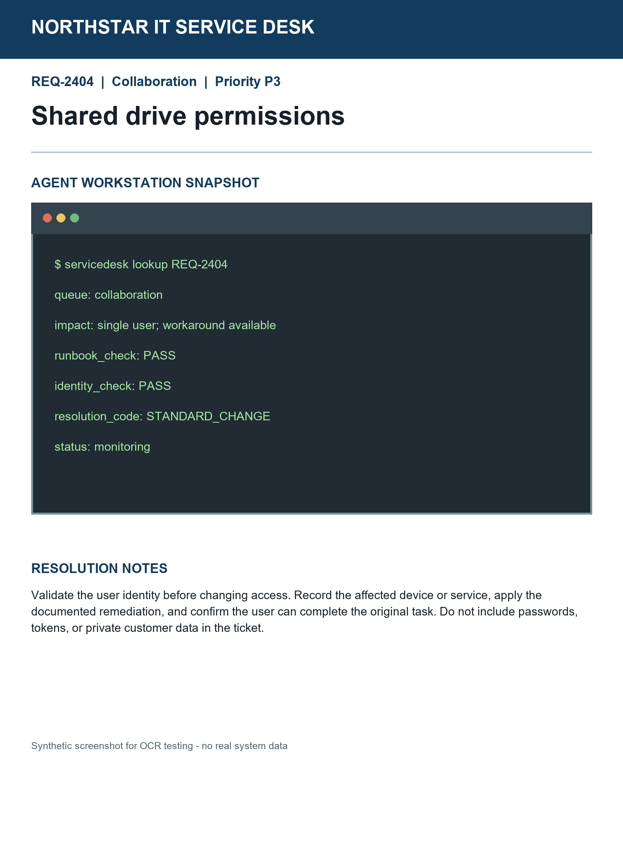

Resolution notes
Validate identity before changing access. Record the affected service, apply the documented remediation, and confirm the original task works. Never record passwords or tokens.

