Complex Conversion Validation Document
This document intentionally includes rich formatting, images, links, and tables to stress Markdown conversion quality.
Section A — Color + Font + Size Stress
Bold text, italic text, and colored emphasis
Bullet hierarchy example:
- Primary bullet item with long explanatory text that should wrap naturally.
- Nested bullet detail item.
- Another top-level bullet with a date 2026-07-30 and code ref ITSD-42.
Reference links: Microsoft Learn and MkDocs

Section B — Embedded Graphics
Graph image below (bar + trend line):
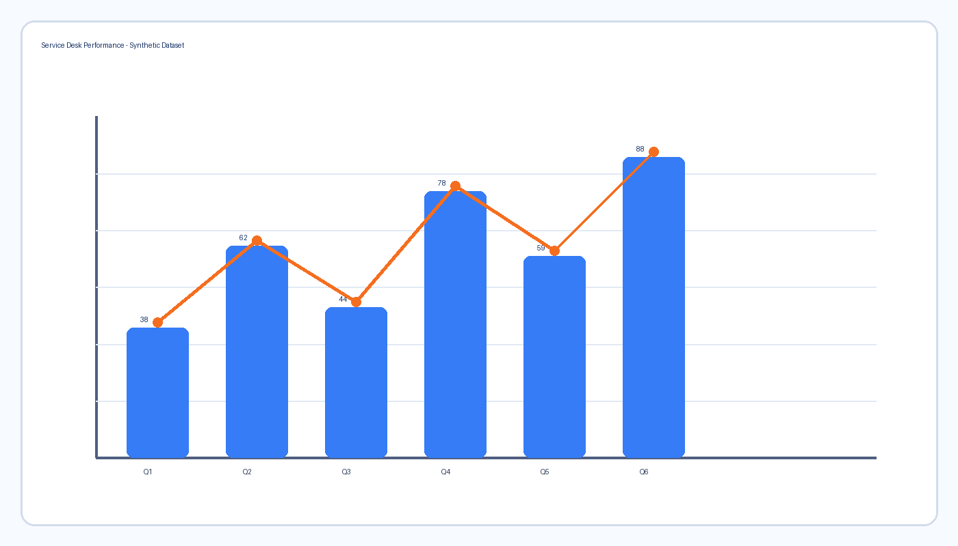
UI mock screenshot below:
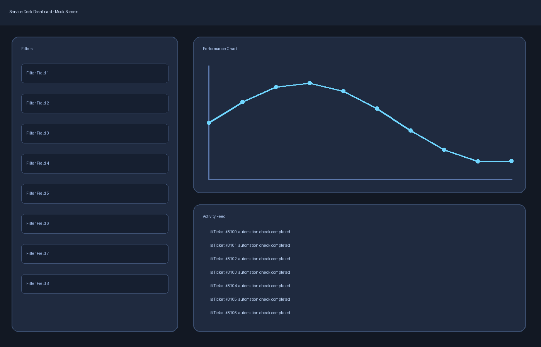

Section C — Table
Metric | Q1 | Q2 | Delta
Tickets Closed | 431 | 509 | +18%
First Contact Resolution | 68% | 74% | +6pp
Avg Handle Time | 11m 02s | 9m 47s | -1m 15s
CSAT | 4.1 | 4.5 | +0.4

