# **LendEase: A community driven lending platform**

## **Link to github repo:** [**dgoswamiOmni/LendEase: a community driven neo-lending bank (github.com)**](https://github.com/dgoswamiOmni/LendEase/tree/main)

## **Inspiration:**

The theme of ‘Finance’ has innumerable problems to solve, however, our main objective was to tackle a challenge in the sector that would encourage sustainable living and community growth. From our research, it was clear that people’s trust in traditional banks have decreased from the great recession, and since the news of the UK entering recession by the last quarter of 2023, there is a chance of confusion and uncertainty among the people for banks. Moreover, traditional banks often do not lend money to specific people without collateral, minorities or documents. Even when they do, it might have to go through a lot of loopholes and take time, which may delay the response time in case of emergencies. Specific communities,like students and elderly also seem to be abused by predatory money lending as they may not be familiar with financial procedures.

| **[1]** |  | **[2]** |  |
| --- | --- | --- | --- |
| **[3]** |  | **[4]** |  |

## 

## **What it does**

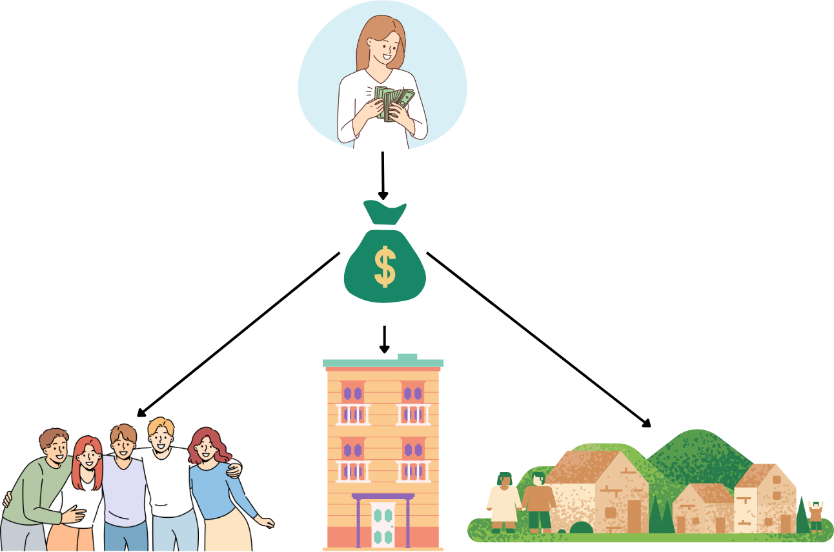

Therefore, we propose this solution ‘LendEase’- a community based lending platform. The main highlights and working of the platform are as follows:

1. A platform where a community like - students union, elderly in care homes, apartments, leisure societies can subscribe into without collateral.
2. While signing up, ids like drivers license can be used for verifying the individual
3. Once subscribed, they can invest money into the pool on a monthly basis.
4. When the pool grows, it is available for the community to use - they can borrow money for emergencies as individuals or use it for communal activities.
5. Top investor in a community will be shown in the dashboard, which will inspire others to invest
6. Investors also get a defined interest for their money every month (this is possible by investing the pool of money into hedge funds or similar)
7. Since it is a community pool, people trust their lenders and borrowers as they might know each other personally. The dashboard also shows the communities near you where you can join.
8. The platform will also provide free financial consultation for the subscribers

## **How you built it:**

* Once we identified the challenge, we did a brainstorming session using whiteboard and chart paper.
* The first step was to create a Business Canvas Model for the idea

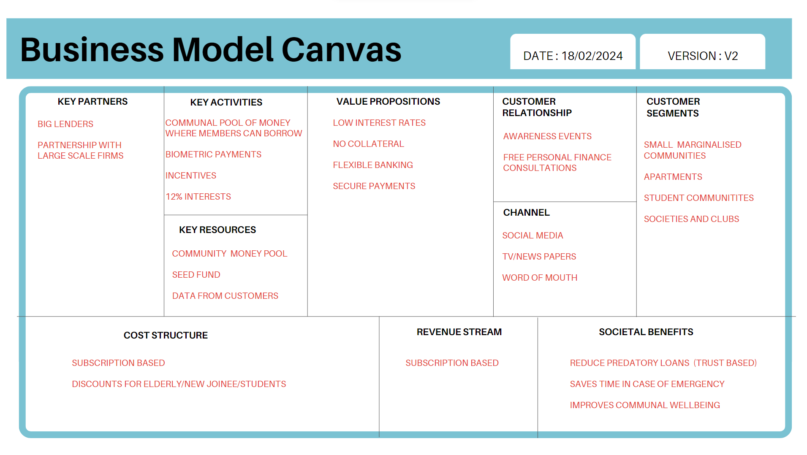

* Once this was done, we moved onto creating a flow chart for our solution

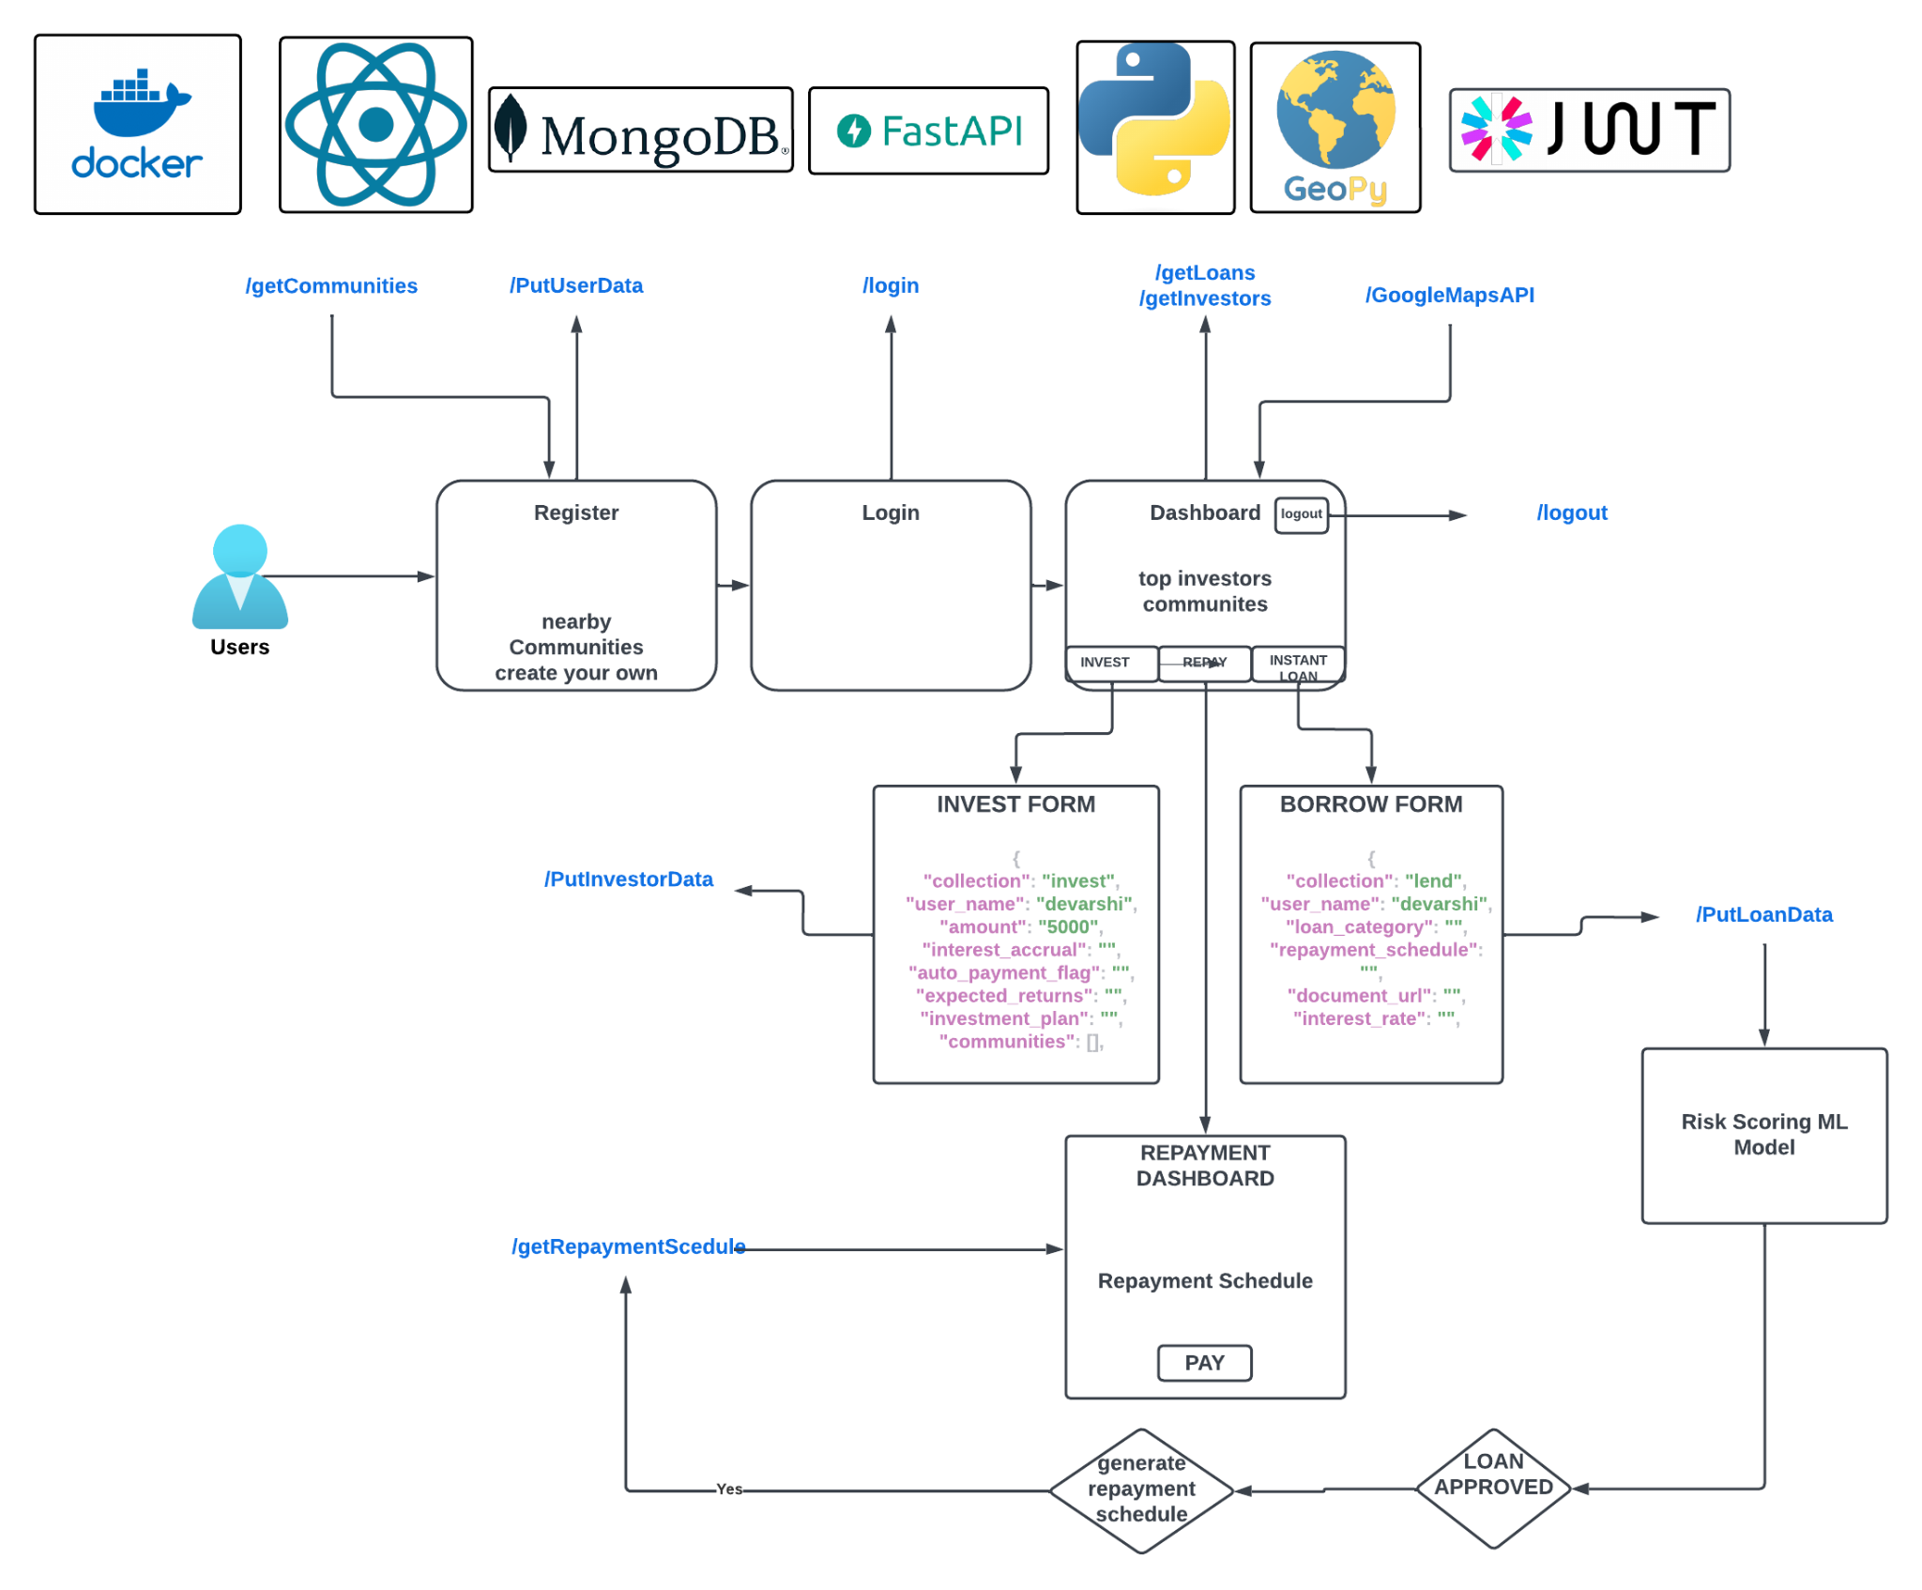

* 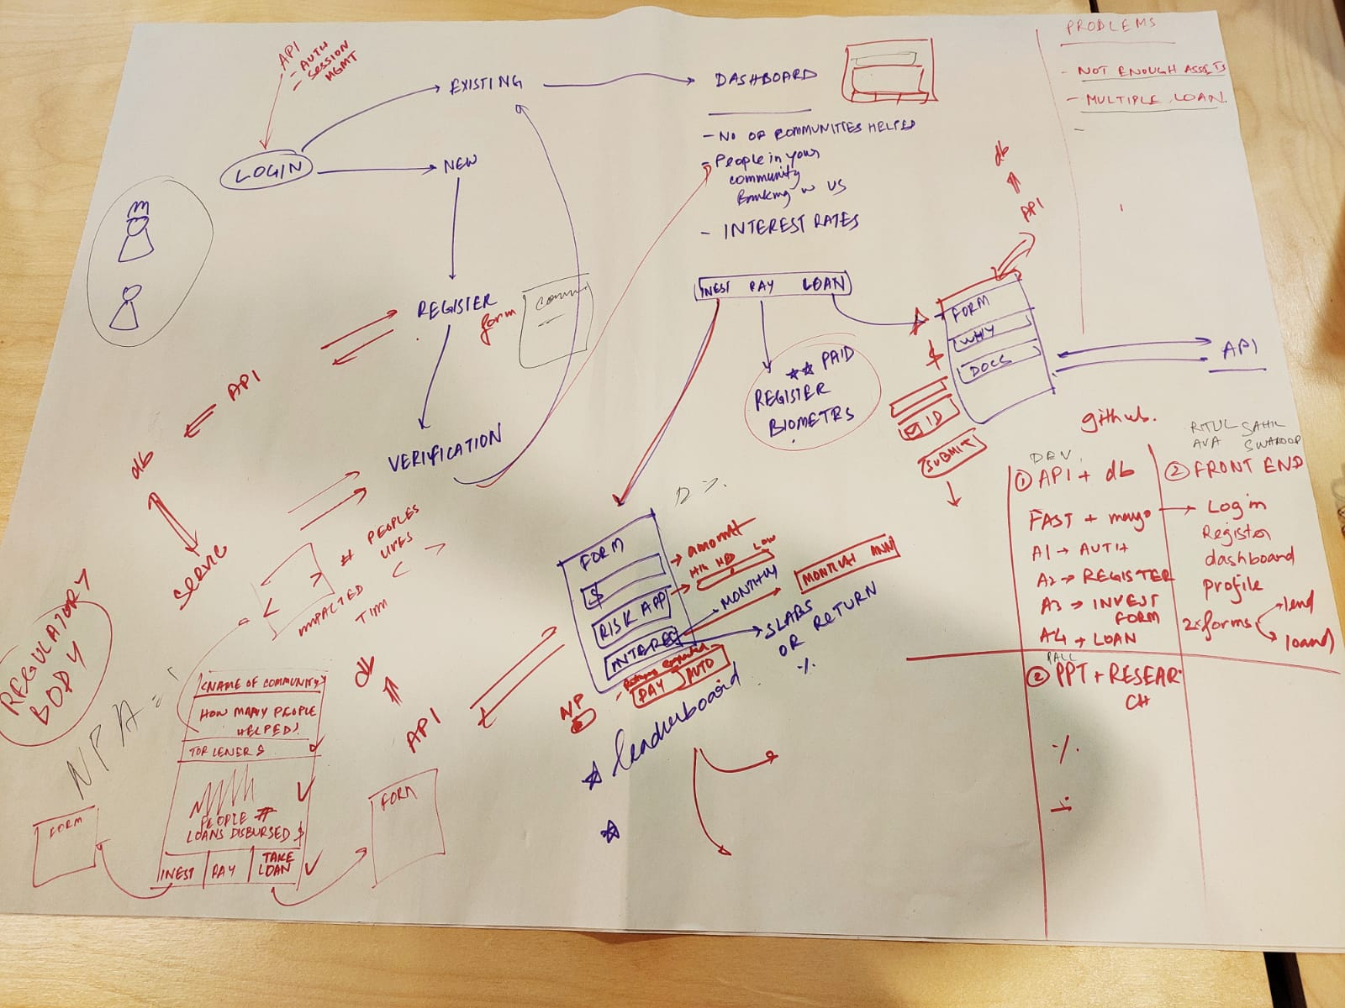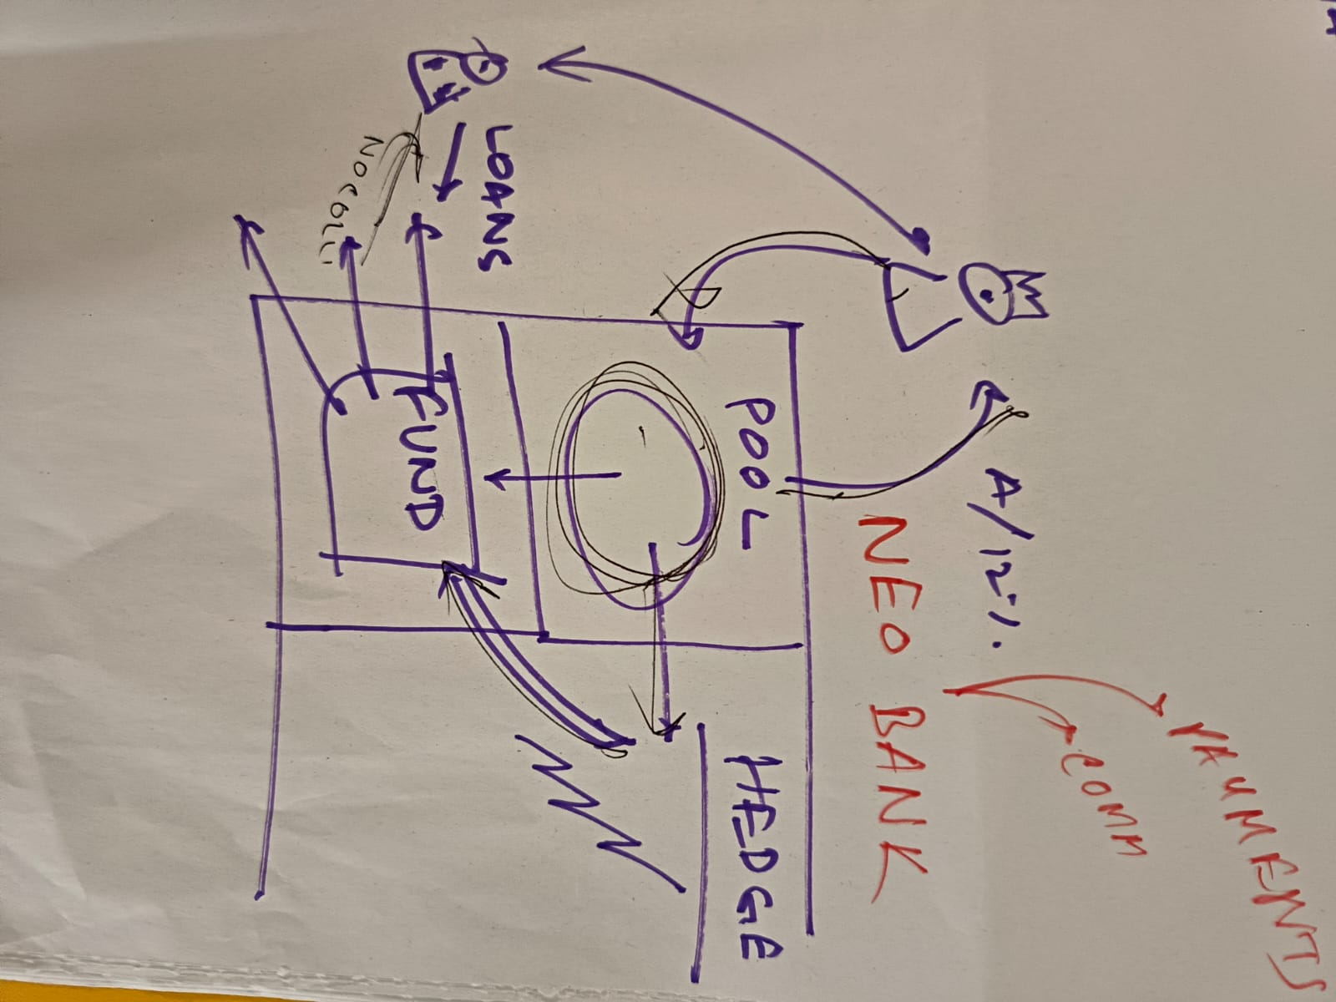
* To start prototyping we then created a figma file

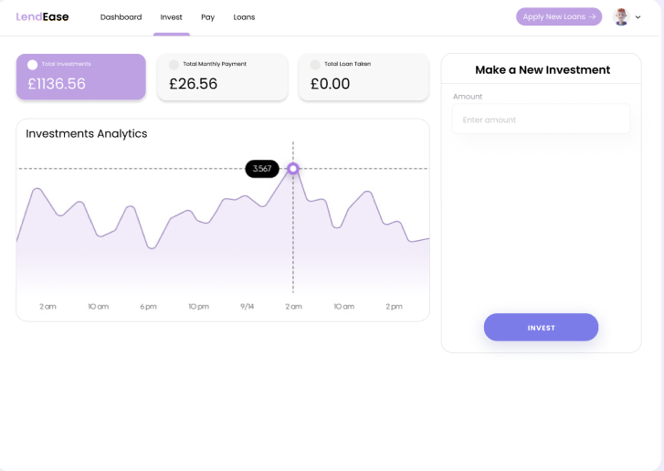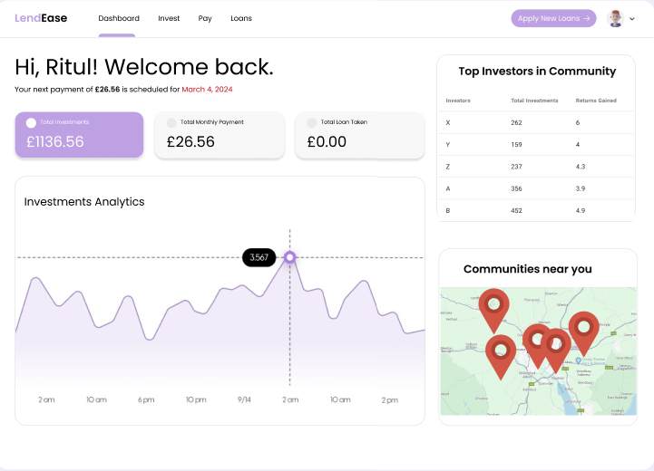 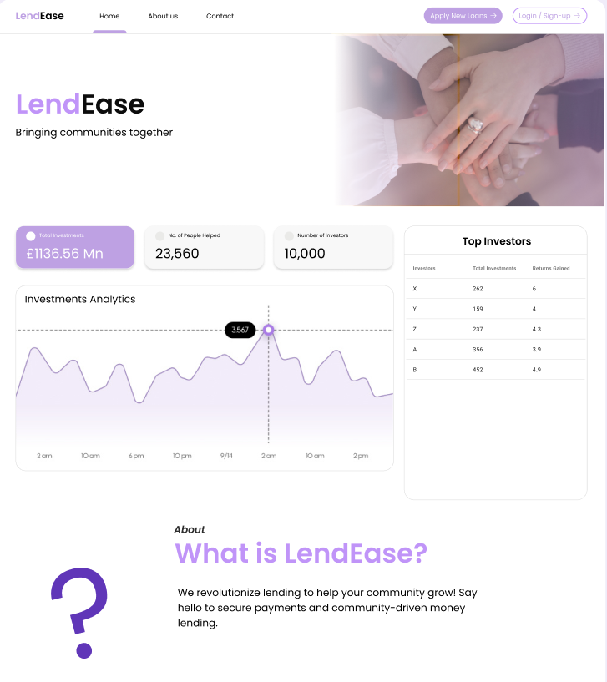

* A kanban board to manage time
* 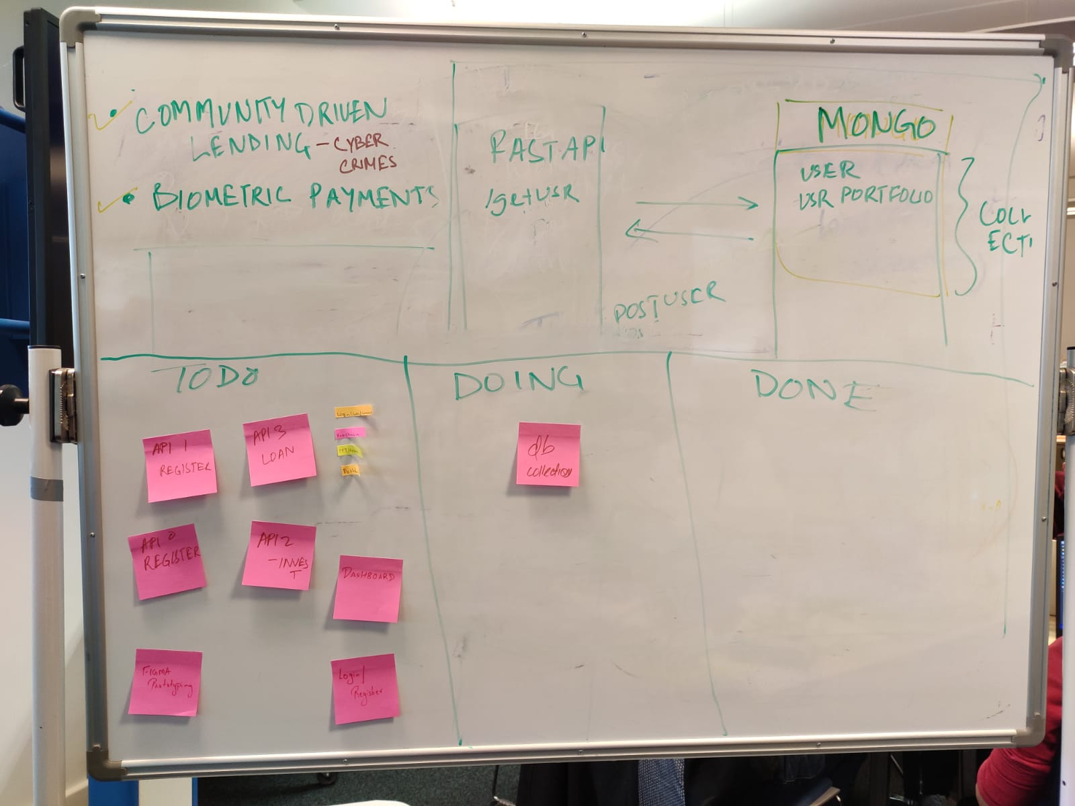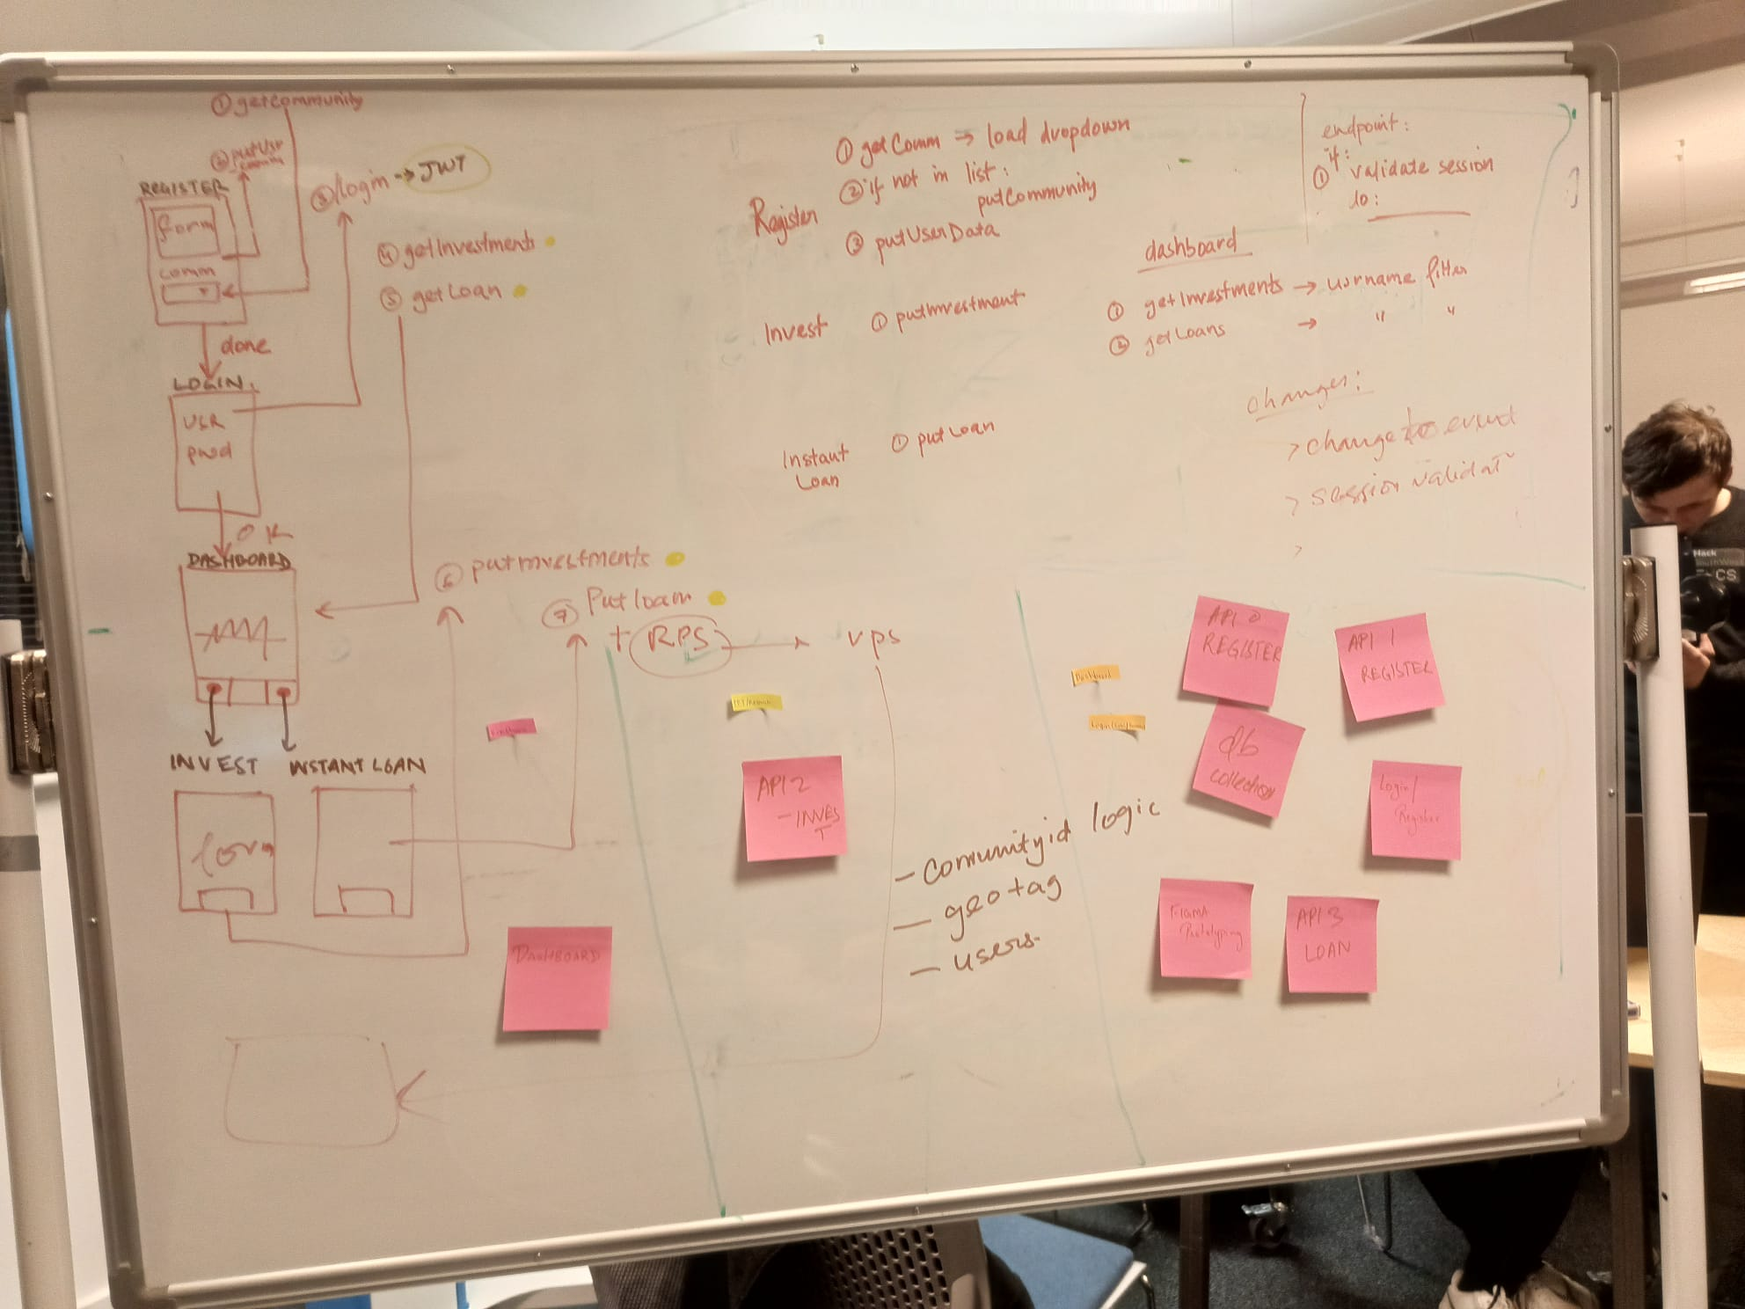
* And finally coding our figma files using React and APIs

## **Challenges you ran into:**

Couple of challenges we considered while creating the platform -

1. **Used up money pool :** What if someone borrows all the money in the pool and it runs out? - This challenge can be solved by creating a threshold for borrowing by an individual or not allowing anyone to borrow if the amount of money in the pool goes under a specific amount, until the issue is resolved
2. **Regulations:** Who is the regulatory authority and what are legislations to consider? - This can be solved by performing an intensive literature review on the current standards and regulations in finance.
3. **Multiple borrowers:** What if multiple people request the same amount of money or the amount they borrow in total causes the pool to run out? - This can be solved by either first come first serve basis or bidding or a central authority validating the requests to avoid conflicts.

## **Accomplishments you’re proud of**

* We are very proud of our team : Everyone had a massive contribution right from brainstorming ideas, to prototyping, to presentation. We are also really proud of how we manage our time.
* Things we accomplished in the limited time: We never thought we could create something in 24 hours, but the teamwork proved otherwise. Everyone was contributing in some way and by the end our product was ready to be pitched!

## **What we learned**

## Teamwork

* Market research
* Time management
* Work allocation and division
* Project management (BMC, Kanban board, flow chart)
* Technical tools and skills (Figma, Python, React, APIs)

## 

## **What’s next for your project:**

1. **Biometric payments:** Biometric information of subscribers in a database connected to bank, which can be used for payments in local shops and trusted senders (without payment card, NFC). For those who may not have NFC enabled phones and wireless cards, biometric authentication is an excellent way to do payments. Our platform could have a secure biometric database connected to the pool and could be used for authenticating payments while shopping at local shops or lending locally. Biometric payments could also be used during emergencies, for example, if the internet is not working for digital payment or you do not have cash.
2. **Lending money through previous history and relationships built using ML:** Emphasize relationship with the bank and the individual based on learning family histories, previous transaction history when making lending decisions.
3. **Contact with credit scoring organizations and invoice financing:** We could collaborate with credit scoring organizations to validate credit score before lending money and could then look into providing invoice quickly.

## 

## **What was it built with**

1. **We started off by building the data collections in mongo**Lend: store data for borrower requests  
   Community: data for community - user mapping  
   Session: session based authentication using JWT  
   User: user profile data  
   Invest: investor data
2. **We started by building the APIs   
     
   /login   
   /logout  
   /putUserData  
   /getUserData  
   /putLoan  
   /getLoan  
   /putInvestments  
   /getInvestements  
   /pushCommunites  
   /getCommunites**
3. **Simultaneously we created the dashboard components and user interface using react**
4. **Then we integrated the API with the front end successfully**
5. **After which we dockerized the application**

**References:**

[1] [INFOGRAPHIC: The High Cost Of Elder Financial Abuse - Elder Protection Center](https://elderprotectioncenter.com/infographic-high-cost-elder-financial-abuse/)

[2] [Student borrowers: prey for predatory loan servicers (policymattersohio.org)](https://www.policymattersohio.org/research-policy/quality-ohio/education-training/higher-education/student-borrowers-prey-for-predatory-loan-servicers)

[3][Chart: Trust in Banks Still Recovering After Great Recession | Statista](https://www.statista.com/chart/15465/trust-in-banks-still-recovering-after-great-recession/)

[4] [How You Can Reverse the Loss of Trust in Financial Institutions (thefinancialbrand.com)](https://thefinancialbrand.com/news/bank-culture/edelman-trust-survey-bank-brands-17474/)

## Appendix:

[1] Community banks:

These smaller banks typically don't have the product range or branch networks available at larger institutions, and often provide loans to local businesses and individuals who may not qualify based on the more standardized criteria used by big banks.

### KEY TAKEAWAYS

* There is no clear-cut definition for "community bank," although they generally are smaller banks that serve customers in a specific geographic area.
* Community banks tend to emphasize relationships and even family histories when making lending decisions, whereas larger banks rely more on credit scores, income, and other quantitative data.
* Because community banks are typically locally owned and managed, proponents argue they are not beholden to Wall Street like their larger counterparts.

*[2]While we have not yet observed any major crises or scandals in fintech lending, there are many ways in which they can create suspicion of being untrustworthy.3 Our analysis suggests that the growth of fintech firms may be halted if there is an event that erodes trust; this would cause funding to dry up and their borrowers to return to banks. We therefore posit that understanding the role of trust in lending is central to understanding the future evolution of the credit market, especially in terms of the relative provision of intermediated and non-intermediated credit.*

3] *They are typically made of friends, relatives, community members or workmates who group to mobilise funds for a common purpose.****Their main advantage is that they are formed by individuals who know each other.*** *This arguably circumvents default issues.*

Reference:

1] [The future of community banks in a global economy | FinTech Magazine](https://fintechmagazine.com/banking/the-future-of-community-banks-in-a-global-economy)

2] [Trust in Lending (nber.org)](https://www.nber.org/system/files/working_papers/w24778/w24778.pdf)

3] [Why lending through community-based organisations makes sense (theconversation.com)](https://theconversation.com/why-lending-through-community-based-organisations-makes-sense-50263)