P1 Report: dgp34

Changing dt in the simulator, Kv & dt_controller in the controller
- Simulator dt changes affect how accurately the simulator reflects reality. The bigger the value of dt, the less accurate the simulator becomes due to the larger time step. Smaller values of dt are preferred, with the value of 0.01 used in the file as recommended.
- Controller Kv changes affect how quickly the controller attempts to correct velocity in order to reach the desired goal. While an increase in Kv does indeed lead to quicker results, an increase greater than 10 will not allow for convergence in velocity, placing the system into a stressful oscillating state. The optimal value has been found to be 5.0, where the speed of system convergence is maximized.
- Controller dt_controller changes affect how quickly the controller publishes signals. As the value is increased, the controller slows. Thus, smaller values are preferred. The current value of 0.1 is acceptable and fairly accurate, however, so this value has been maintained.

Plot & Performance
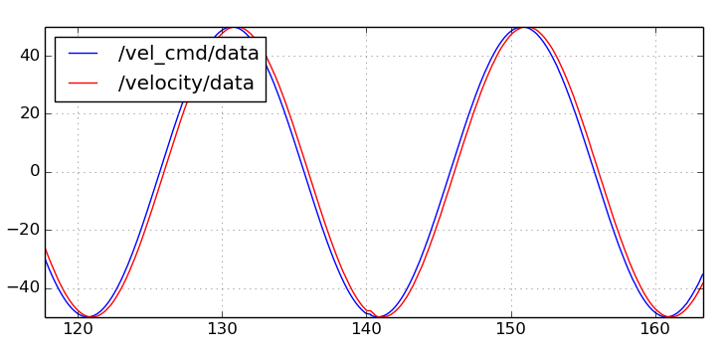
With amplitude at 50 and frequency at 0.2Hz.

While the above figure shows a fairly close relationship between vel_cmd and velocity, an increase in frequency will cause a divergence between the values, with velocity lagging behind vel_cmd by increasing factors as the frequency increases.

