P2 Report: dgp34

The client-service model works fairly efficiently overall. The rqt_plots do point out issues at the exact moment the command is sent by the client, however after that moment the velocity relationships maintain sinusoidal stability. There are certain moments that appear odd, but that is due to VMware lag. Prior issues pointed out in P1 still appear, since P1 code is mostly preserved.

Note for testing: There is no built-in end input. In order to end the client, use ctrl-z for efficiency, as ctrl-c will take a couple minutes before ending the client.

The following is a series of four images that show the client at work, with corresponding rqt_plots:

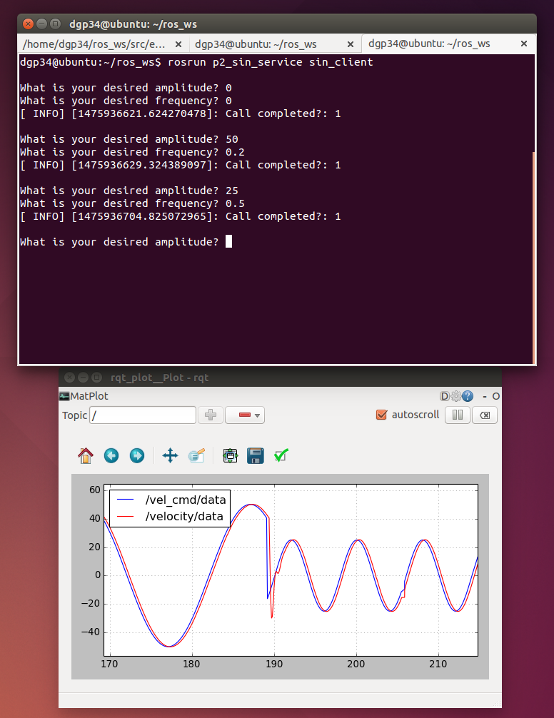

Fig. 1: Input of 25 amplitude and 0.5 frequency, coming from 50 amplitude and 0.2 frequency.

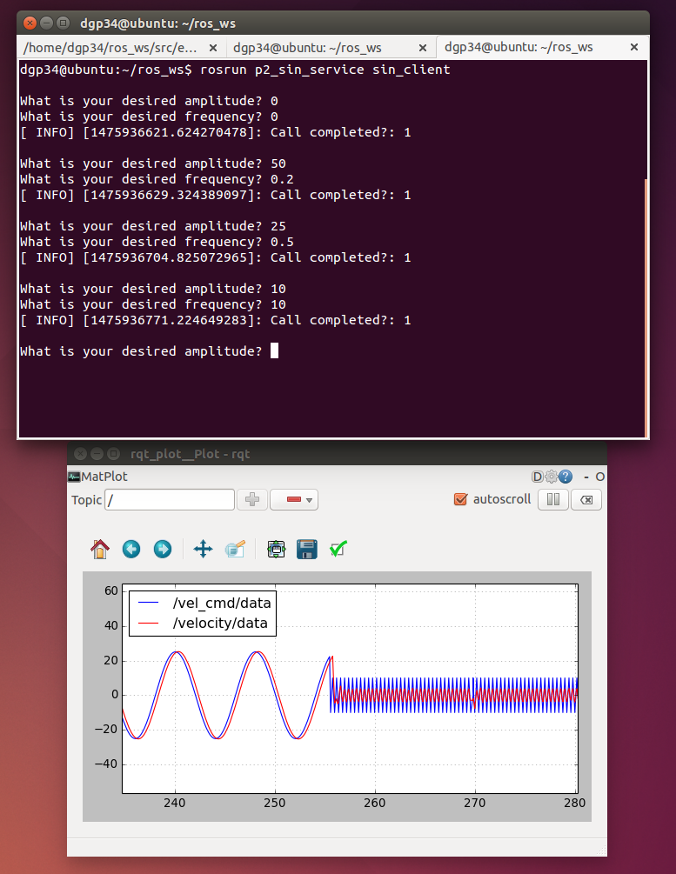

Fig. 2: Input of 10 amplitude and 10 frequency, coming from 25 amplitude and 0.5 frequency.

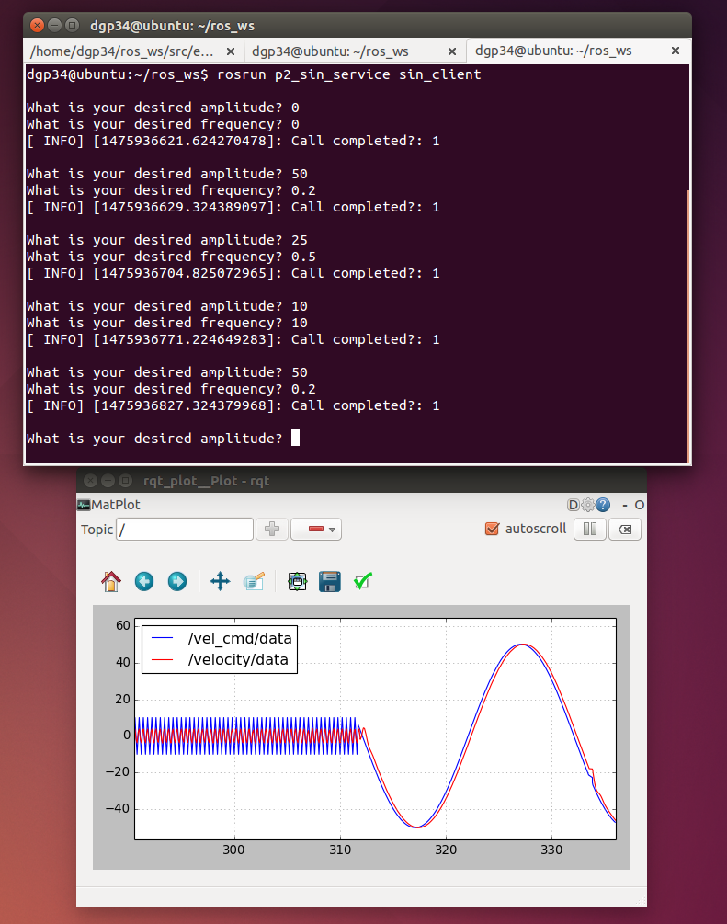

Fig. 3: Input of 50 amplitude and 0.2 frequency, coming from 10 amplitude and 10 frequency.

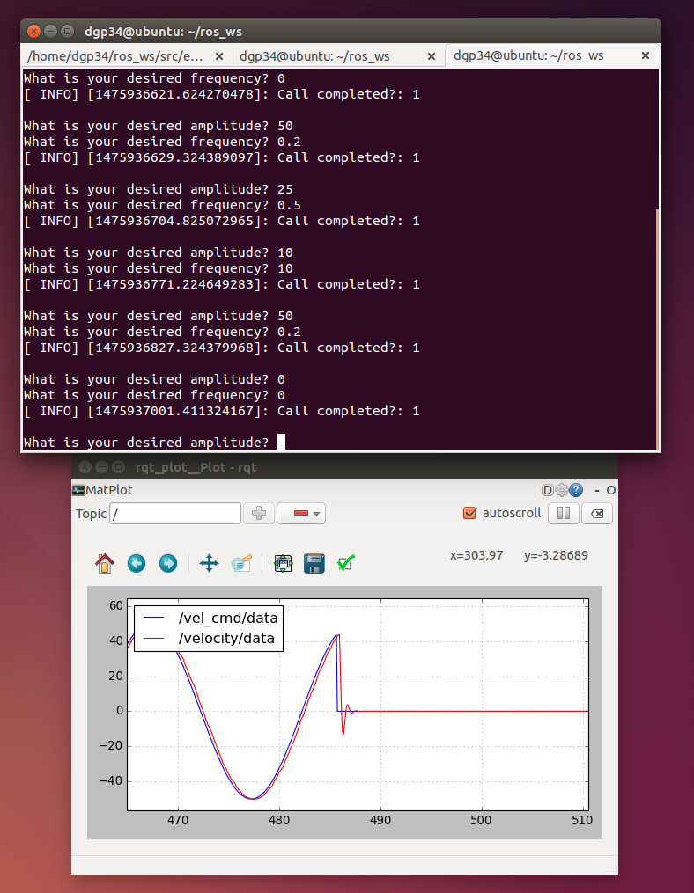

Fig. 4: Sudden stop--Input of 0 amplitude and 0 frequency, coming from 50 amplitude and 0.2 frequency.

