P3 Report: dgp34

The following are a series of images showing successful operation of the action client and action server:
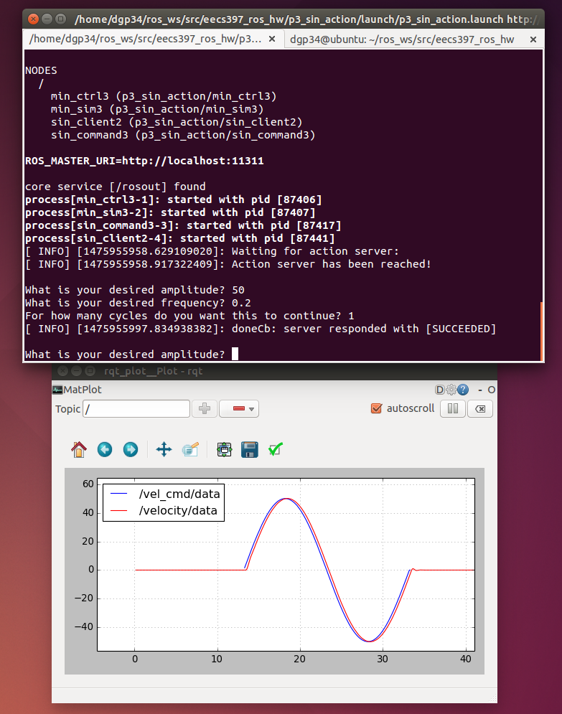

Fig. 1: Input of 50 amplitude, 0.2 frequency, 1 cycle. Success.
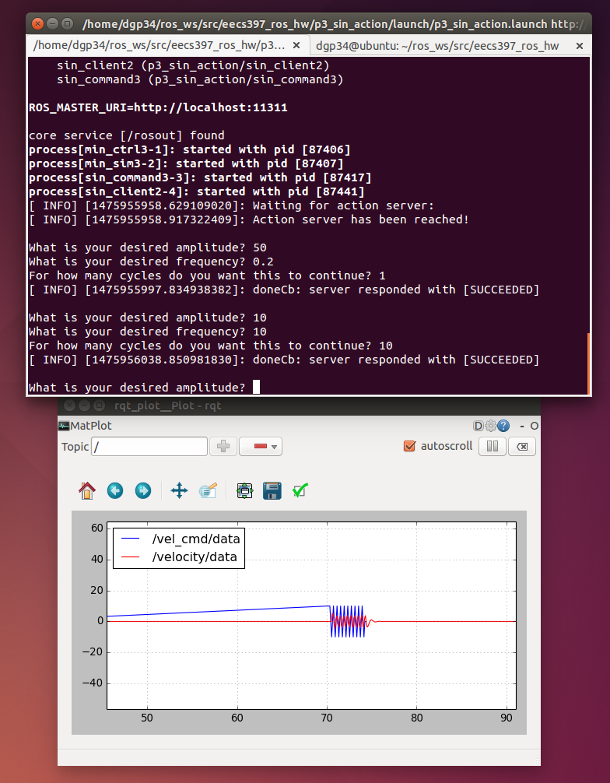

Fig. 2: Input of 10 amplitude, 10 frequency, 10 cycles. Success.
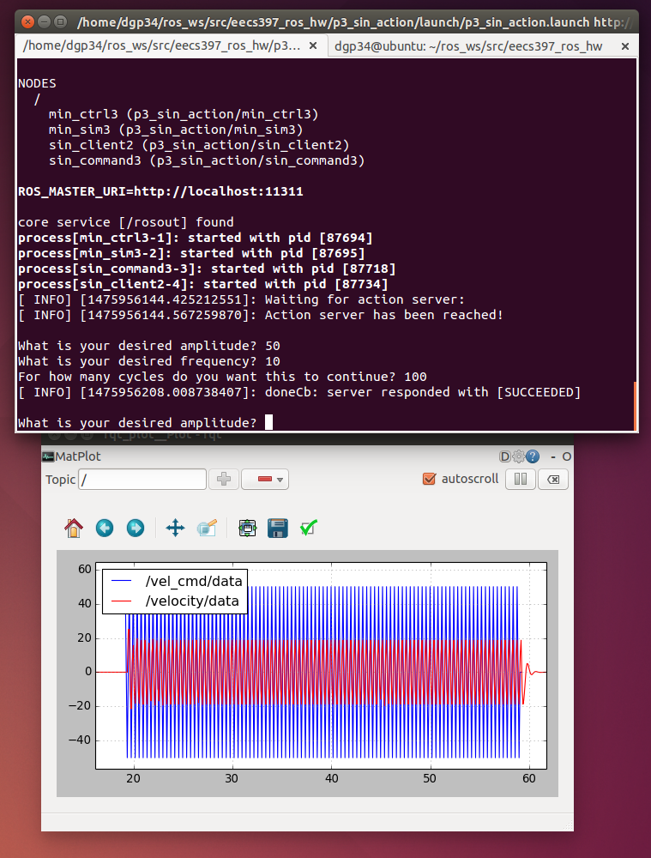

Fig. 3: Input of 50 amplitude, 10 frequency, 100 cycles. Success.
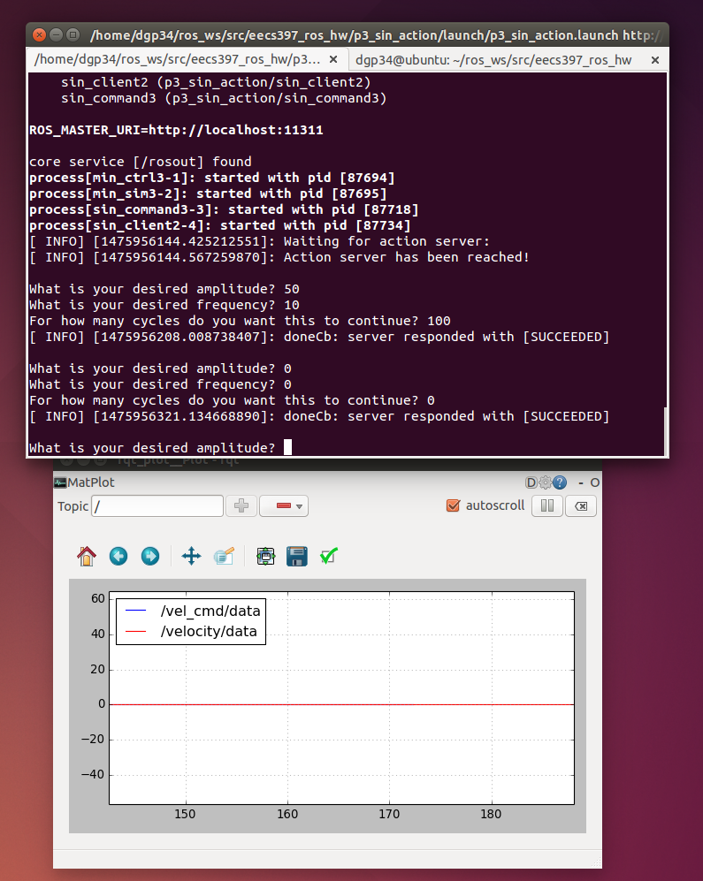

Fig. 4: Special case—Input of 0 amplitude, 0 frequency, 0 cycles. Success.
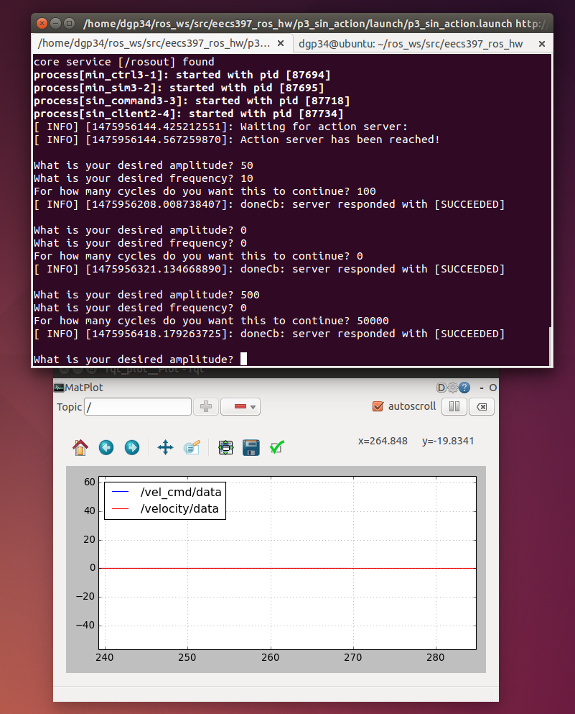

Fig. 5: Demonstration of special case—in the code, frequency is in a denominator position. However, if 0, the code is short-circuited in order to prevent errors. Input 500 amplitude, 0 frequency, 50000 cycles. Success.
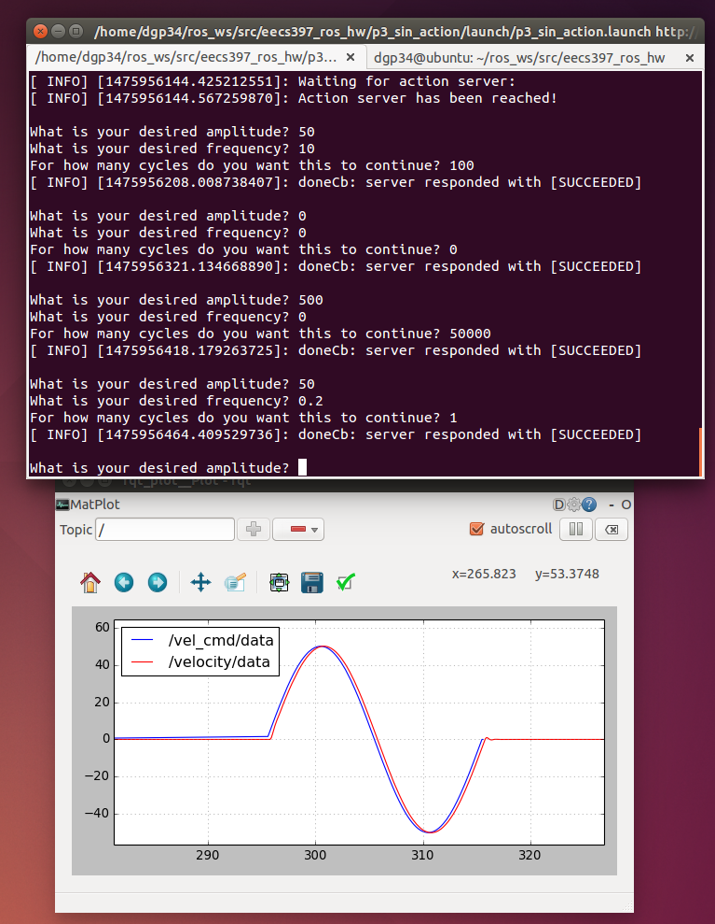

Fig. 6: Input of 50 amplitude, 0.2 frequency, 1 cycle, as in Fig. 1, just to show lack of errors after previous inputs. Success.

