P8 Report: dgp34
This project is a computational task involving calculating the reachability of robots. The first task was to run an existing program that calculated reachability for the Baxter robot. The following is a 3D image of that result generated from the data with MATLAB:

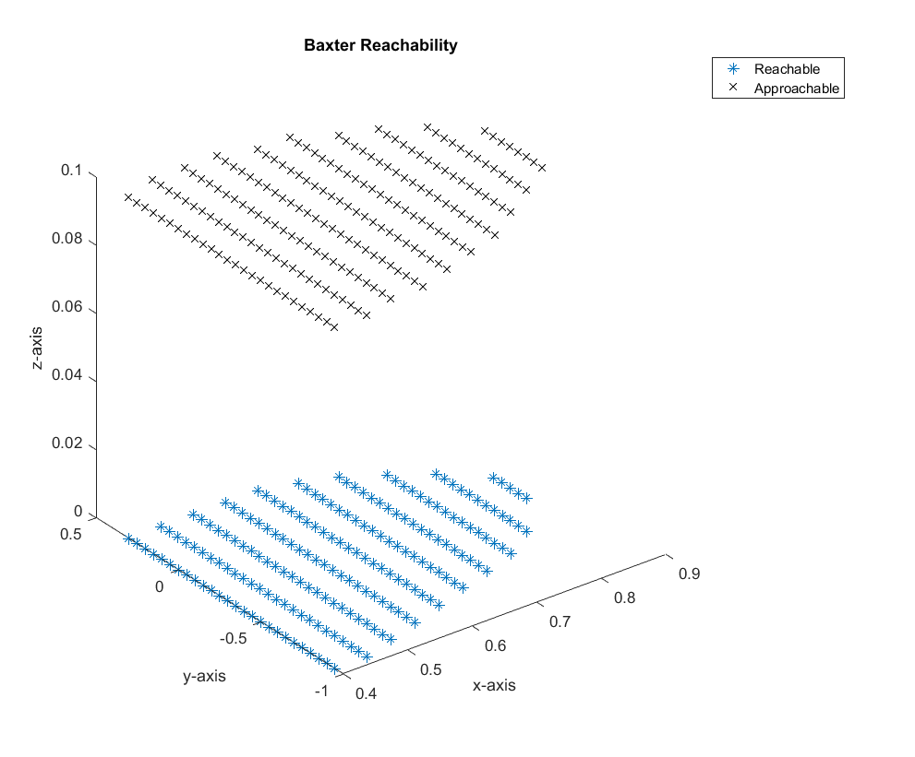

The second task was to create a program that calculated the reachability of the UR10 robot with respect to certain “magic” heights. These heights are from the NIST ARIAC competition and are provided in associated documentation. The following is a 3D image of this reachability result using MATLAB:

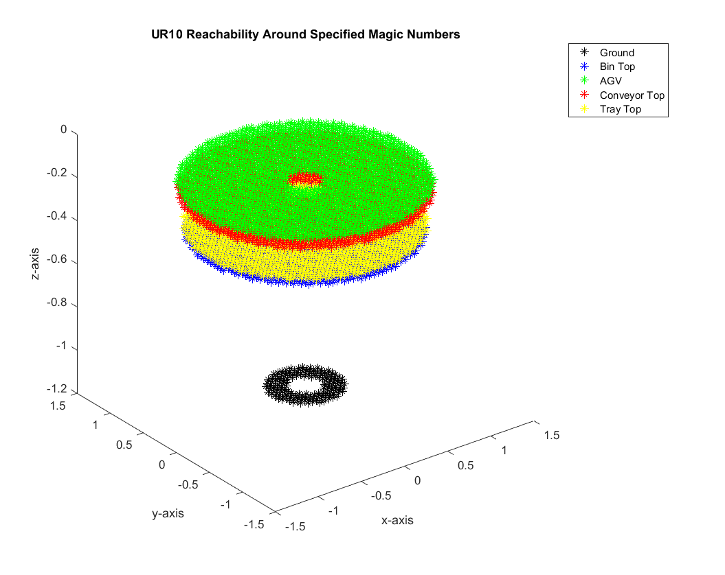

In the event this image needs to be recreated, the .m file has been included in the submission.

