**­­­­­Cambridge Advisor Search**

When the application is launched you will get a home screen that looks like this.

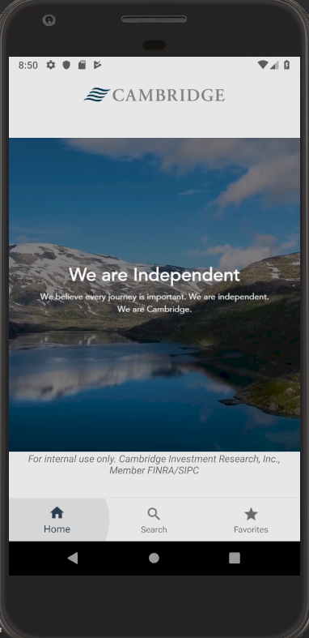

From that screen you will be able to navigate to the search and the favorites tabs.

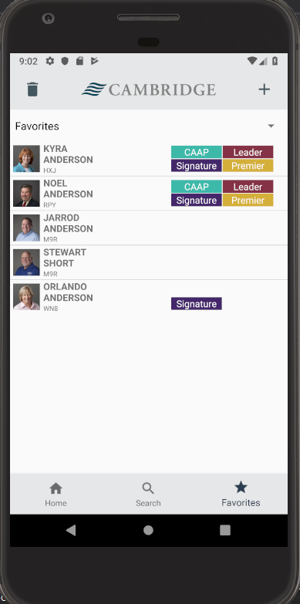

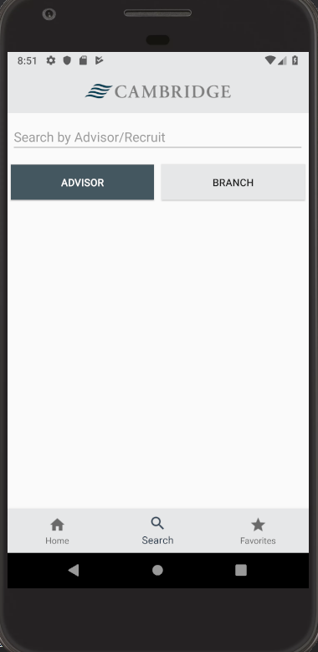

The search screen will originally appear blank. From this screen you can decide whether you want to search by advisor or by branch/company. You would select which ever button you would like and then type in your information and hit the search button on the keyboard. For an advisor you can search for “Kyra Anderson”, and for a company, you could search for “143” and that would give you all information associated with advisors at company 143. All the data is anonymized names and information will not match any data this including advisor photos.

Once you actually search you will be presented with a section of advisors to choose from which you can see in the image above. From that screen you can click on any advisor that you want and that would open the advisor detail page which you can see below

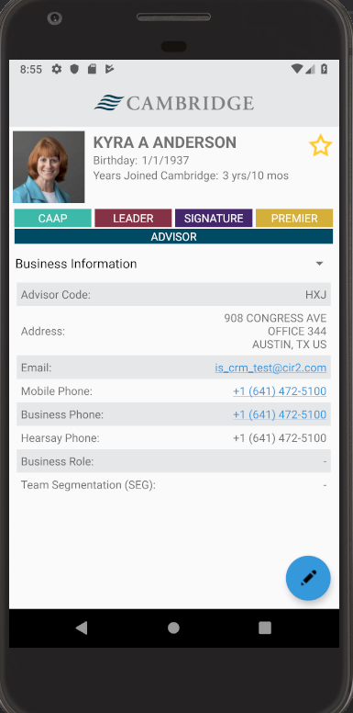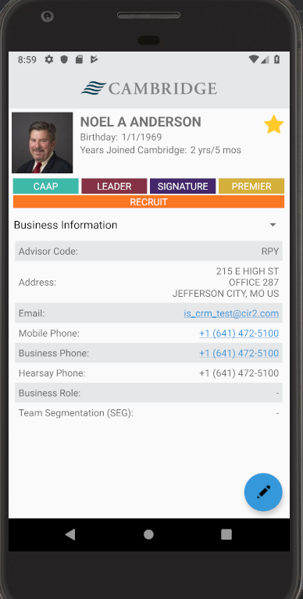

On this screen there is a drop down menu that allows you to go through all the possibility for information about the advisor. You will find the following categories:

* Business Information (Default page, loads this on create of page)
* Branch/Supervision
* Clearing Partner
* Production
* Recruit Business Mix
* Tech Requests
* Notes

You will notice that not all of these fields appear for everybody and this is true. There are certain ones that come up for each person. If they are an advisor then they aren’t going to have the recruit business mix and will have all of the other information but if they are a recruit then they aren’t going to have anything besides Business Information, Recruit Business Mix, and Notes. In the top right there is a star. This star is going to be used to add them to a favorites list. There is going to be a dialog box that opens when you click it to ask you which favorites list you would like to add them to (See screenshot below). They can be added to more than one favorites list at a time depending on where the user wants them.

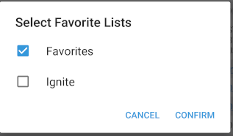

In the bottom right corner you see a floating action button with a pencil on it. This is going to be on the detail page at all time and this is going to be used to add a new note. You can click on it anytime while on this screen and it will take you to a new page that looks like the following which will allow you insert a new note. (Can been seen in the bottom right corner of either advisor detail page 2 screenshots above)

From there I’m going to go to the favorite page which you can get to by going to the favorites tab. There you will see a plus sign in the top right corner. This is going pop up a dialog box asking you to insert a new favorite’s list title. Once you do that it is going to add it to the spinner which is going to have all of the favorite’s lists that the user has added there. In order to delete a favorites list, you will have to select the favorites list that you wish to delete in the spinner and then you click on the trash can icon in the top left. This is going to tell it that you want to delete the active favorites list and that is going to pop up a dialog box. In that dialog box it will be a confirmation asking if you are “sure that you want to delete this favorites list?” See screenshots below. The first is the Favorites page which I showed you earlier. It has the add and delete symbols along the top bar with the Cambridge name and logo. The second and third screenshots are the dialog boxes.



