Crear aplicació

Carpeta nova a ~/odoo_dev/odoo/extra-addons.
Dins la carpeta → __init__.py i __manifest__.py
__manifest__.py:

{
'name': 'Biblioteca',
'description': 'Gestió d\'un catàleg de llibres',
'author': <el teu nom>,
'depends': ['base'],
'application': True,
}

Icona aplicació: ~/odoo_dev/odoo/extra-addons/{app}/static/description/icon.png
Odoo → Mode dev → Apps → Update Apps List

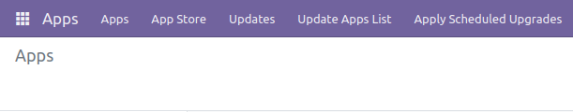
Instal·lar

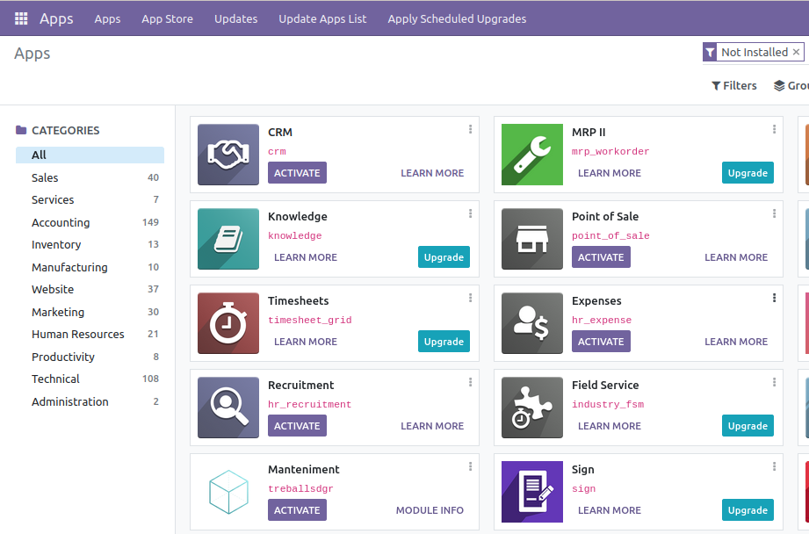
~/odoo_dev/odoo/extra-addons/{app}/models → __init__.py i {app_model}.py
__init__.py → from . import {app_model}
__init__.py d’extra-addons → from . import models
{app_model}.py:
Definir classes del model i camps, exemple:

from odoo import fields, models, api
from datetime import date
from dateutil.relativedelta import relativedelta

class Ordre(models.Model):

_name = 'treballs.ordre'
_description = 'Ordre'

name = fields.Char('Codi', required=True)
active = fields.Boolean('Actiu?', default=True)

job_type = fields.Selection([('maintenance', 'Manteniment'), ('repair', 'Reparació'), ('improvement', 'Millora')], string='Tipus de treball')
operatives = fields.Many2many('res.partner', string='Operaris')
description = fields.Char('Descripció', required=True)
date_start = fields.Date('Data d\'inici', required=True)
date_end = fields.Date('Data de fi')
duration = fields.Integer('Durada', compute='_calcular_durada')

@api.depends('date_start', 'date_end')
def _calcular_durada(self):
for record in self:
if record.date_end:
record.duration = relativedelta(record.date_end, record.date_start).days
else:
record.duration = -1

