M10 UF2 Prova escrita

1A

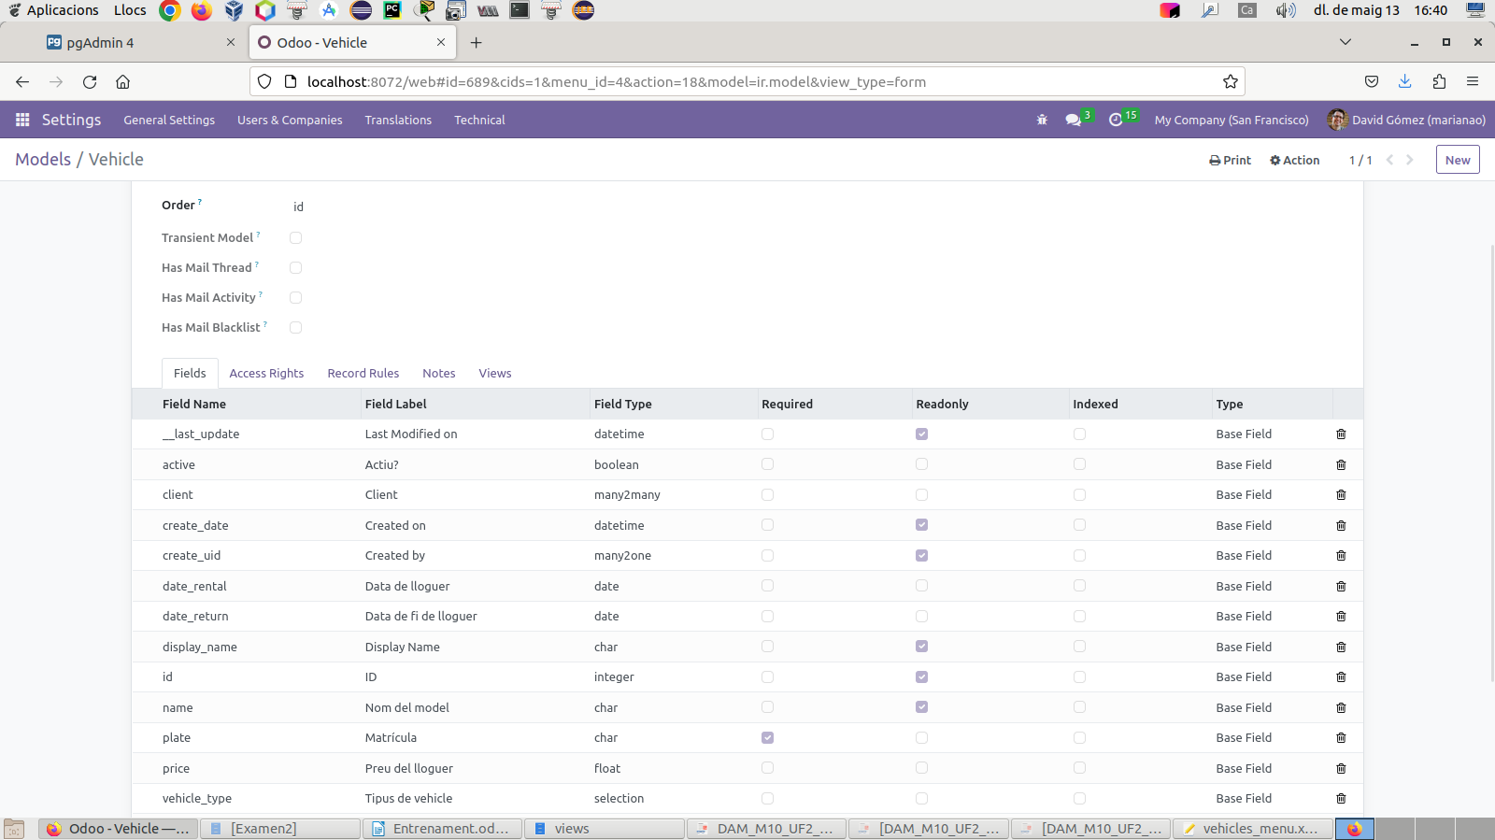
1B

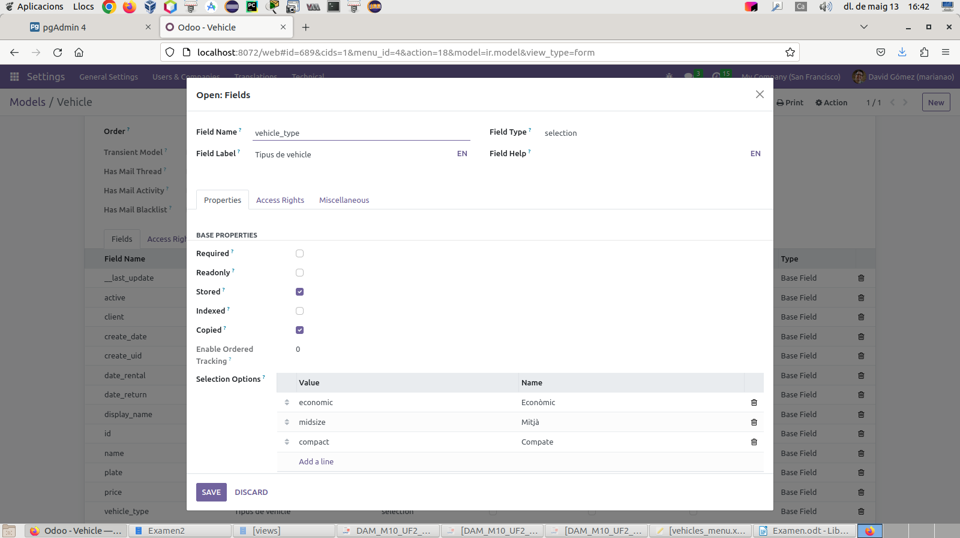
1C

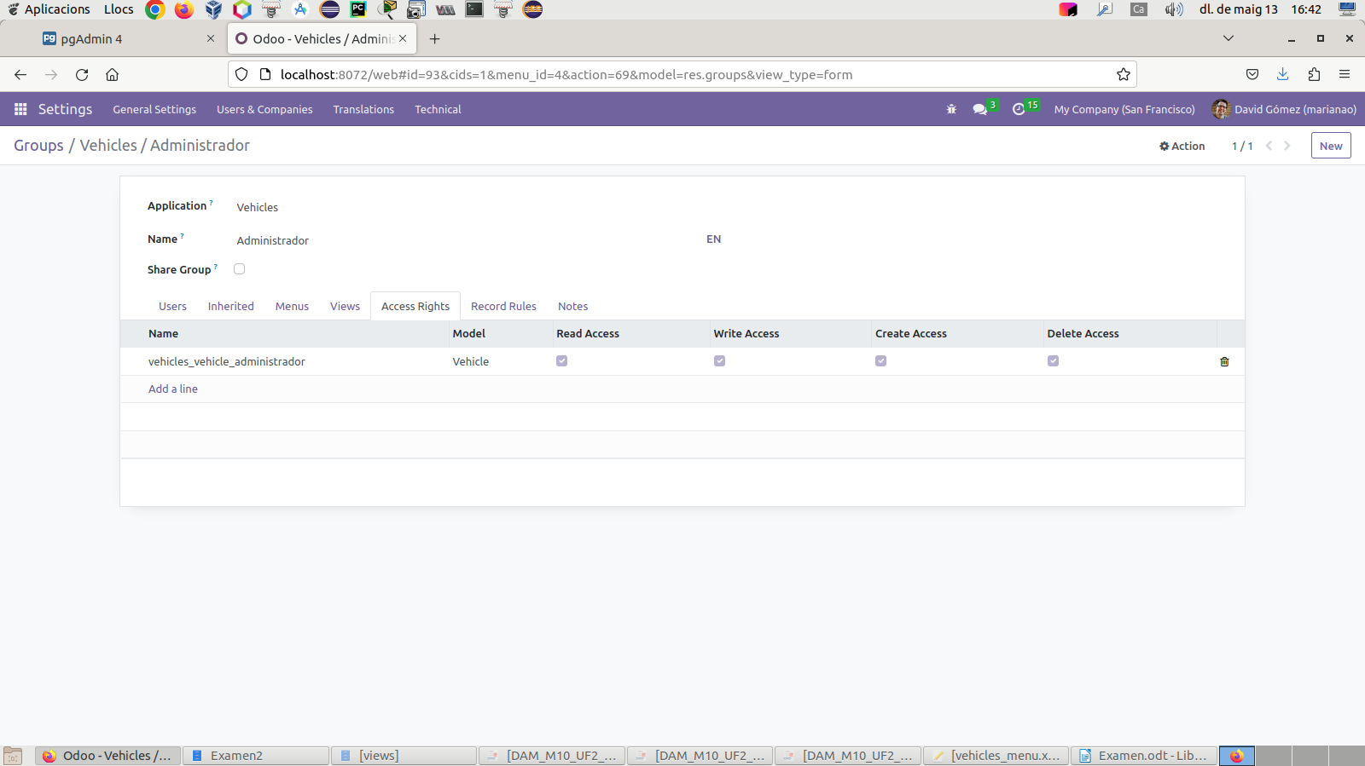
1D

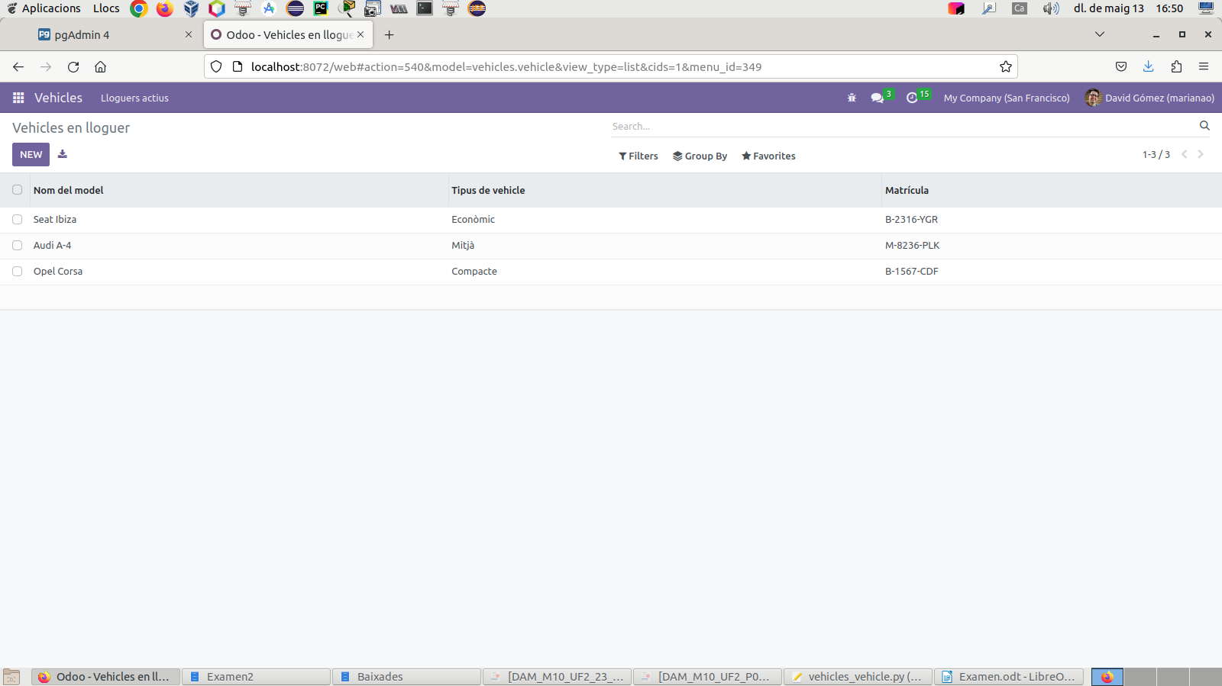

1E

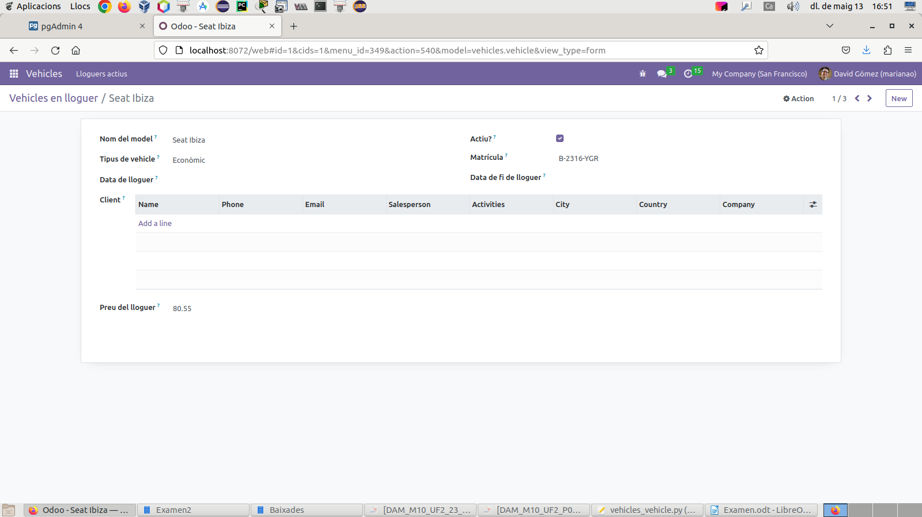
1F

from odoo import api, fields, models

class Vehicle(models.Model):

_name = 'vehicles.vehicle'
_description = 'Vehicle'

name = fields.Char('Nom del model', required=True)
active = fields.Boolean('Actiu?', default=True)

vehicle_type = fields.Selection([('economic', 'Econòmic'), ('midsize', 'Mitjà'), ('compact', 'Compacte')], string='Tipus de vehicle')
plate = fields.Char(string='Matrícula', required=True)
date_rental = fields.Date('Data de lloguer')
date_return = fields.Date('Data de fi de lloguer')
client = fields.Many2many('res.partner', string='Client')
price = fields.Float('Preu del lloguer')

2A

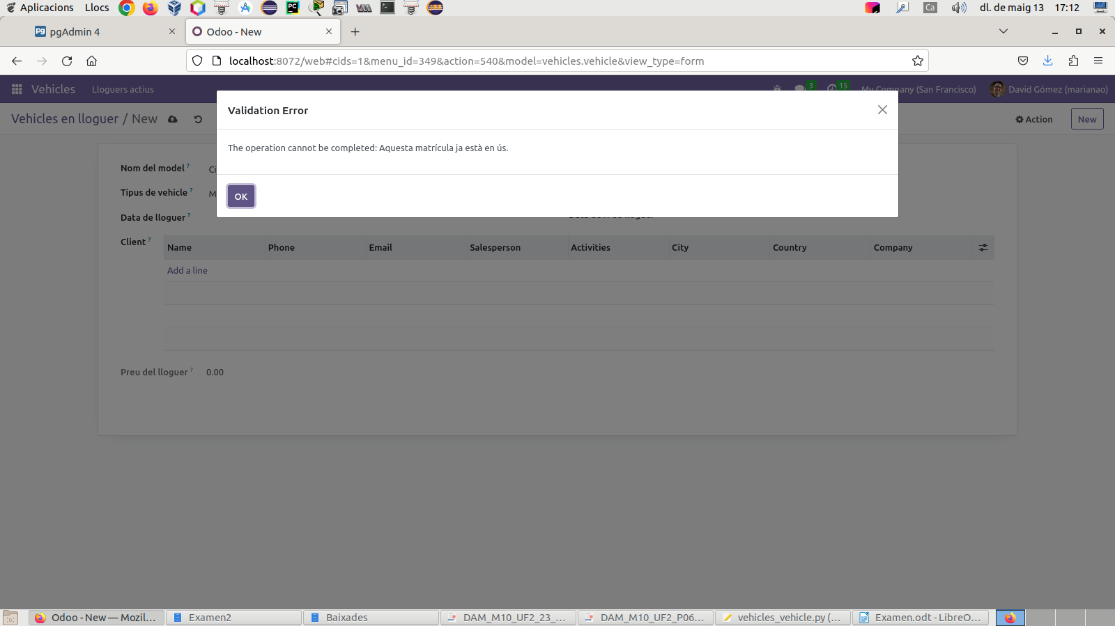
2B

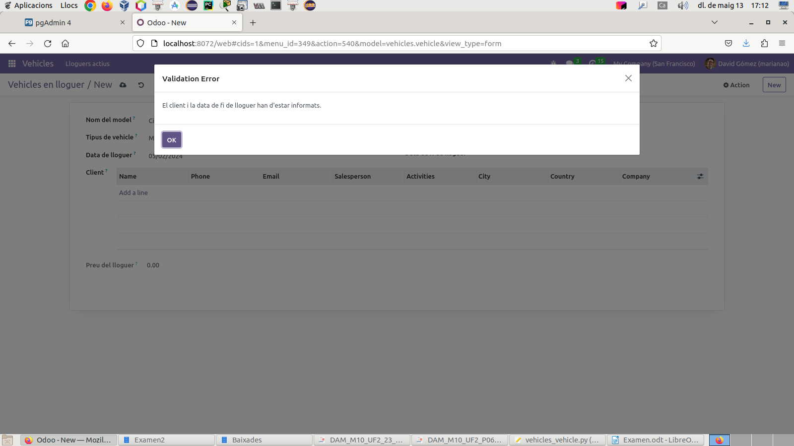

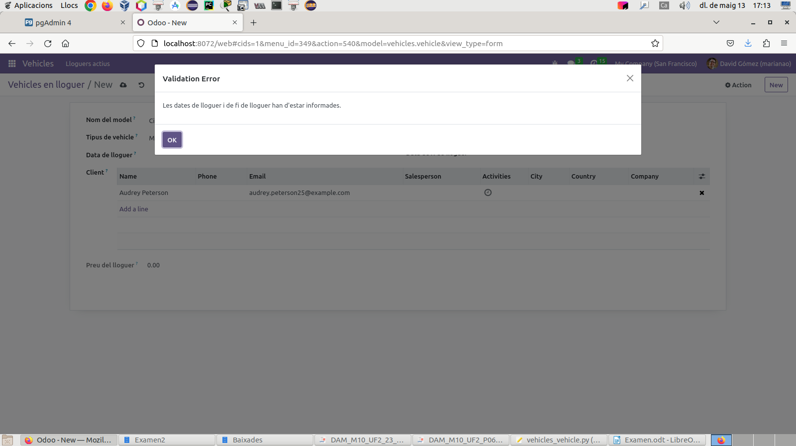
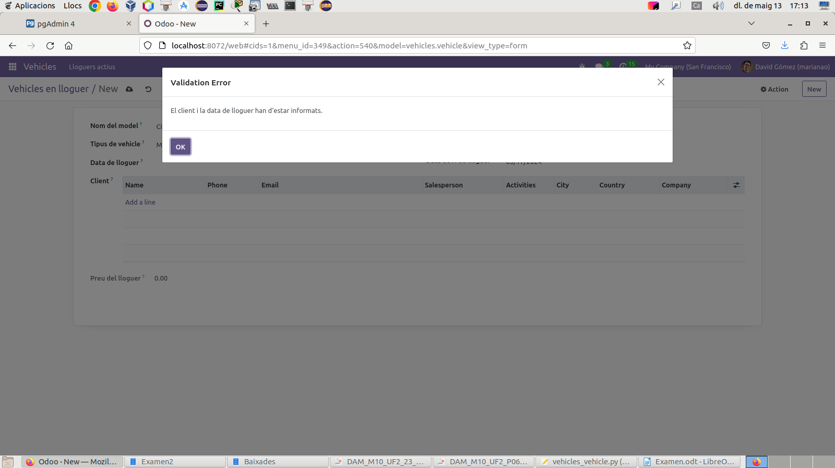

2C

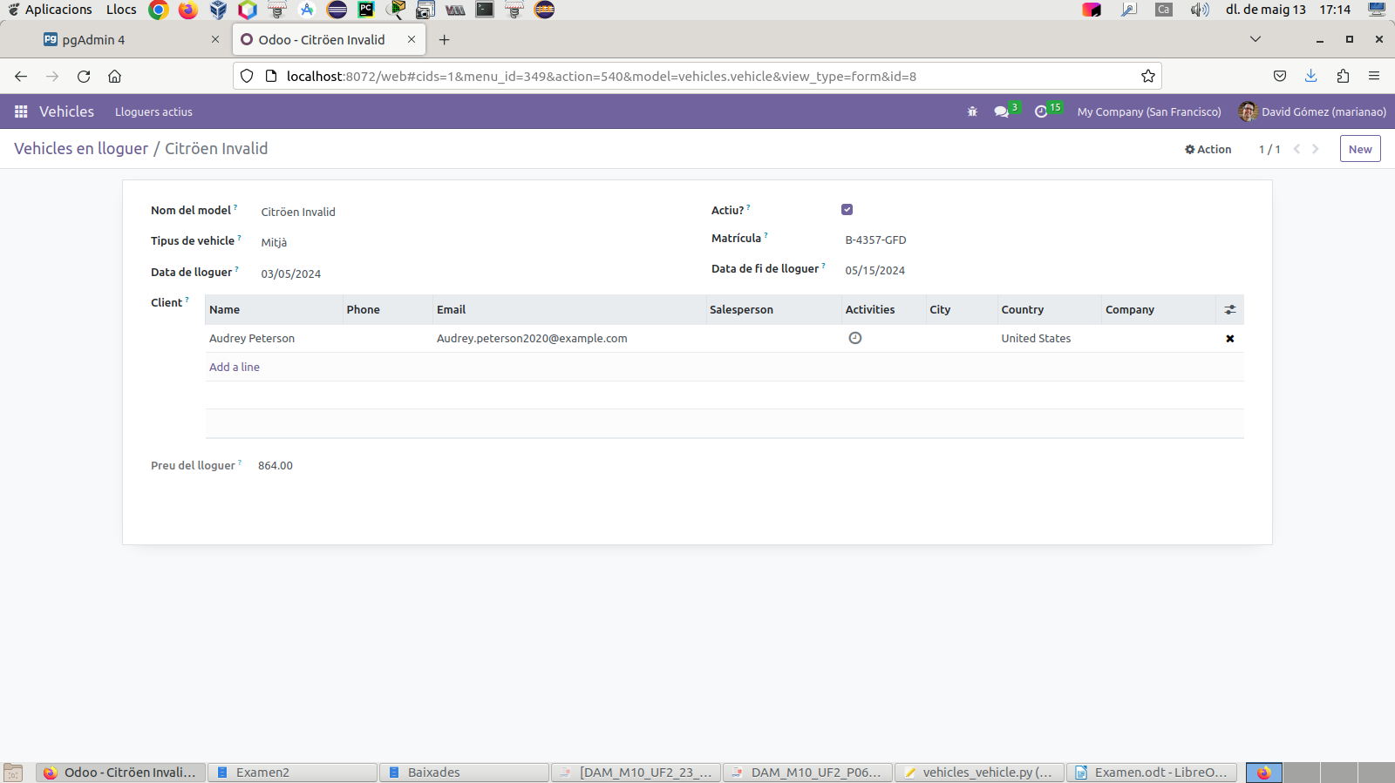
2D

from odoo import api, fields, models
from odoo.exceptions import ValidationError
from datetime import date

class Vehicle(models.Model):

_name = 'vehicles.vehicle'
_description = 'Vehicle'

name = fields.Char('Nom del model', required=True)
active = fields.Boolean('Actiu?', default=True)

vehicle_type = fields.Selection([('economic', 'Econòmic'), ('midsize', 'Mitjà'), ('compact', 'Compacte')], string='Tipus de vehicle')
plate = fields.Char(string='Matrícula', required=True)
date_rental = fields.Date('Data de lloguer')
date_return = fields.Date('Data de fi de lloguer')
client = fields.Many2many('res.partner', string='Client')
price = fields.Float('Preu del lloguer', compute='_preu_lloguer')

_sql_constraints = [
('plate_unique', 'UNIQUE(plate)', 'Aquesta matrícula ja està en ús.'),
]

@api.depends('vehicle_type','date_rental','date_return','price')
def _preu_lloguer(self):
for record in self:
if record.vehicle_type == 'economic':
daily_price = 10
elif record.vehicle_type == 'midsize':
daily_price = 12
elif record.vehicle_type == 'compact':
daily_price = 15
else:
daily_price = 0
if record.date_rental and record.date_return:
total_days = (record.date_return - record.date_rental).days + 1
record.price = daily_price * total_days
else:
record.price = 0

@api.constrains('client','date_rental','date_return')
def _validacio_client_dates(self):
for record in self:
if record.client:
if not record.date_rental or not record.date_return:
raise ValidationError('Les dates de lloguer i de fi de lloguer han d\'estar informades.')
if record.date_rental:
if not record.client or not record.date_return:
raise ValidationError('El client i la data de fi de lloguer han d\'estar informats.')
if record.date_return:
if not record.client or not record.date_rental:
raise ValidationError('El client i la data de lloguer han d\'estar informats.')

3A:

select p.default_code as "Referencia interna",
p.list_price as "Preu de venda",
c.name as "Categoria de producte"
from product_template p join product_category c
on p.categ_id = c.id
where p.detailed_type = 'product'
and p.sale_ok = 'true'
and p.list_price < 100
and p.id not in
(select product_tmpl_id
from product_product
group by product_tmpl_id
having count(*) > 1)
order by p.default_code;

3B:

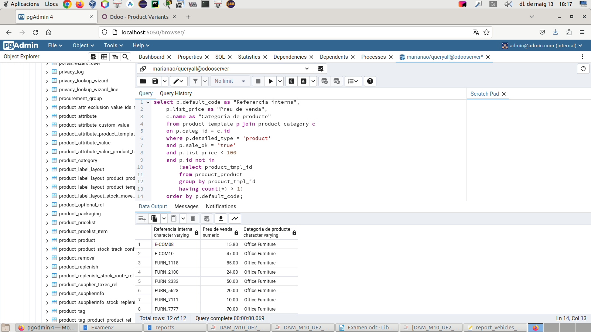

4A:

<?xml version="1.0"?>
<odoo>
<record id="action_vehicles_vehicle_report" model="ir.actions.report">
<field name="name">Vehicles</field>
<field name="model">vehicles.vehicle</field>
<field name="report_type">qweb-html</field>
<field name="report_name">vehicles.report_vehicles_vehicle</field>
<field name="binding_model_id" ref="model_vehicles_vehicle"/>
<field name="binding_type">report</field>
</record>
<template id="vehicles.report_vehicles_vehicle">
<t t-call="web.html_container">
<t t-call="web.external_layout">
<div class="page">
<table>
<style>
span{margin-right:30px}
tr{margin-bottom:40px}
</style>
<tr>
<th><span>Nom</span></th>
<th><span>Tipus de vehicle</span></th>
<th><span>Matrícula</span></th>
<th><span>Data de lloguer</span></th>
<th><span>Data de fi de lloguer</span></th>
<th><span>Client</span></th>
</tr>
<t t-foreach="docs" t-as="v">
<tr>
<td><span t-field="v.name"/></td>
<td><span t-field="v.vehicle_type"/></td>
<td><span t-field="v.plate"/></td>
<td><span t-field="v.date_rental"/></td>
<td><span t-field="v.date_return"/></td>
<td><span t-field="v.client"/></td>
</tr>
</t>
</table>
</div>
</t>
</t>
</template>
</odoo>

4B:

