**SOFTWARE**

**Installing ESP8266 Board in Arduino IDE**

Arduino IDE is one of the recommended and most commonly used development environment for ESP8266

Link: [Program ESP8266 with Arduino IDE](https://randomnerdtutorials.com/how-to-install-esp8266-board-arduino-ide/)

**Setting up Raspberry Pi:**

Install Raspberry Pi OS (Raspbian) on the Raspberry Pi, using Raspberry Pi Imager from <https://www.raspberrypi.org/downloads/>

Using the Imager, download and install Raspberry Pi OS onto a 8GB/16 GB micro SD card and insert it in the SD card slot of the Raspberry Pi and power it ON.

Make sure the packages are in its latest version, by typing the following commands in the console.

*sudo apt update*

*sudo apt upgrade*

**Install Mosquitto MQTT broker and clients on Raspberry Pi**

Mosquitto is a popular MQTT broker being used. Install both the “mosquitto” package for the broker and the “mosquitto-clients” package for clients for the purpose of testing.

Link: Steps to install and run [Mosquitto](https://randomnerdtutorials.com/how-to-install-mosquitto-broker-on-raspberry-pi/) Broker

**Install Node-RED on Raspberry Pi**

Node-RED is an open-source flow-based programming tool, designed for IoT, Node-RED is easy to use and also provides a browser-based editor.

Link: [Steps to install Node-RED](https://pimylifeup.com/node-red-raspberry-pi/)

**Install Influx DB on Raspberry Pi**

InfluxDB is a time-series database system, which helps in monitoring metrics and events. Each datapoint in the database will contain a timestamp.

Link: [Steps to install InfluxDB](https://pimylifeup.com/raspberry-pi-influxdb/)

**Install Grafana on Raspberry Pi**

Grafana is an open-source analytics and monitoring web application, which helps us in monitoring data over time. It provides various visualizations such as charts, graphs, gauges, stats and also has alerting features enabled.

Link: [Steps to install Grafana](https://pimylifeup.com/raspberry-pi-grafana/)

**Install Avahi software in Raspberry Pi for mDNS:**

*sudo apt-get update*

*sudo apt-get install avahi-utils*

*sudo apt-get install avahi-daemon*

*sudo nano /etc/avahi/services/mosquitto.service*

Paste the following text:

<!DOCTYPE service-group SYSTEM "avahi-service.dtd">

<service-group>

 <name replace-wildcards="yes">Mosquitto MQTT server on %h</name>

  <service>

   <type>_mqtt._tcp</type>

   <port>1883</port>

   <txt-record>info=Publish, Publish! Read all about it! mqtt.org</txt-record>

</service>

</service-group>

Close the file

*avahi-browse -a*

To find the hostname for hostname.local

*sudo cat /etc/hostname*

**HARDWARE**

**Components Required:**

Raspberry Pi3 Model B+

SD card

ESP8266 Wi-Fi Module

12V Solenoid Valve

Tube for Solenoid Valve

DHT22 Humidity and Temperature Sensor

Soil Moisture sensor

Relay module

Jumper wires

3.7V 18650 2500mAh Li-Ion Battery

Li-Ion Battery Holder

5V Step-Up Module Lithium Battery USB

USB Cable

**Block Diagram:**

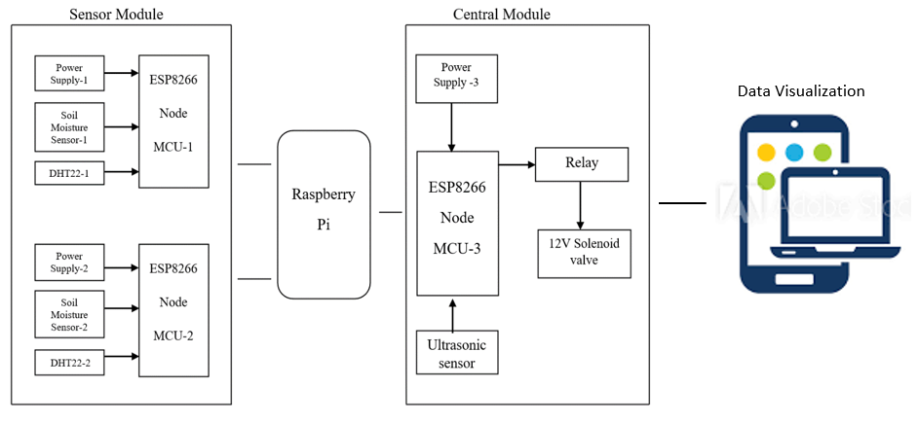

**Circuit Diagrams:**

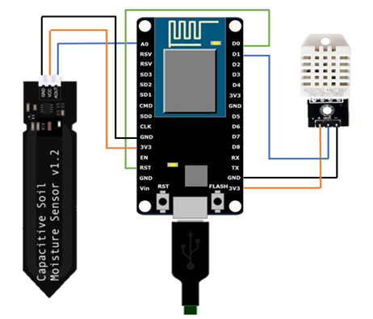

**Circuit Diagram of the Sensor Node**

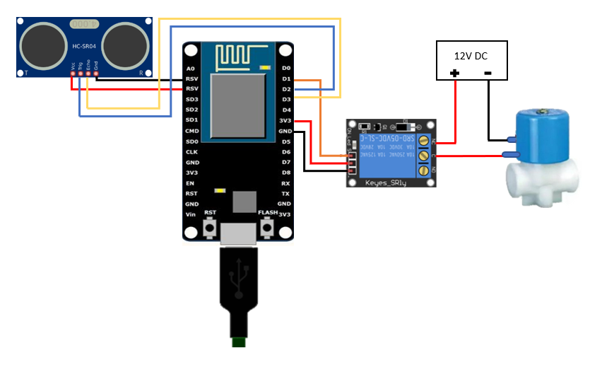

**Circuit Diagram of the Control Node**