Running head: MULTI-LEVEL ANALYSIS OF THE STABILITY-FLEXIBILITY TRADEOFF 1

1 Desperately Seeking Stability-Flexibility Tradeoffs: Relating Switch-Costs To Pre-Trial
2 Stability Across Levels of Analysis

3 Sophia Vi Angleton1, Neha Nagarkar1, Dominik Graetz1, & Ulrich Mayr1

4 1 University of Oregon

5 Author Note

6 The authors made the following contributions. Sophia Vi Angleton: Writing - Original
7 Draft Preparation, Writing - Review & Editing, Formal Analysis, Visualization; Neha
8 Nagarkar: Writing - Review & Editing, Formal Analysis, Visualization; Dominik Graetz:
9 Writing - Review & Editing, Formal Analysis, Visualization; Ulrich Mayr: Conceptualization,
10 Writing - Review & Editing, Project Administration, Supervision.

11 Correspondence concerning this article should be addressed to Ulrich Mayr, Lewis
12 Integrative Science Building, room 350 Eugene, OR 97403-1227. E-mail: mayr@uoregon.edu

13 Abstract
14 While some theories of cognitive control suggest a tradeoff between stable task
15 representations and adapting flexibly to new ones, empirical evidence is inconclusive and has
16 rarely covered the different levels on which such tradeoffs could occur (Egner, 2007; Goschke,
17 n.d., 2000; Rogers & Monsell, 1995). A smaller body of research supports a different account
18 of stability-flexibility, where on the level of within-subject dynamics stability and flexibility
19 are found to co-occur (U. Mayr, Kuhns, & Hubbard, 2014). This raises the question that the
20 stability–flexibility tradeoff seen through experimental level effects is not a fundamental
21 property of cognitive control but may instead reflect the analytic level at which it is
22 measured. Moreover, individual differences work hints at substantial variability in how
23 people balance stability and flexibility, suggesting that the relationship may not be uniform
24 across all individuals (Ulrich Mayr & Grätz, 2024).

25 We used here a particularly sensitive test of tradeoffs, namely by relating
26 task-switching costs to demands on pre-switch stability (by manipulating task conflict), and
27 we simultaneously examined (a) average experimental effects, (b) within-subject, trial-to-trial
28 dynamics, and (c) inter-individual relationships. Across two experiments (Exp 1: N=100,
29 Exp. 2: N=78) we found no consistent tradeoff relationships on the level of experimental
30 effects while within-subject dynamics revealed increased switch-costs following particularly
31 stable pre-switch trials. On the inter-individual level however, we found a clear anti-tradeoff
32 pattern: Individuals with greatest pre-trial stability showed also greatest flexibility. By
33 showing that stability–flexibility dynamics vary across analytic scales, our results challenge
34 the presumed ubiquity of the dominant tradeoff view and highlight the necessity of
35 multi-level approaches for understanding the mechanisms that govern cognitive control.

36 Keywords: Cognitive Control, Multi-Level Analysis, Decision-making, Cognition,
37 Task-Switching, Stability-Flexibility, Experimental Effects, Within-Subject Dynamics,
38 Individual Differences

39 Desperately Seeking Stability-Flexibility Tradeoffs: Relating Switch-Costs To Pre-Trial
40 Stability Across Levels of Analysis

41 Introduction

42 A dominant view in research on cognitive control holds that adjustments of control are
43 constrained by a general stability-flexibility tradeoff. Specifically, increasing the stability of a
44 task-relevant representation makes flexible changes of that representation more difficult
45 (Goschke, 2000). You may have spent weeks memorizing a speech word-for-word reflecting
46 high stability, but falter when mid-talk someone raises a question, forcing you to switch into
47 an improvised, conversational mode thereby reducing flexibility. The very thing that keeps
48 you anchored can also slow you down when you need to pivot. This negative relationship is
49 grounded in connectionist models of cognitive control, which describe task switching within
50 an “attractor landscape” (Fig. 1) (Brown, Reynolds, & Braver, 2007; Geddert & Egner,
51 2022). Different task representations form basins in a state space, and the depth of a basin
52 reflects how strongly a task is currently activated. A deeper basin corresponds to a more
53 stable task state, but it also requires more “energy” to move out of, making task switching
54 more difficult.
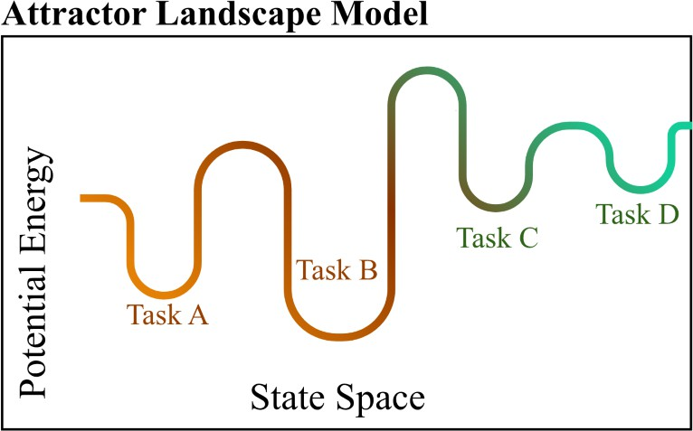

Figure 1 . The landscape attractor model. Tasks are represented as basins of varying depth along a state space. More stable task representations have deeper basins in this attractor model taking more potential energy to flexibly switch to a different task.

55 While foundational theories of cognitive control suggest such a tradeoff, empirical
56 evidence collected over the years are inconclusive and has rarely covered the different levels
57 on which such tradeoffs could occur (Goschke, n.d., 2000; Rogers & Monsell, 1995). Most
58 empirical work has examined the stability–flexibility dilemma using blockwise manipulations,
59 contrasting “stable” versus “flexible” blocks in a task-switching context by manipulating
60 response level conflict and switch-frequency. As Egner has argued, these two manipulations
61 might affect different hierarchical levels of control. It is not clear whether tradeoff patterns
62 could be observed when contrasting demands occur on the same level (Egner, 2007). For this
63 reason we manipulated control demands directly on task level through using either univalent
64 stimuli (associated only with one task) or bivalent stimuli (associated with two competing
65 tasks).
66 The notion of a stability-flexibility tradeoff is typically applied in an indiscriminate
67 manner, painting differences from trial level, individual differences, cultural phenomena, and
68 psychiatric disorders with the same broad brush (Armbruster, Ueltzhöffer, Basten, &
69 Fiebach, 2012; Cepeda, Cepeda, & Kramer, 2000; Colzato, Beste, & Zhang, 2022; Colzato,
70 Hommel, Zhang, Roessner, & Beste, 2022; Cools et al., 2009; D’Cruz et al., 2013; Moss,
71 Kikumoto, & Mayr, 2020; Tajik-Parvinchi, Farmus, Tablon Modica, Cribbie, & Weiss, 2021).
72 Sources of variability across levels of analysis are logically distinct, and systematic analysis of
73 tradeoff phenomena across levels has been rarely conducted. The current study examines
74 tradeoff relationship on the experimental effects (through mean differences), within-subject
75 variability across trials, and average variability across individuals. The later inter-individual
76 differences level requires additional considerations. In previous work (Geddert & Egner,
77 2022) inter-individual tradeoffs have been examined by directly relating factors representing
78 stability and flexibility. This approach ignores the potential contamination of each measure
79 through the “positive manifold” of positive correlations between almost any cognitive task.
80 It is therefore important to carefully control for such positive “baseline” correlations when
81 testing for potential tradeoff relationships at this level. SEM provides a principled way to

82 address this issue by removing the positive-manifold variance shared across tasks and
83 isolating the construct-specific variance that reflects genuine stability–flexibility dynamics.
84 The Current Study. Across two experiments, we used a task-switching ‘shape’ or
85 ‘color’ task with both univalent and bivalent stimuli included to manipulate task conflict. We
86 manipulated these cognitive demands on pre-switch to post-trial for a more detailed measure
87 of how stability-flexibility interact. The main component of experiment 1’s task design was
88 the alternating sequence of four consistent trials per task, which on the one hand offers
89 strong experimental control, also introduces group-to-group consistency. This may increase
90 strategic adaptation, where participants adjust their control settings in anticipation of
91 upcoming task demands rather than responding dynamically to each trial. Experiment 2
92 adopts a more run-by-run design in which task and stimulus conditions varied in a group of 3
93 trials than in fixed groups of 4 to account for this possible adaptation effect. We examine
94 these cognitive demands across three complementary levels of analysis consistent across both
95 experiments: (a) average experimental effects, (b) within-subject, trial-to-trial dynamics, and
96 (c) inter-individual relationships. At the experimental-effects level, we test whether
97 manipulations of previous- and current-trial control demands interact with the switch
98 contrast in a manner consistent with a stability–flexibility tradeoff. At the within-subject
99 level, we assess whether trial-by-trial RT autocorrelations, considered alongside the
100 experimental effects, reveal evidence of a tradeoff in moment-to-moment adjustments.
101 Finally, at the individual-differences level, we use structural equation modeling to examine
102 whether variability in measures of stability and flexibility aligns with the predictions of the
103 tradeoff model. Through this multi-level approach, we directly test whether the
104 stability–flexibility tradeoff emerges consistently across analytic levels or whether different
105 levels reveal distinct patterns.
106 Experimental Level Hypotheses. We hypothesize that 1) previous trial-group
107 bivalence enforces stability and should therefore cause higher switch costs (longer response
108 times, more errors). If the previous group of trials was univalent, previous performance will

109 require less stability and should therefore reduce switch costs (lower response times, fewer
110 errors). 2) Current-trial bivalence requires establishing a stronger task set and therefore
111 further increases RT and errors. Previous and current ambiguity should produce particularly
112 large switch costs (e.g., an interaction between previous and current ambiguity).
113 Within-Subject Level Hypotheses. On the level of individual trials, we are
114 testing whether greater stability leads to greater switch-costs in the subsequent task. Where
115 previous trial stability through bivalence will cause high switch cost, particularly when
116 switching from a bivalent to a bivalent trial (high stability will cause low flexibility).
117 Specifically, we expect a negative coefficient for pre-switch response times by pre-switch
118 conflict and task switch status. This is a more stringent test of the stability-flexibility
119 tradeoff predicted on the experimental level; on this level, we examine if the tradeoff is only
120 revealed when you are particularly fast on previous trials.
121 Inter-individual Differences Level Hypotheses. We test the hypothesis derived
122 from the tradeoff model that 1) participants who are stable under a no-switch condition,
123 which should be more challenging if the previous trials and/or the current trial is bivalent,
124 should be less efficient on switch trials. Because efficiency in almost all cognitive tasks is
125 positively related (i.e., the “positive manifold”) we will conduct a series of model tests, where
126 on each level we will control for relationships occurring on “preceding” conditions to present
127 less of a challenge to the stability-flexibility tradeoff. 2) We predict that with an increase in
128 stability demands (e.g., non-switch trials where the previous and/or current trial group were
129 bivalent), the coefficients should turn negative in case of a tradeoff.

130

131

Participants
Method

132 Our sample size for experiment 1 was 100 (N=100), and the sample size for experiment
133 2 was 78 (N=78). Both experiments subject were collected using convenience sampling
134 methods recruited from the human subjects pool from the University of Oregon. Participants

135 signed an informed consent form given by our lab, then were instructed through the
136 experiment ahead. Upon learning the instructions, participants completed one practice block,
137 then proceeded to the start of the experiment. Upon completion of the experiment, subjects
138 were debriefed and thanked for their time.

139 Procedure

140 Across both experiments, we had the same basic task stimuli with key design
141 differences that we will discuss after setting up the commonalities in structure.
142 Stimuli and Variables. The task involved the subject viewing a colored shape.
143 The stimulus dimension shape and stimulus dimension color were consistent across both
144 experiments 1 and 2, with 3 possible shapes appearing (circle, square, and triangle) as the
145 bivalent stimuli, plus a neutral univalent shape which was a cross. The stimulus shapes were
146 also 3 possible colors (red, green, and blue), with the neutral univalent color being gray. In
147 no condition both univalent dimensions were shown. Per trial, subjects completed one of two
148 tasks, one task, “color” determined what color the stimuli is and “shape”, determined the
149 shape of the presented stimuli. Across both experiments, we were interested in the stimulus
150 dimension shape, the stimulus dimension color, and the sequence position in a group of trials,
151 where the first position versus the remaining position serving as the switch contrast.
152 Sequence position in group changed across both experiments, for experiment 1 there were 4
153 positions per group whereas experiment 2 had 3 positions.
154 Experiment 1. Subjects performed one of two tasks indicated by task instructions
155 “color” or “shape”, where they identified either the color or shape attribute of a presented
156 stimulus. The task switched every 4 trials, where the first trial of every group always marked
157 a task switch into another group of 4 trials. Similar to the alternate cues experimental
158 design, the univalent aspect was manipulated randomly in a between trial groups design, in
159 this case with all four trials in one group being bivalent or all four trials in one group being
160 univalent, so that the participants knew that the stimuli alternated task dimension in groups

161 of four. Subjects completed a total of 8 blocks excluding a practice block, each block
162 containing 112 trials.
163 Experiment 2. In each group, the task remained to be univalent or bivalent, with a
164 task switch after each group of 3 trials. Therefore, for each group, the currently irrelevant
165 task could be either univalent or bivalent, and remained the same per group. The
166 experiment was a task switching paradigm, wherein participants switched between a color
167 and a shape task. In each trial, participants performed one of two tasks- color or shape,
168 where they identify the color or shape of the stimulus, respectively. The task switches every
169 three trials. In other words, the color or shape tasks were active for three consecutive trials.
170 Three trials make up a group. Thus, the first trial of a group marks a task switch into the
171 other task, the following two trials are task repetitions. There was a 100 ms
172 Inter-trial-interval. The participants performed one initial practice block with 126 trials and
173 then moved onto performing 5 experimental blocks with 120 trials each.

174 Analysis and Results

175 Our analysis plan was consistent across both experiments and outlined in a
176 preregistered project found here (link to preregistration). Across both experiments, our
177 exclusion criteria for subjects were accuracy rates below a threshold of 80% accurate across
178 the entire experiment and excluding a practice block that occurred at the beginning of both
179 experiments. In terms of response times, we identified outlier observations through excluding
180 all trials with reaction times having a z-score greater or lower than 3. Outside of our
181 exclusionary criteria, we note that in some models we used, particularly when conducting our
182 within-subjects modeling, we ran into issues of convergence and/or singularity across both
183 experiments. As a result, we conducted a pre-set series of model comparisons detailed below
184 to achieve the most complex model for each experiment that did not have any convergence
185 or singularity issues. We outline the analysis stream for how we conducted our model
186 comparison tests for this in our supplementary materials.

187 Experimental Level Analysis. Analyses of the dependent variables were
188 conducted on the trial level using multilevel modeling. Independent models for response
189 times and error rates were fit according to the valence (univalent, bivalent) of the previous
190 trial group, the valence of the current trial group, and the switch condition. We outline the
191 models we used in the pre-registration which can be found (link to preregistration).
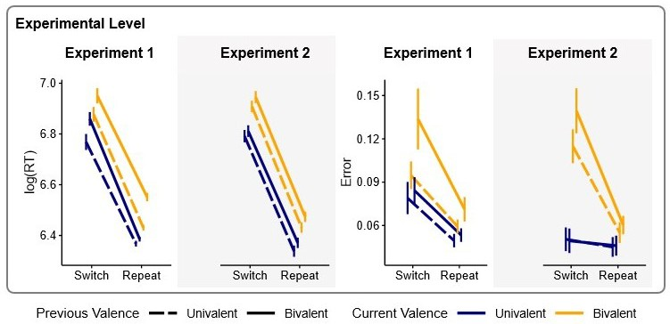

Figure 2 . Average Experimental Effects of logged response times and error rate on previous to current trial valence (uni- or bivalent) and trial type (switching trial or repeat trial).

192 Experimental Level Results. Experiment 1 is inconsistent across variables, with
193 response time revealing a weak anti-tradeoff, error rate a tradeoff relationship. Where in
194 logged response times, we see a significant interaction occurring between current trial valence
195 and task switching (est = 0.03, p = 0.002). When examining error rate, we see a tradeoff
196 occurring with the same interaction, current valence and task switching (odds ratio: 2.24,
197 p<0.001). Experiment 2 finds a weak tradeoff relationship occurring in response time and
198 error rate. Specifically, logged response times reveal a significant interaction between
199 previous trial valence and task switching (est = 0.01, p = 0.033), and a significant 3-way
200 interaction with current trial valence, previous trial valence, and task switching (est = -0.11,
201 p<0.001). Error rate models for experiment 2 reveal a significant interaction between current
202 trial valence and task switching (odds ratio: 1.18, p = 0.009), as well as previous trial

203 valence and task switching (odds ratio: 1.17, p = 0.014). Across the two experiments, we
204 cannot clearly identity a trend how stability-flexibility are related, and therefore on the
205 experimental level we conclude results to be largely inconclusive.
206 Within-Subjects Level Analysis. At the within-subject level, we assessed whether
207 trial-by-trial response time autocorrelations, considered alongside the experimental effects,
208 reveal evidence of a tradeoff in moment-to-moment adjustments. We used a residualized
209 pre-switch logged response time as our predictor variable (residualizing out both the general
210 trends and task) for (n-1 bivalent, n-1 univalent), current-trial valence (n bivalent, n
211 univalent), and switch condition (switch trial, no-switch trial).
212 Within-Subjects Level Results. Across both experiment 1 and 2, we see a
213 tradeoff occurring. Previous trial bivalence has a significant interaction with task switching
214 and previous response times (experiment 1: est = -0.10, p<0.001; experiment 2: est = -0.07,
215 p<0.001). As seen in figure 3, when subjects are coming from a particularly stable trial (lag
216 RT slow), they have a hard time switching, especially into a bivalent trial. Contrary to our
217 hypothesis however, we see that in experiment 1 when coming from a slow performing trial,
218 response times are largest when going from a univalent to a bivalent trial. This finding was
219 not replicated in experiment 2 however but across both, there doesn’t seem to be a significant
220 distinction of a previous trial bivalent to current bivalent trial having the largest switch cost.
221 Instead, a better predictor when coming from a slow stable trial is current trial bivalence.

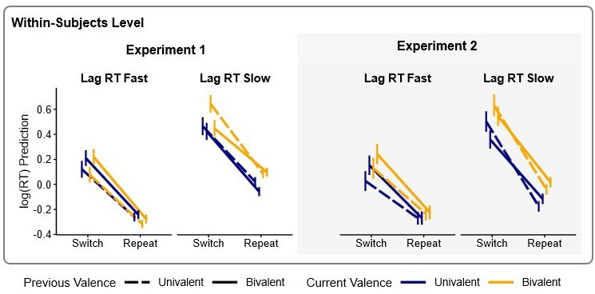
Figure 3 . Within-Subject Dynamics of trial-by-trial logged response time autocorrelations on previous to current trial valence (uni- or bivalent) and trial type (switching trial or repeat trial). Split for visualization purposes into previous fast and slow response times by experiment.

222 Inter-individual Differences Level Analysis. Individuals’ reaction time and error
223 data were aggregated for all crossings of previous-trial group valence (n-1 bivalent, n-1
224 univalent), current-trial valence (n bivalent, n univalent), and switch condition (switch trial,
225 no-switch trial). Reaction times were averaged across the no-switch trials within each trial
226 group. Each trial group consisted of three trials for the alternate-cues experiment and four
227 trials for the alternate-runs experiment. Individual differences analyses of the dependent
228 variable were conducted using linear regression modeling.
229 Inter-individual Differences Level Results. In both experiments, we see a strong
230 co-occurrence of stability-flexibility on the inter-individual level. This positive co-occurrence
231 is consistently found across error rates and logged response times. Where in general,
232 individuals who are better at switch trials will also be better at no-switch trials.
233 Additionally, the switch to no-switch bivalent-bivalent pairing, which is the strongest test of
234 switching from stable trial is strongly positive in error rate. This means that people who are
235 good at bivalent-bivalent switch trials will also be better at bivalent-bivalent no-switch trials.

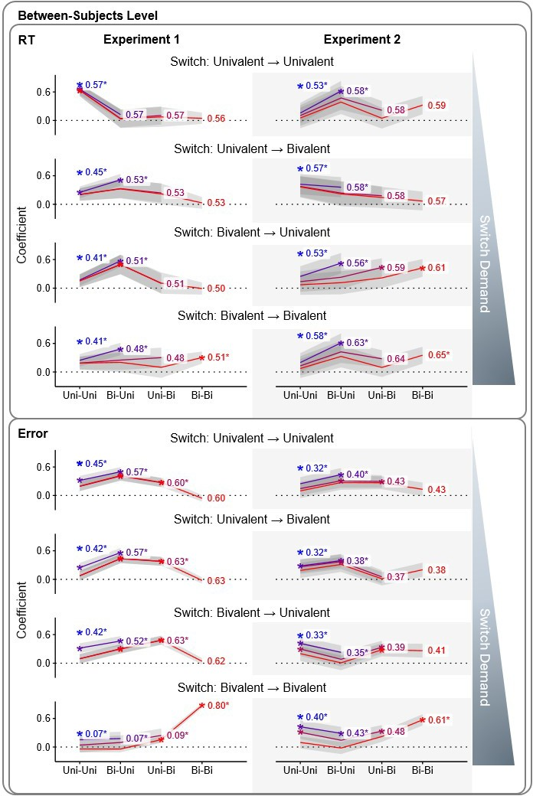

Figure 4 . note: not commenting on this figure because we plan to move this analysis to supplementary materials and instead talk about a SEM analysis we also performed

236 Discussion

237 We find significant differences in how stability-flexibility are related occurring on every
238 level of analysis. Using a stringent manipulation of pre- to post-trial control demands, our
239 results reveal a more complex picture of stability–flexibility dynamics than predicted by a
240 simple, universal tradeoff model.At the experimental-effects level, neither experiment
241 provides strong evidence for either a tradeoff or an anti-tradeoff pattern. In contrast,
242 within-subject dynamics show a reliable negative relationship: when participants come from
243 a particularly stable task state, they are slower to flexibly switch on the next trial. On the
244 inter-individual level we see yet another change in how stability-flexibility are related,
245 revealing an anti-tradeoff (i.e., a co-occurrence of stability and flexibility), meaning
246 individuals with greatest pre-switch stability also showed greatest flexibility.

247 The inconclusive findings on the experimental level replicates the findings from egner. . .

248 Outside of experimental effects, we do not see many studies interested in
249 understanding how stability-flexibility emerges on different levels of analysis. Mayr, Kuhns
250 and Rieter found a positive relationship between stability-flexibility using an eye-tracking
251 task design on the level of within-subject dynamics (U. Mayr, Kuhns, & Rieter, 2013). In
252 our study however, we see a tradeoff occurring in within-sub dynamics. This discrepancy
253 may reflect differences in how stability and flexibility were operationalized, where the Mayr
254 et al. study used a combination of eye-tracking as well as mixed modeling in their methods
255 to understand in a fine-grain manner the dynamic relationship between stability and
256 flexibility within- and across-trials. Interestingly, Mayr et al. found a weak tradeoff of visual
257 spatial attentional setting but not on response times. This points to the notion that it
258 matters how stability-flexibility is represented and created; tasks that evoke
259 stability–flexibility dynamics are not necessarily interchangeable or generalizable.

260 If we are to believe that we can apply general cognitive processes as a behavior that

261 applies to the general population, the tradeoff found at the within-subject level should also
262 apply inter-individually. Instead, we find the opposite: a robust tradeoff within individuals
263 but a clear anti-tradeoff (i.e., a co-occurrence of stability and flexibility) across individuals.
264 These findings align with emerging accounts of cognitive control that emphasize structured,
265 map-like representations rather than simple attractor dynamics (Ulrich Mayr & Grätz, 2024).
266 (add more)

267 Taken together, there seems to not be a unified answer to the stability-flexibility
268 dilemma. Rather than reflecting a universal constraint, tradeoff patterns appear to be
269 contingent on how stability and flexibility are created, measured, and analyzed. Our results
270 challenge the ubiquity of the tradeoff model and point toward the need for a more nuanced
271 framework. We attribute these findings to that the tradeoff model of stability-flexibility is
272 likely not a general phenomenon, instead tradeoffs found are likely a representation of
273 specific phenomenon. Understanding the relationship between stability-flexibilty may be
274 better understood through the lens of conjunctive representations (add more).

275 References

276 Armbruster, D. J., Ueltzhöffer, K., Basten, U., & Fiebach, C. J. (2012). Prefrontal cortical
277 mechanisms underlying individual differences in cognitive flexibility and stability. J Cogn
278 Neurosci, 24, 2385–2399.
279 Brown, J. W., Reynolds, J. R., & Braver, T. S. (2007). A computational model of
280 fractionated conflict-control mechanisms in task-switching. Cognitive Psychology, 55,
281 37–85. https://doi.org/10.1016/j.cogpsych.2006.09.005
282 Cepeda, N. J., Cepeda, M. L., & Kramer, A. F. (2000). Task switching and attention deficit
283 hyperactivity disorder. Journal of Abnormal Child Psychology, 28, 213–226.
284 https://doi.org/10.1023/a:1005143419092
285 Colzato, L. S., Beste, C., & Zhang, W. (2022). Hommel B: A metacontrol perspective on
286 neurocognitive atypicality: From unipolar to bipolar accounts. Front Psychiatry,
287 13 (846607).
288 Colzato, L. S., Hommel, B., Zhang, W., Roessner, V., & Beste, C. (2022). The metacontrol
289 hypothesis as diagnostic framework of OCD and ADHD: A dimensional approach based
290 on shared neurobiological vulnerability. Neurosci Biobehav Rev, 137 (104677).
291 Cools, R., Frank, M. J., Gibbs, S. E., Miyakawa, A., Jagust, W., & D’Esposito, M. (2009).
292 Striatal dopamine predicts outcome-specific reversal learning and its sensitivity to
293 dopaminergic drug administration. J Neurosci, 29, 1538–1543.
294 D’Cruz, A.-M., Ragozzino, M. E., Mosconi, M. W., Shrestha, S., Cook, E. H., & Sweeney, J.
295 A. (2013). Reduced behavioral flexibility in autism spectrum disorders. Neuropsychology,
296 27, 152–160. https://doi.org/10.1037/a0031721
297 Egner, T. (2007). Congruency sequence effects and cognitive control. Cognitive, Affective, &
298 Behavioral Neuroscience, 7, 380–390. https://doi.org/10.3758/cabn.7.4.380
299 Geddert, R., & Egner, T. (2022). No need to choose: Independent regulation of cognitive
300 stability and flexibility challenges the stability-flexibility trade-off. Journal of
301 Experimental Psychology: General, 151 (12), 3009–3027.

302 https://doi.org/10.1037/xge0001241
303 Goschke, T. (n.d.). Voluntary Action and Cognitive Control From a Cognitive Neuroscience
304 Perspective. In Voluntary Action: Brains, Minds, and Sociality (Vol. 2003, pp. 49–85).
305 Oxford University Press.
306 Goschke, T. (2000). Intentional reconfiguration and involuntary persistence in task set
307 switching. Control Cogn Process Atten Perform XVIII.
308 Mayr, Ulrich, & Grätz, D. (2024). Does cognitive control have a general stability/flexibility
309 tradeoff problem? Current Opinion in Behavioral Sciences, 57, 101389.
310 https://doi.org/10.1016/j.cobeha.2024.101389
311 Mayr, U., Kuhns, D., & Hubbard, J. (2014). Long-term memory and the control of
312 attentional control. Cogn Psychol, 72, 1–26.
313 Mayr, U., Kuhns, D., & Rieter, M. (2013). Eye movements reveal dynamics of task control.
314 J Exp Psychol Gen, 142 (489).
315 Moss, M. E., Kikumoto, A., & Mayr, U. (2020). Does conflict resolution rely on working
316 memory? Journal of Experimental Psychology: Learning, Memory, and Cognition,
317 46 (12), 2410–2426. https://doi.org/10.1037/xlm0000801
318 Rogers, R. D., & Monsell, S. (1995). Costs of a predictible switch between simple cognitive
319 tasks. Journal of Experimental Psychology: General, 124, 207–231.
320 https://doi.org/10.1037/0096-3445.124.2.207
321 Tajik-Parvinchi, D., Farmus, L., Tablon Modica, P., Cribbie, R. A., & Weiss, J. A. (2021).
322 The role of cognitive control and emotion regulation in predicting mental health problems
323 in children with neurodevelopmental disorders. Child: Care, Health and Development, 47,
324 608–617. https://doi.org/10.1111/cch.12868

325 Supplementary Materials

326 (write more about our model comparisons decision-tree procedure and how our final
327 models for these ended up looking. can set up here what the procedure was then in each
328 section we describe the ez-ddm models and what our final model looked like, how it differed
329 across exp1 and 2 then again in the within sub section.)

330 Experimental Effects

331 These models were run on the data from both experiments. The outcomes of these
332 analyses guided how subsequent analytic layers were approached. We accounted for the
333 possibility of finding evidence for speed–accuracy trade-offs through observation of opposing
334 effects on reaction times and errors but they did not emerge. Consequently, drift-diffusion
335 modeling (EZ-DDM) was applied not as an additional validation of the observed effects and
336 we proceeded with analysis of within-subject dynamics. For the EZ-DDM analysis, the mean
337 and variance of reaction times and mean error rates were calculated for each subject and for
338 the same contrasts specified above. The resulting parameters were analyzed using linear
339 mixed-effects models with random intercepts for each subject to confirm the robustness of
340 the experimental-level findings.

341 Individual differences analyses of the dependent variable were conducted using linear
342 regression modeling. For each participant, drift rate was computed as a function of switch
343 condition and previous and current group-valence conditions (eight estimates per subject). A
344 stringent test was then performed to determine the presence of a trade-off pattern by adding
345 predictors sequentially. The first model type predicted drift rate in the least-demanding
346 switch condition (univalent-univalent) from the least-demanding non-switch condition
347 (univalent-univalent). Predictors were subsequently added to this model in three steps (see
348 model outline below).

349 (model outline figure here)

350 EZ-DDM parameters of non-decision time (Ter) and boundary separation (a) were also
351 computed. If the EZ-DDM non-decision time parameter (Ter) was negative in fewer than
352 20% of cases across all subjects and conditions, the linear regression models were re-run with
353 data cells in those conditions set as missing. Results obtained from the drift-rate models
354 were cross-referenced with two additional models: one using log-transformed reaction time as
355 the dependent variable and another using error rate as the dependent variable. These models
356 were implemented identically to the steps outlined above.

357 (add in ddm model builds with also explanation across both experiemtns what models
358 were different and why)

