ELEC 327 – Assignment 6

The Xtreme Team

Dennis Grajo, Hojun Lee, Mike McColm, Stephen Obadinma

## 1. Source Listing For Daily/Weekly Script

The code for these scripts can be found in the dailyScript.py file on the team’s GitHub p6 folder.

## 2. Daily Script Inputs

The inputs for the first day are as follows:

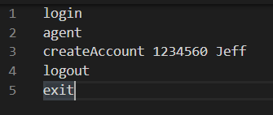

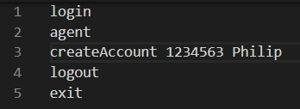

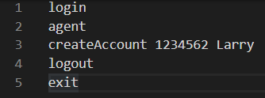

## 3. Merged Transaction Summary File

After the above 3 input scripts were run, the following merged transaction summary file was observed:

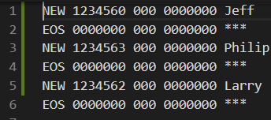

## 4. Master Accounts File

The following master accounts file was observed after the weekly run.

## 5. Integration Default Report

The team encountered the following issues: