Derek Graves

06/28/2024

Lab 1 Submission: Tool installation and a brief taste of the machine learning process

* A screenshot of a computer

  Description automatically generatedA screen shot of a computer

  Description automatically generatedProgress 1 - package installation report for NumPy, JupyterLab, pandas, matplotlib

* Progress 2 - Running JupyterLab

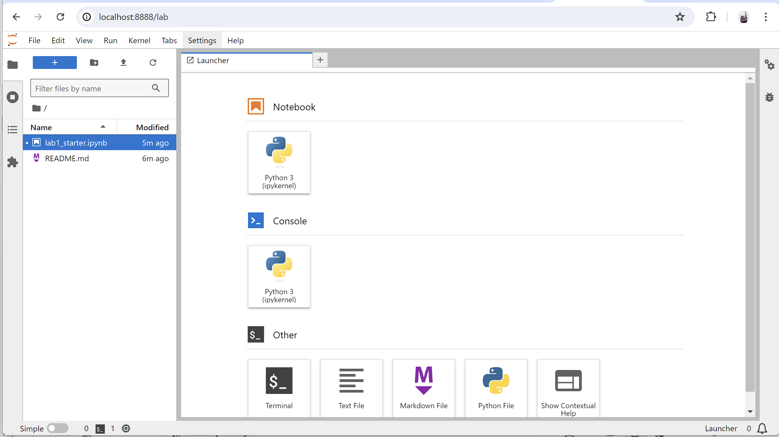

* Progress 3 - JupyterLab with notebook running

* Progress 4 - DataFrame keys displayed

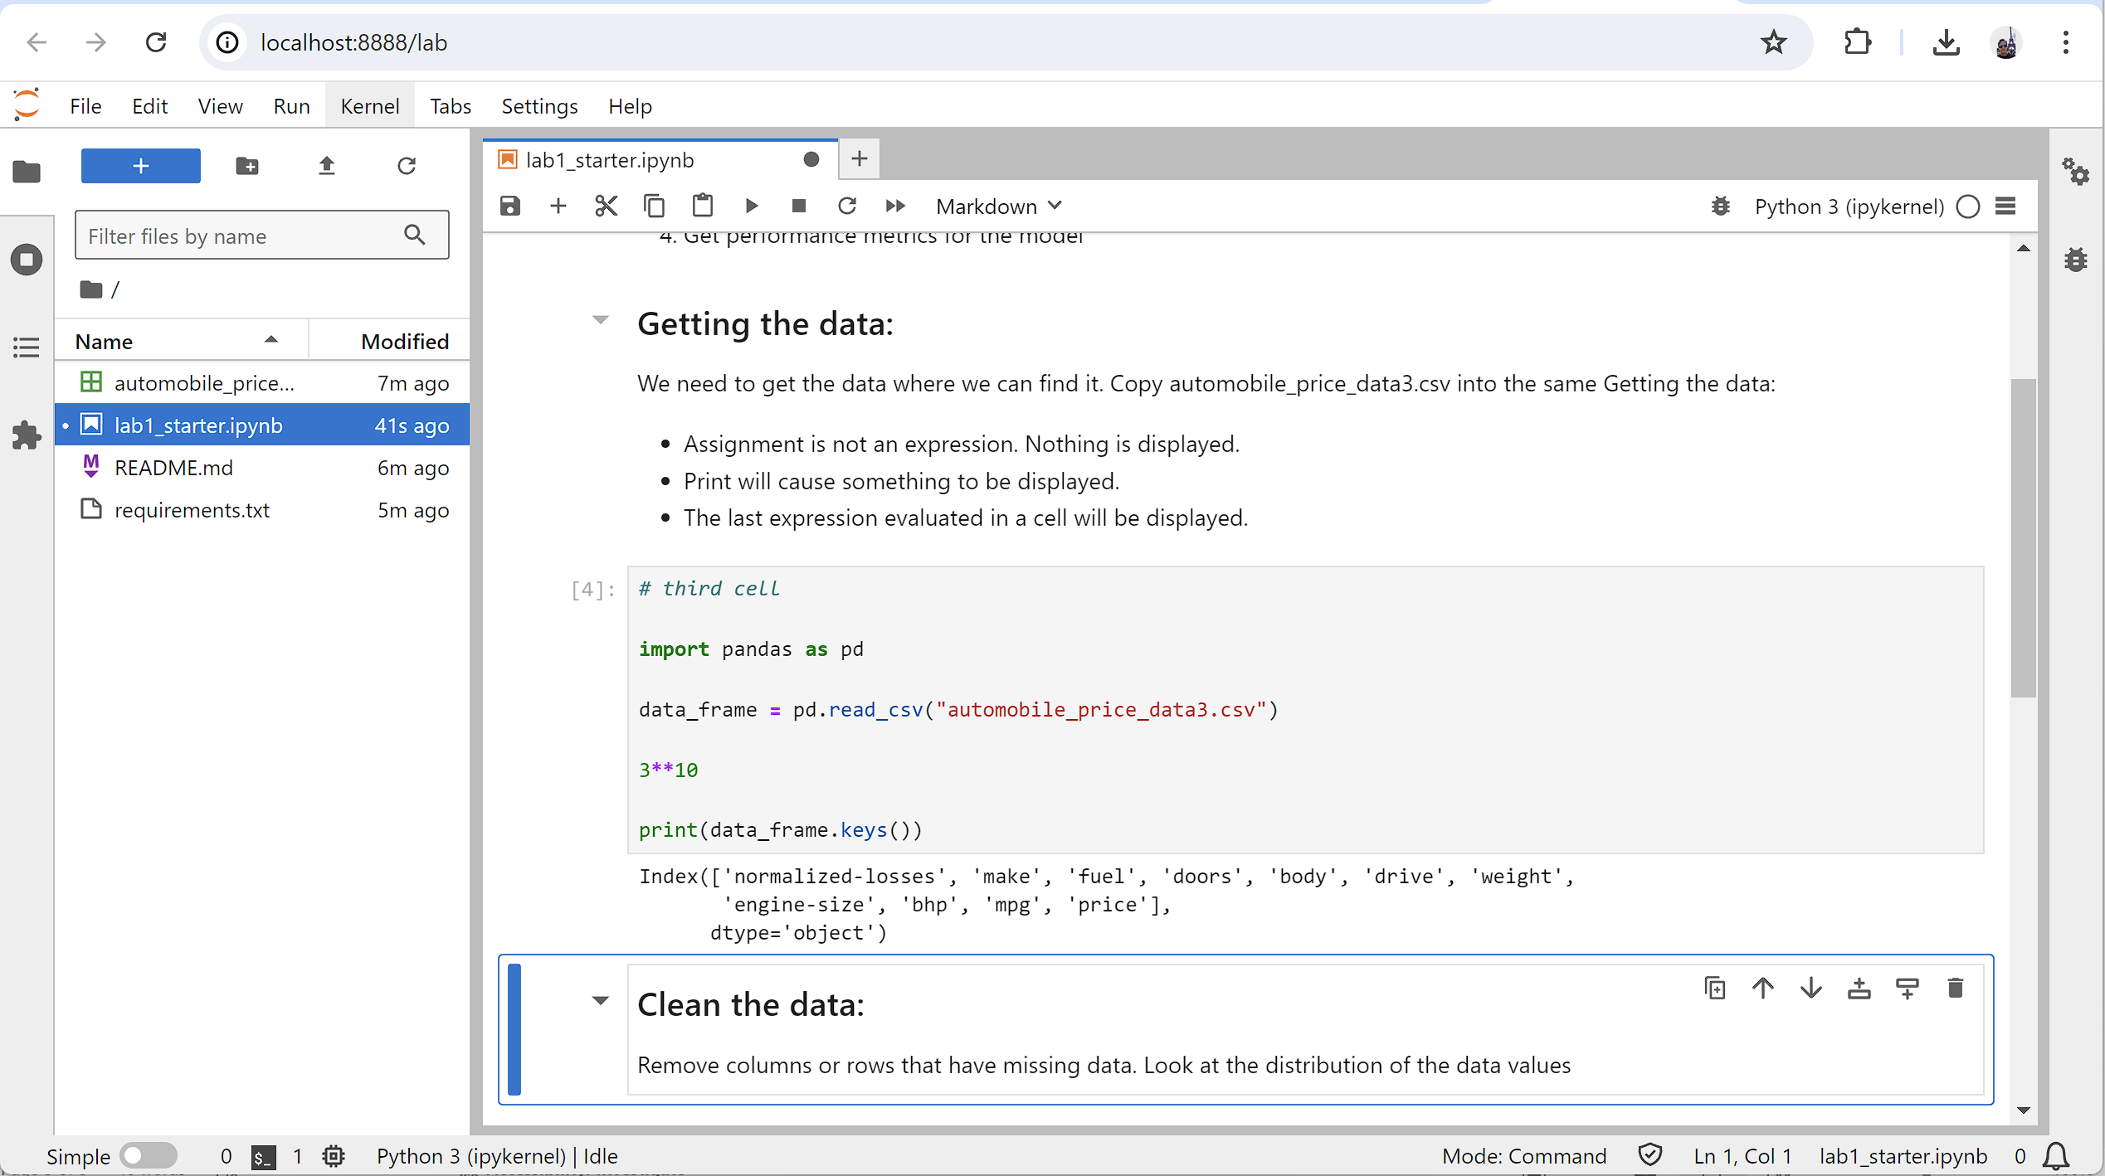

* Progress 5 - histograms for features

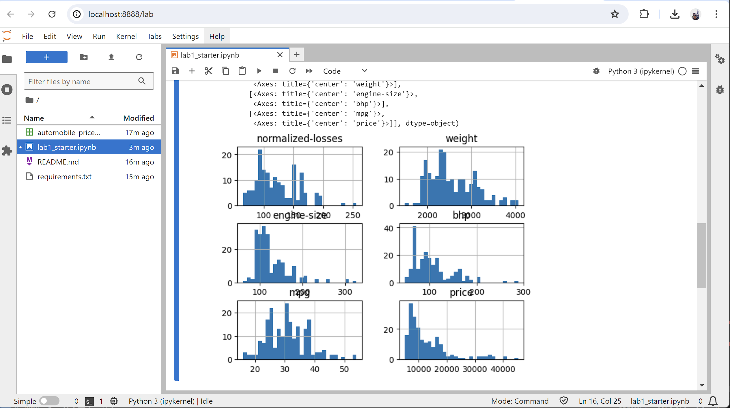

* Progress 6 - Error on accessing removed feature

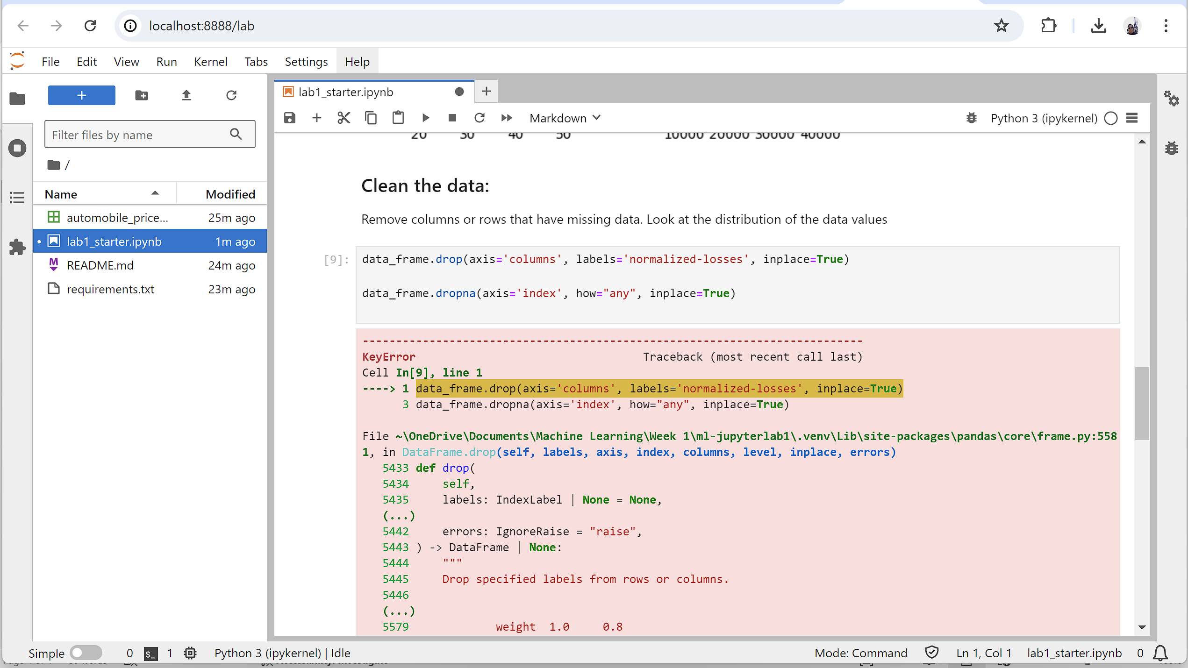

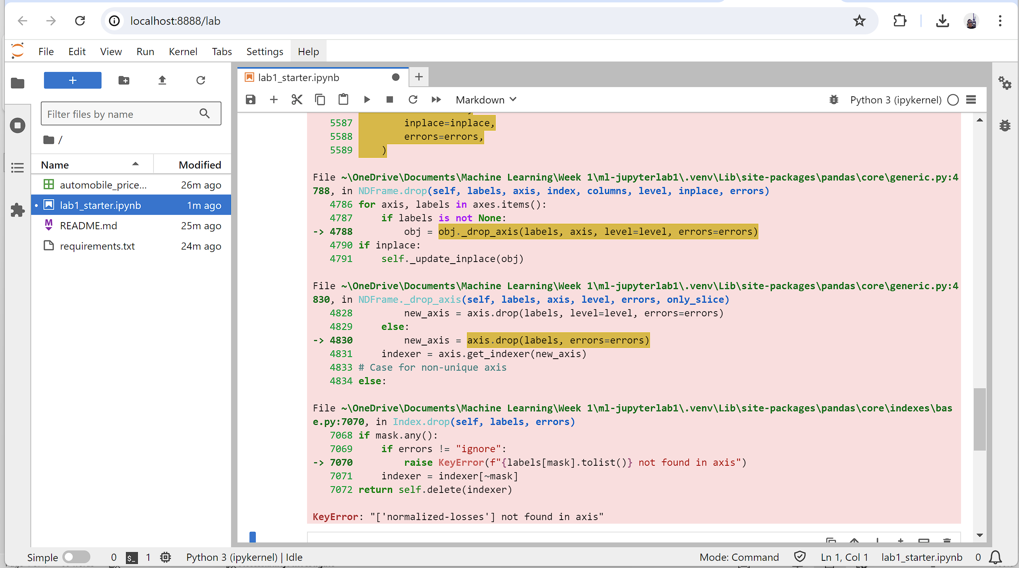

* Progress 7 - Split code

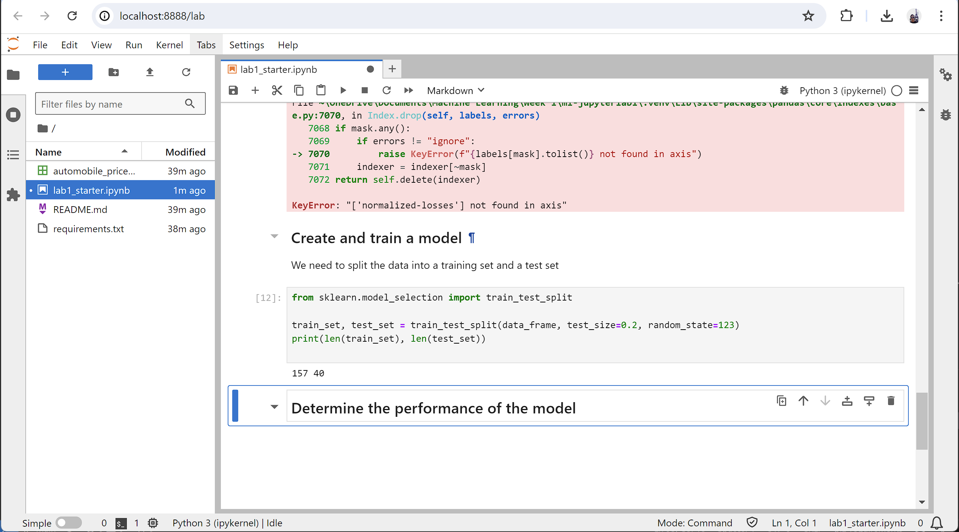

* Progress 8 - Training code and results

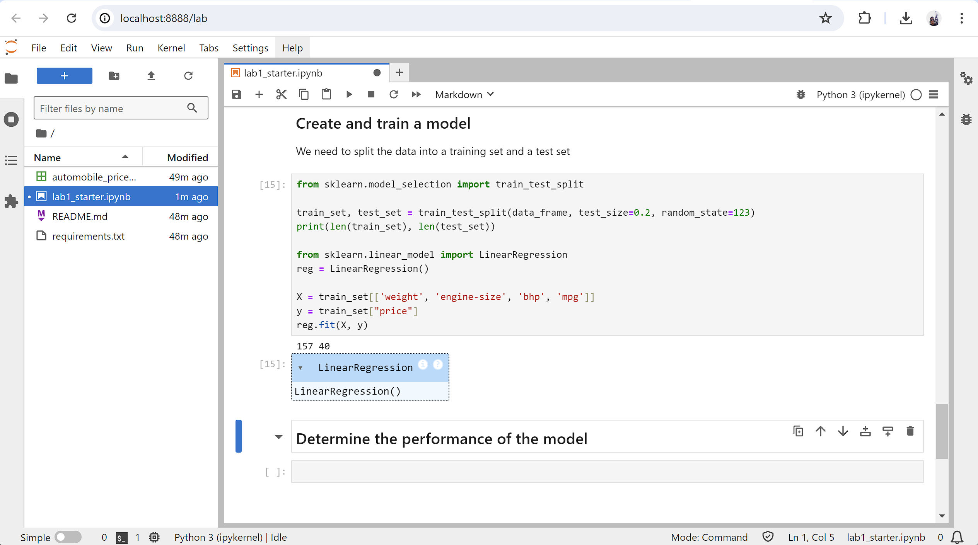

* Progress 9 - Screen shot of internal parameters for trained model

* Progress 10 - Screen shot of performance values

