**Introduction**

LeBron James is widely regarded as one of the greatest basketball players in NBA history. His extraordinary talent and consistent performance have set a high standard in the world of sports, making him a generational icon. In this report, we will delve into an in-depth analysis of LeBron’s career, examining his best and worst statistical performances across different teams. By exploring this data, we aim to highlight both the exceptional moments and challenges in LeBron's illustrious career, offering a comprehensive view of his impact on the game.

**Excel**

To begin this capstone project, I utilized the website Basketball Reference to gather comprehensive data on LeBron James' career statistics. I copied and pasted the relevant data into an Excel sheet, ensuring that all entries were accurate and included details of his performance across the various teams he has played for. With this data in hand, I created a pivot table to analyze and interpret the statistics, allowing me to identify LeBron James' best and worst qualities as a player. This analysis forms the foundation of my case study, providing insights into his strengths and areas for improvement throughout his career.

Excel put the data inside to see if it works or not.

Now after this I tried out the table and realize since it was a lot of information, I wouldn’t be able to put it in properly, so I tried to check out certain stats for LeBron, so I tried out how many games he played started and the avg minutes he played games. So, looking at the stats it looks like 2017-2018 Lebron played the most games and started in the most games but for the high avg number of minutes it looks like 2005-06 Lebron played the highest avg minutes in his career.

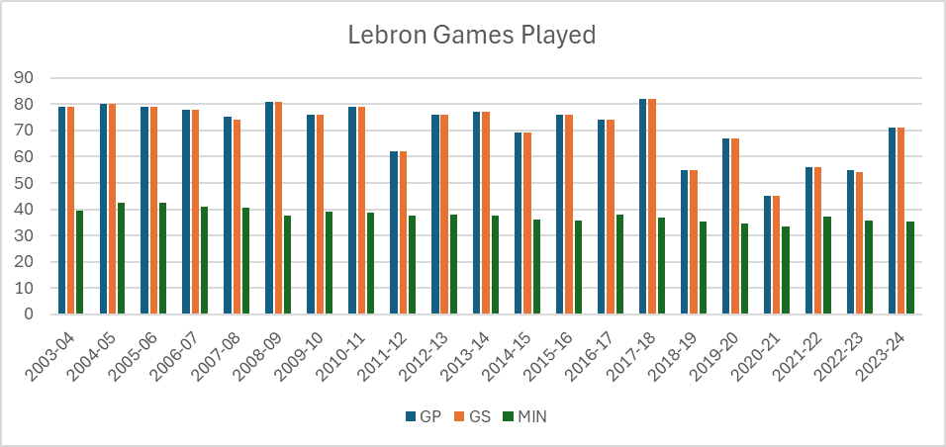\

**Google SQL**

After initially working with the data in Excel, I transitioned to Google Cloud SQL, where I created a new database. I then imported the data from the Excel worksheet into this database. To verify the successful upload and view the entire dataset within SQL, I executed a basic SELECT * command, allowing me to inspect the data directly through SQL.

The SELECT * command allowed me to inspect the entire table. Following this, I executed a SQL query to analyze the data and identify the three teams where LeBron James had the highest average points per game throughout his career. So, we see here that twice in the same team Lebron had a high amount of points in Cleveland it looks back to back but he did do it again with the Lakers.

For the final touch I used the software called Tableau to look at the data but in a more colorful and visual display.

**Tableau**

After completing the data setup in Google Cloud SQL, I utilized Tableau to visualize the statistics. Tableau's powerful data visualization capabilities allowed me to create interactive dashboards and insightful charts that effectively represent the data. Using Tableau, I was able to design clear and engaging visualizations that highlight key metrics, such as LeBron James' performance across different teams. The ability to filter, drill down, and customize visualizations provided a comprehensive view of the data, making it easier to analyze trends and draw meaningful conclusions.

In the tableau you can see more of Lebron points, rebounds, assist and other stats clearer.

You can see in the charts that Lebron was the best rebounder in his Cleveland Days and as well he was the best stats at steals in the team of Cleaveland. But in the Lakers, he had the most assist he has ever avg I his career and his best free throws. Also, you can see 2005-2006 Lebron James has avg the most amount of points in Cleveland as well.

**Results**

With the results seen through this report we can see that Lebron was a generational talent in his Cleveland days of the sport. In the team Cleaveland compared to the Lakers and Miami. Through this report we see Lebron having the most impact in his career and in the game in Cleveland than anywhere else. Also to report as well even though Lebron James in Miami didn’t achieve these high stats he still achieves close stats with his time in the team and in the Lakers Lebron James did avg high amount of assist per game in his time with the team. Showing his value as a facilitator and playmaker.

**Conclusion**

LeBron James has demonstrated exceptional talent and versatility throughout his career. The analysis reveals that his time with the Cleveland Cavaliers was particularly noteworthy, as he excelled in rebounding, stealing, and scoring. His impact during this period was profound, establishing him as a generational talent in the sport.

In contrast, his time with the Los Angeles Lakers has highlighted his evolution as a playmaker and improved free throw shooter. Each phase of his career has showcased different aspects of his game, reflecting his adaptability and growth as a player.

Overall, the findings affirm that LeBron James' most significant impact on the game of basketball occurred during his time with the Cleveland Cavaliers, where his performance metrics were at their most impressive. His contributions across different teams have solidified his legacy as one of the greatest basketball players in history.