**Types of Solar Panels**

The 3 main types of solar panels are; monocrystalline, polycrystalline and thin film.

Monocrystalline is the most sought after panel with polycrystalline gaining momentum.  With around 1% difference, monocrystalline is a fraction more efficient, and expected to last a year or two longer.  Thin Film panels are the least efficient and generally the cheapest, with polycrystalline and monocrystalline being at the higher end.

Because monocrystalline panels are the more efficient, you generate more solar power within a smaller area on your roof.  If you have limited space for solar panels you might want to choose monocrystalline solar panels.

When comparing types of panels, your choice will normally come down to a cost-benefit analysis and what panel type will fit within your budget.

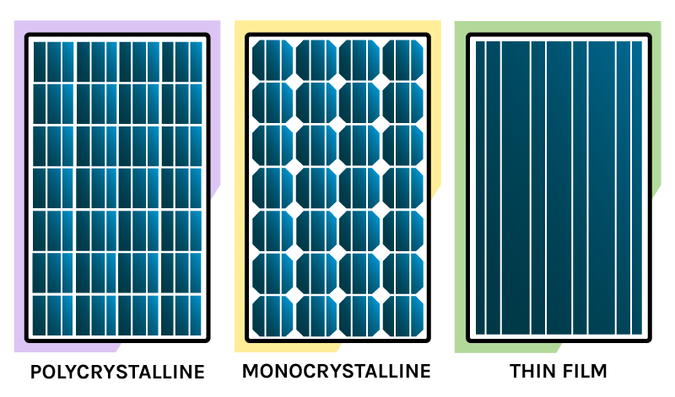

## Performance Data to look out for:

### Power Tolerance

Each solar panel manufacturer claims a specific watt power for their solar panels e.g. 250W.  However, manufacturers also indicate the range a solar panel is expected to exceed.  Most companies indicate both a negative and positive tolerance.  The range can vary as much as +10% to -10%.  If this is the case, then a 250W panel could produce as much as 275W or as little as 227W in ideal conditions.  To ensure expected power output, look for solar panels with a small power tolerance range or a positive only tolerance.

### Temperature co-efficient rating

This rating describes the decreasing power output as the outside temperature increases.  Temperature coefficient Pmax for REC Peak Energy Eco Panels are -0.46%, therefore each degree over 25˚C the maximum power output of the panel is reduced by 0.46%.

### Efficiency

Efficiency shows how much of the sun’s energy the solar panel transforms into electricity.  For example, the Yingli’s Panda Series panels have an efficiency of 17.2%. Efficiency ratings normal range between 14% to 21%

## Warranties on Solar Panels

Most solar panel manufacturers have a performance warranty of 25 years, which indicates the manufacturer is confident that their solar panels will last 25 years, if not longer.

It is important to know that a warranty will only be honored if the company is still in operation, if they are not in operation the performance warranty could still be covered, so long as the company was insured when you purchased the panels.

Therefore, selecting a solar manufacturer that has a good history is worthwhile.

### **Monocrystalline Silicon Solar Cells**

Solar cells made of monocrystalline silicon (mono-Si), also called single-crystalline silicon (single-crystal-Si), are quite easily recognizable by an external even coloring and uniform look, indicating high-purity silicon, as you can see on the picture below:

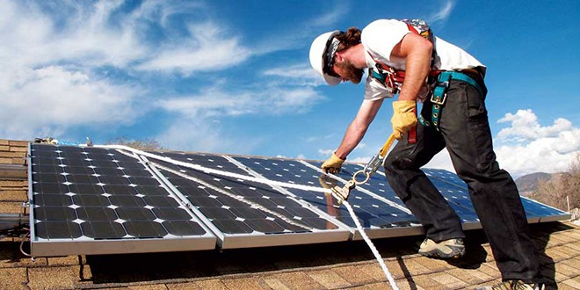

Monocrystalline solar cells are made out of silicon ingots, which are cylindrical in shape. To optimize performance and lower costs of a single monocrystalline solar cell, four sides are cut out of the cylindrical ingots to make silicon wafers, which is what gives monocrystalline solar panels their characteristic look.

A good way to separate mono- and polycrystalline solar panels is that polycrystalline solar cells look perfectly rectangular with no rounded edges.

Single crystal solar panels are currently the most efficient type available, meaning that they produce the most power per square foot of module. This makes them one of the most expensive at a price of about $4-$6 per watt average. The cost of solar panels like this is high, but since they produce more power, it could very well be worth it.

#### **Advantages**

* **Monocrystalline solar panels have the highest efficiency rates since they are made out of the highest-grade silicon**.
* **Monocrystalline silicon solar panels are space-efficient.**
* **Monocrystalline solar panels live the longest.** Most solar panel manufacturers put a 25-year warranty on their monocrystalline solar panels.
* Tend to perform better than similarly rated polycrystalline solar panels at low-light conditions.

#### **Disadvantages**

* **Monocrystalline solar panels are the most expensive.** From a financial standpoint, a solar panel that is made of polycrystalline silicon (and in some cases thin-film) can be a better choice for some homeowners.
* **If the solar panel is partially covered with shade, dirt or snow, the entire circuit can break down.**
* The Czochralski process is used to produce monocrystalline silicon. It results in large cylindrical ingots. Four sides are cut out of the ingots to make silicon wafers. **A significant amount of the original silicon ends up as waste.**
* **Monocrystalline solar panels tend to be more efficient in warm weather.** Performance suffers as temperature goes up, but less so than polycrystalline solar panels. For most homeowners temperature is not a concern.

### **Polycrystalline Silicon Solar Cells**

The first solar panels based on polycrystalline silicon, which also is known as polysilicon (p-Si) and multi-crystalline silicon (mc-Si), were introduced to the market in 1981. Unlike monocrystalline-based solar panels, polycrystalline solar panels do not require the Czochralski process. Raw silicon is melted and poured into a square mold, which is cooled and cut into perfectly square wafers.

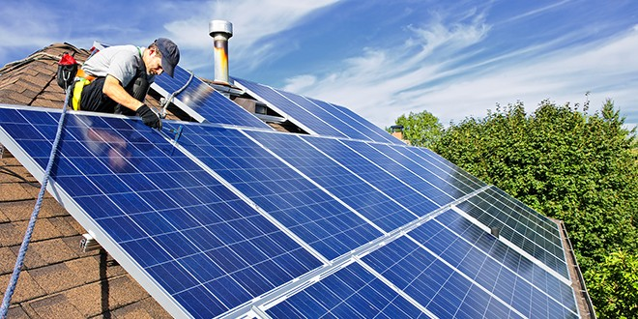

Poly crystal solar panels are slightly less efficient but cost a little less at a price of about $3-$5 per watt average. The cost of solar panels like this is typically lower, but you'll lose some efficiency.

#### **Advantages**

* **The process used to make polycrystalline silicon is simpler and cost less.** The amount of waste silicon is less compared to monocrystalline.
* **Polycrystalline solar panels tend to have slightly lower heat tolerance than monocrystalline solar panels.** This technically means that they perform slightly worse than monocrystalline solar panels in high temperatures. Heat can affect the performance of solar panels and shorten their lifespans. However, this effect is minor, and most homeowners do not need to take it into account.

#### **Disadvantages**

* **The efficiency of polycrystalline-based solar panels is typically 13-16%.**Because of lower silicon purity, polycrystalline solar panels are not quite as efficient as monocrystalline solar panels.
* **Lower space-efficiency.** You generally need to cover a larger surface to output the same electrical power as you would with a solar panel made of monocrystalline silicon. However, this does not mean every monocrystalline solar panel perform better than those based on polycrystalline silicon.
* Monocrystalline and thin-film solar panels tend to be more aesthetically pleasing since they have a more uniform look compared to the speckled blue color of polycrystalline silicon.

**Thin-Film Solar Cells**

Depositing one or several thin layers of photovoltaic material onto a substrate is the basic gist of how thin-film solar cells are manufactured. They are also known as thin-film photovoltaic cells (TFPV). The different types of thin-film solar cells can be categorized by which photovoltaic material is deposited onto the substrate:

* Amorphous silicon (a-Si)
* Cadmium telluride (CdTe)
* Copper indium gallium selenide (CIS/CIGS)
* Organic photovoltaic cells (OPC)

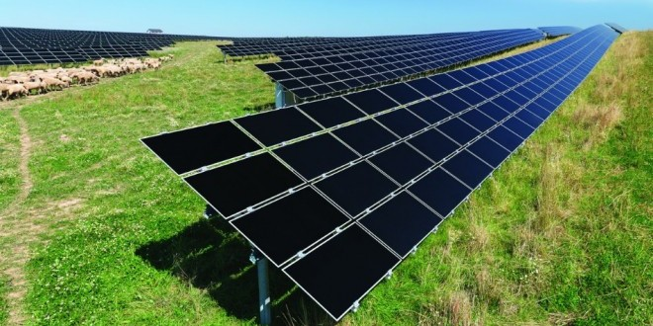

Amorphous silicon solar panels (thin film solar panels) are less efficient, require more space, but are more flexible and can be mounted easily on roofing tiles or shingles. These are the least expensive solar panels available at a price of about $2-$4 per watt average. The cost of solar panels like this would be the lowest, but you'll lose even more efficiency and have to use more of them.

#### **Advantages**

* **Mass-production is simple.** This makes them and potentially cheaper to manufacture than crystalline-based solar cells.
* Their homogenous appearance makes them look more appealing.
* Can be made flexible, which opens up many new potential applications.
* High temperatures and shading have less impact on solar panel performance.
* **In situations where space is not an issue, thin-film solar panels can make sense.**

#### **Disdvantages**

* **Thin-film solar panels are in general not very useful for in most residential situations.**They are cheap, but they also require a lot of space.
* Low space-efficiency also means that the costs of PV-equipment (e.g. support structures and cables) will increase.
* Thin-film solar panels tend to degrade faster than mono- and polycrystalline solar panels, which is why they typically come with a shorter warranty.

**Solar panels based on amorphous silicon, cadmium telluride and copper indium gallium selenide are currently the only thin-film technologies that are commercially available on the market:**

**Other options that don’t do the environment an owchie.**

**Wind Turbines**

**Types:**

Horizontal-axis turbines

Most wind turbines are horizontal-axis turbines - like the ones you see on wind farms. The turbines are mounted on a tower facing the wind. Small scale versions have tail fins to make sure the blades constantly turn towards the wind.

Vertical-axis turbines

Vertical-axis turbines are less common than horizontal-axis turbines, but have the advantage of not needing to face the wind. This is useful where the wind direction varies quickly. Some are small enough to be mounted directly onto a building, others are mounted on a pole in the ground.

Best sites for small wind turbines

In urban areas - even on roof tops - turbines aren’t usually very successful. Winds tend to be turbulent, weak, and erratic because of obstructions such as buildings and trees.

If you live in a rural area that is exposed to strong and consistent wind, and there is no connection to the electricity network, then it may be cost effective for you to install a small scale wind turbine. Households normally usually use micro wind turbines that are smaller than 5 kW. Small communities or groups of houses might use turbines up to 20 kW in size.

Small wind turbines generally cost between $10,000 and $15,000 per kW of rated capacity. So a 2 kW turbine could cost between $20,000 and $30,000, including the cost of installation. A solar electricity system is likely going to be more cost-effective than a small wind turbine.

The average New Zealand household uses about 8 kWh of electricity per person per day. An average family of 4 would need 3 to 13 kW ($30,000 to $195,000) worth of installed wind capacity to provide their own electricity. Even if you make significant energy efficiency improvements, a small wind turbine is unlikely to generate enough electricity to run your house on its own.

Hydro Power

Types of micro-hydro facilities

Small scale hydroelectric facilities are generally classified into three sizes:

micro-hydro - up to 5 kW

mini-hydro - between 5 kW and 20 kW

small commercial hydro - between 20 kW and 10 MW.

Costs vary depending on your location and requirements. Each micro-hydro system is designed to suit the specific features of a property. For a domestic system with a basic layout, expect to pay at least $10,000 to $15,000. Despite the high initial set up cost, running costs are low.

Hydro installations are extremely site specific. Prices vary widely depending on the type and size of system, access to the site, and how much work you are willing to put in yourself.

The basic equipment for a 1kW off-grid battery charging system might cost £5,000 to £6,000 plus installation costs. If you have the technical skills it may be possible to put in a small DIY scheme for under £10,000. In some situations this will be cheaper than paying grid-connection costs.

The total cost of a Pelton turbine producing 5kW on a 25m head site might be around £25,000 if professionally installed, less on a DIY basis. Larger systems can cost tens of thousands of pounds. There is an economy of scale - a 5kW system may only cost 50% more than a 2kW system.