GKE Autopilot: Cluster from Zero
Portfolio Entry — A Reproducible Windows Build on Google Kubernetes Engine
David Grunwald · August 2026 · Project gke-portfolio-2026 · Region us-central1
ONE-LINE LABEL
Stood up a Google Kubernetes Engine (GKE) Autopilot cluster from an empty account: configured project and billing, deployed and scaled an NGINX workload, exposed it to the internet via a cloud load balancer, and tore the environment down cleanly — full command sequence and artifacts in one repo.

What I Accomplished
Provisioned a managed Kubernetes cluster on GKE Autopilot on Windows using the gcloud CLI, from project and billing setup through a live, internet-exposed Deployment and safe teardown. The NGINX workload was scaled to three replicas across multiple Autopilot-provisioned nodes and served publicly through a Google Cloud load balancer, then fully decommissioned in the same session with a verified return to zero running resources.
The build exercises the core declarative Kubernetes model — Deployments, Services, and horizontal scaling — on Google’s fully managed cluster mode, where nodes are provisioned and scaled on demand rather than sized by hand. It also demonstrates cost-aware cloud hygiene: everything ran and was torn down inside a single session, well within free-trial credit.
HONEST SCOPE
This is recent, reproducible portfolio evidence — a first hands-on GKE build, clearly dated — not a claim of production Kubernetes operations. The learning paths at the end are a roadmap, not a résumé line.

Evidence
The workload running at full scale: three replicas Ready across two Autopilot nodes, with the LoadBalancer Service holding a public external IP.
kubectl get service web — the LoadBalancer Service with its assigned external IP, 136.115.147.7.
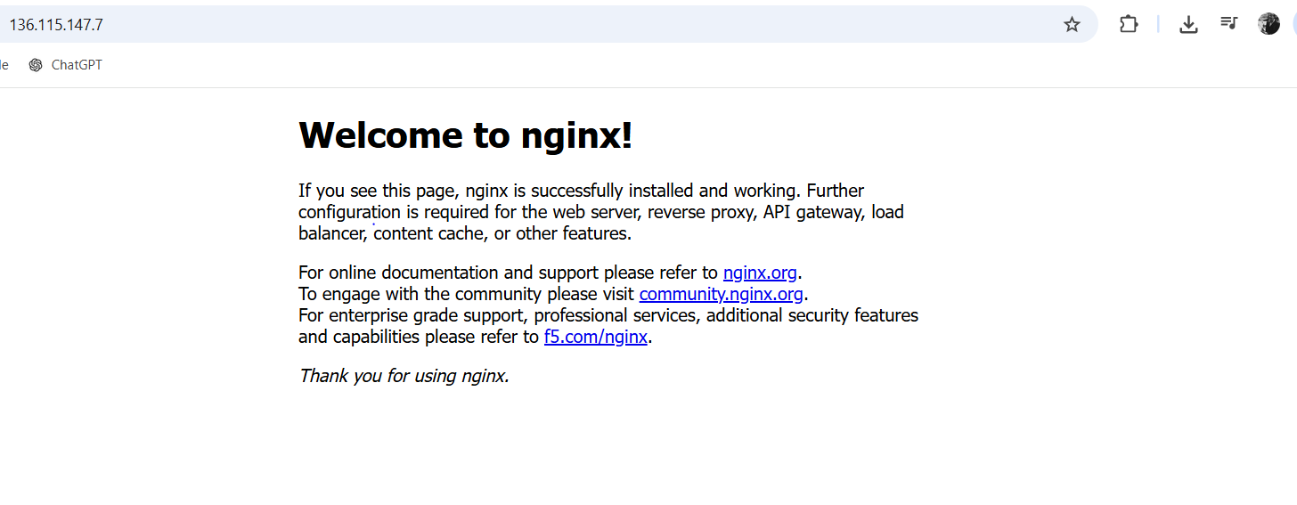
The NGINX welcome page served publicly at http://136.115.147.7 — a live workload reachable from the open internet.

Captured Cluster State (gke-state.txt)
NAME READY UP-TO-DATE AVAILABLE AGE
deployment.apps/web 3/3 3 3 21m

service/web LoadBalancer 34.118.238.181 136.115.147.7 80:30528/TCP

pod/web-5588659d85-2fntg 1/1 Running 0 33s ...pool-2-...-6snd
pod/web-5588659d85-92vbn 1/1 Running 0 21m ...pool-1-...-fwtf
pod/web-5588659d85-g9sjc 1/1 Running 0 33s ...pool-2-...-6snd
Three pods spread across two distinct nodes (pool-1 and pool-2) — Autopilot provisioned the second node to place the scaled replicas.

Command Sequence
The full PowerShell run, create through teardown.
# 1. Create the Autopilot cluster (~5 min)
gcloud container clusters create-auto gke-portfolio-auto --region=us-central1

# 2. Wire up kubectl
gcloud container clusters get-credentials gke-portfolio-auto --region=us-central1
kubectl get nodes

# 3. Deploy NGINX
kubectl create deployment web --image=nginx
kubectl get pods

# 4. Expose to the internet, wait for the external IP
kubectl expose deployment web --port=80 --type=LoadBalancer
kubectl get service web

# 5. Scale and capture evidence
kubectl scale deployment web --replicas=3
kubectl get deployment,service,pods -o wide > gke-state.txt

# 6. Tear down - service first, then cluster
kubectl delete service web
gcloud container clusters delete gke-portfolio-auto --region=us-central1 --quiet

# 7. Verify zero - empty list, 0 forwarding rules
gcloud container clusters list
gcloud compute forwarding-rules list
COST DISCIPLINE
A cluster and its load balancer bill while they exist. The LoadBalancer Service was deleted before the cluster to release the load balancer, then clusters list (empty) and forwarding-rules list (0 items) confirmed no orphaned billing resources remained.

Skills Demonstrated & Where This Leads
Area | Demonstrated now | Next rung
Cluster | Autopilot create / teardown | Standard node pools
Workloads | Deployment + horizontal scaling | Manifests, HPA, probes
Networking | LoadBalancer Service, public IP | Ingress + managed TLS
Delivery | Manual kubectl | Artifact Registry + CI/CD
Accelerators | — (roadmap) | GPU / TPU (separate guide)
Cost | Prompt teardown, verified zero | Budgets + monitoring

Immediate next steps that build directly on this cluster: move from imperative kubectl commands to declarative manifests under version control (GitOps), add an Ingress with a managed certificate for HTTPS, and wire a CI/CD pipeline that builds a custom image, pushes to Artifact Registry, and rolls it out. From there, a Standard-mode cluster introduces node pools and machine types — the on-ramp to GPU and TPU accelerator workloads covered in a separate advanced build guide.

