Neutron Scattering 16-Qubit Tutorial
Simulating Neutron Scattering on KCuF₃
with Quantum Circuits
A working 16-qubit tutorial that runs on a Windows PC, with notes, setup, the full annotated code, a glossary and an explanation of the results.
The whole tutorial in one picture: a pebble in a pond. The chain of spins starts perfectly calm (still water). A neutron nudges one spin in the middle (the pebble). The disturbance spreads through the chain (the ripples). We record how high the “water” is at every spot at every moment, then analyse the ripple pattern into wavelengths and frequencies. The resulting heat map, S(q, ω), is exactly what a real neutron experiment measures, so the quantum simulation can be checked against the lab.
All files are available for download - https://github.com/dgrunwal/Quantum-Neutron-Scattering-on-KCuF-Basic-
Based on Lee et al., Benchmarking quantum simulation with neutron-scattering experiments (arXiv:2603.15608) and IBM's tutorial Simulate neutron scattering in quantum materials with quantum circuits.
Prepared for David, October 6, 2026. Companion files: Quantum_Code.ipynb, Quantum_Code_16q_tutorial.ipynb, requirements.txt, SETUP_16q.md.

Contents
- Quick start: what you need and what you will get
- Notes: the physics and the method, with the questions that cleared them up
- Setup: Python 3.13 virtual environment on Windows
- Adjustments: what changed from IBM's original and why
- The code: every section of the notebook, with plain-language explanations
- Running it: expected output and run time
- Understanding the 16-qubit results: the Green's function and the heat map
- Where to go next
- Troubleshooting
- Glossary
- Appendix: requirements.txt and file list

1. Quick start
You need | A Windows PC with 8 GB+ RAM (16 GB is comfortable), Python 3.13, and about 3 GB of disk for the packages. No IBM account, API key or QPU time.
You run | Quantum_Code_16q_tutorial.ipynb (the annotated version, split into one cell per step) or Quantum_Code.ipynb (your original two-cell version). Both give the same results.
It takes | About 9 to 10 minutes in total here (4-core Linux test machine). Two cells take nearly all of it: Step 2, the AQC compression (about 3.5 minutes here, about 6 minutes on your PC), and Step 3, the statevector simulation (about 4.5 minutes here). Expect a similar or somewhat longer time on a typical PC.
You get | Two pictures: the retarded Green's function (the “movie” of the ripple spreading over 16 qubits and 20 time steps) and the dynamical structure factor S(q, ω) (the neutron-scattering heat map). The tutorial notebook also draws the heat map with the two-spinon edges overlaid.
Size of the run | 16 qubits, 20 Trotter steps of 0.6 (time 0 to 12), AQC compression of the first 3 + 2 steps, ground-state ansatz with 5 layers, MPS bond dimension 32, exact local simulator.
Verified. Both notebooks were run end to end on October 6, 2026 in a fresh Python 3.13.7 virtual environment installed from the included requirements.txt (Linux, 4 cores, 15 GB RAM): your original Quantum_Code.ipynb unchanged (about 10 minutes) and the annotated Quantum_Code_16q_tutorial.ipynb (about 9 minutes). Both finished without errors, and generated images.

2. Notes: the physics and the method
This chapter follows the background sections of IBM's tutorial in order. Each starts with the tutorial excerpt, then a plain-language summary, then the questions asked along the way with the answers that cleared them up.

2.1 Inelastic neutron scattering and the dynamical structure factor
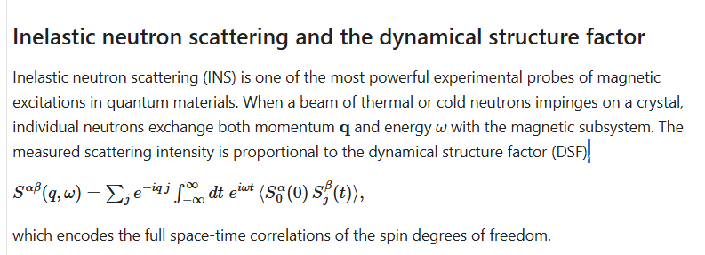
Tutorial excerpt
In plain words. Physicists fire neutrons at a crystal. Each neutron hands the crystal's tiny magnets (spins) a bit of momentum q and energy ω. How many neutrons scatter at each (q, ω) is the dynamical structure factor, S(q, ω). Plotted as a colour map, it is the material's magnetic fingerprint, and it is the thing the quantum computer tries to reproduce.
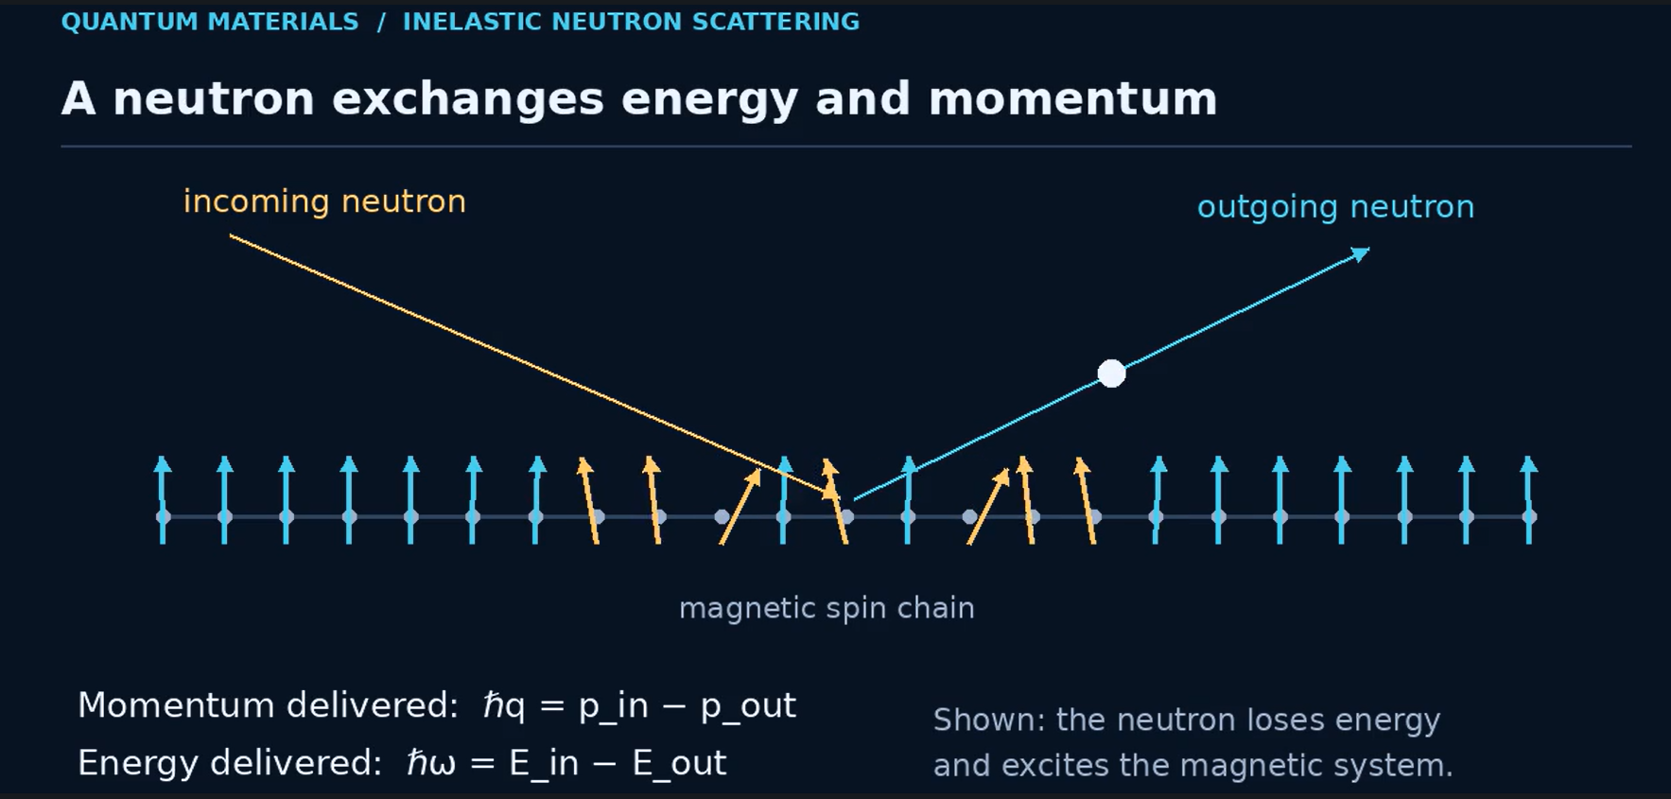
Frame from the companion video 1_Neutron_Scattering_Spin_Correlations.mp4: a neutron hands momentum and energy to the spin chain. Created by D. Grunwald
Q: How exactly does this formula encode the full space-time correlations of the spins?
- The core, ⟨S₀(0) Sⱼ(t)⟩, is a correlation. If I look at the spin at site 0 at time 0, how much does that predict the spin at site j at a later time t? Large means a disturbance at site 0 has travelled to site j by time t. Zero means they are unrelated.
- Varying j and t gives the “space-time” part. Computed for every distance and every delay, it is a complete movie of how a disturbance spreads through the chain. Nothing is averaged away.
- The two sums turn the movie into frequencies. ∫dt e^{iωt} is a Fourier transform in time (“how it changes” becomes “which energies ω”). Σⱼ e^{−iqj} does the same in space (“where” becomes “which momentum q”). Same information, reorganised, like a sound recording versus its spectrum.
- Why the neutron measures exactly this. A neutron can only scatter at a given (q, ω) if the spins have a natural ripple there, so the intensity equals S(q, ω).
- α, β just pick spin directions (x, y or z). The tutorial uses z for both.
In your code: the circuit records ⟨σz⟩ on every site at every time step (the movie), and get_dsf() does the two Fourier sums to make the heat map.
Q: In two sentences, what is happening in the equation?
It measures how a spin at one site and time affects every other spin at every later time, which is a full movie of disturbances rippling through the chain. It then converts that movie into momentum and energy, giving exactly the intensity a neutron would scatter at each (q, ω).

2.2 KCuF₃: a canonical Luttinger-liquid magnet
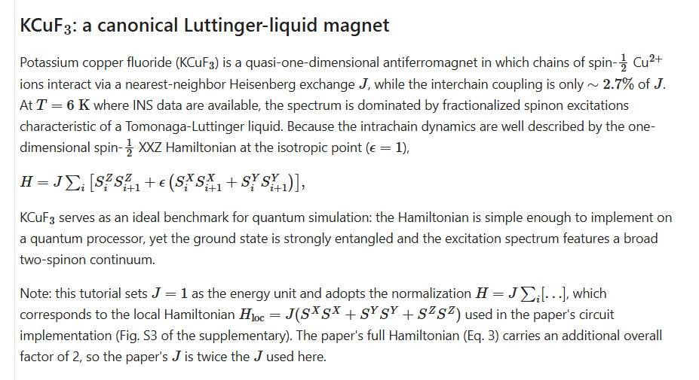
Tutorial excerpt
Q: What is this telling us in simple terms?
The material. KCuF₃ is a crystal in which copper atoms line up in long chains, and each copper atom acts like a tiny magnet. Neighbouring magnets like to point opposite ways (“antiferromagnet”). The chains barely talk to each other, at only about 2.7% strength, so the crystal behaves almost like a set of separate 1D lines. That is why a single row of qubits can model it.
The equation H is the energy rule. For every pair of neighbours i and i+1, it adds a term for how aligned they are in z, x and y. J sets the strength. ε = 1 means all three directions count equally (“isotropic”). This one line is what the quantum circuit simulates.
Why it's a good benchmark. The rule is simple enough to put on a quantum chip, but the resulting state is highly entangled and produces the two-spinon continuum, which is hard to compute classically. Real lab data at 6 K exists for comparison.
The note about J is a units detail. The tutorial sets J = 1 and the paper's J is twice that. Same physics, different axis numbers. “Tomonaga-Luttinger liquid” is just the name for the kind of 1D quantum state in which spin flips break into spinons.

2.3 What we simulate and measure
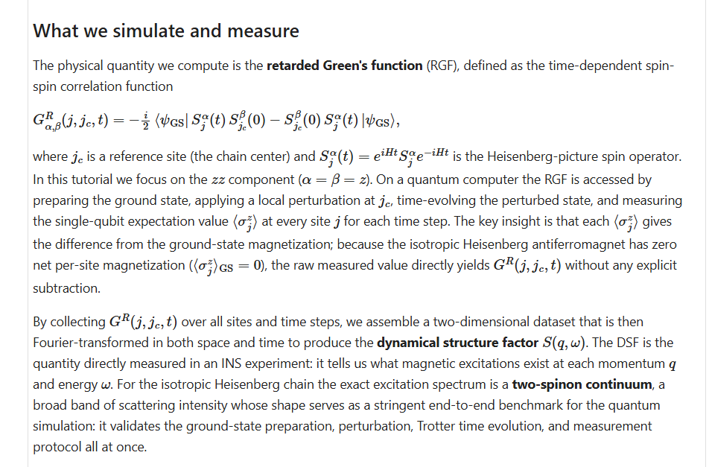
Tutorial excerpt
Q: In simple terms, what is being done here? Give a common comparison.
A pebble in a still pond.
- Still pond = ground state. The chain starts in its calmest state. On average every spin points nowhere, so ⟨σz⟩ = 0, like a flat pond with zero ripple height.
- Drop a pebble in the centre = the kick. One spin at site j_{c} gets a small nudge. In the lab, the neutron does this.
- Let the ripples spread = time evolution (the Trotter steps).
- Measure water height everywhere, every moment = measure ⟨σz⟩ on every qubit at each step. That grid is G^{R}(j, j_{c}, t), the retarded Green's function. Because the pond started flat, any height you see is purely the ripple, so no subtraction is needed. That is the “key insight” in the text.
- Analyse the ripple pattern = the Fourier transform, giving S(q, ω).
Why it's a strong test: in a real pond one pebble gives a clean ring. In this magnet the ripple splits into two spinons that move apart, so the pattern smears into a broad band. If any stage is wrong, the band comes out wrong. “Retarded” just means it only looks forward in time from the kick.
Q: What exactly is the two-spinon continuum?
A spin flip in KCuF₃ doesn't travel as one particle. It breaks into two spinons, each carrying half of it, that move apart independently. The neutron gives a fixed q and ω, and the two spinons can split that momentum between them in many ways, each with a slightly different total energy. One particle gives one energy per q, a sharp line. Two particles give a whole range of energies per q, a filled band. Its edges are the dashed curves on the tutorial's plots:
- Bottom edge (π/2)|sin q|: one spinon takes nearly everything.
- Top edge π|sin(q/2)|: the two share the momentum equally.
Intensity is brightest near q = π and along the lower edge.
Q: What does “if the simulation fills the region between the two curves, it has reproduced the hallmark” mean?
The final heat map (q across, ω up) is the pass/fail check. Real neutron data on KCuF₃ shows a glowing band filling the space between the dashed curves; that band is the “hallmark” that spinons exist. A bright band between the curves means the simulation captured the real physics. A thin line, or brightness outside the curves, means something went wrong, such as too much hardware noise, a chain that's too short, or too few time steps.
Q: So we compare lab vs quantum measurement?
Yes, with one clarification: the quantum side is a simulation of the model, not a measurement of the crystal. The lab fires neutrons at a real crystal and gets the measured heat map; the qubits stand in for the spins and give a predicted heat map. If they match, the quantum computer correctly predicted real physics, and the paper uses this as a benchmark. In this tutorial you only make the quantum plot, and the dashed curves stand in for the lab result.

2.4 Quantum-simulation workflow
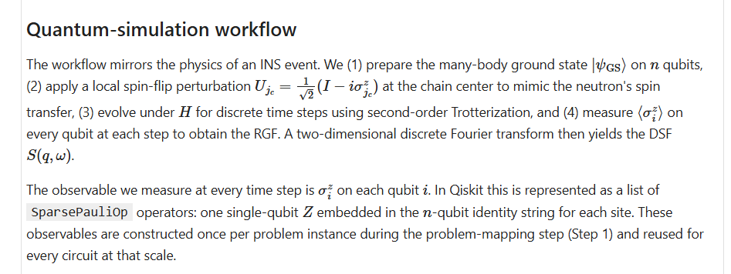
Tutorial excerpt
Q: Provide a simple explanation for a beginner.
- Prepare the ground state: set the qubits into the chain's calmest arrangement. Pond: still water.
- Apply the kick U at the centre: (I − iσz)/√2 is a quarter-turn twist of the middle qubit around z. In code it's one gate, rz(π/2). Pond: drop the pebble.
- Evolve with Trotter steps: real physics flows continuously, but a computer moves in small time jumps, like film frames. “Second-order” is a more accurate way of slicing each frame. Pond: let the ripples spread.
- Measure ⟨σz⟩ on every qubit at every step: whether each spin leans up or down on average, giving a site × time grid (the RGF). Pond: water height everywhere, every frame.
- 2D Fourier transform: turn the grid into S(q, ω).
The second paragraph is about the code. To tell Qiskit “measure qubit i in z”, you build a label like IIZII (Z at position i, I meaning “ignore” elsewhere), one per qubit, packed as SparsePauliOp. You build the list once and reuse it at every time step, like setting up your sensors once before filming.

2.5 Approximate quantum compiling (AQC) and MPS simulation
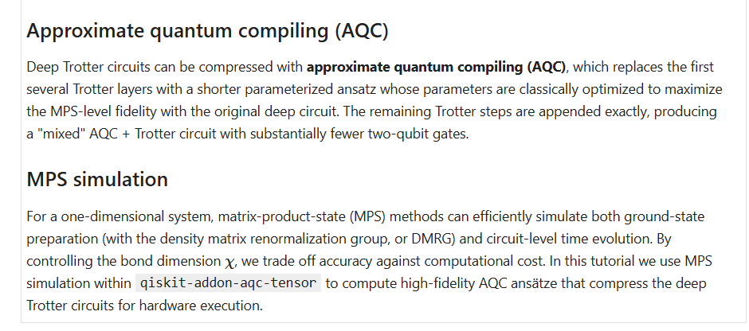
Tutorial excerpt
In plain words. Every Trotter step adds gates, and every gate on today's chips adds noise. After many steps the answer turns to static. AQC uses an ordinary computer to design a much shorter circuit that lands in almost the same place, and MPS is the trick that lets the ordinary computer simulate a 1D chain cheaply enough to do that design work.
Q: Explain these concepts in simplest terms.
AQC is a shortcut route. Imagine directions with 200 turns to reach a town. A computer studies the route and finds a 20-turn road that ends up almost exactly at the same spot. The ansatz is that short road: a small circuit with adjustable knobs (parameters). A normal computer turns the knobs until the short circuit's output matches the long one as closely as possible; that match is the fidelity. Only the first part of the route is compressed; the last steps are added unchanged (“mixed AQC + Trotter”). The result is far fewer two-qubit gates, the error-prone ones.
MPS is how the normal computer checks the shortcut. A full description of 50 qubits needs more numbers than any computer can store. In a 1D chain each spin mostly talks to its neighbours, so a matrix product state stores the chain as a row of small linked blocks, like a bead necklace. Bond dimension χ is how much information each link can carry: bigger is more accurate but slower (32 for small runs, 128 for IBM's large one). DMRG is the MPS method for finding the calm ground state, the still pond.
Q: Is this like a quantized version of the route?
Close, but “compressed” fits better. Trotter is the chopped-up part: smooth time is cut into fixed steps, like turning a curve into a staircase. AQC is the shortcut part: it takes that long staircase and finds a shorter road to nearly the same place, like zipping a file.
Q: How is “compression” done exactly?
- Make the target. Simulate the long circuit (here the first 1 to 5 Trotter steps) with MPS to get the state it produces. That's the answer key.
- Build a short template (the ansatz). Copy the gate layout of just 1 or 2 Trotter steps, with every rotation angle a free knob.
- Score it. Simulate the short circuit with MPS and measure how closely it matches the target (1.0 is perfect).
- Turn the knobs. An optimizer (L-BFGS-B) uses gradients to nudge all the angles and re-score, up to 100 times.
- Lock it in. The best angles become fixed; the short circuit replaces the long steps and the remaining Trotter steps follow it.
Q: Is this done to save space or time?
Mainly neither: it's done to reduce errors on real hardware. A shorter circuit finishes before noise takes over. It costs extra classical time. (On the noise-free local simulator used here, the compression is kept so the tutorial teaches the full method; it is not needed for accuracy.)
Q: What exactly does the compression? Is it a computational operation?
Yes, purely computational, on an ordinary computer. The library is qiskit-addon-aqc-tensor: quimb runs the MPS simulations, and JAX with SciPy's L-BFGS-B computes gradients and tunes the angles. In this notebook it all runs on your PC.
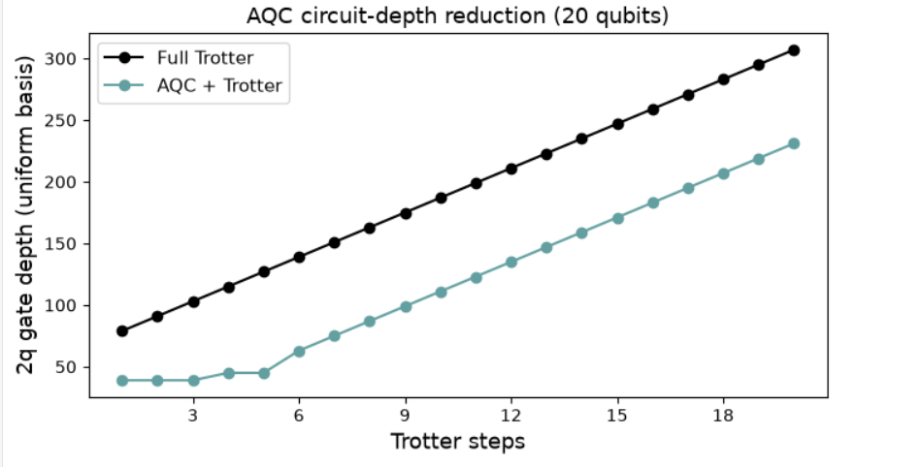
From the earlier 20-qubit attempt: AQC cut the 2q gate depth at step 20 from 307 to 231.

2.6 Running it: the two IBM notebooks
IBM offers two versions of this experiment: the step-by-step notebook (compression on your own computer, a 10-qubit simulator part and a 50-qubit hardware part) and the Serverless notebook (compression on IBM's cloud as one function call, 30-qubit hardware part, needs an account even for the simulator). Both do the same science with different packaging. This tutorial is a pared-down step-by-step notebook: the large-scale recipe, shrunk to 16 qubits and finished on a local simulator.

2.7 The whole story in six lines
The lab | Neutrons hit KCuF₃ and the scattering map S(q, ω) shows a broad two-spinon band.
The model | A 1D chain of spins with the Heisenberg rule H; one qubit per spin.
The experiment on qubits | Calm state, kick the middle, let it evolve, measure ⟨σz⟩ everywhere at every step.
The math | A 2D Fourier transform turns the site × time grid into S(q, ω).
The trick | AQC, designed with MPS on a classical computer, shortens the circuit so noise doesn't win.
The test | A bright band between the dashed curves means the simulation reproduced the real material.

3. Setup: Python 3.13 virtual environment on Windows
These steps match how the notebook was run on your PC (folder C:\python3_13\quantum_test). Use any folder you like. Put requirements.txt and the notebook(s) in it, then open PowerShell in that folder.

3.1 Check for Python 3.13
py -3.13 --version
python --version
If py is “not recognized”, the Python launcher isn't installed. Either call Python 3.13 by its full path, for example & "$env:LOCALAPPDATA\Programs\Python\Python313\python.exe", or install Python 3.13 (which adds py):
winget install Python.Python.3.13
or use the installer from python.org and tick “Add python.exe to PATH”. Close and reopen PowerShell afterwards. Ignore a python that opens the Microsoft Store; that is only a stub.

3.2 Create and activate the virtual environment
cd C:\python3_13\quantum_test
py -3.13 -m venv .venv
.venv\Scripts\Activate.ps1
If activation is blocked (“running scripts is disabled on this system”), allow local scripts once for your user, then activate again:
Set-ExecutionPolicy -Scope CurrentUser -ExecutionPolicy RemoteSigned
.venv\Scripts\Activate.ps1
Your prompt should now start with (.venv), and python --version should print 3.13.x.

3.3 Install the packages
python -m pip install --upgrade pip
python -m pip install -r requirements.txt
This takes a few minutes (JAX, quimb and Jupyter are large). The file pins qiskit-addon-aqc-tensor[quimb-jax]==0.3.1 (the version IBM's tutorial uses), scipy>=1.14 (needed for the COBYQA optimizer) and qiskit-ibm-catalog>=0.20 (older versions crash on import). The IBM packages are only needed if you later move to real hardware; the full file is in the Appendix.

3.4 Check the install
python -c "import qiskit, quimb, jax, qiskit_addon_aqc_tensor, qiskit_quimb; print('OK, qiskit', qiskit.__version__)"

3.5 Register the kernel and open the notebook
python -m ipykernel install --user --name neutron-313 --display-name "Python 3.13 (neutron)"
jupyter lab
Open Quantum_Code_16q_tutorial.ipynb and pick the kernel Python 3.13 (neutron) (Kernel menu → Change Kernel). In VS Code, click the kernel name at the top right of the notebook, choose “Select Kernel” → “Python Environments”, and pick the one under .venv. Your notebook's metadata already names this kernel, so it is usually picked automatically.

3.6 Before you run
- Close memory-hungry programs (browsers with many tabs, games). The AQC step uses the most memory.
- Run the cells top to bottom, once. Don't re-run Steps 2 and 3 unless you have to; they are the slow ones. Step 3 shows no progress while it runs, which is normal.
- The first AQC step prints JAX/XLA compile warnings and pauses; that is expected.

4. Adjustments: what changed from IBM's original and why
Your notebook is IBM's large-scale recipe (the same nine steps as the 10-qubit practice run), reduced until it ran reliably on a PC, with IBM's hardware step swapped for a local simulator. Here is every change, and the problem it solved.
Setting | IBM large-scale | This tutorial | Why
n_qubits | 50 | 16 | 50 qubits ran out of memory (MemoryError) during AQC. 20 qubits compressed fine but the kernel crashed afterwards. 16 runs reliably on a PC and is still longer than the 10-qubit practice run.
aqc_n_steps_1 / _2 | 6 + 4 | 3 + 2 | Fewer compressed steps means smaller targets and less optimizer memory. The rest of the 20 steps are plain Trotter steps.
mps_max_bond (χ) | 128 | 32 | The biggest memory saver. 32 is what IBM uses for the 10-qubit run; it is plenty for 16 qubits.
n_steps, time_step | 20, 0.6 | 20, 0.6 (unchanged) | Gives time 0 to 12, twice the practice run, so the ripple has time to travel.
gs_n_layers | 5 | 5 (unchanged) | Ground-state ansatz depth; the fidelity at 16 qubits is about 0.93.
Step 3 (execution) | QiskitRuntimeService, Heron backend, transpile, EstimatorV2 with dynamical decoupling, twirling and TREX | StatevectorEstimator() on your PC | The hardware step stopped with AccountNotFoundError (no IBM account saved), and the free plan's ~10 QPU minutes/month would not cover the run. A 16-qubit statevector is exact, free and fast. No transpiling or error mitigation is needed, because there is no hardware noise.
Cell layout | Many cells | Your version: two cells (helpers + everything). Tutorial version: one cell per step. | After the kernel crash, putting everything in one pass guaranteed nothing depended on lost variables. The tutorial version splits it again so you can see each step's output and re-run Step 3/4 without redoing the slow AQC.

Small additions in the tutorial notebook only
- plot_dsf(..., show_bounds=True) draws the two-spinon edges (π/2)|sin q| and π|sin(q/2)| on the heat map, so you can judge the result against the “answer key”. IBM's small-scale plot has these as dashed curves.
- save_as= on both plot functions saves PNGs next to the notebook (rgf_16q.png, dsf_16q.png, dsf_16q_bounds.png).
- Step 2 prints the 2q gate depth with and without AQC at step 20; Step 3 prints how long the simulation took.
- The two unused qiskit_ibm_runtime imports were removed (they are only needed for real hardware). The parameter comment now says “16-qubit local run”.
Nothing in the physics or the maths was changed: the helper functions, the ground-state preparation, the kick, the Trotter circuits, the AQC settings and get_dsf are identical to your notebook.
If the kernel crashes or shows “unknown”. This means Python itself stopped, almost always from running low on memory after the AQC step, and every variable is lost.
- Reconnect: in Jupyter use Kernel → Restart Kernel; in VS Code use Select Kernel → Python Environments → the .venv one.
- Re-run from the top. Close other programs first.
- If it crashes again, lower n_qubits to 12 (keep it even) or set aqc_n_steps_2 = 0.
- To try 20 qubits again later, change only n_qubits = 20. A 20-qubit statevector needs about 16 MB per state, so the simulator is fine; the pressure is in AQC.

5. The code, section by section
The notebook is like a cooking recipe: it gathers the tools, preps the ingredients, cooks, then plates the dish. The code below is from Quantum_Code_16q_tutorial.ipynb. It is your notebook's code with the small additions listed in chapter 4.

5.1 Setup: imports and helper functions (laying out the kitchen tools)
This first cell loads the libraries and defines reusable functions. Nothing is computed yet. What each piece is for:
Function | What it does, in plain words
xxz_hamiltonian_mpo | Writes the rules of the game: the energy rule H for the chain, in the bead-necklace (MPO) format that DMRG needs. Each neighbour pair gets a ZZ term and a “flip-flop” (+−, −+) term.
build_ground_state_ansatz | Builds the adjustable circuit (HVA) that will become the still pond: pairs of qubits start as singlets (each pair pointing opposite ways), then layers of pair gates with tunable angles θ mix them.
optimize_ground_state_ansatz | Turns the θ knobs (COBYQA optimizer) until the circuit's state matches the DMRG ground state as closely as possible. Returns the best angles; 1 − result is the fidelity.
trotter_evolution | Writes one “film” of n time steps: second-order Trotter, a half layer on even pairs, alternating full layers, and a closing half layer.
get_dsf | The Fourier transform: turns the time × qubit table into the S(q, ω) heat map (“split the song into notes”). It uses the centre site as the reference, symmetrises around q = π and clips negative values to 0.
plot_dsf, plot_rgf | Draw the two pictures.
uniform_2q_depth | Counts how many layers of two-qubit gates a circuit needs, to compare circuit lengths fairly.
import timeit
import warnings
from collections.abc import Iterator, Sequence
from functools import partial
import matplotlib.pyplot as plt
import numpy as np
import quimb.tensor as qtn
import scipy.optimize
from numpy.typing import NDArray
from qiskit import QuantumCircuit
from qiskit.circuit import CircuitInstruction, ParameterVector, Qubit
from qiskit.circuit.library import PauliEvolutionGate
from qiskit.primitives import StatevectorEstimator
from qiskit.quantum_info import SparsePauliOp
from qiskit.transpiler.preset_passmanagers import generate_preset_pass_manager
from qiskit_addon_aqc_tensor import generate_ansatz_from_circuit
from qiskit_addon_aqc_tensor.objective import MaximizeStateFidelity
from qiskit_addon_aqc_tensor.simulation import tensornetwork_from_circuit
from qiskit_addon_aqc_tensor.simulation.quimb import QuimbSimulator
from qiskit_quimb import quimb_circuit
from scipy.sparse import SparseEfficiencyWarning
# scipy.sparse.linalg.expm (reached via PauliEvolutionGate.to_matrix) prefers
# CSC and warns when handed the CSR matrix from SparsePauliOp.to_matrix; the
# result is unaffected, so silence the cosmetic warning.
warnings.filterwarnings("ignore", category=SparseEfficiencyWarning)
def xxz_hamiltonian_mpo(
n_qubits: int, interaction: float = 1.0, anisotropy: float = 1.0
) -> qtn.MatrixProductOperator:
"""1D XXZ Hamiltonian as a quimb MPO.
Builds the Hamiltonian using ``qtn.SpinHam1D``.
Args:
n_qubits: Number of sites.
interaction: Overall interaction strength (J in the paper).
anisotropy: XY/Z anisotropy (ε in the paper). ``ε = 1`` is the
isotropic Heisenberg point; ``ε = 0`` is the Ising limit.
Returns:
The Hamiltonian as a matrix product operator.
"""
builder = qtn.SpinHam1D(S=1 / 2)
builder += interaction * anisotropy * 0.5, "+", "-"
builder += interaction * anisotropy * 0.5, "-", "+"
builder += interaction, "Z", "Z"
return builder.build_mpo(L=n_qubits)
def build_ground_state_ansatz(n_qubits: int, n_layers: int) -> QuantumCircuit:
"""Hamiltonian variational ansatz (HVA) circuit for ground-state preparation.
Starts from a product of singlet pairs and applies alternating
odd/even layers of parameterized XXZ pair-evolution gates.
The returned circuit is parameterized: it carries a ``ParameterVector``
named ``"theta"`` of length ``2 * n_layers`` whose values must be
assigned (e.g. via ``circuit.assign_parameters``) before simulation.
Element ``2 * r`` is the odd-layer angle and element ``2 * r + 1`` is the
even-layer angle of layer ``r``.
Args:
n_qubits: Number of qubits (must be even).
n_layers: Number of HVA layers.
Returns:
The parameterized HVA preparation circuit.
"""
theta = ParameterVector("theta", 2 * n_layers)
circuit = QuantumCircuit(n_qubits)
# Initial singlet product state
for i in range(n_qubits // 2):
circuit.x(2 * i)
circuit.x(2 * i + 1)
circuit.h(2 * i + 1)
circuit.cx(2 * i + 1, 2 * i)
# Variational layers: each pair gate is exp(-i theta (XX+YY+ZZ)/2)
pair_ham = SparsePauliOp(
["XX", "YY", "ZZ"], coeffs=[0.5, 0.5, 0.5]
) # H_pair (HVA form)
for r in range(n_layers):
for i in range(1, (n_qubits + 1) // 2): # odd layer
circuit.append(
PauliEvolutionGate(pair_ham, time=theta[2 * r]),
[2 * i - 1, 2 * i],
)
for i in range(n_qubits // 2): # even layer
circuit.append(
PauliEvolutionGate(pair_ham, time=theta[2 * r + 1]),
[2 * i, 2 * i + 1],
)
return circuit
def optimize_ground_state_ansatz(
ansatz: QuantumCircuit,
x0: NDArray[np.floating],
target_mps: qtn.MatrixProductState,
*,
max_bond: int | None = None,
cutoff: float = 1e-10,
method: str = "COBYQA",
options: dict | None = None,
) -> scipy.optimize.OptimizeResult:
"""Optimize HVA parameters by maximizing fidelity with a target MPS.
The HVA circuit is simulated as a matrix product state with the given
bond-dimension truncation, and the parameters are optimized to maximize
the state fidelity ``|<psi_HVA | target_mps>|**2`` with the DMRG ground
state. Both states are normalized, so the minimized objective is the
infidelity ``1 - |<psi_HVA | target_mps>|**2``.
Args:
ansatz: Parameterized HVA circuit from ``build_ground_state_ansatz``.
The length of ``x0`` must equal ``ansatz.num_parameters``.
x0: Initial parameters.
target_mps: Target MPS (DMRG ground state) to maximize fidelity with.
max_bond: Maximum MPS bond dimension during gate application.
cutoff: Singular-value cutoff during gate application.
method: ``scipy.optimize.minimize`` method.
options: Options dict forwarded to ``scipy.optimize.minimize``.
Returns:
The Scipy OptimizeResult.
"""
def infidelity(params: NDArray[np.floating]) -> float:
circuit = ansatz.assign_parameters(params)
circuit_mps = quimb_circuit(
circuit.decompose(["PauliEvolution"]),
quimb_circuit_class=qtn.CircuitMPS,
max_bond=max_bond,
cutoff=cutoff,
)
return 1 - abs(circuit_mps.psi.H @ target_mps) ** 2
return scipy.optimize.minimize(
infidelity, np.asarray(x0), method=method, options=options
)
def trotter_evolution(
qubits: Sequence[Qubit],
interaction: float,
anisotropy: float,
time_step: float,
n_steps: int,
) -> Iterator[CircuitInstruction]:
"""Second-order Trotter steps of the XXZ pair Hamiltonian.
While the paper used a hand-optimized circuit for the Trotter steps, we use
PauliEvolutionGate here for simplicity and generality. The final two-qubit gate
count and gate depth are equivalent when transpiled with ``optimization_level=3``.
Args:
qubits: Qubits to act on (length ``n_qubits``).
interaction: Overall interaction strength (J in the paper).
anisotropy: XY/Z anisotropy (ε in the paper). ``ε = 1`` is the
isotropic Heisenberg point; ``ε = 0`` is the Ising limit.
time_step: Per-step Trotter time.
n_steps: Number of Trotter steps.
Yields:
``CircuitInstruction``s implementing the Trotter steps.
"""
if n_steps == 0:
return
n_qubits = len(qubits)
pair_ham = SparsePauliOp(
["XX", "YY", "ZZ"],
coeffs=[
0.25 * interaction * anisotropy,
0.25 * interaction * anisotropy,
0.25 * interaction,
],
)
half_evo = PauliEvolutionGate(pair_ham, time=time_step / 2)
full_evo = PauliEvolutionGate(pair_ham, time=time_step)
for i in range(n_qubits // 2): # half even layer
yield CircuitInstruction(half_evo, (qubits[2 * i], qubits[2 * i + 1]))
for i in range(n_qubits // 2 - 1): # full odd layer
yield CircuitInstruction(
full_evo, (qubits[2 * i + 1], qubits[2 * i + 2])
)
for _ in range(n_steps - 1): # interior steps
for i in range(n_qubits // 2):
yield CircuitInstruction(
full_evo, (qubits[2 * i], qubits[2 * i + 1])
)
for i in range(n_qubits // 2 - 1):
yield CircuitInstruction(
full_evo, (qubits[2 * i + 1], qubits[2 * i + 2])
)
for i in range(n_qubits // 2): # half even layer
yield CircuitInstruction(half_evo, (qubits[2 * i], qubits[2 * i + 1]))
def get_dsf(
n_qubits: int,
rgf_mat: NDArray[np.floating],
time_step: float,
n_steps: int,
n_points_momentum: int,
n_points_frequency: int,
) -> NDArray[np.floating]:
"""Compute the dynamical structure factor from the retarded Green's function.
Uses the center-site approximation and a discrete Fourier transform.
The result is symmetrized about the momentum axis and clipped to
non-negative values, ready for plotting.
Args:
n_qubits: Number of qubits (sites).
rgf_mat: RGF matrix of shape ``(n_steps, n_qubits)``.
time_step: Trotter time-step size.
n_steps: Number of time steps.
n_points_momentum: Number of momentum points.
n_points_frequency: Number of frequency points.
Returns:
DSF array of shape ``(n_points_frequency, n_points_momentum)``,
symmetrized about the momentum axis and clipped to non-negative values.
"""
max_frequency = np.pi / time_step
momentum_range = np.linspace(0, 2 * np.pi, n_points_momentum)
frequency_range = np.linspace(0, max_frequency, n_points_frequency)
result = np.zeros((frequency_range.shape[0], momentum_range.shape[0]))
center = n_qubits // 2 - 1
for iw, w in enumerate(frequency_range):
exponent = np.exp(1j * w * time_step * np.arange(1, n_steps + 1))
# S = sigma/2, so two spin operators contribute a factor of (1/2)(1/2) = 1/4.
rgf_omega = (
np.dot(rgf_mat.T, exponent) * time_step / 4
) # S(omega): time Fourier slice of the Green's function
for iq, q in enumerate(momentum_range):
momentum_phases = np.exp(
-1j * q * np.arange(-center, center + 2, 1)
)
result[iw, iq] = np.imag(np.dot(rgf_omega, momentum_phases))
result = -(result + result[:, ::-1]) / 2
result = np.clip(result, a_min=0, a_max=None)
return result
def plot_dsf(
dsf: NDArray[np.floating],
time_step: float,
n_points_momentum: int,
n_points_frequency: int,
title: str | None = None,
show_bounds: bool = False,
save_as: str | None = None,
) -> None:
"""Heat-map of the dynamical structure factor.
Args:
dsf: DSF array of shape ``(n_points_frequency, n_points_momentum)``.
time_step: Trotter time-step size.
n_points_momentum: Number of momentum points.
n_points_frequency: Number of frequency points.
title: Optional plot title.
show_bounds: Draw the two-spinon continuum edges (dashed), the
lower edge (pi/2)|sin q| and the upper edge pi|sin(q/2)|.
save_as: Optional PNG filename to save the figure to.
"""
max_frequency = np.pi / time_step
momentum_range = np.linspace(0, 2 * np.pi, n_points_momentum)
frequency_range = np.linspace(0, max_frequency, n_points_frequency)
x, y = np.meshgrid(momentum_range, frequency_range)
fig, ax = plt.subplots(figsize=(8, 5))
c = ax.pcolormesh(x, y, dsf / np.max(dsf), cmap="viridis", shading="auto")
fig.colorbar(c, ax=ax, label="Normalized intensity")
ax.set_ylim(0, 3.6)
ax.set_xlim(0, 2 * np.pi)
ax.set_xlabel(r"$q$", fontsize=16)
ax.set_ylabel(r"$\tilde{\omega} = \omega / J$", fontsize=16)
ax.set_xticks([0, np.pi / 2, np.pi, 3 * np.pi / 2, 2 * np.pi])
ax.set_xticklabels(["0", r"$\pi/2$", r"$\pi$", r"$3\pi/2$", r"$2\pi$"])
if show_bounds:
q = np.linspace(0, 2 * np.pi, 400)
ax.plot(q, np.pi / 2 * np.abs(np.sin(q)), "w--", lw=1.5, label="lower edge")
ax.plot(q, np.pi * np.abs(np.sin(q / 2)), "w:", lw=1.5, label="upper edge")
ax.legend(loc="upper right", fontsize=9)
if title:
ax.set_title(title, fontsize=14)
plt.tight_layout()
if save_as:
fig.savefig(save_as, dpi=150)
plt.show()
def plot_rgf(
n_qubits: int,
rgf_mat: NDArray[np.floating],
time_step: float,
n_steps: int,
title: str | None = None,
save_as: str | None = None,
) -> None:
"""Heat-map of the retarded Green's function in real space and time.
Args:
n_qubits: Number of qubits (sites).
rgf_mat: RGF matrix of shape ``(n_steps, n_qubits)``.
time_step: Trotter time-step size.
n_steps: Number of time steps.
title: Optional plot title.
save_as: Optional PNG filename to save the figure to.
"""
fig, ax = plt.subplots(figsize=(8, 6))
qubit_axis = np.arange(n_qubits)
t_axis = np.arange(1, n_steps + 1) * time_step
x, y = np.meshgrid(qubit_axis, t_axis)
c = ax.pcolormesh(
x,
y,
np.real(rgf_mat),
cmap="RdBu",
vmax=0.5,
vmin=-0.5,
shading="auto",
)
fig.colorbar(c, ax=ax, label=r"Re $G^R(j, j_c, t)$")
ax.set_xlabel("Qubit", fontsize=16)
ax.xaxis.set_major_locator(
plt.matplotlib.ticker.MaxNLocator(integer=True)
)
ax.set_ylabel(r"Time", fontsize=16)
if title:
ax.set_title(title, fontsize=14)
plt.tight_layout()
if save_as:
fig.savefig(save_as, dpi=150)
plt.show()
def uniform_2q_depth(circuit: QuantumCircuit) -> int:
"""Two-qubit gate depth in a standardized basis."""
pass_manager = generate_preset_pass_manager(
optimization_level=0, basis_gates=["cz", "id", "rz", "sx", "x"]
)
return pass_manager.run(circuit).depth(
lambda inst: inst.operation.num_qubits == 2
)

5.2 Parameters (the recipe card)
n_qubits is the chain length (one qubit per copper spin). interaction = J and anisotropy = ε = 1 make it the isotropic Heisenberg chain of KCuF₃. time_step × n_steps = 0.6 × 20 = 12 is how long the film runs. aqc_n_steps_1/2 say how many early steps are squeezed into the 1-layer and 2-layer shortcuts. mps_max_bond and mps_cutoff control the bead-necklace accuracy. center = 7 is the qubit that gets kicked (for an even chain there is no exact middle, so it is the left of the two centre qubits).
# ── Parameters (16-qubit local run) ─────────────────────────────────────────
n_qubits = 16
interaction = 1.0
anisotropy = 1.0
time_step = 0.6
n_steps = 20
aqc_n_steps_1 = 3
aqc_n_steps_2 = 2
aqc_n_steps_total = aqc_n_steps_1 + aqc_n_steps_2
gs_n_layers = 5
mps_max_bond = 32
mps_cutoff = 1e-8
center = n_qubits // 2 - 1

5.3 Step 1a: the ground state (smoothing the pond)
DMRG finds the calmest arrangement on the ordinary computer and prints its energy. Then the HVA circuit's 10 knobs (2 per layer × 5 layers) start near (0, π/2) with a little random jitter (fixed seed 12345 so runs are repeatable) and are tuned so the qubit circuit recreates that state. It's like copying a photo of still water onto your own pond; the printed fidelity is how good the copy is. About 0.93 at 16 qubits means the copy is good but not perfect, which is why the plots are not textbook-clean.
# ── Step 1: ground state, kick, Trotter circuits, sensors ────────────────────
ham_mpo = xxz_hamiltonian_mpo(n_qubits, interaction, anisotropy)
dmrg = qtn.DMRG2(ham_mpo)
dmrg.solve(tol=1e-8)
print(f"Ground-state energy (DMRG): {dmrg.energy:.6f}")
gs_ansatz = build_ground_state_ansatz(n_qubits, gs_n_layers)
rng = np.random.default_rng(12345)
x0 = np.tile([0.0, np.pi / 2], gs_n_layers) + rng.normal(scale=0.1, size=2 * gs_n_layers)
print("Optimizing ground state ansatz...")
result = optimize_ground_state_ansatz(
gs_ansatz, x0, dmrg.state,
max_bond=mps_max_bond, cutoff=mps_cutoff, options=dict(maxiter=100),
)
print(f"Ground state ansatz fidelity: {1 - result.fun:.6f}")
gs_circuit = gs_ansatz.assign_parameters(result.x)

5.4 Step 1b: kick, Trotter circuits and sensors (dropping the pebble, writing the film)
perturbed.rz(np.pi / 2, center) is the pebble: one quarter-turn of qubit 7. The loop then builds 20 circuits, one per time step, each a copy of the kicked state followed by t Trotter steps, so each is longer than the last. Finally 16 “sensors” are built, one Z per qubit (labels like IIIIIIIZIIIIIIII), once, to be reused at every step.
perturbed = gs_circuit.copy()
perturbed.rz(np.pi / 2, center)
circuits = []
for t in range(1, n_steps + 1):
circuit = perturbed.copy()
for instr in trotter_evolution(circuit.qubits, interaction, anisotropy, time_step, t):
circuit.append(instr)
circuits.append(circuit)
observables = [
SparsePauliOp.from_sparse_list([("Z", [i], 1)], num_qubits=n_qubits)
for i in range(n_qubits)
]

5.5 Step 2: AQC compression (asking a GPS for a shorter route)
What happens, in order:
- Targets: the circuits for steps 1–5 are simulated as MPS (the answer keys).
- Templates: generate_ansatz_from_circuit copies the gate layout of the 1-step circuit (template 1) and the 2-step circuit (template 2), with every angle a free knob.
- Tuning: for k = 1…3 template 1 is fitted to target k; for k = 4, 5 template 2 is used. Each fit starts from the previous step's answer when it can (same_stage), which is much faster than starting cold. L-BFGS-B with JAX gradients maximises the fidelity, up to 100 iterations. The printed fidelity and time are shown for each k.
- Assembly: the 5 compressed circuits are used for steps 1–5, and steps 6–20 are built as “compressed step 5 + k ordinary Trotter steps”. That makes the full set of 20 circuits.
# ── Step 2: AQC compression ──────────────────────────────────────────────────
target_circuits = {k: circuits[k - 1] for k in range(1, aqc_n_steps_total + 1)}
aqc_sim = QuimbSimulator(
quimb_circuit_factory=partial(
qtn.CircuitMPS, gate_opts=dict(max_bond=mps_max_bond, cutoff=mps_cutoff)
),
autodiff_backend="jax",
)
target_mps = {
k: tensornetwork_from_circuit(target_circuits[k].decompose(["PauliEvolution"]), aqc_sim)
for k in range(1, aqc_n_steps_total + 1)
}
ansatz_1, initial_params_1 = generate_ansatz_from_circuit(
target_circuits[1].decompose(["PauliEvolution"]), qubits_initially_zero=True
)
ansatz_2, initial_params_2 = generate_ansatz_from_circuit(
target_circuits[2].decompose(["PauliEvolution"]), qubits_initially_zero=True
)
initial_params_1 = np.array(initial_params_1)
initial_params_2 = np.array(initial_params_2)
aqc_circuits, aqc_params = {}, {}
for k in range(1, aqc_n_steps_total + 1):
if k <= aqc_n_steps_1:
ansatz, base_params = ansatz_1, initial_params_1
else:
ansatz, base_params = ansatz_2, initial_params_2
same_stage = (k - 1 >= 1) and ((k - 1 <= aqc_n_steps_1) == (k <= aqc_n_steps_1))
x0 = aqc_params[k - 1] if same_stage else base_params
obj = MaximizeStateFidelity(target_mps[k], ansatz, aqc_sim)
t0 = timeit.default_timer()
res = scipy.optimize.minimize(
obj.loss_function, x0, method="L-BFGS-B", jac=True, options=dict(maxiter=100)
)
aqc_params[k] = res.x
aqc_circuits[k] = ansatz.assign_parameters(res.x)
print(f" k={k}: fidelity = {1 - res.fun:.4f}, {timeit.default_timer() - t0:.1f}s")
all_circuits = [aqc_circuits[k] for k in range(1, aqc_n_steps_total + 1)]
base = aqc_circuits[aqc_n_steps_total]
for k in range(1, n_steps - aqc_n_steps_total + 1):
circuit = base.copy()
for instr in trotter_evolution(circuit.qubits, interaction, anisotropy, time_step, k):
circuit.append(instr)
all_circuits.append(circuit)
print(f"Assembled {len(all_circuits)} circuits")
# Optional check: how much shorter did AQC make the deepest circuit?
print(f"At step {n_steps}: Trotter 2q depth = {uniform_2q_depth(circuits[-1])}, "
f"AQC+Trotter 2q depth = {uniform_2q_depth(all_circuits[-1])}")

5.6 Step 3: run on the local simulator (taking the measurements)
- StatevectorEstimator() creates a “pretend quantum computer” inside your PC. It does exact maths, so there's no noise; like a flight simulator instead of a real plane.
- pubs = [...] pairs each of the 20 circuits (one per time frame) with the list of 16 sensors: “run film frame 1, read all 16 sensors; frame 2, read all 16…”.
- estimator.run(pubs).result() runs every circuit and reads every sensor: it drops the pebble and records the water height at every spot, frame by frame.
t0 = timeit.default_timer()
# ── Step 3 (local, free): simulate on this PC ────────────────────────────────
estimator = StatevectorEstimator()
pubs = [(circuit, observables) for circuit in all_circuits]
result = estimator.run(pubs).result()
print(f"Simulated {len(pubs)} circuits in {timeit.default_timer() - t0:.1f}s")

5.7 Step 4: post-process and plot (turning the recording into pictures)
- rgf_mat = np.stack(...) stacks all readings into one 20 × 16 table, time down and qubits across. That table is the movie, the retarded Green's function.
- get_dsf(...) runs the Fourier transform on the table on a 100 × 100 grid of (q, ω).
- plot_rgf draws the red/blue grid of ripples spreading over time; plot_dsf draws the heat map you would compare with the neutron lab, once plain and once with the two-spinon edges.
# ── Step 4: post-process and plot ────────────────────────────────────────────
rgf_mat = np.stack([pub_result.data.evs for pub_result in result])
n_points_momentum, n_points_frequency = 100, 100
spectrum = get_dsf(n_qubits, rgf_mat, time_step, n_steps,
n_points_momentum, n_points_frequency)
plot_rgf(n_qubits, rgf_mat, time_step, n_steps,
title=f"Retarded Green's function — {n_qubits} qubits (simulation)",
save_as=f"rgf_{n_qubits}q.png")
plot_dsf(spectrum, time_step, n_points_momentum, n_points_frequency,
title=f"Dynamical structure factor — {n_qubits} qubits (simulation)",
save_as=f"dsf_{n_qubits}q.png")
# Same heat map with the two-spinon edges drawn on (the "answer key")
plot_dsf(spectrum, time_step, n_points_momentum, n_points_frequency,
title=f"DSF with two-spinon edges — {n_qubits} qubits",
show_bounds=True, save_as=f"dsf_{n_qubits}q_bounds.png")

6. Running it: expected output

Your run on Windows
Ground-state energy (DMRG): -6.911737
Optimizing ground state ansatz...
Ground state ansatz fidelity: 0.932623
k=1: fidelity = 1.0000, 48.6s
k=2: fidelity = 0.9969, 54.7s
k=3: fidelity = 0.9868, 77.6s
k=4: fidelity = 0.9951, 94.1s
k=5: fidelity = 0.9898, 87.9s
Assembled 20 circuits

Check run of the tutorial notebook (Python 3.13.7, 4-core Linux)
Ground-state energy (DMRG): -6.911737
Optimizing ground state ansatz...
Ground state ansatz fidelity: 0.933461
k=1: fidelity = 1.0000, 26.9s
k=2: fidelity = 0.9967, 40.2s
k=3: fidelity = 0.9904, 39.4s
k=4: fidelity = 0.9954, 47.9s
k=5: fidelity = 0.9902, 48.7s
Assembled 20 circuits
At step 20: Trotter 2q depth = 307, AQC+Trotter 2q depth = 231
Simulated 20 circuits in 280.7s
The DMRG energy matches test exactly (−6.911737). The ansatz fidelity came out 0.9335 in this run and 0.9439 in a second run of your original notebook on the same machine: the COBYQA optimizer's path depends slightly on low-level floating-point details, so anything around 0.93–0.94 is normal. The AQC fidelities agree with yours to within about 0.005. The depth line shows what AQC buys: at step 20 the circuit needs 231 layers of two-qubit gates instead of 307, about 25% shorter. Note that the Step 3 simulation (about 4.5 minutes here) takes longer than the whole AQC step.
How to read the numbers. The DMRG energy is the exact-ish ground-state energy of a 16-spin chain. The ansatz fidelity (≈ 0.93) is how good the circuit's copy of it is. The AQC fidelities near 0.99 mean each shortcut lands almost exactly where the long circuit does; k = 1 is 1.0000 because a 1-step circuit fits a 1-step template perfectly. Small differences from run to run (in the 3rd–4th decimal, and in the timings) come from different CPUs and library builds and do not matter.

7. Understanding the 16-qubit results
Your two images are below, each followed by how to read it, what it shows, and what it means. They are the same two plots as the 10-qubit practice run, but from a chain 60% longer, run for twice as long.

7.1 Image 1: the retarded Green's function (the movie)
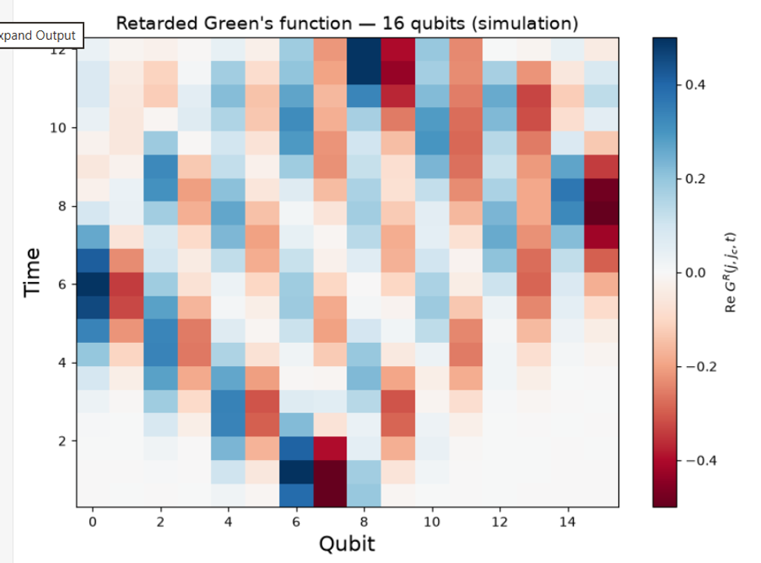
Your result: Retarded Green's function, 16 qubits (simulation)

How to read it
- Across: the 16 qubits, 0 to 15, which are the spins in the chain. The kick was on qubit 7 (center = 16 // 2 − 1).
- Up: time, from just after the kick at the bottom (t = 0.6) to t = 12 at the top, in 20 frames of 0.6.
- Colour: what each spin is doing compared with calm. White means calm, blue means it leans one way, red the other. Darker means a stronger ripple (the scale runs from −0.5 to +0.5).

What it shows
Bottom rows (t ≈ 0.6 to 2): the splash. Almost everything is white except qubits 6 and 7, which are dark blue and dark red, with a fainter echo on 5 and 8. That's the pebble landing at the centre. Qubit 6 lights up along with 7 because the first layer of gates, both in the ground-state circuit and in each Trotter step, couples qubits in pairs (6, 7), so the kick on 7 immediately pulls its partner the opposite way.
Moving upward: the light cone. The coloured patches spread outward, to qubits 4–5 and 8–9 by t ≈ 2–3, to 2–3 and 10–11 by t ≈ 4, and so on. The spreading “V” shape is the ripple travelling along the chain. Reading the front edge off the plot, it moves about 1.5 sites per unit of time (from qubit 4 at t ≈ 1.5 to qubit 0 at t ≈ 4.5), close to the theoretical spinon speed of π/2 ≈ 1.57 for this chain. That straight-edged V is the “light cone”: nothing outside it has felt the kick yet.
The ripple hits the walls at different times. On the left it reaches qubit 0 at about t ≈ 5–6 (the dark blue/red patch at the left edge). On the right it reaches qubit 15 later, around t ≈ 7.5–8.5 (the dark red patch at the right edge). The V is lopsided because the kick was on qubit 7: there are 7 sites to the left wall and 8 to the right.
Top rows (t ≈ 8 to 12): echoes coming back. After hitting the ends, the ripples reflect and travel back inward, like waves bouncing off the sides of a small pond. The strong dark blue/red pair on qubits 8–9 at the very top is where the returning waves overlap near the centre.
Why the colours alternate. Neighbouring spins prefer to point opposite ways, so along any row the ripple has a red/blue checkerboard pattern rather than one solid colour. That alternation is the q = π pattern that becomes the bright spot in the second image.

Why are the centre squares white in the middle of the plot?
Around qubits 6–8 between t ≈ 4 and 8, most squares are white or pale even though that is where the kick happened. They're white because the ripple has moved away from there. Right after the pebble lands, the splash point is wild; a moment later the ring has spread outward and the middle settles back toward flat. The energy hasn't vanished; it's out at the edges of the ring. In the chain, the two spinons travel left and right and carry the disturbance with them, leaving the centre close to its calm value. The signal also wobbles as it fades, so a white square can also be the moment a spin swings through zero, like a pendulum at the bottom of its swing.

Compared with the 10-qubit practice run
In the 10-qubit run the ripple reached the walls at t ≈ 4 and the film stopped at t = 6, so most of the plot was edge bouncing. Here you get a clean, open light cone for about 5–8 time units before the walls matter, and you can see the reflections clearly afterwards. That clean section is what gives the sharper heat map below.

7.2 Image 2: the dynamical structure factor S(q, ω) (the heat map)
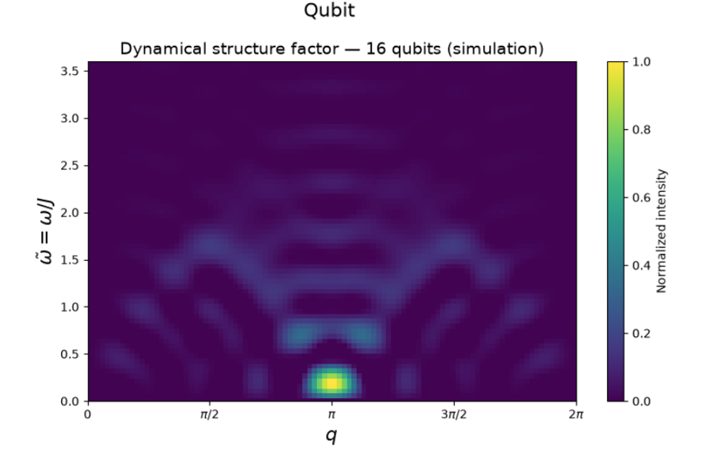
Your result: Dynamical structure factor, 16 qubits (simulation). (The word “Qubit” above the title is the x-axis label of the previous plot, caught in the screenshot.)
This is the final answer. It's the movie from the first image run through the Fourier transform (“split the song into notes”), and it is the plot you would compare with real neutron data.

How to read it
- Across (q): the ripple's wavelength, or momentum. q = π means a pattern that flips every site, the red/blue checkerboard you saw. The plot is mirror-symmetric about π by construction.
- Up (ω̃ = ω/J): the ripple's energy, or how fast it vibrates.
- Colour: how strongly the chain responds at that combination, scaled so the brightest point is 1. Yellow is strong, dark purple is none.

What it shows
The bright yellow spot at q = π, low energy (ω ≈ 0.2). The strongest response is the checkerboard pattern at low energy. That matches the real crystal: neighbouring spins want to point opposite ways, so that ripple is the easiest to make. In an infinite chain it would reach all the way down to ω = 0; a 16-site chain can't hold an arbitrarily slow ripple, so the spot sits slightly above zero.
The arch: the lower edge of the continuum. A chain of blobs rises from the bottom corners (q ≈ 0 and 2π) up to ω ≈ 1.6 at q ≈ π/2 and 3π/2, then dips back toward the centre. That is the shape of the lower edge (π/2)|sin q|, which peaks at π/2 ≈ 1.57 exactly at q = π/2. In the 10-qubit run this arch was barely visible; here it is clearly traced.
The fainter stack above the centre. Between the arch and the top of the plot around q = π there are stacked horizontal bands at ω ≈ 2.0, 2.3, 2.8 and 3.3. That region lies inside the upper edge π|sin(q/2)|, which reaches π ≈ 3.14 at q = π. So weight is landing where the two-spinon continuum lives, just broken into stripes.
The stripes, rings and gaps are mostly artifacts. Two finite sizes cause them. The film is only 12 time units long, so energies can only be told apart about 2π/12 ≈ 0.5 apart: that's the vertical spacing of the stripes. The chain is only 16 sites long, so momenta are only resolved to about 2π/16 ≈ 0.4: that's the blob width across. On top of that, the wall reflections seen in image 1 add “echo” patterns. A short recording of a song gives a blurry, ringing spectrum in exactly the same way.

With the answer key drawn on
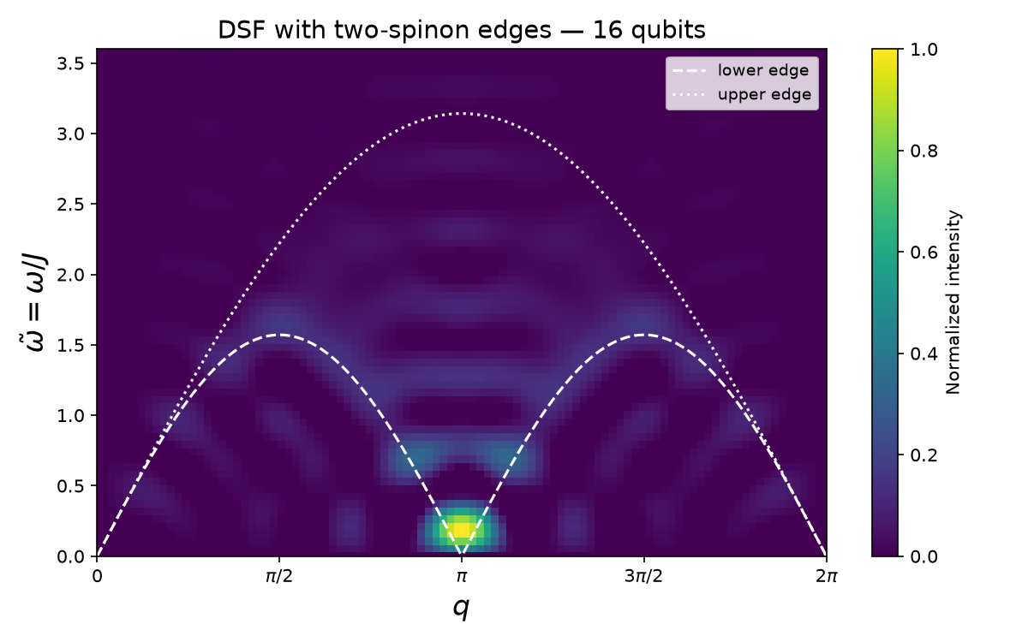
The same 16-qubit heat map from the check run, drawn by the tutorial notebook with show_bounds=True. Dashed: lower edge (π/2)|sin q|. Dotted: upper edge π|sin(q/2)|.
With the curves drawn on, the picture is easy to judge. The two arch peaks at q ≈ π/2 and 3π/2 sit right on the lower edge where it tops out at 1.57. The stacked stripes above the centre lie between the two curves, under the upper edge's peak of π. The bright spot sits in the narrow gap at q = π where the lower edge touches zero, which is where the real material's strongest signal is. The faint diagonal streaks in the bottom corners (q below π/2 or above 3π/2, ω under 1) fall below the lower edge, outside the continuum: those are finite-size leakage, not physics, and they shrink as the chain gets longer.

Verdict
This is a solid second draft, and a clear step up from the 10-qubit run. It has the bright spot in the right place, the arch follows the lower edge of the two-spinon continuum, and the weight sits between the two curves. What it doesn't have yet is the smooth, filled band of the real neutron data: the band is still broken into stripes because the chain is short and the film ends at t = 12. IBM's 50-qubit hardware run, with a longer chain, fills the band in properly between the dashed curves.

8. Where to go next
- Try 20 qubits. Change only n_qubits = 20 in the parameters cell and re-run from the top with other programs closed. The arch and the band should get smoother. If the kernel crashes, go back to 16.
- Try other chain lengths or times. Changing n_steps to 30 makes the film longer (finer energy stripes) but more of it is edge bouncing unless the chain is also longer. Always keep n_qubits even.
- Try another material. Set anisotropy below 1 (for example 0.5) to move toward the Ising limit; the heat map changes shape. This is the kind of “what if” the method is for.
- Real hardware, later. Create an API key and an instance on the free Open plan at quantum.cloud.ibm.com, save them once with QiskitRuntimeService.save_account(...) (see the last cell of the tutorial notebook), and use IBM's original Step 3. Start small (16 qubits, fewer steps): the free plan gives about 10 QPU minutes a month, and the 50-qubit run uses more. On hardware the AQC compression matters, because shorter circuits mean less noise.

9. Troubleshooting
Symptom | Fix
py is not recognized | See 3.1: call Python 3.13 by its full path, or winget install Python.Python.3.13.
Activate.ps1 blocked | Set-ExecutionPolicy -Scope CurrentUser -ExecutionPolicy RemoteSigned, then activate again.
MemoryError during Step 2 (AQC) | The problem is too big for the PC. Lower n_qubits (16 → 12), then aqc_n_steps_2 = 0; keep mps_max_bond = 32. Restart the kernel first to free memory.
Kernel “unknown”, “dead” or restarting | Python crashed, usually out of memory, and the variables are gone. Reconnect the kernel (chapter 4 box), close other programs, re-run from the top.
NameError: all_circuits (or similar) | The kernel was restarted since that variable was made. Re-run the cells from the top in order.
AccountNotFoundError | Code is trying to use IBM hardware. This tutorial doesn't need it: use the local Step 3 (StatevectorEstimator).
Long pause or “XLA slow compile” / JAX warnings in Step 2 | Expected on the first AQC step. They don't affect results.
COBYQA unknown method | SciPy is older than 1.14: pip install "scipy>=1.14".
No module named qiskit_ibm_runtime.runtime_job | pip install "qiskit-ibm-catalog>=0.20" (only matters for the Serverless notebook).
Wrong Python in the notebook | Change the kernel to “Python 3.13 (neutron)” or the .venv interpreter (3.5).
Step 3 seems stuck with no output | Normal: simulating 20 circuits of 16 qubits takes a few minutes and prints nothing until it finishes.
Plots don't appear | Make sure the cell finished (no [*]). In VS Code, scroll the output or click “Expand Output”.

10. Glossary
Key terms from Lee et al., "Benchmarking quantum simulation with neutron-scattering experiments" (arXiv:2603.15608) and the two IBM Quantum tutorials that reproduce it. Terms are grouped by topic and alphabetical within each group.

1. Physics And Materials
Antiferromagnet
A magnetic material in which neighbouring spins prefer to point in opposite directions, so the net magnetisation is zero. KCuF3 is an antiferromagnet.
Anisotropy (epsilon, ϵ)
How differently the spins interact along different directions. In the XXZ model, ϵ scales the XX and YY coupling relative to ZZ. ϵ = 1 is isotropic (all directions equal, the Heisenberg point); ϵ = 0 removes XX+YY; small ϵ is close to the Ising limit.
Bethe ansatz
An exact mathematical method (Hans Bethe, 1931) for solving the 1D Heisenberg chain. It is why KCuF3's spectrum is known exactly, making it a trusted benchmark.
Bose-Einstein distribution, n_B(ω)
Thermal occupation factor that links the DSF to the Green's function at finite temperature. It goes to zero at zero temperature.
CsCoX3 (X = Cl, Br, I)
Caesium cobalt halides. Quasi-1D magnets with strong Ising-like anisotropy whose chains also feel next-nearest-neighbour couplings. Used in the paper as a harder, non-integrable test case (modelled above their Néel temperature).
Dynamical structure factor (DSF), S(q, ω)
The central quantity. A 2D map of how strongly a material scatters neutrons at each momentum transfer q and energy transfer ω. Mathematically, the Fourier transform in space and time of the spin-spin correlation function. Measured by neutron scattering and computed by the quantum simulation.
Dispersion
The relationship between energy ω and momentum q of an excitation; the curve or band you see in an S(q, ω) plot.
Exchange interaction (J, J')
The quantum-mechanical coupling strength between neighbouring spins. J is the nearest-neighbour coupling; J' is the next-nearest-neighbour coupling. The tutorial sets J = 1 as the energy unit (the paper's J is twice the tutorial's J).
Fluctuation-dissipation theorem
A general result connecting how a system responds to a kick (the Green's function) to its spontaneous fluctuations (the DSF). Justifies Eq. 2 in the paper.
Fractionalisation
When an excitation splits into pieces carrying a fraction of the original quantum numbers. In 1D chains, one spin flip (spin 1) splits into two spinons (spin ½ each).
Gapless / gapped spectrum
Gapless: excitations can have arbitrarily low energy (KCuF3). Gapped: there is a minimum energy needed to create an excitation (the CsCoX3 model).
Hamiltonian (H)
The operator that gives a system's total energy and governs how it evolves in time.
Heisenberg model
Spin model with equal coupling in X, Y and Z: H = J Σ S_i · S_{i+1}. The isotropic (ϵ = 1) point of the XXZ model. Describes KCuF3's chains.
Inelastic neutron scattering (INS)
An experiment in which neutrons exchange energy and momentum with a material. Measuring the scattered neutrons reveals the material's magnetic excitations. "Inelastic" means the neutron's energy changes.
Integrable / non-integrable
Integrable models (like the 1D Heisenberg chain) have exact analytic solutions. Non-integrable models (like the NNN model here) do not, so simulation is the only way to get answers.
Ising limit
The case where only the ZZ interaction matters (ϵ → 0). Spins act like classical up/down arrows.
KCuF3 (potassium copper fluoride)
The real crystal studied. Its copper (Cu2+) spin-½ ions form 1D antiferromagnetic chains with weak interchain coupling (~2.7% of J). A textbook example of a Tomonaga-Luttinger liquid. Neutron data were taken at 6 K.
Light cone
The V-shaped region in the space-time Green's function plot: a disturbance at the centre spreads outward at a finite speed, so distant sites stay quiet at early times.
Magnetic form factor, F(q)
A factor in the neutron cross-section reflecting the spatial shape of the magnetic electron cloud of the ion.
Magnon
A conventional, particle-like spin wave with a sharp dispersion. Contrasts with the broad continuum produced by spinons.
Momentum transfer (q)
The change in the neutron's momentum during scattering; the horizontal axis of an S(q, ω) plot. In the simulation it comes from Fourier transforming over qubit position.
Energy transfer (ω, omega)
The energy the neutron gives to (or takes from) the sample; the vertical axis of an S(q, ω) plot. In the simulation it comes from Fourier transforming over time.
Néel temperature
The temperature below which an antiferromagnet develops long-range order.
Next-nearest-neighbour (NNN) interaction
A coupling between spins two sites apart (i and i+2). Added for the CsCoX3 model to mimic interchain effects; breaks integrability.
Quasi-one-dimensional (quasi-1D)
A 3D crystal whose magnetic behaviour is dominated by 1D chains because couplings between chains are weak.
Quantum wake
Long-lived oscillations inside the light cone, from interference of spinons moving in opposite directions.
Retarded Green's function (RGF), G^R(j, j_c, t)
The response at site j and time t to a perturbation at site j_c at time 0. On the quantum computer it is read directly as <σ^z_j>(t) after the kick. Fourier transforming it gives the DSF.
Soliton / two-soliton continuum
In Ising-like chains, an excitation is a domain wall (soliton). A spin flip creates two, giving a "bow-tie" shaped continuum in S(q, ω).
Spin-½
The smallest quantum spin, with two states (up/down). Maps directly onto a qubit.
Spin operators (S^x, S^y, S^z)
Operators measuring spin along each axis. S = σ/2, where σ are Pauli matrices.
Spinon
A spin-½ quasiparticle created when a spin flip fractionalises in a 1D chain. Pairs of spinons produce the broad two-spinon continuum seen in KCuF3.
Spectral weight
How much of the total scattering intensity lies in a given region of S(q, ω). Experiment ~48%, quantum ~50%, MPS 58.9% in the main band.
Superdiffusive / ballistic / diffusive transport
How fast correlations spread: ballistic (constant speed, XX model, t^-1 decay), superdiffusive (Heisenberg chain, t^-2/3 decay), diffusive (Ising-like, t^-1/2).
Tomonaga-Luttinger liquid
The universal low-energy state of 1D interacting quantum systems; excitations are collective (e.g. spinons) rather than individual particles.
Two-spinon continuum
The broad band of scattering in S(q, ω) of the Heisenberg chain, bounded below by (π/2)|sin q| and above by π|sin(q/2)| (tutorial units).
XX model
The XXZ model with the ZZ term removed. Simple, solvable, ballistic transport; used in the paper as a baseline check.
XXZ model
Spin chain Hamiltonian: H = J Σ [S^z_i S^z_{i+1} + ϵ (S^x_i S^x_{i+1} + S^y_i S^y_{i+1})]. Covers Ising, XX and Heisenberg as special cases.

2. Quantum Computing
Ansatz
A parameterised circuit template whose parameters are tuned by optimisation.
Approximate quantum compiling (AQC)
Replacing a deep circuit with a shorter parameterised one, tuned classically to produce nearly the same quantum state. Here it compresses the early Trotter steps.
AQC-Tensor (qiskit-addon-aqc-tensor)
Qiskit add-on that performs AQC using tensor-network (MPS) simulation to compute the fidelity and its gradients.
AQC checkpoint
A time step at which a compressed circuit is built. The tutorial uses 1-layer ansätze for early checkpoints and 2-layer for later ones (5 checkpoints small-scale, 10 large-scale).
CNOT / two-qubit gate
A gate acting on two qubits. The main source of hardware error; each Trotter pair term compiles to three CNOTs.
Circuit depth
Number of sequential gate layers. Deeper circuits accumulate more noise.
Dynamical decoupling (DD)
Error suppression: inserting pulse sequences (e.g. XY4) on idle qubits to cancel unwanted interactions with the environment.
Error mitigation / error suppression
Techniques that reduce the effect of noise without full error correction. This experiment uses DD, Pauli twirling and TREX.
Estimator (EstimatorV2, StatevectorEstimator)
Qiskit primitive that returns expectation values of observables. StatevectorEstimator is the exact local simulator; EstimatorV2 from qiskit-ibm-runtime runs on real QPUs.
Expectation value, <σ^z_j>
The average measured value of an observable. The quantity read out on each qubit.
Fidelity
How close two quantum states are (1 = identical). AQC maximises fidelity with the exact Trotter state.
Gate error rate
Probability a gate introduces an error. ibm_boston's median two-qubit error was ~1.08 × 10^-3 (0.108%); ibm_kingston's ~1.88 × 10^-3.
Hamiltonian variational ansatz (HVA)
A circuit made of layers of the Hamiltonian's own interaction terms, with tunable angles. Used to prepare the ground state (3 layers small-scale, 5 large-scale).
Heron (r2, r3)
IBM's generation of superconducting quantum processors. ibm_kingston and ibm_boston are Heron devices.
Pauli matrices (X, Y, Z / σ^x, σ^y, σ^z)
Basic single-qubit operators. Hamiltonians are written as sums of Pauli strings.
PauliEvolutionGate
Qiskit gate implementing exp(-i t H) for a Pauli-operator H; used for each Trotter pair term.
Pauli twirling
Inserting random Pauli gates around two-qubit gates (and undoing them) so coherent errors average into simpler random noise. 1000 randomizations in the tutorial.
Perturbation (the "kick")
The local operation U = (1/√2)(I - iσ^z) = R_z(π/2) on the centre qubit that mimics a neutron disturbing one spin.
Pre-fault-tolerant
Today's quantum computers: no full error correction, but low enough error to do useful work with mitigation.
Primitive
Qiskit's standard interfaces for running circuits (Estimator and Sampler).
QPU
Quantum processing unit; the real quantum hardware.
Qubit
The basic unit of quantum information. Here, one qubit represents one spin.
R_z gate
Single-qubit rotation about the Z axis.
SparsePauliOp
Qiskit's data structure for operators written as weighted sums of Pauli strings.
Superconducting quantum processor
Hardware whose qubits are superconducting circuits cooled near absolute zero (IBM's technology).
Transpilation / pass manager
Rewriting a circuit into the native gates and connectivity of a specific device. generate_preset_pass_manager does this in Qiskit.
TREX (twirled readout error extinction)
Mitigation that learns and removes measurement (readout) errors.
Trotterisation / Trotter step
Approximating time evolution exp(-iHt) by repeatedly applying short evolutions of each term. Second-order Trotter (symmetric ordering) is used. One step = one Δt.
Time step (Δt, dt)
Duration of one Trotter step: 0.6 for KCuF3, 0.8 for CsCoX3 in the paper.

3. Classical Simulation And Math
Bond dimension (χ, max_bond)
The size limit of an MPS. Larger χ captures more entanglement but costs more memory/time (32 small-scale, 128 large-scale).
COBYQA
A derivative-free optimiser in SciPy (needs SciPy ≥ 1.14), used to fit the ground-state ansatz in the tutorial.
DMRG (density matrix renormalisation group)
The standard classical algorithm for finding ground states of 1D systems as MPS. Provides the target ground state.
Exact diagonalisation
Computing a Hamiltonian's eigenstates directly. Limited to roughly 20-30 spins.
Fourier transform (2D)
Converts the space-time data G^R(j, t) into momentum-energy data S(q, ω).
JAX
Python library for fast numerical computing with automatic differentiation; gives AQC its gradients.
L-BFGS-B
Gradient-based optimiser from SciPy used to tune AQC parameters.
Matrix product state (MPS)
Efficient tensor-network representation of 1D quantum states. Used for ground states, for AQC, and as the noise-free classical benchmark.
MPO (matrix product operator)
The operator analogue of an MPS; used to represent the Hamiltonian in quimb.
quimb
Python tensor-network library used for MPS/DMRG simulation (quimb.tensor).
Tensor network
Representing a large quantum state as a network of small linked tensors.
t-DMRG
Time-dependent DMRG; classical method for dynamics, limited by entanglement growth.

4. Benchmarking Metrics
FWHM (full width at half maximum)
Width of a peak measured at half its height. Used to judge peak-position accuracy.
Line scan
A 1D cut through S(q, ω) at fixed q (e.g. q = π or π/2).
MSE (mean squared error)
Average squared pixel-by-pixel difference between two spectra. Lower is better.
nQFI (normalised quantum Fisher information)
An entanglement witness computed from the spectrum. nQFI above k implies at least (k+1)-party entanglement; the paper found at least four-partite entanglement.
One-tangle (τ1) / two-tangle (τ2)
Measures of single-site entanglement and pairwise entanglement respectively.
SSIM (structural similarity index measure)
Image-comparison score from -1 to 1 (1 = identical) that rewards matching structure.
Wasserstein distance
"Earth mover's distance": how much intensity must be moved to turn one spectrum into the other. Captures global similarity.

5. Tools, Platforms And Facilities
aqc-dynamics-function
The IBM function template that packages Trotter synthesis, AQC compression and mitigated execution in one Serverless call. Must be deployed to your account first.
ibm_boston / ibm_kingston
The two IBM Heron processors used in the paper. ibm_boston's lower error rate gave the quantitative agreement with experiment.
IBM Quantum Platform
IBM's cloud service for accessing QPUs. Requires an account and API key.
ISIS / MAPS
ISIS is a UK neutron and muon source; MAPS is the spectrometer that measured the KCuF3 data used for comparison.
Jupyter notebook (.ipynb)
Interactive document mixing code, output and text. Both tutorials are notebooks.
Qiskit
IBM's open-source Python SDK for quantum computing (v2.x required).
qiskit-ibm-catalog / QiskitServerless
Client library for loading and calling functions deployed to Qiskit Serverless.
qiskit-ibm-runtime / QiskitRuntimeService
Client for running circuits on IBM QPUs; QiskitRuntimeService handles your account.
qiskit-quimb
Bridge that converts Qiskit circuits into quimb tensor-network circuits.
Qiskit Serverless
IBM's managed classical compute that runs Python workloads (like long AQC optimisations) next to the QPU, so they keep going after you close your laptop.
Spallation Neutron Source (SNS)
Neutron facility at Oak Ridge National Laboratory, used for part of the research.

6. Added For The 16-Qubit Local Tutorial
AccountNotFoundError
The error QiskitRuntimeService raises when no IBM Quantum account is saved on the computer. This tutorial avoids it by using the local StatevectorEstimator.
Centre site (center, j_c)
The qubit that gets the kick. For n_qubits = 16 it is n_qubits // 2 - 1 = 7, the left of the two middle qubits.
Edge reflection / finite-size effects
In a short open chain the ripple hits the ends and bounces back. These echoes, and the limited length and run time, produce the rings and stripes in a small-chain S(q, ω) plot instead of a smooth band.
Frequency and momentum resolution
How finely the heat map can separate energies and momenta: roughly 2π / (total time) in ω and 2π / (number of sites) in q. For 16 sites and time 12: about 0.4 and 0.5.
Kernel (Jupyter kernel)
The Python process that runs a notebook's cells and holds its variables. If it crashes ("unknown" / "dead"), every variable is lost and cells must be re-run.
MemoryError
Python ran out of RAM. Here it happened in AQC at 50 qubits; fixed by shrinking n_qubits and the number of compressed steps.
Statevector
The full list of 2^n complex amplitudes describing n qubits exactly. 16 qubits need 65,536 numbers (about 1 MB), small enough for any PC; 50 qubits would need petabytes, which is why the large run needs MPS or real hardware.
Virtual environment (venv)
A private folder of Python packages for one project (.venv), so this tutorial's library versions don't clash with anything else on the PC.

11. Appendix

A. requirements.txt
# Requirements for the 16-qubit local tutorial (Quantum_Code.ipynb /
# Quantum_Code_16q_tutorial.ipynb) and for both IBM neutron-scattering tutorials.
# Tested with Python 3.13. The qiskit-ibm-* packages are only needed for real
# IBM hardware or Serverless; the local tutorial runs without an account.
# Qiskit SDK v2 (with circuit-drawing extras)
qiskit[visualization]>=2.0,<3
# IBM hardware access (EstimatorV2, QiskitRuntimeService)
qiskit-ibm-runtime>=0.40.1
# Qiskit Serverless client. Must be >=0.20: older catalog releases pull in a
# qiskit-serverless that crashes on import with recent qiskit-ibm-runtime
# ("No module named 'qiskit_ibm_runtime.runtime_job'").
qiskit-ibm-catalog>=0.20
# AQC + tensor-network stack (pinned to the version the tutorials specify)
qiskit-addon-aqc-tensor[quimb-jax]==0.3.1
qiskit-quimb
# Scientific Python (SciPy >=1.14 is needed for the COBYQA optimizer)
numpy
scipy>=1.14
matplotlib
# Notebook environment
jupyter
ipykernel
A fully pinned requirements-lock.txt (generated on Linux) is in the earlier setup files; on Windows, prefer requirements.txt.

B. Files in the tutorial-16q folder
File | What it is
Neutron_Scattering_16q_Tutorial.pdf | This document.
Quantum_Code_16q_tutorial.ipynb | The annotated tutorial notebook: one cell per step, explanations, bounds overlay and PNG saving. Run this one.
Quantum_Code.ipynb | Your original two-cell notebook, unchanged.
requirements.txt | Packages to install (Appendix A).
SETUP_16q.md | The Windows setup steps and crash tips from chapters 3 and 4, as a short text file.
rgf_16q.png, dsf_16q.png | Your two 16-qubit result images.
dsf_16q_bounds.png | The heat map with the two-spinon edges, from the check run.
1_Neutron_Scattering_Spin_Correlations.mp4 | The companion video referenced in section 2.1.

C. Sources
- K. Lee et al., Benchmarking quantum simulation with neutron-scattering experiments, arXiv:2603.15608.
- IBM Quantum tutorial, Simulate neutron scattering in quantum materials with quantum circuits (step-by-step notebook), and its Serverless companion.
- Earlier project notes: neutron-scattering-overview.pdf, study-guide.pdf, glossary.txt, SETUP.md, and Explaination.docx.

