Reading Your Venera 13 Frequency Mask Output

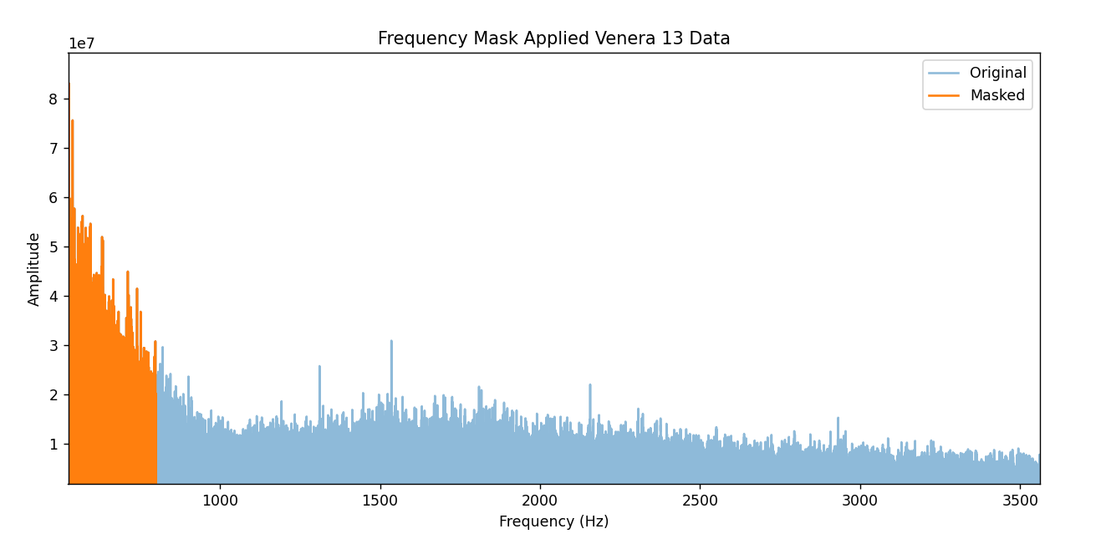
What the Plot Shows
The chart overlays two spectra:
- Blue = original full signal
- Orange = what survived the mask (0–~750Hz retained)

Key Observations
1. Dominant Energy is Sub-750Hz The orange region captures the vast majority of signal amplitude — peaks reaching 7.5 × 10⁷ — meaning almost all meaningful acoustic energy in this recording lives in the low-frequency range.
2. Sharp Roll-off at ~750Hz There's a hard cliff where orange stops and blue continues flat. Above ~750Hz the amplitude drops to roughly 1.5 × 10⁷ and stays relatively consistent — this looks like broadband noise rather than structured signal.
3. Interesting Spikes in the Blue (Unmasked) Region
- ~1500Hz — small spike
- ~1750Hz — notable spike
- ~2150Hz — notable spike
These isolated peaks above your mask cutoff could be worth investigating — they stand above the noise floor and may be real acoustic events.

Scientific Interpretation
Feature | Possible Meaning
Huge low-freq energy (<750Hz) | Wind pressure fluctuations, atmospheric turbulence, or lander vibration/motor noise
Flat noise floor 750Hz–3500Hz | Instrument self-noise or thermal atmospheric hiss
Isolated spikes at 1500/1750/2150Hz | Possible mechanical resonance, or genuine atmospheric acoustic events

Suggestions
1. Your mask cutoff may be too high The signal energy essentially collapses after ~750Hz — you could tighten the band to 20Hz–700Hz to be more precise.
2. Investigate the spikes
# Zoom into spike regions for closer inspection
axes[0].set_xlim(1400, 2300)
Run a separate narrow band-pass around 1500Hz, 1750Hz, and 2150Hz to isolate and listen to those events individually.
3. Check if low-freq dominance is wind or noise
# Split into sub-bands and compare energy
infrasound = (np.abs(frequencies) < 20) # Should be noise/vibration
wind_band = (np.abs(frequencies) >= 20) & (np.abs(frequencies) <= 200)
acoustic = (np.abs(frequencies) >= 200) & (np.abs(frequencies) <= 750)
Wind turbulence typically dominates 20–200Hz, while structured acoustic events appear 200Hz+.
4. Consider a spectrogram instead of static FFT A static FFT averages over the entire recording. A spectrogram shows when events occur:
from scipy.signal import spectrogram
f, t, Sxx = spectrogram(data, sample_rate)
plt.pcolormesh(t, f, 10 * np.log10(Sxx), shading='gouraud')
This could reveal whether those spikes are brief transient events or persistent tones.

Summary in Plain Terms
The Venera 13 audio is dominated by very low frequency energy, consistent with dense atmospheric pressure and wind turbulence expected on Venus. Above ~750Hz the signal flattens to what appears to be noise, though a handful of isolated spikes warrant closer examination as potential real acoustic phenomena.
https://claude.ai/share/9d7036ce-de86-4126-9d17-f434ae7b3008

