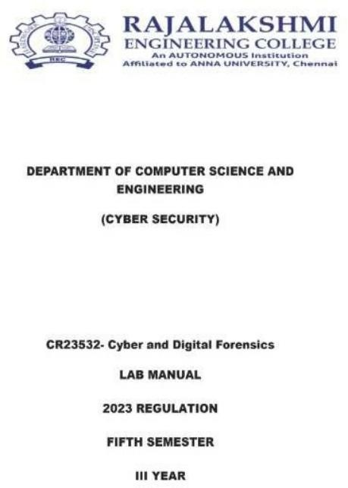

EXPERIMENT 1

STUDY OF COMPUTER FORENSICS AND DIFFERENT TOOLS USED FOR FORENSIC INVESTIGATION
AIM:
To study computer forensics, understand the digital forensic investigation process, and examine the different tools used for forensic investigation.
SOFTWARE REQUIREMENTS:
- Operating System: Windows / Linux
- Digital forensic tools: Autopsy, FTK Imager, The Sleuth Kit, and other forensic utilities.
THEORY:
Computer forensics, also known as digital forensics, is the process of identifying, collecting, preserving, examining, and analyzing digital evidence from computers and other digital devices. It is used to investigate cybercrimes, security incidents, unauthorized access, and other activities involving digital systems.
Digital forensic investigators examine data from storage devices, operating systems, application logs, browser histories, deleted files, and other sources to identify evidence relevant to an investigation.
The primary objective of digital forensics is to recover and analyze digital evidence while maintaining its integrity and ensuring that the findings can be presented accurately.
DIGITAL FORENSICS PROCESS:
The digital forensic investigation process consists of the following stages:
- Identification
Identifying potential sources of digital evidence, such as computers, hard disks, USB drives, mobile devices, and log files.

- Collection
Collecting relevant digital evidence using appropriate forensic procedures and tools.
- Preservation
Protecting the collected evidence from unauthorized modification or damage. Investigators may create forensic images and calculate hash values to help verify evidence integrity.
- Examination
Examining the collected evidence to locate relevant files, metadata, deleted data, and other artifacts.
- Analysis
Analyzing the extracted information to establish relationships between events, identify suspicious activities, and develop findings relevant to the investigation.
- Presentation
Documenting the investigation methods, observations, and conclusions in a report suitable for technical or legal review.
DIFFERENT TOOLS USED IN COMPUTER FORENSICS
The lab manual discusses commercial forensic suites and free or open-source tools used in digital investigations.
- EnCase Forensic
EnCase Forensic is a commercial digital forensic investigation tool used to acquire, examine, and analyze digital evidence. It supports forensic investigations involving computers and storage devices.
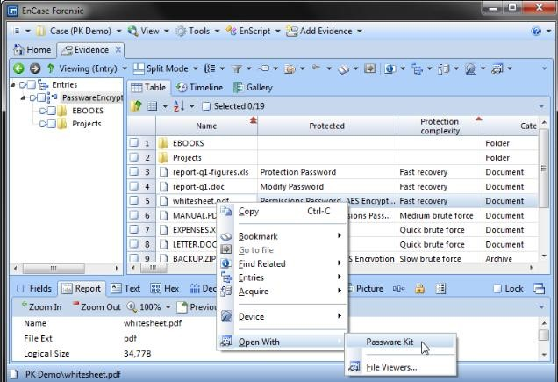
- Forensic Toolkit (FTK)
FTK is a digital forensic investigation suite used to analyze digital evidence. It supports searching, file analysis, and examination of information collected during investigations.
- The Sleuth Kit (TSK)
The Sleuth Kit is an open-source collection of command-line tools used to analyze disk images and file systems. It helps investigators examine file-system structures and recover information relevant to an investigation.
- Autopsy
Autopsy is a digital forensic platform that provides a graphical interface for The Sleuth Kit and other forensic tools. It supports the examination of disk images, file recovery, keyword searching, and analysis of digital artifacts.
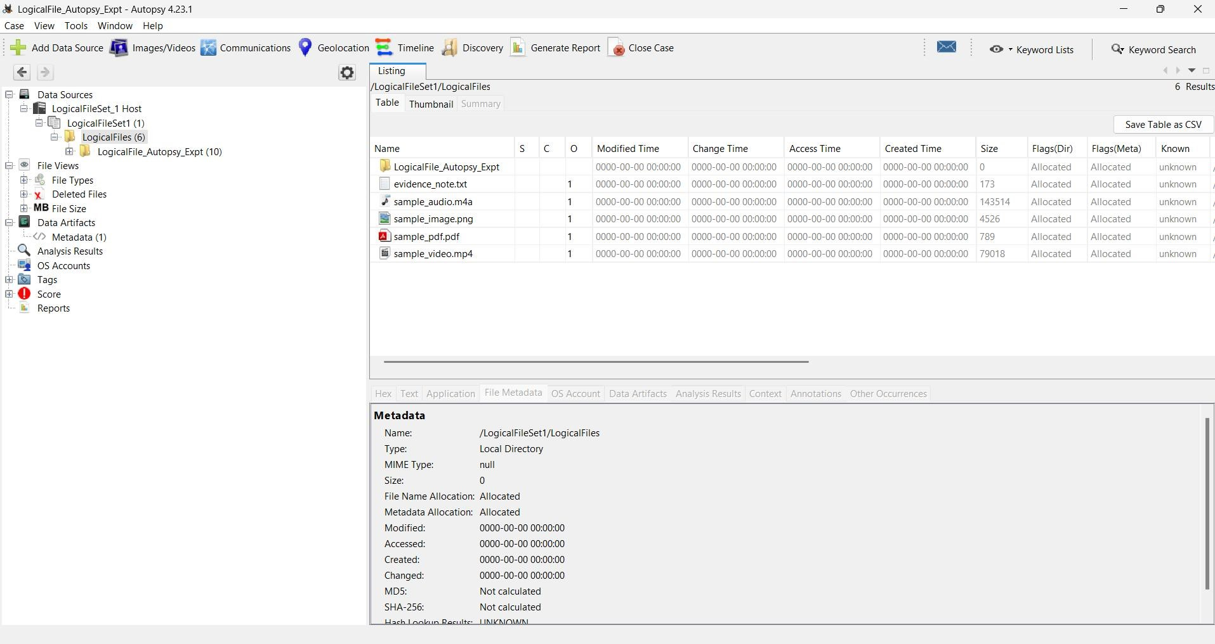
- FTK Imager
FTK Imager is a forensic imaging utility used to acquire and examine forensic images of storage devices. It can also help investigators inspect files and folders contained in supported evidence images.
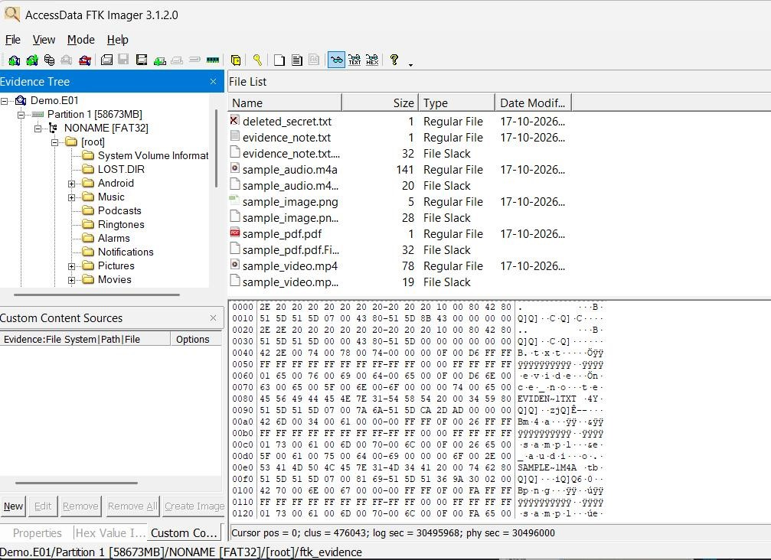
APPLICATIONS OF COMPUTER FORENSICS:
Digital forensics is used in several areas:
  - Cybercrime investigation: Examining digital evidence associated with unauthorized access, malware, and other cyber incidents.
  - Data recovery: Recovering deleted or inaccessible files where possible.
  - Incident response: Investigating security incidents and determining their possible causes.
  - Employee misconduct investigation: Examining relevant digital artifacts during authorized workplace investigations.
  - Legal investigations: Preserving and analyzing digital evidence for potential use in legal proceedings.
  - Network investigation: Examining network logs and related artifacts to understand suspicious communications and activities.
GENERAL PROCEDURE:
  - Study the fundamental concepts of computer and digital forensics.
  - Identify the major stages of the digital forensic investigation process.
  - Study the different commercial and open-source forensic tools.
  - Understand the purpose and functions of tools such as FTK Imager, Autopsy, and The Sleuth Kit.
  - Examine the applications of digital forensics in cybercrime investigation and data recovery.
  - Document the observations and findings.
OBSERVATION:
The study provided an understanding of computer forensics and the importance of digital evidence in cybercrime investigations.
Different forensic tools were examined based on their purposes and capabilities. The investigation process was understood to involve identifying, collecting, preserving, examining, analyzing, and presenting digital evidence.
RESULT:
Thus, the study of computer forensics and the different tools used for forensic investigation was completed successfully.

EXPERIMENT 2

LIVE FORENSICS CASE INVESTIGATION USING AUTOPSY
AIM:
To perform a digital forensic investigation using Autopsy by creating a case, adding a data source, analyzing digital evidence, and examining the forensic artifacts generated by the tool.
SOFTWARE REQUIREMENTS:
- Operating System: Windows
- Software: Autopsy Digital Forensic Tool
- Evidence source: A suitable forensic image or disk image
- Hardware: Computer with sufficient storage and memory THEORY:
Autopsy is a digital forensic investigation platform that provides a graphical interface for examining digital evidence. It uses The Sleuth Kit and other tools to help investigators analyze files, disk images, and digital artifacts.
Autopsy supports activities such as file-system analysis, keyword searching, recovery of deleted files, and examination of information related to user activities.
In a forensic investigation, a case is created to organize the investigation details and associated evidence. A data source, such as a disk image, is then added to the case. Autopsy processes the source using selected ingest modules and displays the extracted information for examination.
The results can help investigators identify relevant files, user accounts, browser activity, metadata, and other artifacts associated with the evidence source.
PROCEDURE:
Step 1: Open Autopsy
- Download and install Autopsy from its official website.
- Launch the Autopsy application.
- Select New Case from the welcome screen.
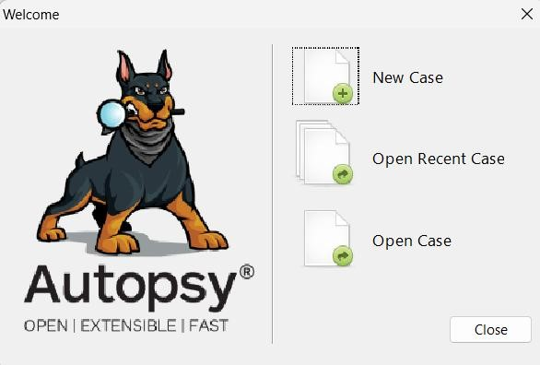
Step 2: Create a new case
- Enter a suitable case name.
- Specify the base directory where the case data will be stored.
- Click Next to proceed.
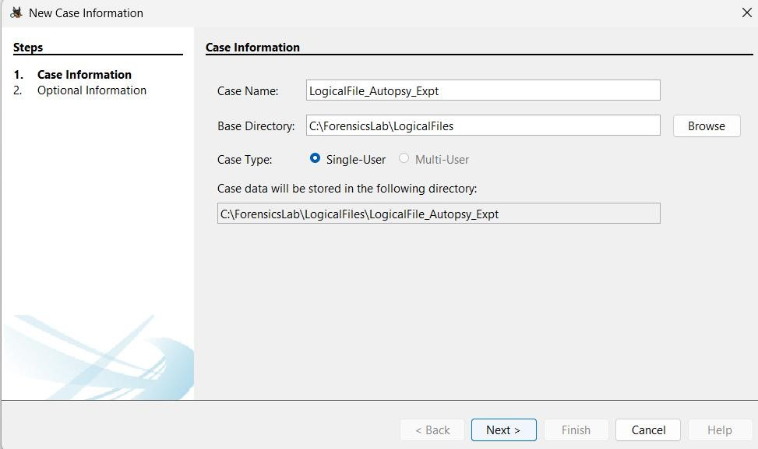
Step 3: Enter case information
- Enter the case number.
- Provide the examiner's details.
- Enter any additional information required by the application.
- Click Finish to create the case.
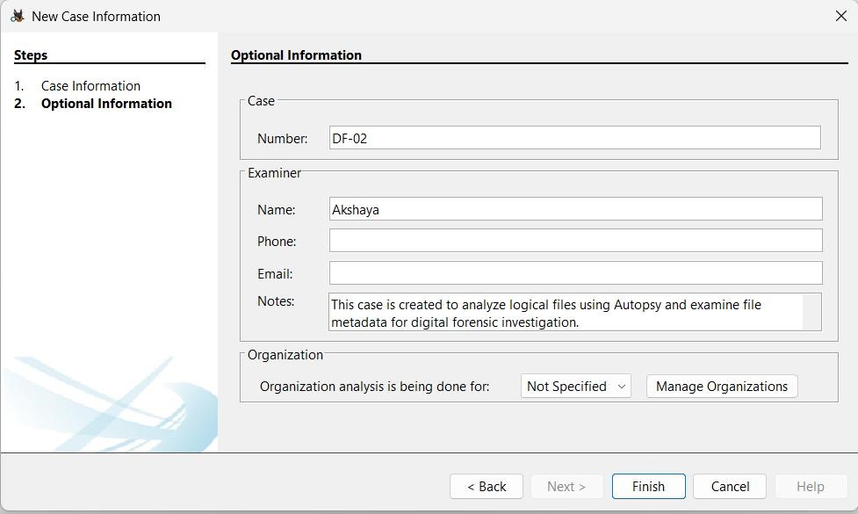
Step 4: Add a data source
- After creating the case, select the option to add a data source.
- Choose the appropriate source type, such as a disk image or virtual machine file.
- Browse to the location of the forensic image.
- Select the image and proceed to the next step.
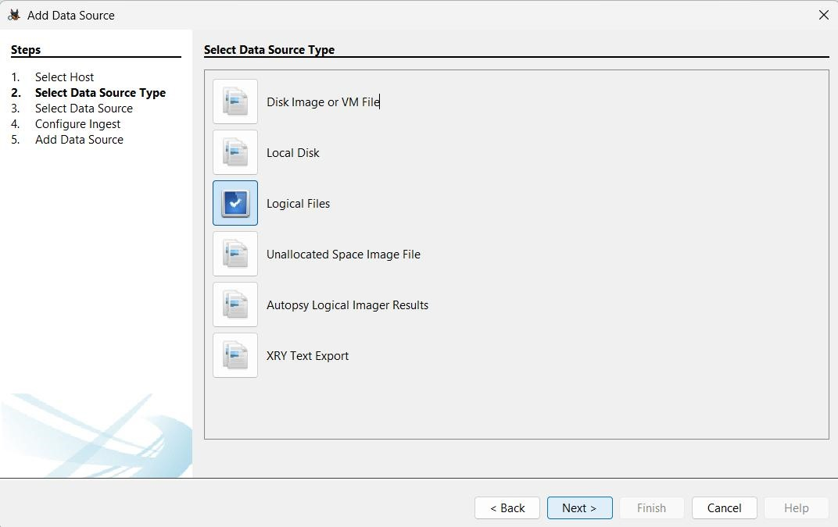

Step 5: Configure ingest modules
- Review the available ingest modules.
- Select the modules required for the investigation.
- Click Next to continue.
- Review the settings and complete the data-source addition.
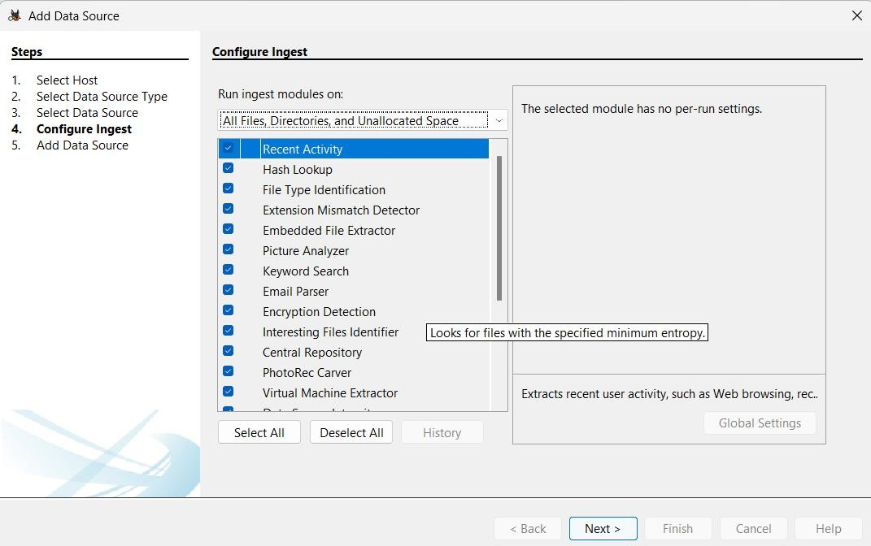
Step 6: Process the data source
- Complete the Add Data Source wizard.
- Allow Autopsy to process the selected image.
- Wait for processing to finish.
- Examine the results displayed in the case interface.
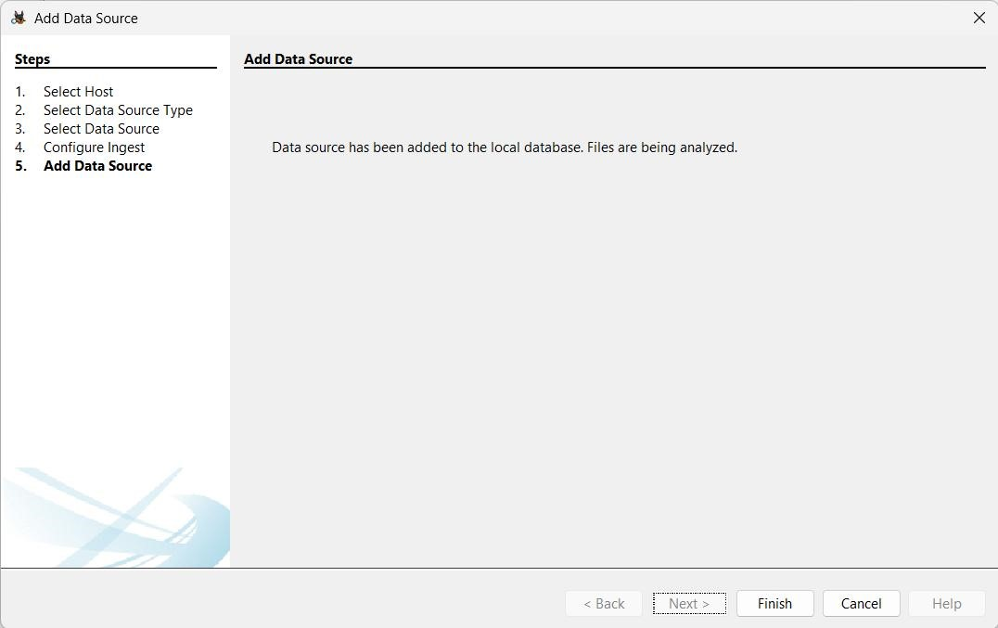
Step 7: Examine the forensic artifacts
After processing, examine the available artifacts in Autopsy. Depending on the evidence and the modules selected.

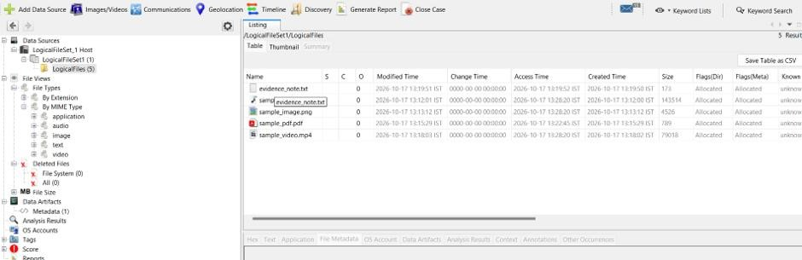
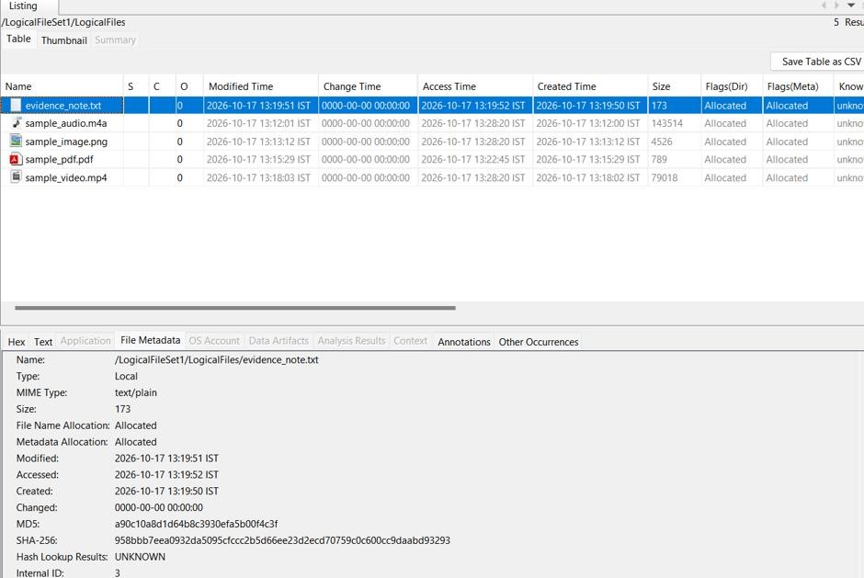

VERIFICATION OF EVIDENCE INTEGRITY USING SHA-256:
After processing the logical files in Autopsy, the integrity of the evidence was crossverified using the SHA-256 hashing algorithm in Windows Command Prompt.
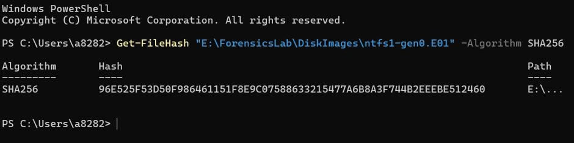
OBSERVATION:
Autopsy was used to create a forensic case and add a data source for investigation. The selected ingest modules processed the evidence and generated artifacts for examination.
The resulting interface provided access to the files and other information identified during processing. The available artifacts depended on the contents of the selected evidence image

RESULT:
Thus, the procedure for conducting a digital forensic investigation using Autopsy was studied and performed by creating a case, adding a data source, processing the evidence, and examining the available forensic artifacts.

EXPERIMENT 3

RECOVER DELETED FILES USING FORENSIC TOOLS
AIM:
To recover deleted files from a forensic image using digital forensic tools and verify the recovered data.
SOFTWARE REQUIREMENTS:
- Operating System: Windows
- FTK Imager
- Recover My Files
- USB storage device or suitable test evidence source
THEORY:
File deletion does not always immediately erase the underlying data from a storage device. In many file systems, deletion marks the space occupied by a file as available for reuse. Until the data is overwritten, some or all of the deleted file's contents may remain recoverable.
Digital forensic tools help investigators examine storage devices and forensic images to locate and recover deleted files. FTK Imager is used to acquire or examine forensic images, while file recovery tools can search the image for deleted files and other recoverable data.
A forensic image preserves a representation of the source at the time of acquisition, allowing investigators to examine the acquired data without repeatedly accessing the original device.
PROCEDURE:
Step 1: Create a sample file
- Open Notepad.
- Type some sample text for testing.
- Save the file as deleted_secret.txt on a test USB drive or another location.
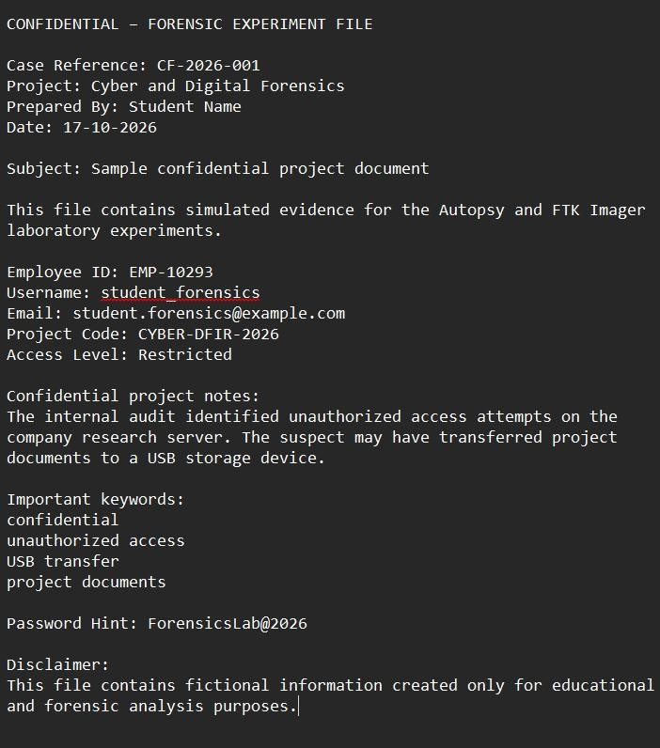
Step 2: Delete the sample file
- Locate deleted_secret.txt.
- Right-click the file and select Delete.
- Confirm that the file is no longer visible in its original location.
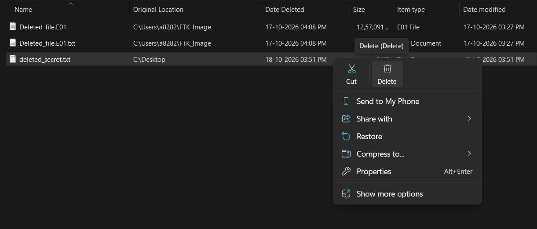
Step 3: Create a forensic image using FTK Imager
- Open FTK Imager.
- Select File → Create Disk Image.
- Choose the appropriate source type.
- Select the test device containing the deleted file.
- Enter the required case and evidence details.
- Specify the destination folder and image format.
- Start the imaging process and wait for it to complete.
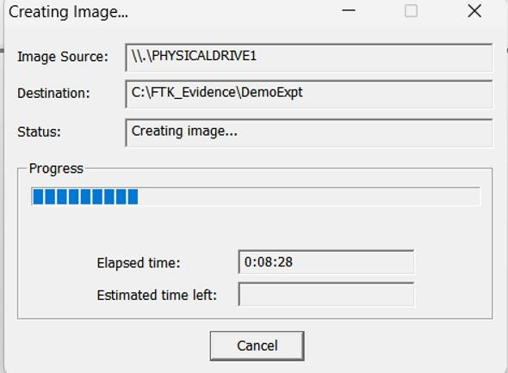
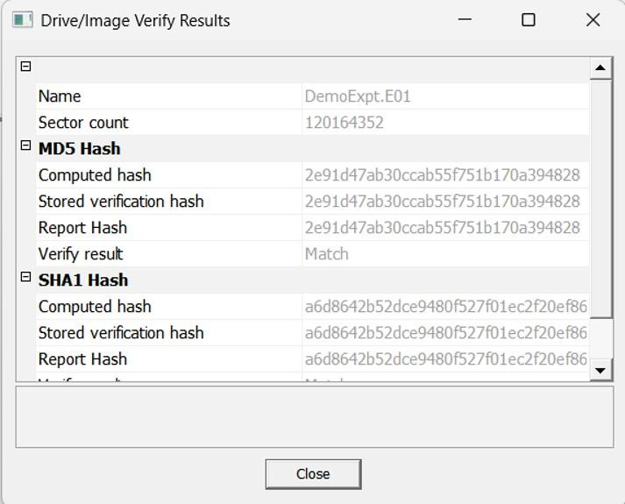
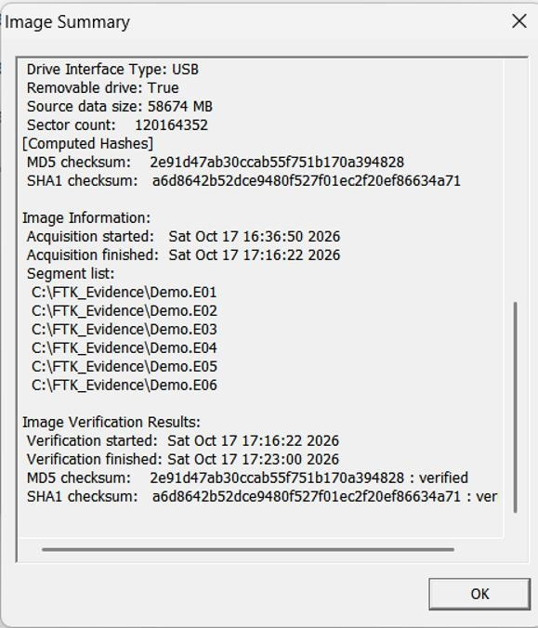

Step 4: Verify the recovered file
- Open the recovered file.
- Check whether the original sample text is present.
- Compare the recovered contents with the text entered before deletion.
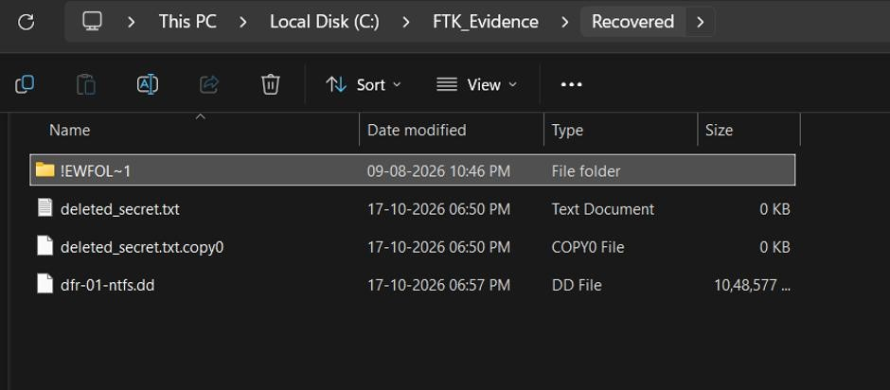
OBSERVATION:
A sample text file was created and deleted from a test storage location. A forensic image was then created using FTK Imager and examined using a file recovery tool.
The recovery results were inspected to determine whether the deleted file and its contents could be retrieved. Recovery depended on the file system, the imaging
method and wheather original data has been overwritten.

RESULT :
Thus, the procedure for recovering deleted files using forensic tools was studied and performed. The forensic image was examined for deleted data, and the recovery results were verified where the file was successfully recovered.

EXPERIMENT 4

FIND LAST CONNECTED USB ON YOUR SYSTEM (USB FORENSICS) AIM:
To identify USB devices previously connected to the computer and examine their details using the USBDeview forensic utility.
SOFTWARE REQUIREMENTS:
- Operating System: Windows
- Tool: USBDeview
- Computer with a history of USB device connections THEORY:
USB forensics involves examining records of USB devices connected to a computer. These records can help investigators identify previously connected devices and determine relevant device information.
USBDeview is a Windows utility that lists currently connected USB devices and devices previously used on the system. It can display information such as:
- Device name and description
- Device type
- Serial number, when available
- Date and time the device was connected or added to the system
- Vendor ID (VID)
- Product ID (PID)
This information can help investigators examine USB connection history during a digital forensic investigation.
PROCEDURE:
- Download and launch the USBDeview utility on the Windows system.
- Allow the utility to display the USB devices detected on the computer.
- Examine the list of currently connected and previously connected USB devices.
- Identify the device name and description of the required USB device.
- Examine the available serial number, Vendor ID, and Product ID.
- Check the displayed date and time information associated with the device.
- Record the relevant details for forensic examination.
- Capture screenshots showing the device list and the selected device's details.
OBSERVATION:
USBDeview displays information about USB devices connected to the system, including devices that were previously used. The available device details can be examined to identify relevant USB connection records.
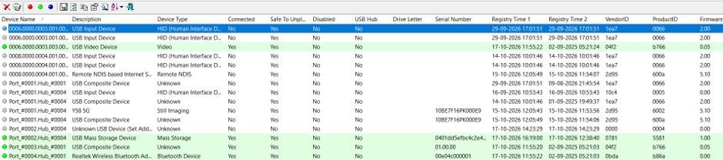
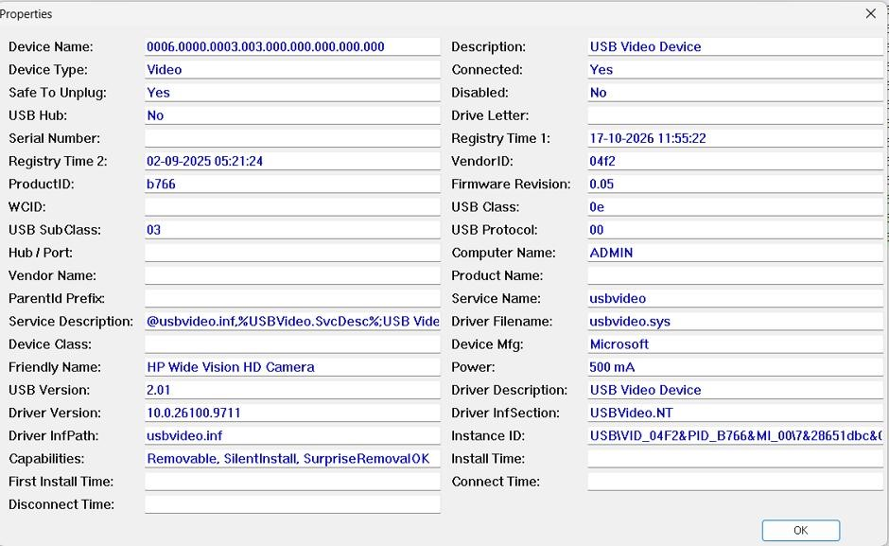
RESULT:
Thus, USBDeview was used to examine USB device connection records and view the available device details for forensic investigation.

EXPERIMENT 5

VIEW LAST ACTIVITY OF YOUR PC
AIM:
To examine the recent activities and system events recorded on a Windows computer using the LastActivityView forensic utility.
SOFTWARE REQUIREMENTS:
- Operating System: Windows
- Tool: LastActivityView
THEORY:
LastActivityView is a utility for Windows that collects information from different sources on the system and displays a log of user activities and events that occurred on the computer.
It can help investigators examine activity records, such as system events and certain recent user actions. The information available depends on the records present on the computer.
PROCEDURE:
- Download and launch the LastActivityView utility on the Windows computer.
- Allow the utility to scan the available system records.
- Examine the activity log displayed in the main window.
- Observe the available details, such as the activity description, filename or application, and recorded date and time, where available.
- Identify relevant entries for recent computer activities.
- Record the observations for forensic analysis.
- Capture screenshots of the activity log and relevant entries.
OBSERVATION:
LastActivityView displays available records of activities and events associated with the Windows computer. These records can be examined to understand certain aspects of the system's recent activity.
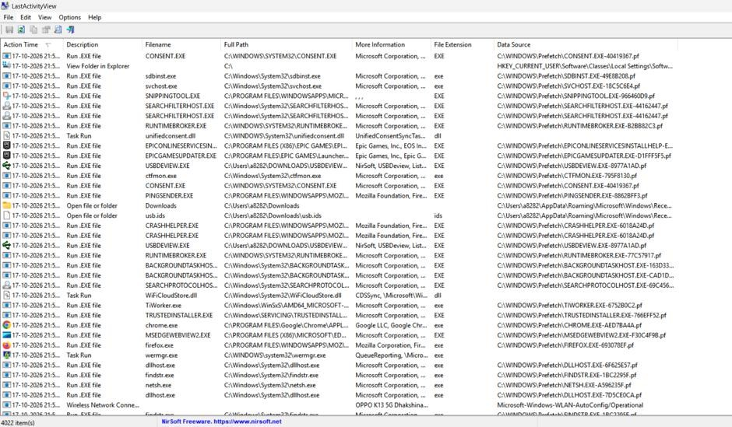
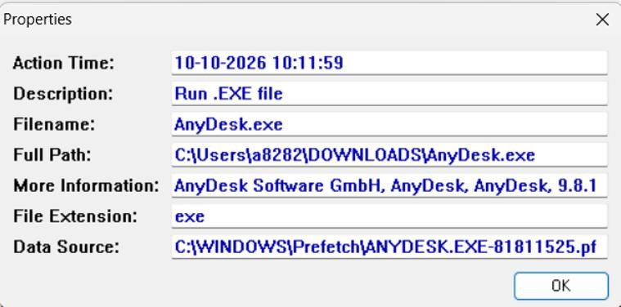
RESULT:
Thus, Last Activity View was used to examine available records of recent computer activities and system events for digital forensic investigation.

EXPERIMENT 6

EXTRACTION OF BROWSER ARTIFACTS
AIM
To extract and examine browser artifacts, including cached files and browsing history, using ChromeCacheView and ChromeHistoryView.
SOFTWARE REQUIREMENTS
- Operating System: Windows
- Web Browser: Google Chrome
- Tools: ChromeCacheView and ChromeHistoryView
THEORY
Browser artifacts are data generated and stored by a web browser during internet usage. These artifacts can provide useful information during digital forensic investigations.
ChromecacheView is a utility that reads the cache folder of Google Chrome and displays information about cached files. The information may include the URL, file type, cache filename, file size, and access time, depending on the available records.
ChromeHistoryView is a utility that reads the history data of Google Chrome and displays records of websites visited by the user. It can show information such as the URL, page title, visit count, and last visit time, depending on the available records.
These tools help investigators examine browser cache and browsing history as part of a digital forensic investigation.
4. PROCEDURE
- EXAMINATION USING CHROMECACHEVIEW
  - Download and launch ChromeCacheView on the Windows computer.
  - Allow the utility to locate and read the Google Chrome cache data.
  - Examine the list of cached files displayed in the main window.
  - Observe the available details, including the URL, file type, cache filename, file size, and access time.
  - Identify relevant cached entries for examination.
  - Capture a screenshot showing the cached file records.
- EXAMINATION USING CHROMEHISTORYVIEW
  - Download and launch ChromeHistoryView on the Windows computer.
  - Allow the utility to locate and read the Google Chrome browsing history data.
  - Examine the list of browsing history records displayed in the main window.
  - Observe the available details, including the URL, page title, visit count, and last visit time.
  - Identify relevant browsing history entries.
  - Capture a screenshot showing the extracted browsing history records.
OBSERVATION:
The two tools were used to examine different types of browser artifacts.
S.  NO. | TOOL NAME | ARTIFACT  EXAMINED | OBSERVATION
1 | ChromeCacheView | Cached files | Cached file details were displayed where available.
2 | ChromeHistoryView | Browsing history | Website history records were displayed where available.
DETAILS OBSERVED USING CHROMECACHEVIEW
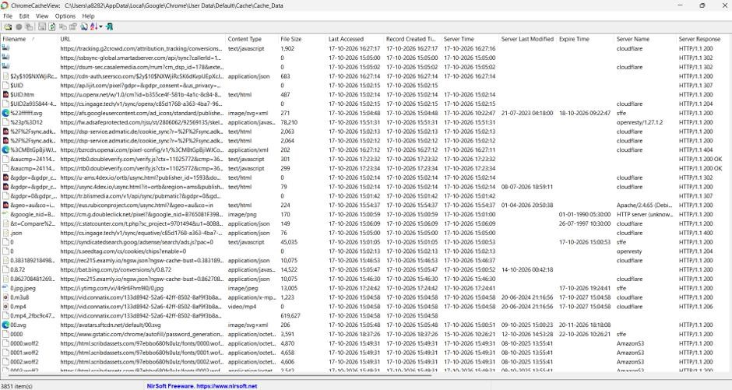
DETAILS OBSERVED USING CHROMEHISTORYVIEW
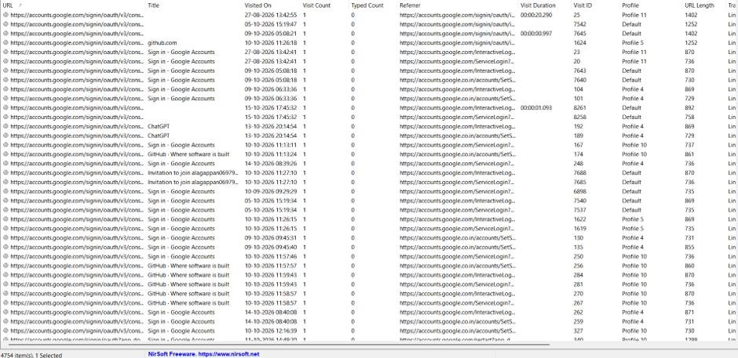
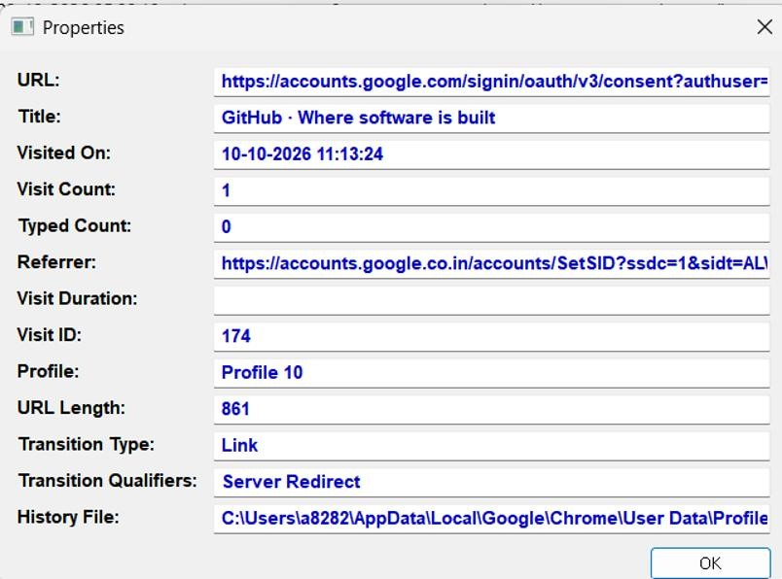

RESULT:

Thus, browser artifacts were examined using Chrome Cache View and Chrome History View. Cached file information and available browsing history records were extracted and analyzed for digital forensic investigation.
EXPERIMENT 7

COMPARISON OF TWO FILES FOR FORENSIC INVESTIGATION USING COMPARE IT SOFTWARE
AIM:
To compare two files using Compare It software and identify differences between their contents for digital forensic investigation.
SOFTWARE REQUIREMENTS:
- Operating System: Windows
- Software: Compare It
- Two sample files for comparison THEORY:
File comparison is a technique used in digital forensics to identify differences between two files. It helps investigators determine whether a file has been modified or whether two files contain different information.
Compare It is a file comparison tool that displays two files side by side and highlights the differences using colours. It helps users identify added, deleted, or modified content between files.
The comparison results can assist investigators in examining changes in documents and understanding possible file modifications.
PROCEDURE:
- Download and install Compare It software on the Windows computer.
- Prepare two sample files for comparison. The files may contain similar text with a few differences.
- Launch the Compare It application.
- Select the first file and click OPEN.
- Select the second file and click OPEN.
- Allow the software to display both files side by side.
- Examine the highlighted sections to identify differences between the files.
- Observe any added, deleted, or modified text.
- Record the observations and capture a screenshot of the comparison results.
OBSERVATION:
Compare It displays both files side by side and highlights differences in their contents.
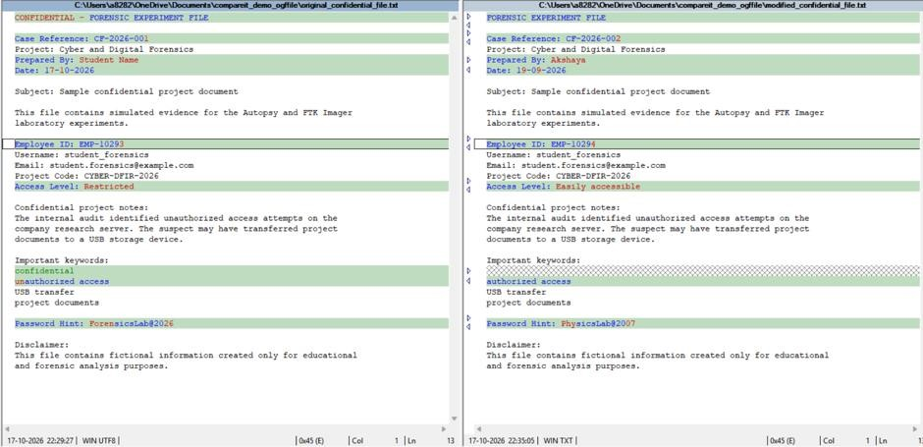
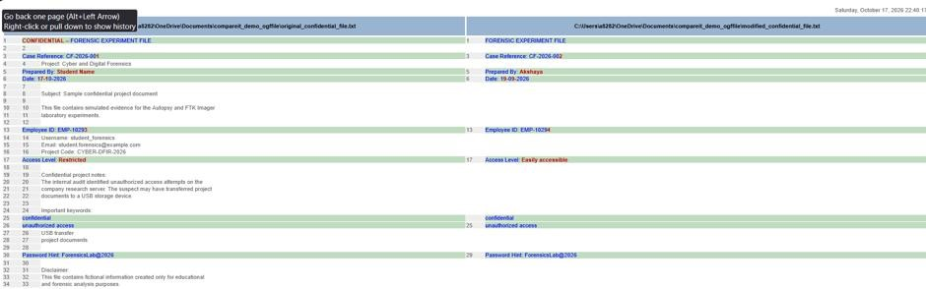
RESULT:
Thus, two files were compared using Compare It software, and the differences in their contents were identified for forensic examination.

EXPERIMENT 8

COLLECTING EMAIL EVIDENCE IN VICTIM PC
AIM:
To collect email-related evidence from a computer by acquiring its RAM using DumpIt and examining the acquired memory for relevant information.
SOFTWARE REQUIREMENTS:
- Operating System: Windows
- Tool: DumpIt
- Memory analysis tool or scripts specified in the lab procedure
THEORY:
Email forensics involves identifying and examining email-related information available on a computer. Such information may help investigators understand communication activities during a digital forensic investigation.
DUMPIT is a memory acquisition utility used to create a physical memory dump of a Windows computer. Volatile memory may contain temporary information associated with running applications, including browser-based email activity.
After acquiring the memory dump, investigators can examine it using suitable forensic analysis tools to identify potentially relevant artifacts, such as email addresses and other email-related information.
The acquired memory must be preserved carefully to maintain the integrity of the evidence.
PROCEDURE:
- CAPTURING RAM USING DUMPIT
  - Download and prepare the DumpIt utility on the Windows computer.
  - Run DumpIt.exe with the required administrative permissions.
  - Read the confirmation prompt displayed by the tool.
  - Enter Y to confirm and begin the memory acquisition, as instructed by the manual.
  - Wait for the acquisition process to complete.
  - Locate the generated raw memory dump in the directory specified by the tool.
  - Record the dump filename and file size.
- EXAMINING EMAIL-RELATED EVIDENCE
  - Open the acquired memory dump using the memory examination procedure specified in the lab manual.
  - Examine the available results for email-related information.
  - Open email.txt to inspect the email-related information identified by the procedure.
  - Open email_histogram.txt to examine the email-related summary or histogram output.
  - Record relevant observations from the generated files.
  - Preserve the acquired dump and analysis results for documentation.
OBSERVATION:
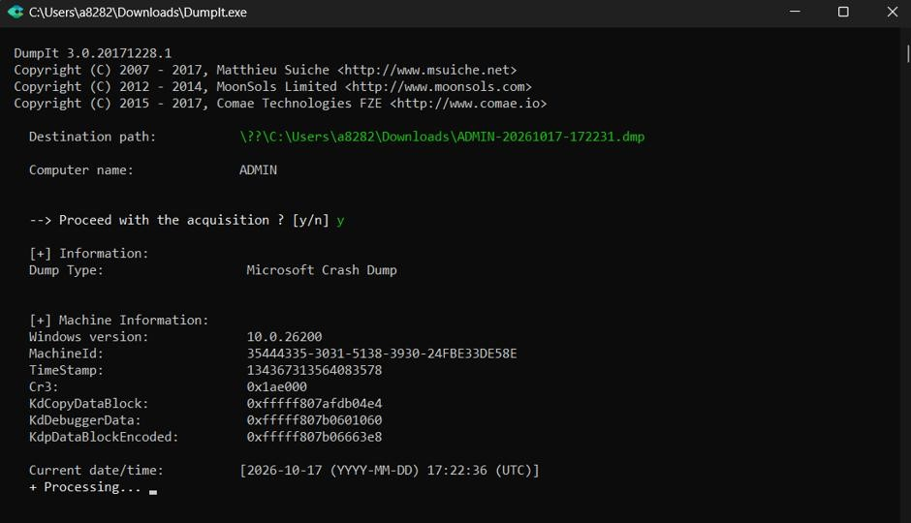
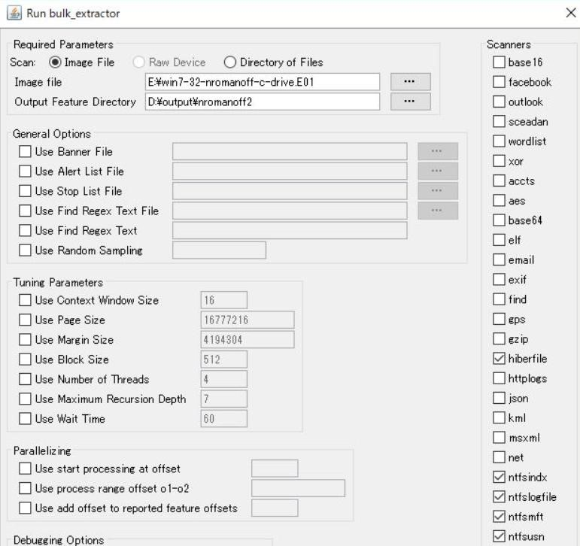
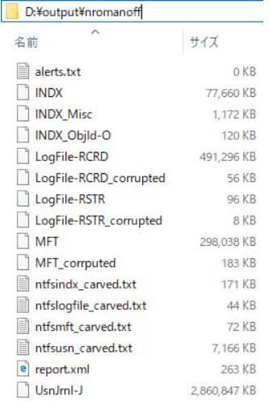
RESULT:
Thus, the procedure for collecting email-related evidence from a computer using DumpIt for RAM acquisition and subsequent memory examination was studied.
EXPERIMENT 9

HIDING AND EXTRACTING A TEXT FILE BEHIND AN IMAGE/AUDIO FILE USING COMMAND PROMPT
AIM:
To demonstrate how to hide a text file behind an image file and an audio file using Command Prompt, with WinRAR used for preparing the archive in the audio method.
SOFTWARE REQUIREMENTS:
- Operating System: Windows
- Command Prompt (CMD)
- WinRAR (for the audio file method)
- Image file (B.jpeg)
- Audio file (sound.mp3)
- Text files (A.txt and secret.txt)
THEORY:
File concatenation is a technique in which the contents of two files are combined into a single output file. In this experiment, a text file is appended to an image file using Command Prompt. For the audio method, the text file is first compressed into a ZIP archive using WinRAR, and the archive is then appended to an audio file using Command Prompt.
The resulting files contain the original image or audio data followed by the additional data. This technique demonstrates how information can be concealed within a combined file. Digital forensic investigators can examine file structures to identify additional data and investigate whether concealed information can be recovered.
PROCEDURE:
A. HIDING A TEXT FILE BEHIND AN IMAGE FILE USING CMD
- Create a folder named hiding_text_in_image on the Desktop.
- Place the image file B.jpeg and text file A.txt inside the folder.
- Open Command Prompt.
- Navigate to the working directory using the following command:
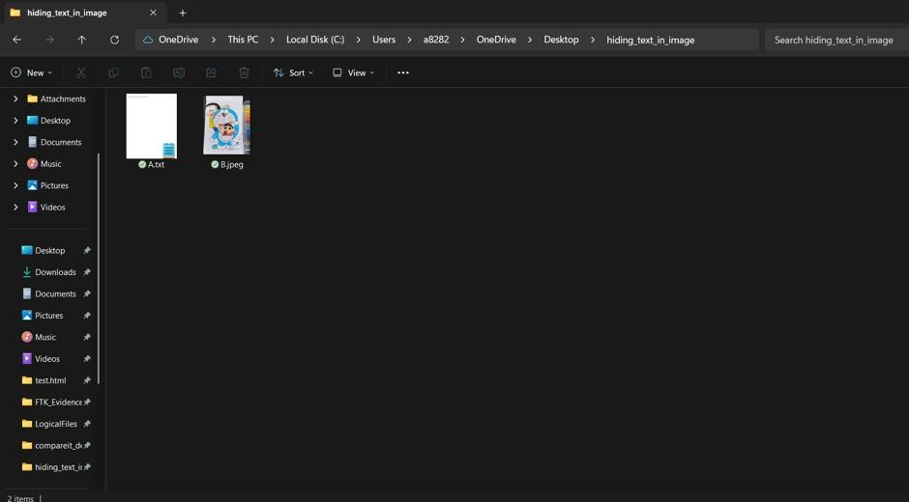
Execute the following command to combine the files: copy /b B.jpeg + A.txt C.jpeg
Where,
- B.jpeg — Original image file.
- A.txt — Text file to be appended.
- C.jpeg — Combined output file.
- /b — Specifies binary mode.
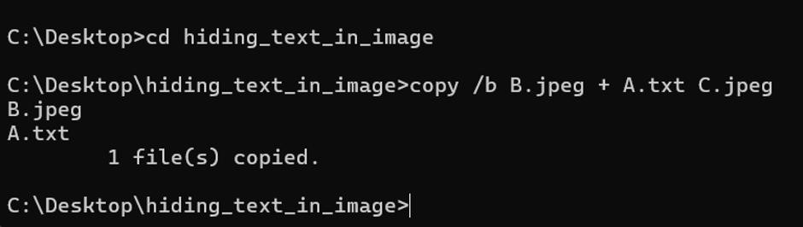
- Wait for the command to complete.
- Verify that the output file C.jpeg is created in the working directory.
- Record the output displayed in Command Prompt.
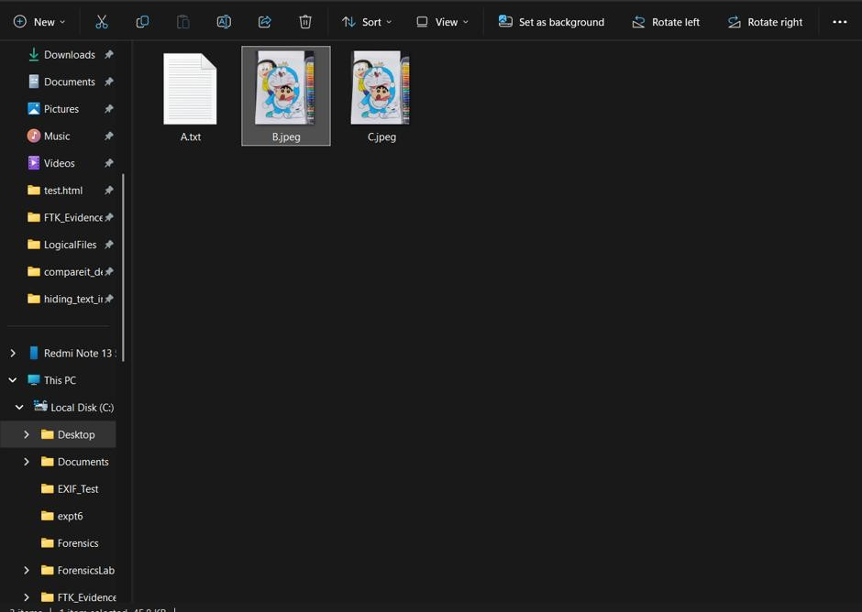
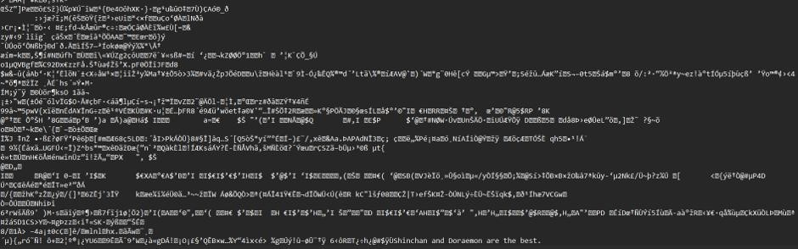
B. HIDING A TEXT FILE BEHIND AN AUDIO FILE USING WINRAR AND CMD
- Create a text file named secret.txt using Notepad.
- Enter sample text and save the file.
- Select secret.txt and use WinRAR to create a ZIP archive named secret.zip.
- Ensure that sound.mp3 and secret.zip are in the same working directory.
- Open Command Prompt and navigate to the Steganography folder. Execute the following command to append the ZIP archive to the audio file: copy /b sound.mp3+secret.zip newfile.mp3
Where,
- sound.mp3 — Original audio file.
- secret.zip — ZIP archive containing the text file.
- newfile.mp3 — Combined output file.
- /b — Specifies binary mode.
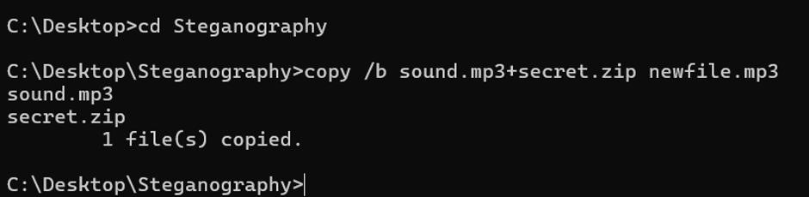
- Wait for the command to complete.
- Verify that the output file newfile.mp3 is created.
- Open newfile.mp3 in Notepad to observe its binary content, if required.
- To attempt recovery, make a copy of newfile.mp3 and try opening the copy using WinRAR. If the appended archive is recognized, extract its contents and verify whether secret.txt can be recovered.
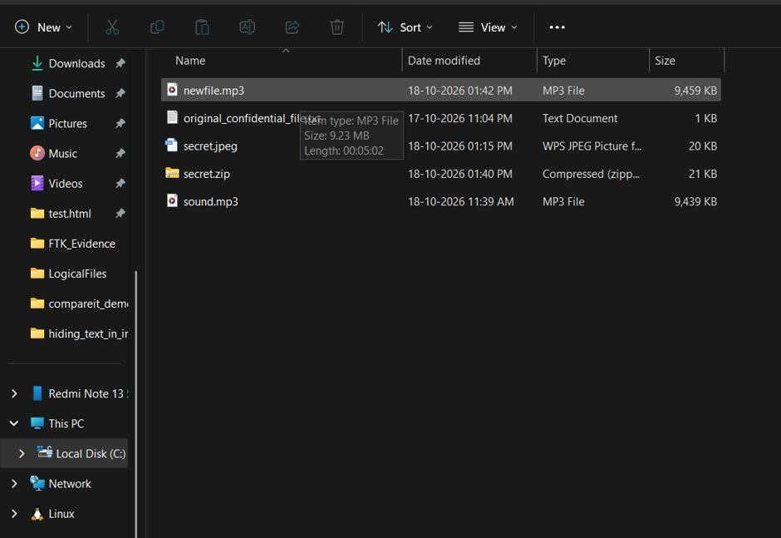
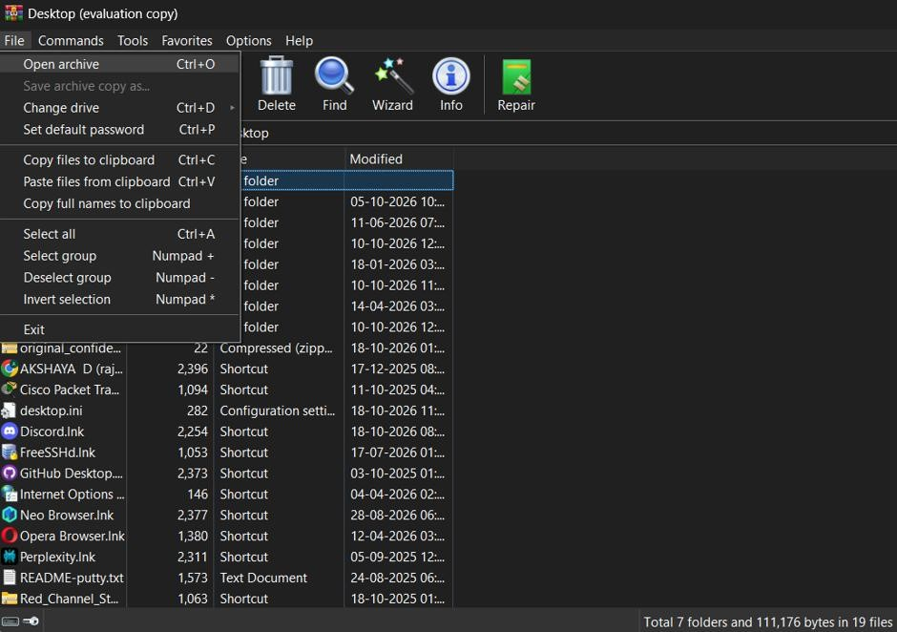
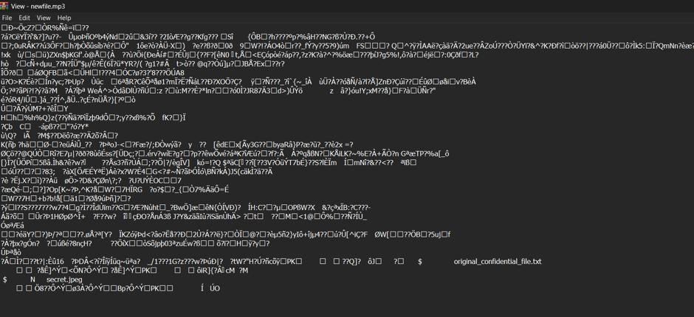
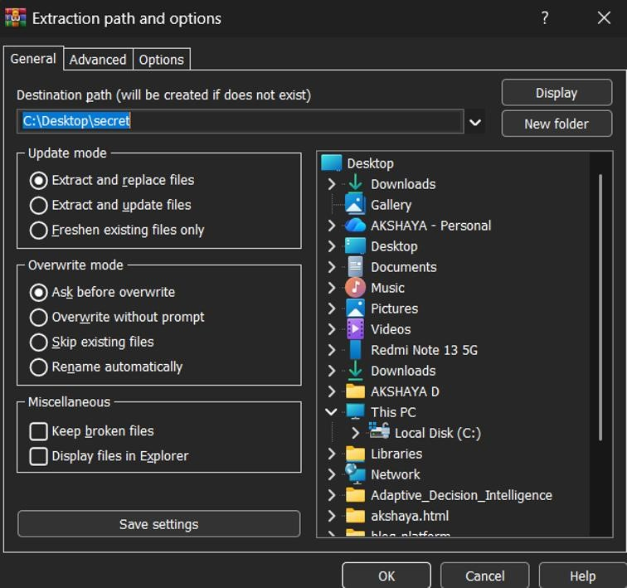
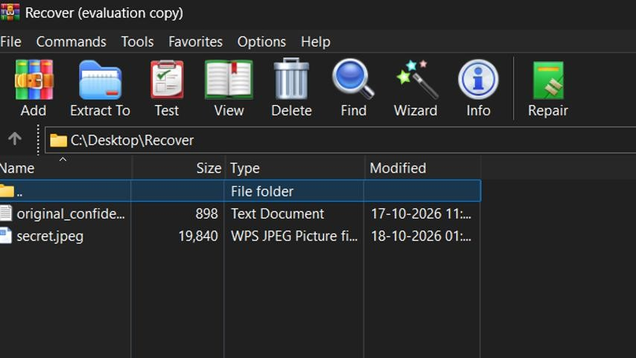

RESULT:

Thus, a text file was appended to an image file using Command Prompt, producing C.jpeg. A ZIP archive containing a text file was also appended to an audio file using WinRAR and Command Prompt, producing newfile.mp3.
EXPERIMENT 10

EXTRACT EXIF DATA FROM IMAGE FILES USING EXIFREADER SOFTWARE
AIM:
To extract and examine Exchangeable Image File Format (EXIF) metadata from an image file using ExifReader software.
SOFTWARE REQUIREMENTS:
- Operating System: Windows
- Software: ExifReader
- An image file in JPEG or JPG format THEORY:
EXIF is a standard used to store metadata associated with digital images. This information may be recorded by digital cameras, smartphones, and other imaging devices.
EXIF metadata may contain details such as:
- CAMERA MAKE AND MODEL: Information about the device used to capture the image.
- DATE AND TIME: The recorded date and time associated with the image, if available.
- CAMERA SETTINGS: Information such as shutter speed, aperture, and exposure.
- FLASH INFORMATION: Indicates whether the camera flash was used, if recorded.
- IMAGE DIMENSIONS: The width and height of the image.
- GPS INFORMATION: Geographic coordinates, if the device recorded them and the metadata remains available.
ExifReader is a Windows-based utility used to display EXIF metadata associated with supported image files. This information can help investigators examine images during a digital forensic investigation.

PROCEDURE:
- Download and prepare ExifReader on the Windows computer.
- Launch the ExifRead.exe application.
- Click the OPEN button in the application window.
- Browse to the location of the image file to be examined.
- Select a JPEG or JPG image file and open it.
- Observe the selected image displayed in the application.
- Examine the EXIF metadata displayed by the software.
- Identify the available details, such as camera information, image dimensions, date and time, and camera settings.
- Record the relevant metadata for forensic examination.
- Capture a screenshot showing the image and its available EXIF information.
OBSERVATION:
ExifReader displays the selected image and the EXIF metadata available within the file.
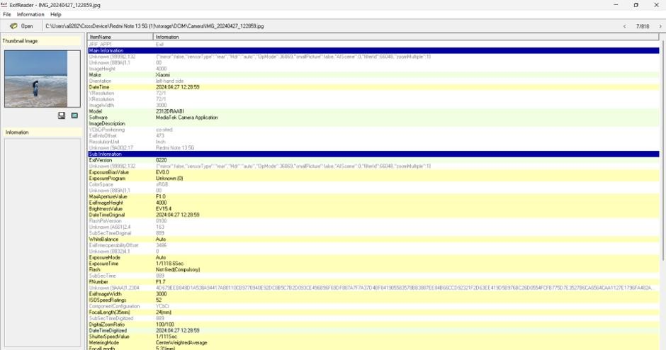
RESULT:
Thus, EXIF metadata was examined using ExifReader software to identify the available information associated with the selected image file.

