MCE 466 - Computer Assignment #2

**Beam Bending Analysis**

*(Due: X/X/2022 at 11:30 PM)*

Consider the beam bending problem shown below. The beam is constructed from steel (E=30 x 106 psi, ν= 0.3, G=11.5 x 106 psi). The beam is simply supported at points *A* and *B*. The beam cross-section is rectangular with a depth, *b*=2 in, and height, *h*=5 in. A uniform distributed load, *w*, is applied between points *A* and *B*. Parameters *w, l* and *a* are given in Table 1.

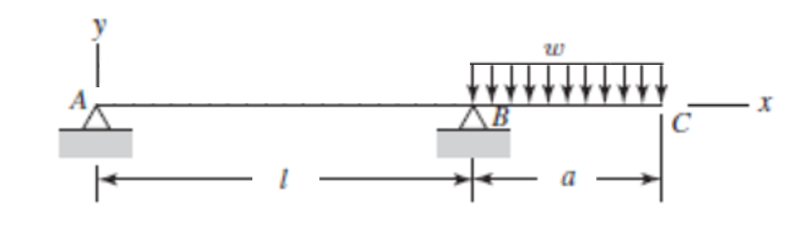

**Part A: Hand calculations**

The analytic solution for the moment distribution and beam deflection is provided in Shigley’s text[1] (see Appendix). Bending stresses can be computed using beam bending theory[2] determine the following results and report them on the attached Solution Summary form:

* Vertical displacement of point C (in)
* Maximum vertical deflection along AB (in)
* Location of maximum vertical deflection along AB as measured by distance from point A (in)
* Maximum bending stress (psi)
* Location of maximum bending stress as measured by distance from point A (in)

**Part B: Abaqus finite element analysis**

Create an Abaqus finite element model using beam elements with a recommended element size of 0.5 in. Report your results on the attached Solution Summary form and compare them to those found in Part A. Attach a screen shot showing contours of bending stress (S11) on the deformed mesh.

Submit your results by uploading the following to Brightspace (look under Assignments - Computer Assignment #2):

1. The solution summary form (see attached)
2. A screen shot showing contours of bending stress (S11) on the deformed mesh.
3. Scanned copy of your hand calculations for Part A
4. Your Abaqus “.cae” file for Part B

**Table 1. Cases**

|  |  |  |  |  |
| --- | --- | --- | --- | --- |
| **Case** | **Student** | ***w* (lb/in)** | ***l* (in)** | ***a* (in)** |
| 1 | Baccala, James | 1000 | 30 | 10 |
| 2 | Bjorn, Rachael | 1000 | 30 | 12 |
| 3 | Borbon, Derek | 1000 | 30 | 14 |
| 4 | Bornstein, Jeremy | 1000 | 30 | 16 |
| 5 | Bulley, Ty | 1000 | 30 | 18 |
| 6 | Chaffey, Evan | 900 | 32 | 10 |
| 7 | Champney, Zach | 900 | 32 | 12 |
| 8 | Coretti, Tony | 900 | 32 | 14 |
| 9 | Dellavalle, Matt | 900 | 32 | 16 |
| 10 | Donahue, Tyler | 900 | 32 | 18 |
| 11 | Driskill, Owen | 800 | 34 | 10 |
| 12 | Gaipo, Christopher | 800 | 34 | 12 |
| 13 | Gervasini, Victor | 800 | 34 | 14 |
| 14 | Hanley, Kevin | 800 | 34 | 16 |
| 15 | Henderson, Nathaniel | 800 | 34 | 18 |
| 16 | Kann, Michael | 700 | 36 | 10 |
| 17 | Kruzick, Danny | 700 | 36 | 12 |
| 18 | Lavoie, Cameron | 700 | 36 | 14 |
| 19 | Lin, Alison | 700 | 36 | 16 |
| 20 | Mirandou, Jason | 700 | 36 | 18 |
| 21 | Murphy, Jacob | 600 | 38 | 10 |
| 22 | Naughton, Aidan | 600 | 38 | 12 |
| 23 | Pollack, Marshall | 600 | 38 | 14 |
| 24 | Pomfret, Benjamin | 600 | 38 | 16 |
| 25 | Stephenson, Keith | 600 | 38 | 18 |
| 26 | Turer, Gavin | 500 | 40 | 10 |
| 27 | Venagro, Connor | 500 | 40 | 12 |
| 28 | Vietri, Noah | 500 | 40 | 14 |

**Appendix – Moment Distribution and Beam Deflection**

Excerpt from Shigley’s problem 4-20



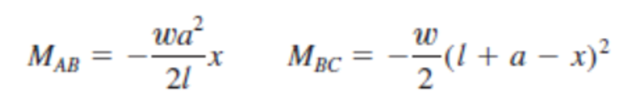

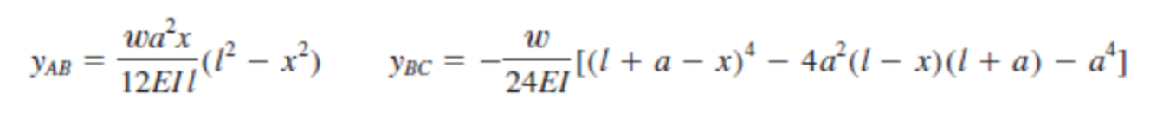

Name________________________________

**Computer Assignment #2 - Solution Summary**

Instructions:

1. Report your solution by filling all fields on this form.
2. Be sure your answers are in the requested units.
3. All numeric values should be reported to three significant digits.
4. Also submit a screen shot showing contours of bending stress (S11) on the deformed mesh, a scanned copy of your hand calculations for Part A and your Abaqus “.cae” file for Part B

|  |  |
| --- | --- |
| *Case #* |  |
| *w* (lb/in) |  |
| *l* (in) |  |
| *a* (in) |  |

|  |  |  |
| --- | --- | --- |
|  | Hand Calculation | Finite Element Results |
| Moment of inertia of the cross-section (in4) |  |  |
| Vertical displacement of point C (in) |  |  |
| Maximum vertical deflection along AB (in) |  |  |
| Location of maximum vertical deflection along AB as measured by distance from point A (in) |  |  |
| Maximum bending stress (psi) |  |  |
| Location of maximum bending stress as measured by distance from point A (in) |  |  |

1. “Shigley's Mechanical Engineering Design,” 10th Edition, Budynas and Nisbett, p. 211, 2015.
2. https://www.youtube.com/watch?v=f08Y39UiC-o&ab_channel=TheEfficientEngineer