MCE 466 - Computer Assignment #3

**Plane Stress Analysis**

*(Due Thursday 4/21/22, 11:30 PM)*

The cruciform test specimen shown below is used to characterize materials subjected to a biaxial stress state.

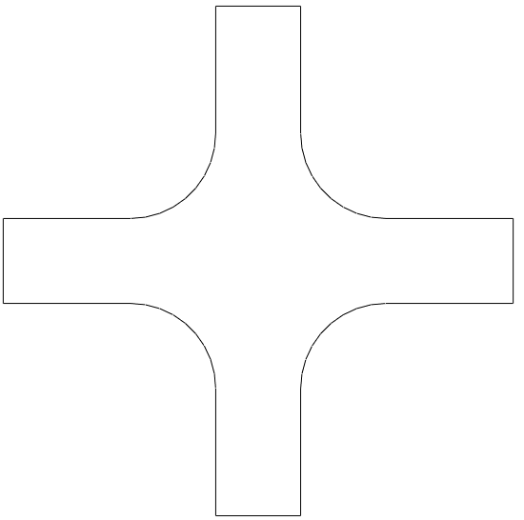

*L*

*w*

*y*

*σy*

*x*

*σx*

*R*

The plate shown has a thickness of 10 mm and is subjected to the applied stresses:

$\begin{matrix}σ_{x}= 100 MPa along x=±L/2 \\ σ_{y}=100 MPa along y=±L/2\end{matrix}$.

According to Hooke’s law, the axial strains are given by

$$\begin{matrix}ε_{x}= \frac{1}{E} \left[σ_{x}-ν \left(σ_{y}+σ_{z}\right)\right] \\ ε_{y}= \frac{1}{E} \left[σ_{y}-ν \left(σ_{x}+σ_{z}\right)\right]\end{matrix}$$

where, in this case, $σ_{z}=0$. Using the properties in Table 1, one might expect that the stresses and strains at (*x*,*y*)=(0,0) would be $σ_{x}=σ_{y}= 100 MPa$ and $ε_{x}=ε_{y}= 9.58×{10}^{-4}$. However, as we will see, the actual stresses and strains deviate from these values and are dependent on the specimen’s fillet radius, *R*.

Use Abaqus to determine the stress at the center of the specimen (*x*=*y*=0) and the magnitude and location of the maximum von Mises stress. Use symmetry conditions where possible. Use the elastic properties given in Table 1 and the parameters given in Table 2. Assume plane stress conditions.

Compare the performance of linear triangles (CST) to quadratic (LST) triangles. For each case, perform a mesh convergence study (evaluate at least 3 meshes for each element type) to convince yourself that your converged solution is within 2% of the exact solution. For the “coarse” and “medium” meshes, use a uniform mesh density. For the “fine” mesh, refine the mesh near regions of stress concentration. Prepare a report that includes:

1. Your results on the Solution Summary sheet
2. Screen shots of each of the 6 meshes
3. von Mises stress contours for two cases: CST fine and LST fine (turn off stress averaging)

Combine your results in a single file named ***your_last_name_CA3.docx*** (or ***.pdf***). Upload this file to Brightspace (under Assignments) by 11:55 PM on X/X/2022

**Table 1. Material Properties**

|  |  |  |
| --- | --- | --- |
| **Material** | **Young's Modulus (GPa)** | **Poisson's ratio** |
| Aluminum | 68.9 GPa | 0.34 |

**Table 2. Cases**

(For all cases, L=300 mm)

|  |  |  |  |
| --- | --- | --- | --- |
| **Student** | **Case** | **w (mm)** | **R (mm)** |
| Baccala, James | 1 | 40 | 20 |
| Bjorn, Rachael | 2 | 40 | 30 |
| Borbon, Derek | 3 | 40 | 40 |
| Bornstein, Jeremy | 4 | 40 | 50 |
| Bulley, Ty | 5 | 45 | 20 |
| Chaffey, Evan | 6 | 45 | 30 |
| Champney, Zach | 7 | 45 | 40 |
| Coretti, Tony | 8 | 45 | 50 |
| Dellavalle, Matt | 9 | 50 | 20 |
| Donahue, Tyler | 10 | 50 | 30 |
| Driskill, Owen | 11 | 50 | 40 |
| Gaipo, Christopher | 12 | 50 | 50 |
| Gervasini, Victor | 13 | 55 | 20 |
| Hanley, Kevin | 14 | 55 | 30 |
| Henderson, Nathaniel | 15 | 55 | 40 |
| Kann, Michael | 16 | 55 | 50 |
| Kruzick, Danny | 17 | 60 | 20 |
| Lavoie, Cameron | 18 | 60 | 30 |
| Lin, Alison | 19 | 60 | 40 |
| Mirandou, Jason | 20 | 60 | 50 |
| Murphy, Jacob | 21 | 65 | 20 |
| Naughton, Aidan | 22 | 65 | 30 |
| Pollack, Marshall | 23 | 65 | 40 |
| Pomfret, Benjamin | 24 | 65 | 50 |
| Stephenson, Keith | 25 | 70 | 20 |
| Turer, Gavin | 26 | 70 | 30 |
| Venagro, Connor | 27 | 70 | 40 |
| Vietri, Noah | 28 | 70 | 50 |

Name __________________________________

**Computer Assignment #3 - Solution Summary**

Instructions:

1. Report your solution by filling all fields on this form.
2. Be sure your answers are in the requested units.
3. All numeric values should be reported to three significant digits.
4. Attach a screen shot of each of the 6 meshes and the von Mises stress contours for the LST fine case (zoom in to the fillet region and turn off stress averaging).
5. Save your report as ***your_last_name_CA3.docx*** (or ***.pdf***). Include all screen shots in this file and upload to Brightspace under "Computer Assignment #3" by X/X/XXXX, 11:55 PM. (Note: **Please upload a single file with both tables and all screenshots**.)

**Case Parameters**

|  |  |
| --- | --- |
| Case # |  |
| *w (*mm*)* |  |
| *R* (mm) |  |

**Results**

|  |  |  |  |  |
| --- | --- | --- | --- | --- |
| **Model** | **# Elements** | **σx at (*x,y*)=(0,0)** | **εx at (*x,y*)=(0,0)** | **Max. von Mises stress (MPa)** |
| CST - coarse |  |  |  |  |
| CST - medium |  |  |  |  |
| CST - fine |  |  |  |  |
| LST - coarse |  |  |  |  |
| LST - medium |  |  |  |  |
| LST - fine |  |  |  |  |