MCE 466 - Computer Assignment #4

**3-D Analysis**

*Due: 4/28/22*

Consider the acoustic transducer shown in Figure 1 (left). The transducer consists of a hollow cylindrical body constructed from aluminum with piezoelectric PZT disks bonded to the top and bottom surfaces as shown in Figure 1 (right). The transducer is designed to measure acoustic signals underwater at depths of up to 50 m. At this depth, the transducer is exposed to an external pressure of about 0.5 MPa. In designing such a device, it is desired to determine the displacements and stresses associated with the pressure loading as well as the natural frequencies of vibration.

Perform 3-D finite element analysis using hexahedral brick elements. Use a 1/2 symmetry model (see Figure 3), applying displacement boundary condition $u_{z}=0$ on the symmetry plane ($z=0$). Compare the response due to both the pressure loading and the natural frequencies of vibration. Perform a two-step analysis to determine:1) the change in cavity thickness and stresses due to an external pressure load of 0.5 MPa and 2) the natural frequencies of vibration.

Report your results using the attached solution summary form. In your report, include the following results:

1. The change in cavity thickness along the center line (r=0) due to the pressure loading. This change in thickness will be twice the axial displacement of the node located at (r,z)=(0,h/2-t1-t2).
2. The von Mises effective stress in the PZT material at the top center location (r,z)=(0,h/2) due to the pressure loading.
3. The first three “unique” natural frequencies of vibration.
4. The vibration mode shapes associated with these three frequencies (attach screen shots to your solution summary.

Upload your report and your .cae file to Brightspace under "Computer Assignment #4" by 4/28/22, 11:30 PM.

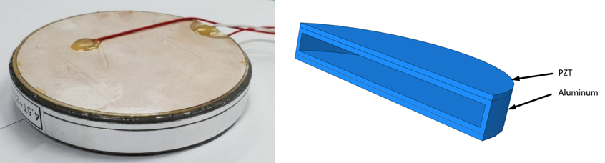

Figure 1. Acoustic transducer: photograph (left), cutaway view (right)

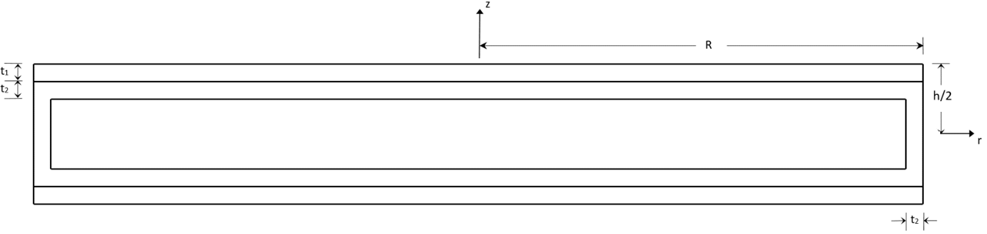

Figure 2. Transducer Cross-section showing critical dimensions

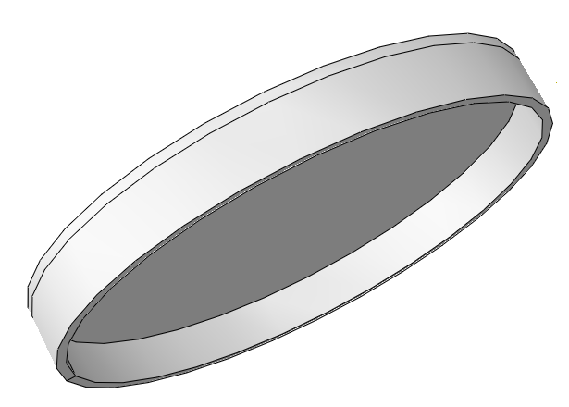

Figure 3. 3-D model - symmetry plane at $z=0$.

Modeling Tips

1. Abaqus requires the user to specify consistent units (see Table 1) throughout the analysis. For this assignment, use the SI (mm) units.
2. In the Sketch module, draw the exterior profile as shown in Figure 4, including points at the interface between the aluminum and the PZT layer .

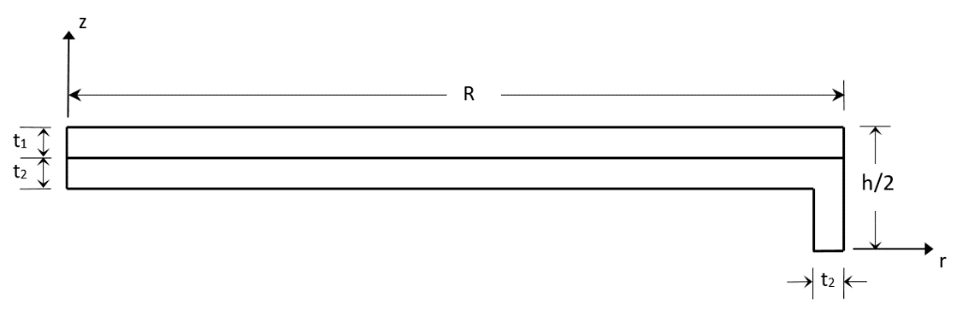

Figure 4. Sketch dimensions

1. In the Parts model, create a part using 3D => Solid => Revolution => Angle = 360. Partition the Part into three regions (PZT, aluminum side wall and aluminum disk) using Tools => Partition => Cell => Define cutting plane => Select cells to partition => Point & Normal or 3 Points.
2. In the Property module, create two materials and specify material density using "General => Density" and "Mechanical => Elasticity => Elastic" and assign these properties to the appropriate regions.
3. In the Step module, create two steps. The first step is "Procedure type: General => Static General" and the second step is "Procedure type: Linear Perturbation => Frequency => Number of eigenvalues requested => Value = 10."
4. In the Mesh module, it is recommended that you create a mesh with 20 node hexahedral, elements of size 0.5 mm.

Table 1. Abaqus Consistent Units

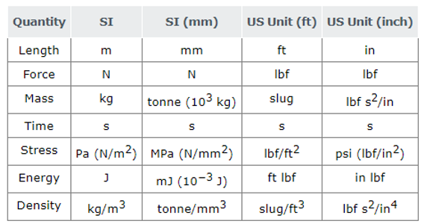

Table 2. Material Properties

|  |  |  |  |
| --- | --- | --- | --- |
| **Material** | **Young's Modulus (GPa)** | **Poisson's ratio** | **Density (tonne/mm3)** |
| Aluminum | 68.9 | 0.34 | 2.70 E-09 |
| PZT | 99.0 | 0.31 | 7.60 E-09 |

Table 3. Cases

(For all cases, h=20 mm)

|  |  |  |  |  |
| --- | --- | --- | --- | --- |
| **Student** | **Case** | **t1 (mm)** | **t2(mm)** | **R (mm)** |
| Baccala, James | 1 | 1.5 | 1.5 | 40 |
| Bjorn, Rachael | 2 | 1.5 | 1.5 | 45 |
| Borbon, Derek | 3 | 1.5 | 1.5 | 50 |
| Bornstein, Jeremy | 4 | 1.5 | 1.5 | 55 |
| Bulley, Ty | 5 | 1.5 | 2 | 40 |
| Chaffey, Evan | 6 | 1.5 | 2 | 45 |
| Champney, Zach | 7 | 1.5 | 2 | 50 |
| Coretti, Tony | 8 | 1.5 | 2 | 55 |
| Dellavalle, Matt | 9 | 1.5 | 2.5 | 40 |
| Donahue, Tyler | 10 | 1.5 | 2.5 | 45 |
| Driskill, Owen | 11 | 1.5 | 2.5 | 50 |
| Gaipo, Christopher | 12 | 1.5 | 2.5 | 55 |
| Gervasini, Victor | 13 | 1.5 | 3 | 40 |
| Hanley, Kevin | 14 | 1.5 | 3 | 45 |
| Henderson, Nathaniel | 15 | 1.5 | 3 | 50 |
| Kann, Michael | 16 | 1.5 | 3 | 55 |
| Kruzick, Danny | 17 | 2 | 1.5 | 40 |
| Lavoie, Cameron | 18 | 2 | 1.5 | 45 |
| Lin, Alison | 19 | 2 | 1.5 | 50 |
| Mirandou, Jason | 20 | 2 | 1.5 | 55 |
| Murphy, Jacob | 21 | 2 | 2 | 40 |
| Naughton, Aidan | 22 | 2 | 2 | 45 |
| Pollack, Marshall | 23 | 2 | 2 | 50 |
| Pomfret, Benjamin | 24 | 2 | 2 | 55 |
| Stephenson, Keith | 25 | 2 | 2.5 | 40 |
| Turer, Gavin | 26 | 2 | 2.5 | 45 |
| Venagro, Connor | 27 | 2 | 2.5 | 50 |
| Vietri, Noah | 28 | 2 | 2.5 | 55 |

Name __________________________________

**Computer Assignment #4 - Solution Summary**

Instructions:

1. Report your solution by filling all fields on this form.
2. Be sure your answers are in the requested units.
3. All numeric values should be reported to three significant digits.
4. Attach a screen shot of the final (converged) mesh with von Mises stress contours due to the pressure loading.
5. Also attach screen shots of each of the frequencies listed in the table below.
6. Combine your results in a single file named ***your_last_name_CA4.docx*** (or ***.pdf***)
7. Save your Abaqus .cae file as ***your_last_name_CA4.cae***
8. Upload both files to Brightspace under "Computer Assignment #4" by 4/28/22, 11:30 PM.

**Case Parameters**

|  |  |
| --- | --- |
| Case # |  |
| *t1* (mm) |  |
| *t2* (mm) |  |
| *R* (mm) |  |

**Results**

|  |  |
| --- | --- |
| Change in cavity thickness along the center line (r=0) due to the pressure loading. This change in thickness will be twice the axial displacement of the node located at (r,z)=(0,h/2-t1-t2). (mm) |  |
| The von Mises effective stress in the PZT material at the top center location (r,z)=(0,h/2) due to the pressure loading. (MPa) |  |
| Starting with the lowest natural frequencies of vibration, record all “unique” natural frequencies up to the third natural frequency (Hz) |  |