MCE 466 - Computer Assignment #5

**Transient Heat Transfer Analysis**

*Due: 5/5/2022 @ 11:30 PM*

In this exercise, we will use Abaqus to study heating of a sphere immersed in boiling water. For these problems, we will compare the effect of specifying: 1) temperature boundary conditions at the surface to 2) convection conditions where the heat flow at the surface, $\dot{q}$, is proportional to the difference of surface temperature, $T_{s}$, and the water temperature, $T_{w}$ and the according to

$$\dot{q}=h \left(T_{s}-T_{w}\right)$$

where *h* is the convection heat transfer coefficient.

**Part A.** Simulation of a boiled egg (see demonstration video posted on course website)

To validate our solution approach, we will first use Abaqus to reproduce the online COMSOL simulation[1] of a boiling egg. In this simulation, the egg is approximated as a sphere with radius, *R*=2.5 cm. The egg has an initial temperature of 5°C and at time zero is immersed in hot water at a temperature, *Tw*=95°C. The thermal properties of the simulated egg are given in Table 1. Although the COMSOL simulation utilizes a 3D model, due to symmetry conditions we can model this problem in Abaqus using axisymmetric elements with no loss in accuracy. Create an axisymmetric model using the geometry shown in Figure 1. Note that in order to use consistent units, we will use SI units as shown in Table 2. Note that with SI units, the geometry is to be sketched using meters (R=.025 m). Since the heat flow is purely in the radial direction, we can treat the left and bottom edges as insulated surfaces, where no boundary conditions are specified. On the surface, *r*=*R*, impose a convective film coefficient of h=1,200 W/(m-°C). Perform a transient heat transfer analysis using a fixed time step of 1 second. Determine the time required for the center of the sphere to reach a temperature of 70°C and compare your result to the COMSOL solution of 860 sec. Repeat the analysis, replacing the convection boundary condition at the surface with a specified surface temperature *T*=95°C.

**Part B**. Simulation of a glass sphere using temperature boundary conditions

Perform a similar analysis as Part A, using the thermal properties of glass (see Table 1) and parameters given in Tables 2 and 3. The glass sphere has an initial temperature of 25°C and at time zero is immersed in boiling water at a temperature, *T*=*Twater*. For this analysis (Part B), impose temperature boundary conditions, *T*= *Twater*, at the glass/water interface. Determine the temperature at the center of the sphere after being submerged for one hour. Refine the mesh and adjust the time step as needed to assure that your solution is within 2% of the exact solution.

**Part C**. Simulation of a glass sphere using convection surface conditions

Modify the model created for Part B, deleting the surface temperature boundary condition and creating surface boundary conditions using parameters specified in Tables 1-3. Determine the temperature at the center of the sphere and at the glass/water interface after being submerged for one hour.

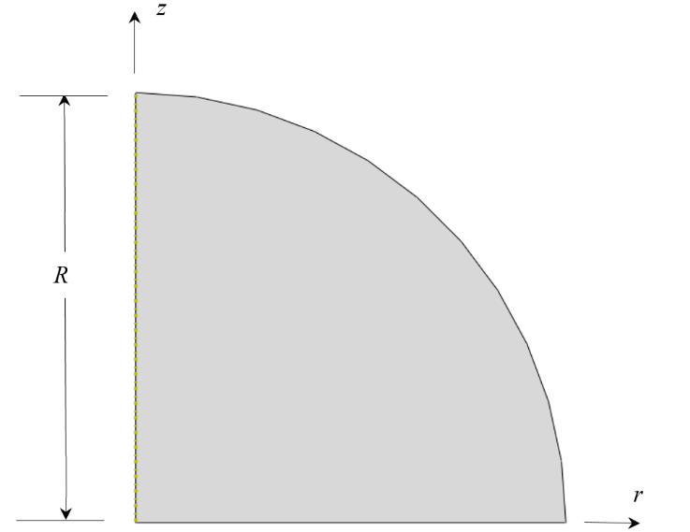

Figure 1. Finite Element Axisymmetric Model Geometry

Table 1. Thermal Properties

|  |  |  |
| --- | --- | --- |
| **Property (units)** | **Simulated Egg** | **Glass** |
| Conductivity, k, W/(m-°C) | 0.627 | 1.0 |
| Density, ρ, kg/m3 | 993.05 | 2400 |
| Specific heat, cp, J/(kg-°C) | 4178.5 | 800 |

Table 2. Abaqus Consistent Units

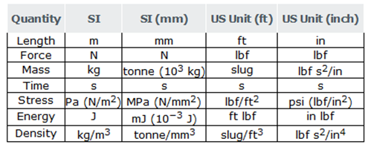

**Table 3. Cases**

|  |  |  |  |  |
| --- | --- | --- | --- | --- |
| **Student** | **Case** | ***R* (cm)** | ***Twater* (°C)** | ***h* (W/(m-°C))** |
| Baccala, James | 1 | 12 | 70 | 10 |
| Bjorn, Rachael | 2 | 12 | 70 | 50 |
| Borbon, Derek | 3 | 12 | 70 | 100 |
| Bornstein, Jeremy | 4 | 14 | 80 | 10 |
| Bulley, Ty | 5 | 14 | 80 | 50 |
| Chaffey, Evan | 6 | 14 | 80 | 100 |
| Champney, Zach | 7 | 16 | 90 | 10 |
| Coretti, Tony | 8 | 16 | 90 | 50 |
| Dellavalle, Matt | 9 | 16 | 90 | 100 |
| Donahue, Tyler | 10 | 18 | 70 | 10 |
| Driskill, Owen | 11 | 18 | 70 | 50 |
| Gaipo, Christopher | 12 | 18 | 70 | 100 |
| Gervasini, Victor | 13 | 20 | 80 | 10 |
| Hanley, Kevin | 14 | 20 | 80 | 50 |
| Henderson, Nathaniel | 15 | 20 | 80 | 100 |
| Kann, Michael | 16 | 22 | 70 | 10 |
| Kruzick, Danny | 17 | 22 | 70 | 50 |
| Lavoie, Cameron | 18 | 22 | 70 | 100 |
| Lin, Alison | 19 | 24 | 80 | 10 |
| Mirandou, Jason | 20 | 24 | 80 | 50 |
| Murphy, Jacob | 21 | 24 | 80 | 100 |
| Naughton, Aidan | 22 | 26 | 90 | 10 |
| Pollack, Marshall | 23 | 26 | 90 | 50 |
| Pomfret, Benjamin | 24 | 26 | 90 | 100 |
| Stephenson, Keith | 25 | 28 | 70 | 10 |
| Turer, Gavin | 26 | 28 | 70 | 50 |
| Venagro, Connor | 27 | 28 | 70 | 100 |
| Vietri, Noah | 28 | 30 | 80 | 10 |

Name________________________________

**Computer Assignment #5 - Solution Summary**

Instructions:

1. Report your solution by filling all fields in the tables below
2. Be sure your answers are in the requested units.
3. All numeric values should be reported to three significant digits.
4. For Parts B & C, include screen shots of your final mesh and the temperature distribution at *t* = 60 min.

**Results – Part A**

|  |  |
| --- | --- |
| Element Shape (triangle/quadrilateral) |  |
| Interpolation function (linear/quadratic) |  |
| Number of elements |  |
| Number of time steps |  |
| Time required to reach 70°C (convection surface conditions) |  |
| Time required to reach 70°C (temperature conditions at surface) |  |

**Results – Parts B & C**

|  |  |
| --- | --- |
| Case # |  |
| *R (*cm*)* |  |
| *Twater* (°C) |  |
| *h* (W/(m-°C)) |  |
| Element Shape (triangle/quadrilateral) |  |
| Interpolation function (linear/quadratic) |  |
| Number of elements |  |
| Number of time steps |  |
| **Part B:** Temperature at center of sphere, *r*=0, at time = 60 min (°C) |  |
| **Part C:** Temperature at center of sphere, *r*=0, at time = 60 min (°C) |  |
| **Part C:** Temperature at outer surface *r*=*R*, at time = 60 min (°C) |  |

Upload the following files to Brightspace under Computer Assignment #5 by 11:30 PM on 5/5/22:

1. An MSWord (or pdf) file with this solution summary form and the Abaqus screen shots.
2. Your Abaqus “.cae” files (Part B & C)

1. COMSOL Conduction heat transfer - Boiling Eggs, *https://www.youtube.com/watch?v=HZtdfpbAz9E*