MCE 466 - Computer Assignment #1

**Truss Analysis**

*(Due: 10/4/21, 11:30 PM)*

The plane truss shown below has 17 members (*AB, AC, BC, BD, CD, CE, CF, DE, EF, EH, EG, FH, GH, GI, HI, HJ* and *IJ)*. The members are constructed from steel (Young’s modulus = 30 x 106 psi and Poisson’s ratio = 0.29). All members have circular cross sections with radii of 1 in. Note that joints *B* and I are midway between joints *A* & *D* and *G* & *J*, respectively.

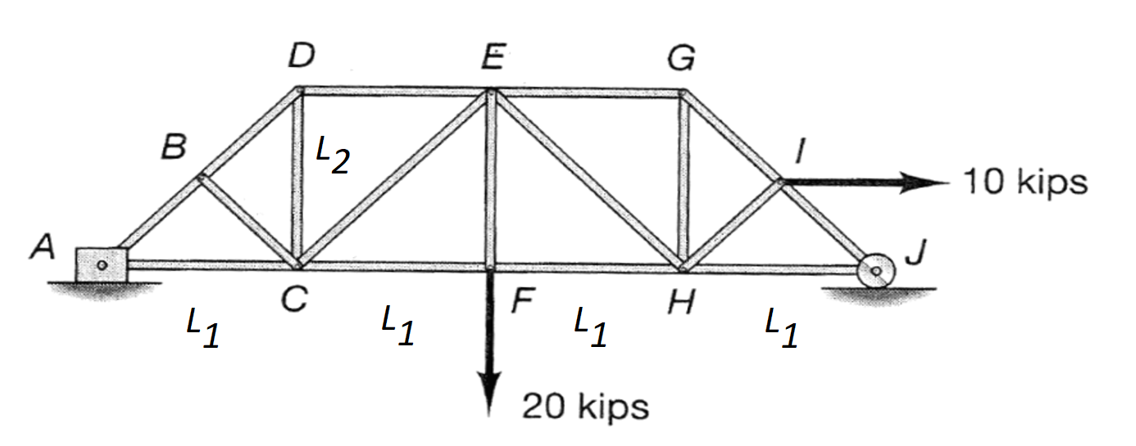

**Part A:** Using the case definitions given in Table 1, perform a hand calculation using the method of joints[1] and/or the method of sections[2] to determine the following:

Which member (identified by joint letters, e.g. *AB*, *AC*, etc.) has the largest tensile stress?

What is the stress (in ksi) in the member with the largest tensile stress?

Which member (identified by joint letters, e.g. *AB*, *AC*, etc.) has the largest compressive stress?

What is the stress (in ksi) in the member with the largest compressive stress?

**Part B:** Perform a finite element analysis using the Matlab code provided in class and compare the results to those in Part A. Also, determine the horizontal and vertical displacement (in inches) of joint F?

**Part C:** Create an Abaqus model for the same problem analyzed in Parts A and B and compare the results.

Submit your results by uploading the following three files to Brightspace (look under Computer Assignment #1):

1. The solution summary form (see last page of this assignment)
2. Scanned copy of your hand calculations for Part A
3. Your Matlab “.m” file for Part B
4. Your Abaqus “.cae” file for Part C

**Table 1. Cases**

|  |  |  |  |
| --- | --- | --- | --- |
| **Case #** | **Student** | ***L1 (ft)*** | ***L2 (ft)*** |
| 1 | Antoch, Seth | 8 | 8 |
| 2 | Badick, Jake | 8 | 10 |
| 3 | Berry, Mike | 8 | 12 |
| 4 | Carella, Jacob | 8 | 14 |
| 5 | Charbonneau, Jay | 8 | 16 |
| 6 | Damm, Stephan | 10 | 8 |
| 7 | Darkow, Grace | 10 | 10 |
| 8 | Gattoni, Eric | 10 | 12 |
| 9 | Haddock, Justin | 10 | 14 |
| 10 | Jasinski, Peter | 10 | 16 |
| 11 | Lavoie, Jake | 12 | 8 |
| 12 | Mullin, Patrick | 12 | 10 |
| 13 | Murphy, Adam | 12 | 12 |
| 14 | Nguyen, Emmett | 12 | 14 |
| 15 | O'Connor, Morgan | 12 | 16 |
| 16 | Pratt, Austin | 14 | 8 |
| 17 | Rouillier, Connor | 14 | 10 |
| 18 | Royal, Jaxon | 14 | 12 |
| 19 | Sitar, Carter | 14 | 14 |
| 20 | Townsend, Brad | 14 | 16 |
| 21 | Treacy, Collin | 16 | 8 |
| 22 | Turnbull, Maya | 16 | 10 |
| 23 | Turner, Justin | 16 | 12 |
| 24 | Vieira, Jacob | 16 | 14 |
| 25 | Zhen, Honghao | 16 | 16 |

Name________________________________

**Computer Assignment #1 - Solution Summary**

Instructions:

1. Report your solution by filling all blank fields on this form.
2. Be sure your answers are in the requested units.
3. All numeric values should be reported to three significant digits.
4. Be sure to identify members by joint letters (e.g. *AB, AC, BC*, etc.). Do not report Matlab or Abaqus generated element numbers.

Upload the following files to Brightspace under Computer Assignment #1 by 11:30 PM on 10/4/21:

1. This solution summary form
2. Scanned copy of your hand calculations for Part A
3. Your Matlab “.m” file for Part B
4. Your Abaqus “.cae” file for Part C

|  |  |  |  |
| --- | --- | --- | --- |
| *Case* # _______ | Hand Calculation | Matlab | Abaqus |
| *L1*(ft) |  |  |  |
| *L2* (ft) |  |  |  |
| Horizontal displacement of joint E (in) |  |  |  |
| Vertical displacement of joint E (in) |  |  |  |
| Member(s) with largest tensile stress (identify by joint letters) |  |  |  |
| Stress in member with largest tensile stress (ksi) |  |  |  |
| Member(s) with largest compressive stress (identify by joint letters) |  |  |  |
| Stress in member with largest compressive stress (ksi) |  |  |  |

1. https://www.youtube.com/watch?v=08ChRvOt9iI&ab_channel=Engineer4Free
2. https://www.youtube.com/watch?v=PXS9n-b5CA8&ab_channel=Engineer4Free