MCE 466 - Computer Assignment #2

**Beam Bending Analysis**

*(Due: 10/18/2021 at 11:30 PM)*

Using ABAQUS, solve the beam bending problem shown below. The beam is constructed from steel (E=30 x 106 psi, ν= 0.3, G=11.5 x 106 psi). The loads are given as *P*=2,000 lb and *w*=500 lb/in. Model parameters *L1* and *L2* are given in Table 1.

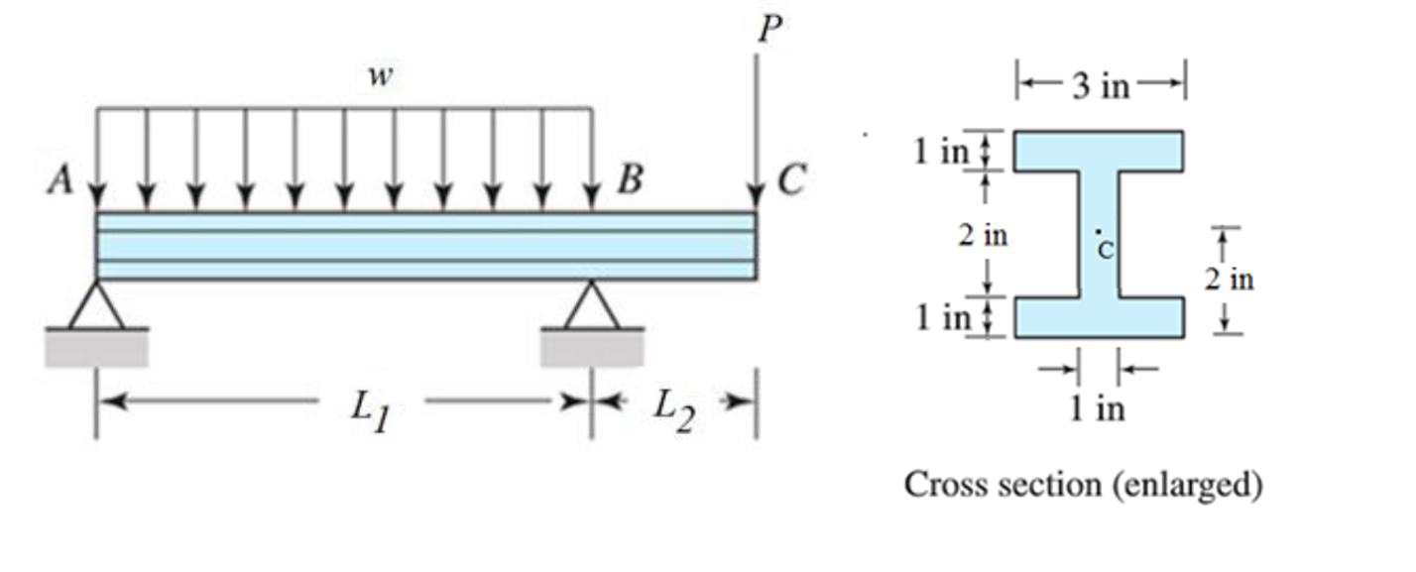

**Part A:** Perform hand calculations, determine the following results and report them on the attached Solution Summary form:

* Vertical displacement of point C (in)
* Maximum vertical deflection along AB (in)
* Location of maximum vertical deflection along AB as measured by distance from point A (in)
* Maximum bending stress (psi)
* Location of maximum bending stress as measured by distance from point A (in)

Note that the moment of inertia of the cross-sections can be computed using composite area analysis and the parallel axis theorem[1]. Shear and bending moment diagrams can be derived through application of equilibrium[2]. Beam bending theory can be applied to determine the bending stresses[3]. Beam deflections can be computed using superposition (see Shigley’s example 4.3, attached below as an Appendix)

**Part B:** Using beam elements, create a finite element model with approximately 50 elements. Report your results on the attached Solution Summary form and compare them to those found in Part A. Attach a screen shot showing contours of bending stress (S11) on the deformed mesh.

Submit your results by uploading the following to Brightspace (look under Assignments - Computer Assignment #2):

1. The solution summary form (see last page of this assignment)
2. A screen shot showing contours of bending stress (S11) on the deformed mesh.
3. Scanned copy of your hand calculations for Part A
4. Your Abaqus “.cae” file for Part B

**Table 1. Cases**

|  |  |  |  |
| --- | --- | --- | --- |
| Case | Student | *L1* (in) | *L2* (in) |
| 1 | Antoch, Seth | 20 | 10 |
| 2 | Badick, Jake | 20 | 12 |
| 3 | Berry, Mike | 20 | 14 |
| 4 | Carella, Jacob | 20 | 16 |
| 5 | Charbonneau, Jay | 20 | 18 |
| 6 | Damm, Stephan | 22 | 10 |
| 7 | Darkow, Grace | 22 | 12 |
| 8 | Gattoni, Eric | 22 | 14 |
| 9 | Haddock, Justin | 22 | 16 |
| 10 | Jasinski, Peter | 22 | 18 |
| 11 | Lavoie, Jake | 24 | 10 |
| 12 | Mullin, Patrick | 24 | 12 |
| 13 | Murphy, Adam | 24 | 14 |
| 14 | Nguyen, Emmett | 24 | 16 |
| 15 | O'Connor, Morgan | 24 | 18 |
| 16 | Pratt, Austin | 26 | 10 |
| 17 | Rouillier, Connor | 26 | 12 |
| 18 | Royal, Jaxon | 26 | 14 |
| 19 | Sitar, Carter | 26 | 16 |
| 20 | Townsend, Brad | 26 | 18 |
| 21 | Treacy, Collin | 28 | 10 |
| 22 | Turnbull, Maya | 28 | 12 |
| 23 | Turner, Justin | 28 | 14 |
| 24 | Vieira, Jacob | 28 | 16 |
| 25 | Zhen, Honghao | 28 | 18 |

Name________________________________

**Computer Assignment #2 - Solution Summary**

Instructions:

1. Report your solution by filling all fields on this form.
2. Be sure your answers are in the requested units.
3. All numeric values should be reported to three significant digits.
4. Also submit a screen shot showing contours of bending stress (S11) on the deformed mesh, a scanned copy of your hand calculations for Part A and your Abaqus “.cae” file for Part B

|  |  |  |
| --- | --- | --- |
| *Case #* | Hand Calculation | Finite Element Results |
| *L1* (in) |  |  |
| *L2* (in) |  |  |
| Moment of inertia of the cross-section (in4) |  |  |
| Vertical displacement of point C (in) |  |  |
| Maximum vertical deflection along AB (in) |  |  |
| Location of maximum vertical deflection along AB as measured by distance from point A (in) |  |  |
| Maximum bending stress (psi) |  |  |
| Location of maximum bending stress as measured by distance from point A (in) |  |  |

**Appendix – Beam Deflection by Superposition[4]**

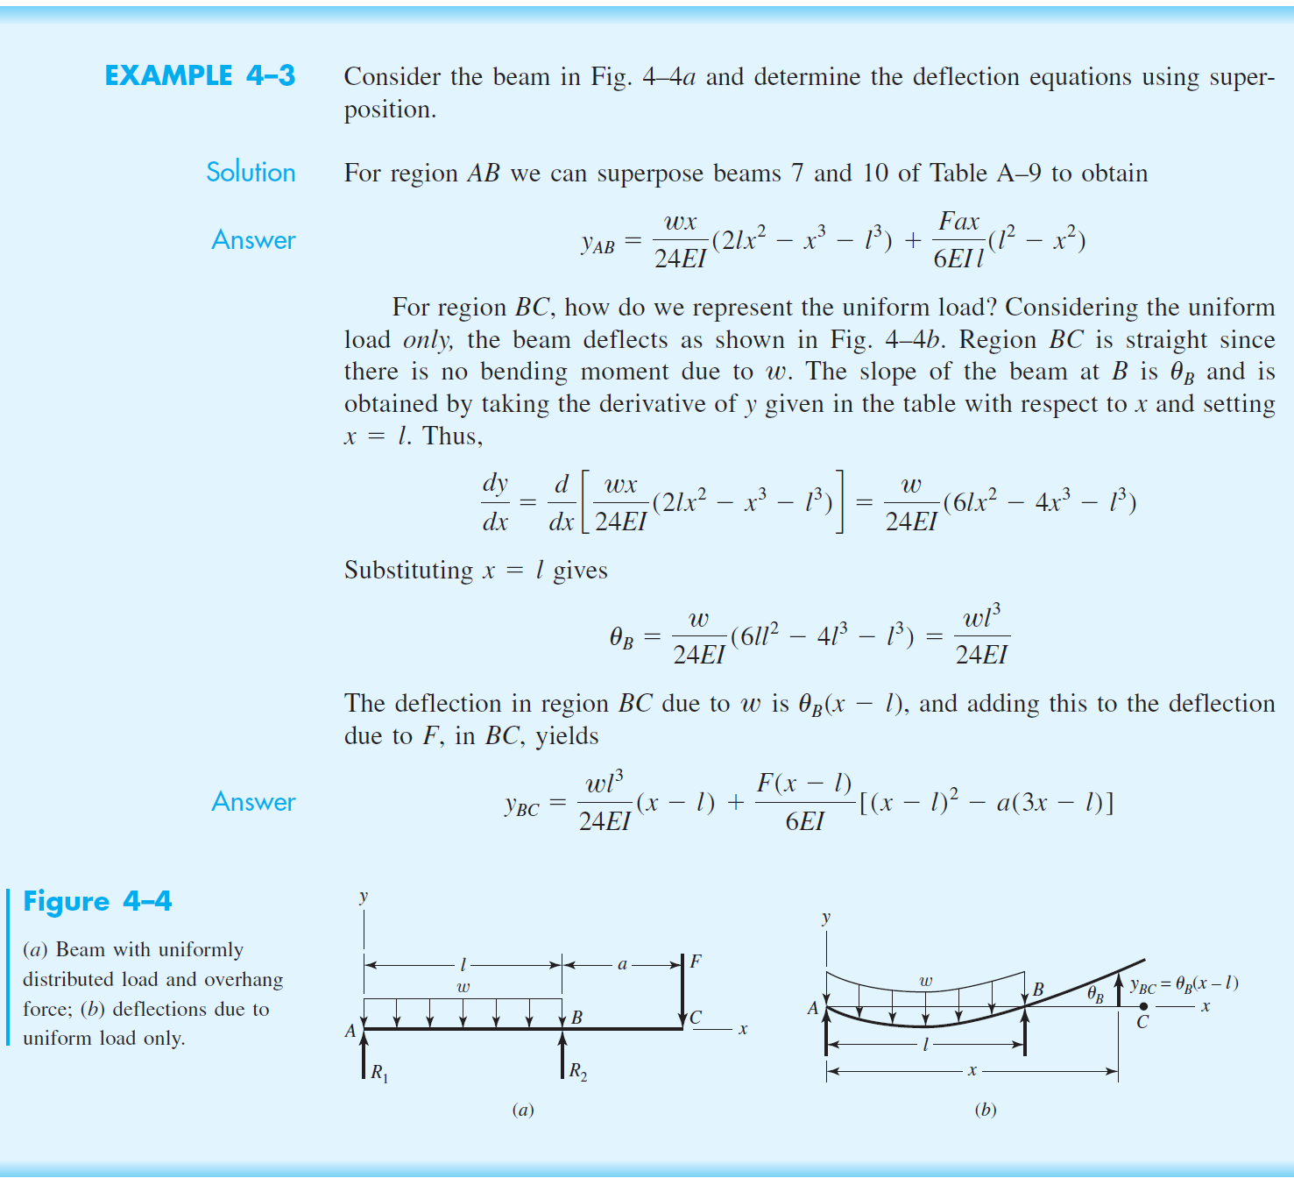

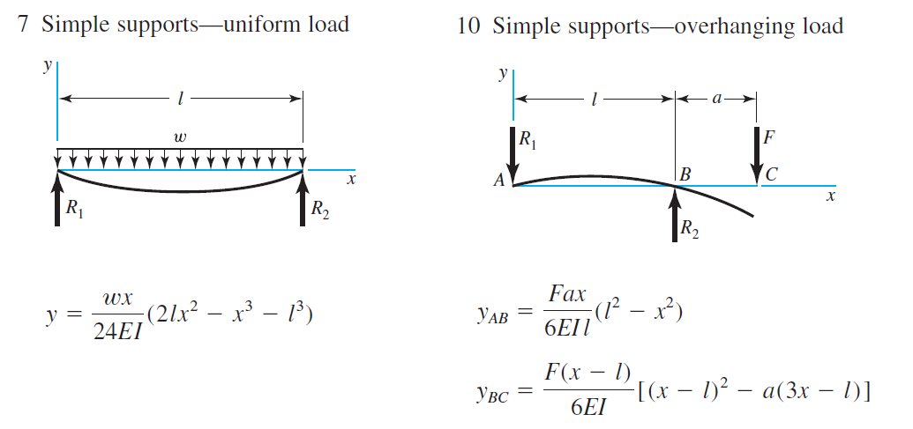

1. https://www.youtube.com/watch?v=Ag7XpNqEUqs&ab_channel=MechanicsChannelbyMarkBarkey
2. https://www.youtube.com/channel/UCXAS_Ekkq0iFJ9dSUIkcAkw
3. https://www.youtube.com/watch?v=f08Y39UiC-o&ab_channel=TheEfficientEngineer
4. Budynas, R.G and Nisbett, J.K, “Shigley’s Mechanical Engineering Design,” 10th edition, 2015, McGraw Hill.