MCE 466 - Computer Assignment #3

**Plane Stress Analysis**

*Due:* 11/3/21, 11:30 PM

Consider a square plate of width and height, *W*=10 in, thickness, *t*=0.1 in, with a central hole of radius, *a*, as shown in Figure 1. The plate is constructed from steel with elastic properties given in Table 1. The plate is subjected to a vertical stress of *T*=1,000 psi and a horizontal stress, *S*, given in Table 2. The objective of this assignment is to determine the stress and strain response associated with this loading.

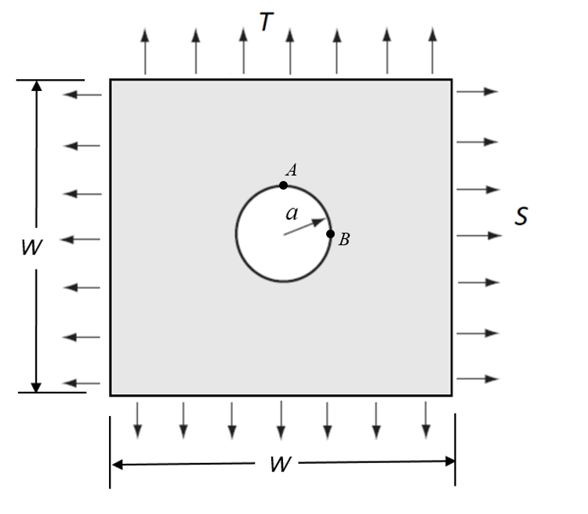

Figure 1. Square Plate with Central Hole under Biaxial Loading

**Table 1. Material Properties**

|  |  |  |
| --- | --- | --- |
| **Material** | **Young's Modulus (psi)** | **Poisson's ratio** |
| Aluminum | 10 x 106 | 0.34 |

Part A – Hand calculations

We can estimate the stress and strain solution using the theoretical solution for a stress-free hole in an infinite plate under biaxial far-field loading (See Figure 1).

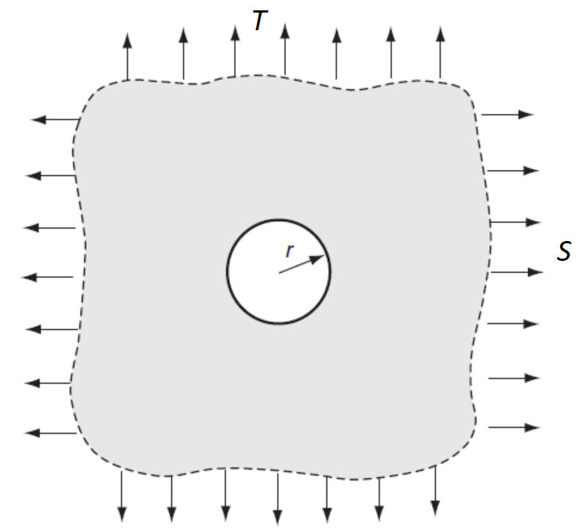

Figure 2. Stress-Free Hole in Infinite Plate Under Biaxial Far-Field Loading[1]

The theoretical solution, developed in the Elasticity text by Sadd1, can be used to show that the maximum stresses occur at the hole boundary, where, in cylindrical coordinates, $σ_{r}= τ_{rθ}=0$. The circumferential stress, $σ_{θ}$ is given by

$$σ_{θ}\left(r,θ\right)= \frac{\left(S+T\right)}{2}\left(1+\frac{a^{2}}{r^{2}}\right)-\frac{ S\cos{2θ}+T\cos\left(2θ+π\right)}{2}\left(1+\frac{3a^{4}}{r^{4}}\right)$$

At Point A (top of the hole), where $\left(r,θ\right)=\left(a,π/2\right)$ and $\left(x,y\right)=\left(0,a\right)$

$$σ_{θ}\left(a,π/2\right)= σ_{x}\left(0,a\right)= 3S-T$$

At Point B (right edge of the hole), where $\left(r,θ\right)=\left(a,0\right)$ and $\left(x,y\right)=\left(a,0\right)$

$$σ_{θ}\left(a,0\right)= σ_{y}\left(a,0\right)= 3T-S$$

Using the infinite plate solution, determine the following and record your results on the Solution Summary Form, attached:

1. For an infinite plate, far from the hole, the state of stress is $σ_{x}=S$, $σ_{y}=T$, and ${σ_{z}=τ}_{xy}=τ_{xz}=τ_{yx}= 0$. For this stress state, using the elastic properties given in Table 1 and the parameters given in Table 2 for your case, determine the far field normal strains, $ε_{x}$, and $ε_{y}$ using the relations[2]
2. For the far field stress state, the von Mises effective stress given by2

For your case, compute the far field von Mises effective stress.

1. As $W→∞$, the horizontal stress at the top of the hole (Figure 2 - Point A) is given by

$σ_{x}\left(0,a\right)=3 S-T$ and $σ_{y}\left(0,a\right)=0$

and the vertical stress at the right edge of the hole is (Figure 2 - Point B) is given by

$σ_{x}\left(a,0\right)=0$ and $σ_{y}\left(a,0\right)=3 T-S$

Note that the maximum von Mises stress is the maximum of $\left|σ_{x}\left(0,a\right)\right|$ and $\left|σ_{y}\left(a,0\right)\right|$.

For your case, compute $σ_{x}\left(0,a\right)$ and $σ_{y}\left(a,0\right)$ and the maximum von Mises stress.

1. Determine the stress concentration factor defined as

$$K= \frac{maximum von Mises stress}{far field von Mises stress}$$

Part B – Finite Element Analysis

Use Abaqus to create a finite element model for your case. Use symmetry conditions where possible. Assume plane stress conditions. Compare the performance of linear triangles (CST) to quadratic (LST) triangles. For each case, perform a mesh convergence study (evaluate at least 3 meshes for each case) to convince yourself that your converged solution is within 2% of the unknown exact solution. For the “coarse” and “medium” meshes, use a uniform mesh density. For the “fine” mesh, refine the mesh near regions of stress concentration. Recommended seed sizes:

Coarse mesh – 0.25 inch uniform mesh density

Medium mesh – 0.10 inch uniform mesh density

Fine mesh – 0.02 inch at the hole, 0.10 inch far from the hole with bias transitions

Report the maximum von Mises stress for each case in the first table provided on the Summary Sheet.

For you most accurate result (which should be LST – fine mesh), determine the following and report the results on the second table provided on the Summary Sheet.

1. the magnitude of the far field strains, $ε_{x}$ and $ε_{y}$, and von Mises stress, i.e. at the point .

2. the stresses and $σ_{von Mises}$ at Points A and $σ_{y}$ and at B.

3. the magnitude of the maximum von Mises stress.

4. The von Mises stress concentration factor, *K*.

**Table 2. Cases**

(For all cases, T=1,000 psi)

|  |  |  |  |
| --- | --- | --- | --- |
| **Student** | **Case #** | ***a* (in)** | **S (psi)** |
| Antoch, Seth | 1 | 0.3 | -1500 |
| Badick, Jake | 2 | 0.35 | -1400 |
| Berry, Mike | 3 | 0.4 | -1300 |
| Carella, Jacob | 4 | 0.45 | -1200 |
| Charbonneau, Jay | 5 | 0.5 | -1100 |
| Damm, Stephan | 6 | 0.55 | -900 |
| Darkow, Grace | 7 | 0.6 | -800 |
| Gattoni, Eric | 8 | 0.3 | -700 |
| Haddock, Justin | 9 | 0.35 | -600 |
| Jasinski, Peter | 10 | 0.4 | -500 |
| Lavoie, Jake | 11 | 0.45 | -400 |
| Mullin, Patrick | 12 | 0.5 | -300 |
| Murphy, Adam | 13 | 0.55 | -200 |
| Nguyen, Emmett | 14 | 0.6 | -100 |
| O'Connor, Morgan | 15 | 0.3 | 100 |
| Pratt, Austin | 16 | 0.35 | 200 |
| Rouillier, Connor | 17 | 0.4 | 300 |
| Royal, Jaxon | 18 | 0.45 | 400 |
| Sitar, Carter | 19 | 0.5 | 500 |
| Townsend, Brad | 20 | 0.55 | 600 |
| Treacy, Collin | 21 | 0.6 | 700 |
| Turnbull, Maya | 22 | 0.3 | 800 |
| Turner, Justin | 23 | 0.35 | 900 |
| Vieira, Jacob | 24 | 0.4 | 1100 |
| Zhen, Honghao | 25 | 0.45 | 1200 |

Name __________________________________

**Computer Assignment #3 - Solution Summary**

Instructions:

1. Report your solution by filling all fields on this form.
2. Be sure your answers are in the requested units.
3. All numeric values should be reported to three significant digits.
4. Attach a screen shot of each of the 6 meshes in the mesh convergence study and the von Mises stress contours for the LST fine case (turn off stress averaging).
5. Save your report as ***your_last_name_CA3.docx*** (or ***.pdf***). Include the solution summary form, a scanned copy of your hand calculations for Part A and all screen shots in this file and upload to Brightspace by 11/3/21, 11:30 PM. (Note: Please upload a **single file**).
6. Also upload your Abaqus “.cae” file for your LST-fine case.

**Case Parameters**

|  |  |
| --- | --- |
| Case # |  |
| *a (*in*)* |  |
| *S* (psi) |  |

**Results**

|  |  |  |
| --- | --- | --- |
| **Model** | **# Elements** | **Max. von Mises stress (psi)** |
| CST - coarse |  |  |
| CST - medium |  |  |
| CST - fine |  |  |
| LST - coarse |  |  |
| LST - medium |  |  |
| LST - fine |  |  |

**Mesh Convergence Study**

**Comparison with Hand Calculations**

|  |  |  |  |
| --- | --- | --- | --- |
| **Result** | **Hand Calculation** | **Finite Element Result  (LST – fine)** | **Percent Difference $$\frac{\left(Hand Calc-FEA\right)}{Hand Calc} x 100$$** |
| Far field εx  (%)* |  |  |  |
| Far field εy  (%)* |  |  |  |
| Far field von Mises stress (psi)* |  |  |  |
| σx  at Point A (psi) |  |  |  |
| $σ_{von Mises}$ at Point A (psi) |  |  |  |
| σy  at Point B (psi) |  |  |  |
| $σ_{von Mises}$ at Point B (psi) |  |  |  |
| Maximum von Mises stress (psi) |  |  |  |
| Von Mises stress concentration factor, *K* |  |  |  |

* For FEA result, take the far field result to be the result at (x,y)=(W/2,W/2)

1. Sadd, M. H., "Elasticity: Theory, Applications, and Numerics," Third edition, 2014, Elsevier.
2. Budynas, R.G and Nisbett, J.K, "Shigley’s Mechanical Engineering Design," 10th edition, 2015, McGraw Hill.