MCE 466 - Computer Assignment #4

**3D Stress Analysis**

*Due: 12/1/2021 @ 11:30 PM*

In this exercise, we will use Abaqus to determine the load bearing capacity of the eyebolt shown in Figure 1. As shown it the figure, the loading is idealized as a concentrated load, *F*, applied at top and bottom of the eyebolt. Ignoring the stress concentration effects at the load points, the maximum stress is expected to be due to bending at the inner radius at left side of the eyebolt (see Appendix – Curved Beams in Bending).

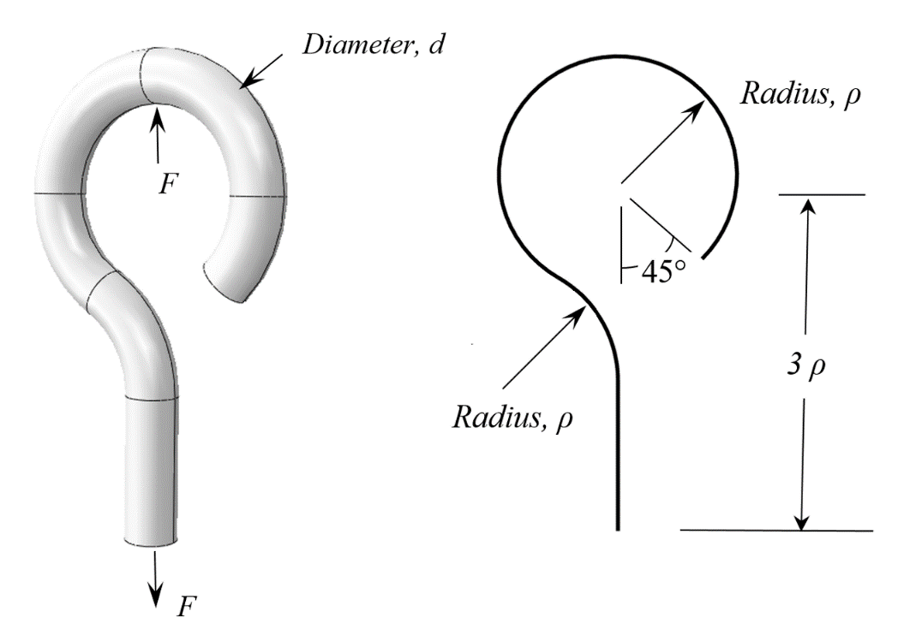

Figure 1. Eyebolt Geometry

The eyebolt is constructed from steel (Young’s modulus *E*=207 GPa, Poisson’s ratio *ν*=0.26, and yield strength Sy=250 MPa). The objective of the analyses is to determine the maximum force, *Fmax*, that can safely be applied to the eyebolt based on a factor of safety, n=2.

Hand Calculations

Using eyebolt dimensions given in Table 1, perform a stress analysis similar to that in Shigley’s problem 3-122 (see Appendix). To determine the maximum force, *Fmax*, that can safely be applied to the eyebolt, apply a nominal force, *Fnom*= 1 N and determine the maximum tensile stress which occurs at the inner radius of section A-A (see Figure 2). Since the stress state at this point is uniaxial, we can take this stress to be the nominal von Mises stress, . Assuming a factor of safety, *n*=2, where

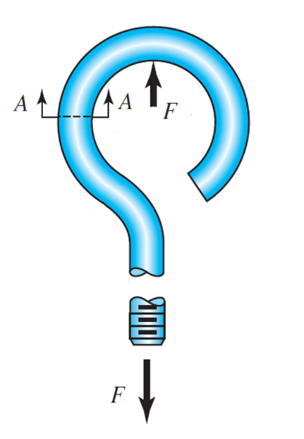

the maximum force, *Fmax*, that can safely be applied to the eyebolt is

Record the results of your hand calculations on the Solution Summary Form (attached).

Figure 2. Eyebolt section A-A.

Finite Element Analysis

Create a 3-D model by sketching the sweep path shown in Figure 1 in the Sketch Module and then create a 3D part in the Part module using “sweep” of a circular profile of diameter, *d*, where parameters *ρ* and *d* are given in Table 1. Perform a mesh convergence study, exploring tetrahedral and hexahedral element shapes and linear and quadratic interpolation. Use a nominal applied load of *F*nom=1 N at the top of the eyebolt and impose boundary conditions at the base to prevent rigid body translation and rotation. Determine the von Mises stress, , at the lateral sides of the hook (ignore stress concentration effects at the load application points). In examining von Mises stress contours, set the contour limit so that the bending stress distribution at the lateral sides of the hook is clearly visible (use Option=>Contour=>Limits). Convince yourself that your final (best mesh) reported stress levels are within 2% of the actual (fully converged) solution. Using the von Mises stress, , and the equation given above, calculate the maximum force, *Fmax*, that can safely be applied to the eyebolt.

On the Solution Summary Form (attached), record the global element size used in your final mesh, the element type (tetrahedral or hexahedral), interpolation type (linear or quadratic), the von Mises stress, , at the lateral sides of the hook due to the nominal load of *F*nom=1 N and the maximum force, *Fmax*, that can safely be applied to the eyebolt.

**Table 1. Cases**

|  |  |  |  |
| --- | --- | --- | --- |
| **Student** | **Case** | ***ρ (mm)*** | ***d (mm)*** |
| Antoch, Seth | 1 | 20 | 8 |
| Badick, Jake | 2 | 20 | 9 |
| Berry, Mike | 3 | 20 | 10 |
| Carella, Jacob | 4 | 20 | 11 |
| Charbonneau, Jay | 5 | 20 | 12 |
| Damm, Stephan | 6 | 25 | 8 |
| Darkow, Grace | 7 | 25 | 9 |
| Gattoni, Eric | 8 | 25 | 10 |
| Haddock, Justin | 9 | 25 | 11 |
| Jasinski, Peter | 10 | 25 | 12 |
| Lavoie, Jake | 11 | 30 | 8 |
| Mullin, Patrick | 12 | 30 | 9 |
| Murphy, Adam | 13 | 30 | 10 |
| Nguyen, Emmett | 14 | 30 | 11 |
| O'Connor, Morgan | 15 | 30 | 12 |
| Pratt, Austin | 16 | 35 | 8 |
| Rouillier, Connor | 17 | 35 | 9 |
| Royal, Jaxon | 18 | 35 | 10 |
| Sitar, Carter | 19 | 35 | 11 |
| Townsend, Brad | 20 | 35 | 12 |
| Treacy, Collin | 21 | 40 | 8 |
| Turnbull, Maya | 22 | 40 | 9 |
| Turner, Justin | 23 | 40 | 10 |
| Vieira, Jacob | 24 | 40 | 11 |
| Zhen, Honghao | 25 | 40 | 12 |

**Appendix A – Curved Beams in Bending[1]**

Excerpt from Shigley’s Section 3-18:

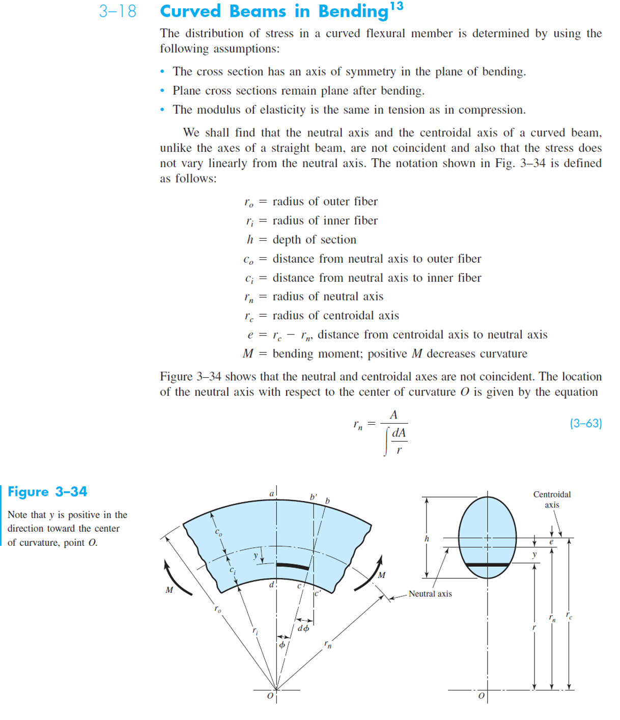

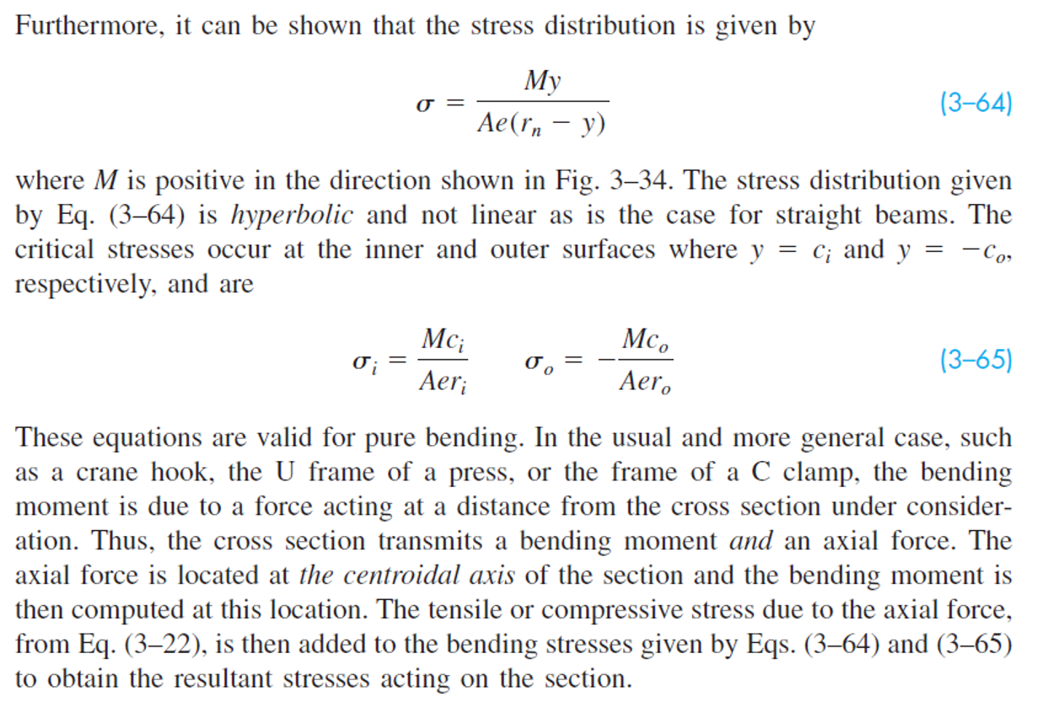

Excerpt from Table 3-4:

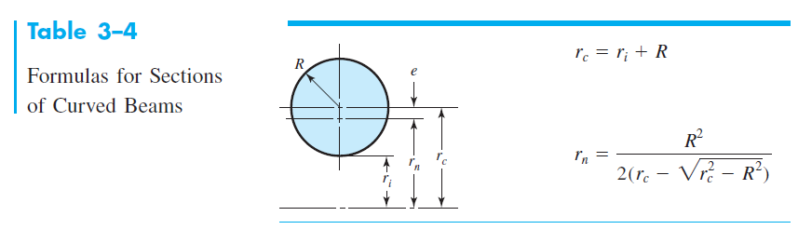

Problem 3-122:

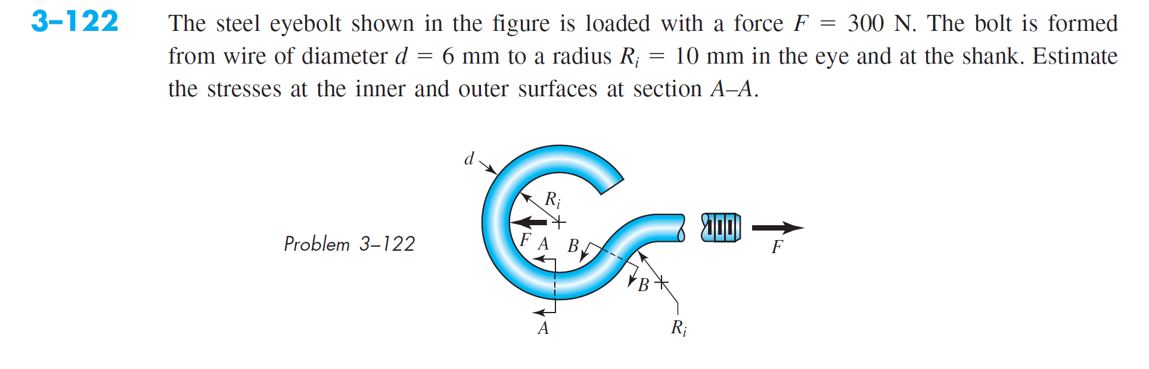

Solution:

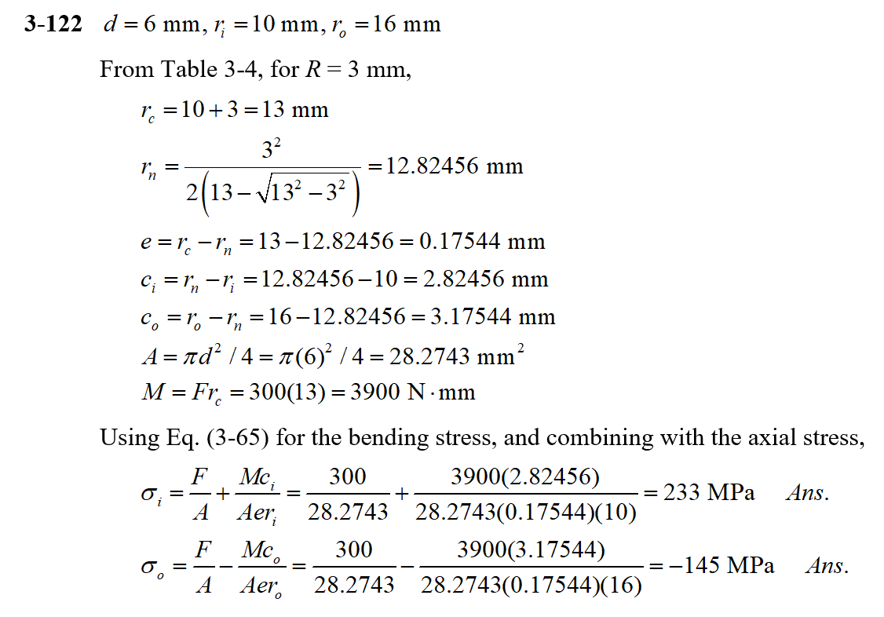

Name________________________________

**Computer Assignment #4 - Solution Summary**

Instructions:

1. Report your solution by filling all fields in the tables below
2. Be sure your answers are in the requested units.
3. All numeric values should be reported to three significant digits.
4. Include screen shots of your final mesh and the von Mises stress contours

**Case Parameters**

|  |  |
| --- | --- |
| Case # |  |
| *ρ (*mm*)* |  |
| *d* (mm) |  |

**Results**

|  |  |  |
| --- | --- | --- |
|  | Hand Calculation | FEA Result |
| Global element size (mm) | N/A |  |
| Element shape (tetrahedral or hexahedral) | N/A |  |
| Interpolation type (linear or quadratic) | N/A |  |
| von Mises stress at the inner radius of section A-A for an applied force, *Fnom*=1 N (MPa) |  |  |
| Safe operating load of eyebolt based on factor of safety, n=2 (N) |  |  |

Upload you’re the following files to Brightspace under Computer Assignment #5 by 11:30 PM on 12/1/21:

1. An MSWord (or pdf) file with this solution summary form, hand calculations and Abaqus screen shots.
2. Your Abaqus “.cae” file

1. Curved Beams in Bending in “Shigley's Mechanical Engineering Design,” 10th Edition, Budynas and Nisbett, pp. 132-135, 2015.