**Name(s) ________________________________________**

**________________________________________**

**ECE/CoE 1188: Cyber-Physical Systems Laboratory**

***Lab #7 Worksheet (100 points)***

*Due Friday 4/20 (Before Midnight)*

*Accepted with a 10% late penalty up until midnight Weds 4/25*

# **Final Design**

1. 30 pts **Show and explain your design. Include images of your final hardware design and software application (Node-RED) schematic**

My design takes tweets regarding trump and checks their sentiment and checks the temperature on the temperature sensor from the booster pack and looks for outliers in the data. Every time the temperature is polled the server computes the zscore and checks if the zscore is greater than 0.5. If so, then the alert is triggered and set to 1. It then checks the sentiment on the most recent tweet mentioning #trump. If the sentiment is greater than 5, then it assumes people are happy, if it is between 5 and -5 then people are neutral, if it is below -5 then people are unhappy. Unfortunately people seem to tend to be happy when tweeting #trump… This gets sent back to the microcontroller who then displays a message on the serial monitor indicating if an outlier was found and how people are feeling about Trump.

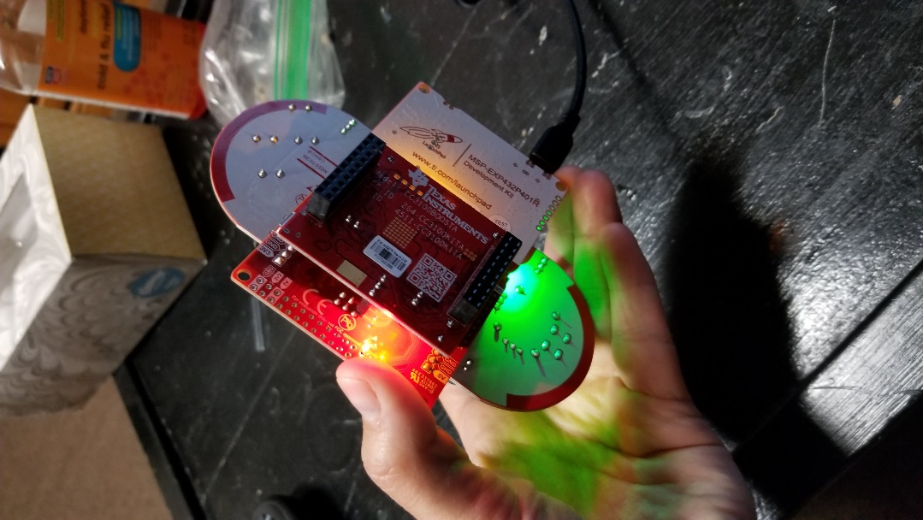 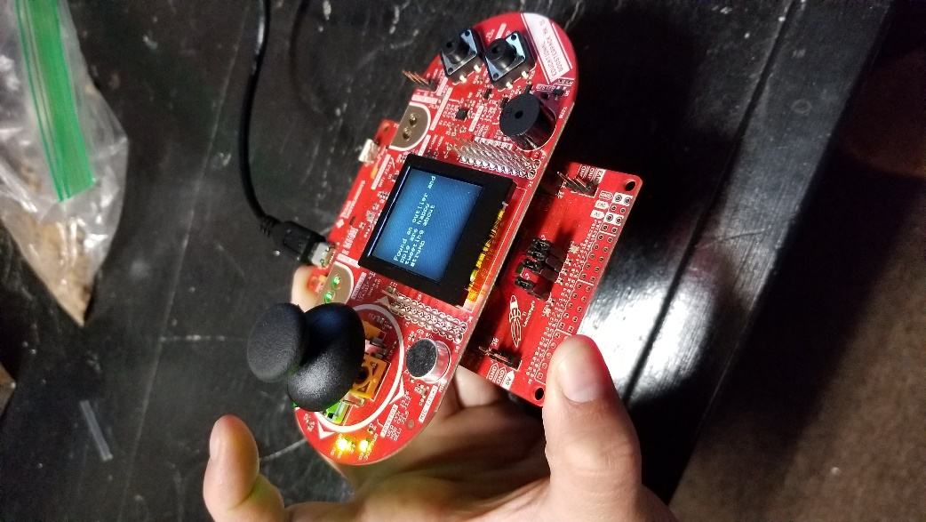

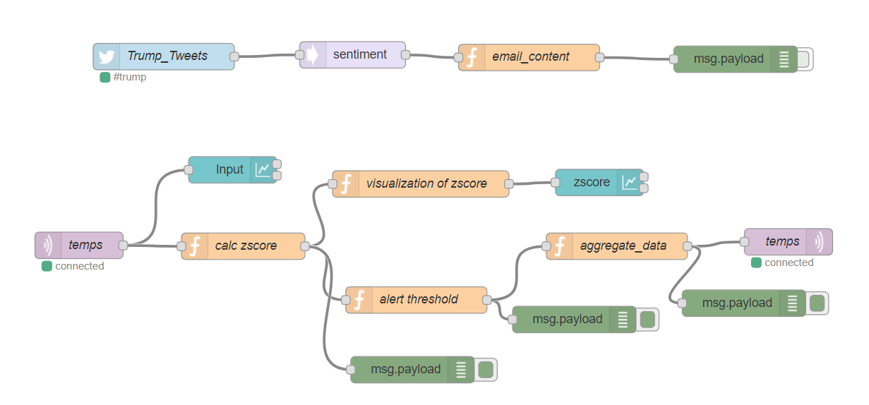

# **Final Demonstration**

**You will demonstrate the functionality of your design functions via videos. You can either a) upload videos to YouTube, providing the links below or b) upload video files directly to courseweb, including the videos in the zip file that also contains your source code. You can either create multiple videos or show all of the below using one video, just make sure that all of the points are clearly covered.**

**If final design is not fully functional, in order to receive partial credit, you can include the results of test cases that highlight that highlight the individual parts that do work**

[**https://photos.app.goo.gl/zLoDzuO8Tsozd7Av1**](https://photos.app.goo.gl/zLoDzuO8Tsozd7Av1)

10 pts **Demonstrate that you can use the MSP432 and CC3100 to publish sensor data using MQTT (e.g. publish current temperature readings)**

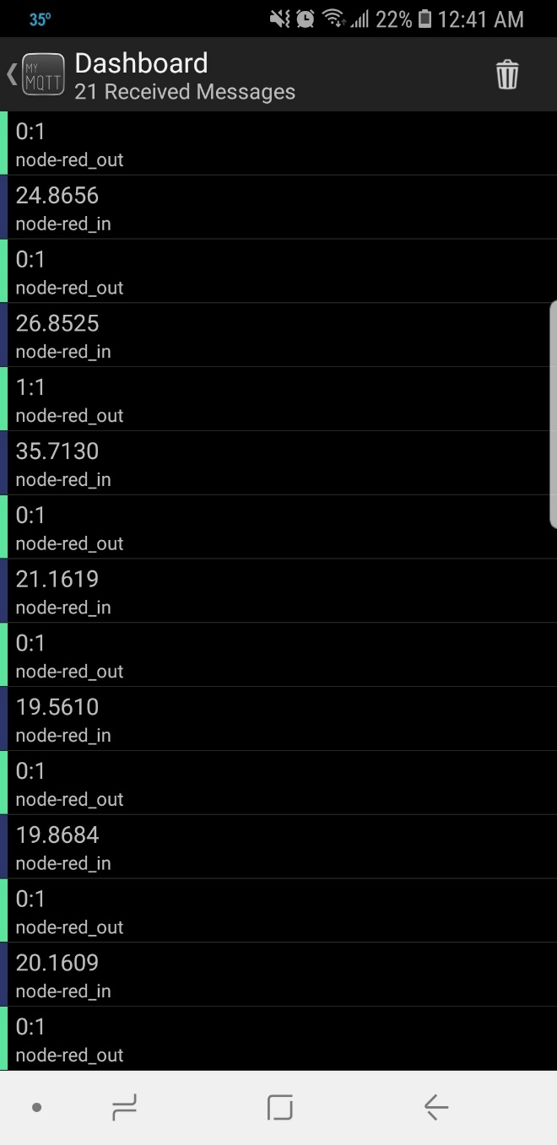

10 pts **Demonstrate that you can use the MSP432 and CC3100 to subscribe to MQTT topic and receive data extract information. (e.g parse and decipher the contents of a message)**

10 pts **Demonstrate that you can use your z-score function to detect an anomalous event in the sensor data (e.g. temperature readings that are 0.5 std deviations from the windowed mean or something similar)**

10 pts **Show that you can graphically display streaming sensor data and z-score results (graph, table, meter, etc)**

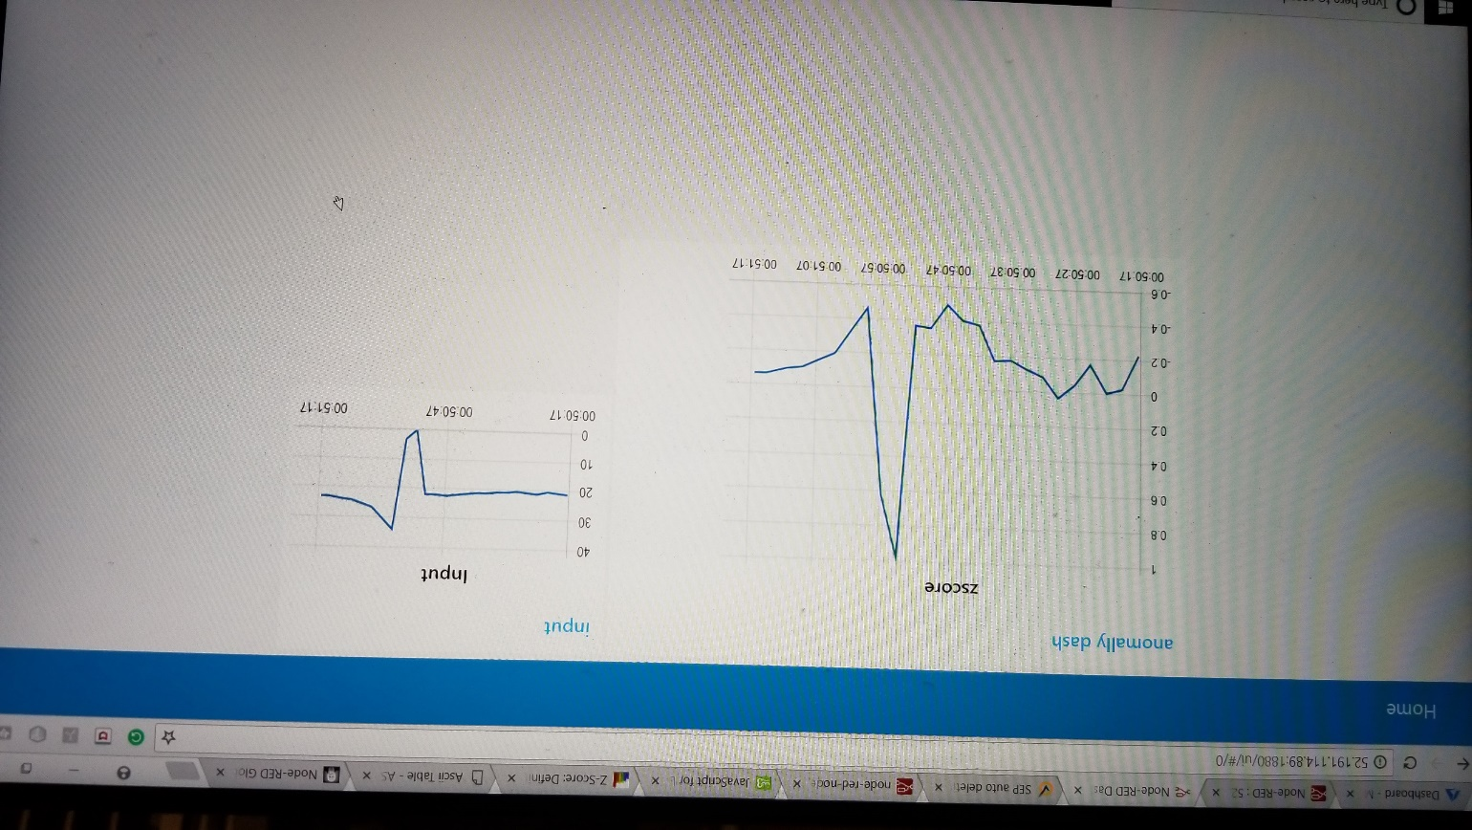

10 pts **Demonstrate that you can send out a notification based on the occurrence of an anomalous event (e.g. twitter, email, SMS, etc)**

10 pts **Demonstrate the use of one of the advance analytic nodes (e.g. sentiment analysis)**

10 pts **Demonstrate that the result of your cloud processing can be transmitted back to the board and initiates some sort of corresponding action (e.g. lights, display, sound, etc)**

# **Final Submission**

**Create a zip file that includes ALL of the source code necessary run your design and as well as documentation. Make sure that you include:**

* 1. **Code you use to publish MQTT data via the MSP432 and CC3100**
  2. **Code you use to subscribe to MQTT data via the MSP432 and CC3100**
  3. **A separate text file that contains a copy-paste of the Z-score function that you wrote**
  4. **An export of your Node-RED flows and custom nodes**
  5. **In addition to the above, please include any other custom files or libraries needed in order to run your design.**
  6. **Include this document, filled out**
  7. **If you are not using YouTube to share videos, include the video files that you recorded.**