**Name(s) _________________Dannah Gersh_____________**

**________________________________________**

**ECE/CoE 1188: Cyber-Physical Systems Laboratory**

***Lab #4 Worksheet (60 points)***

Fill out all requested items, export to a PDF document and then ***upload this document*** to courseweb. ***Upload separate source code files*** for each part

1. 15 pts **Detailed Schematic or Annotated Photo of Prototyped System**

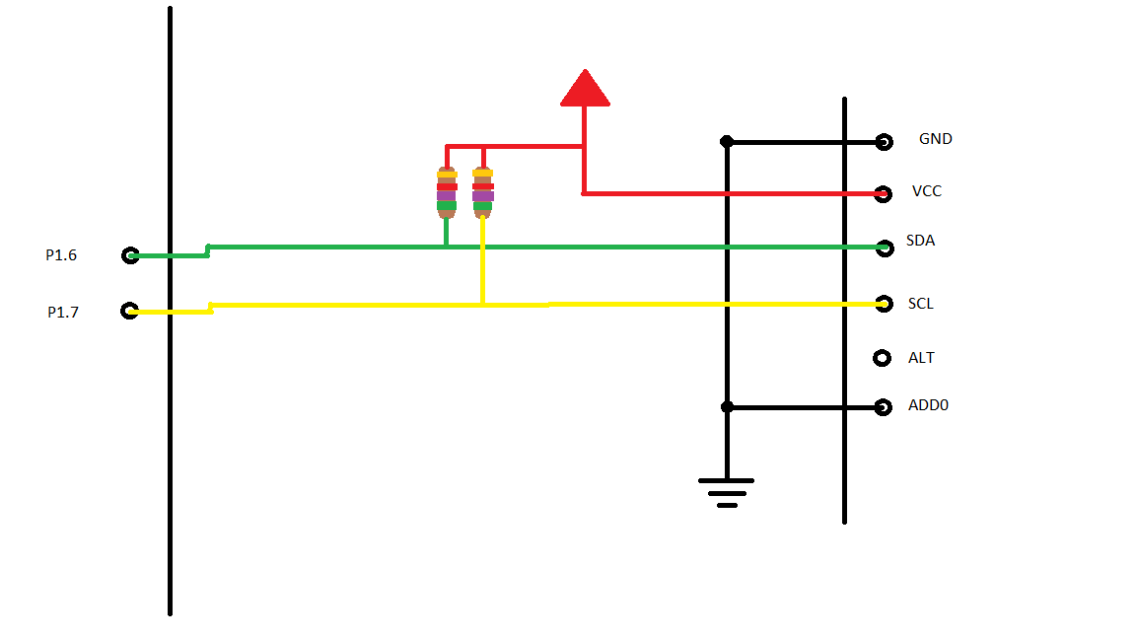

1. 10 pts **Completed Source Code for serial transmission of data**
2. 10 pts **Completed Source Code for serial reception of data**
3. 10 pts **Completed Source Code to assemble received bytes and convert to celcius/farenheit**
4. 15 pts **Annotated Oscilloscope/Analyzer Photo (s) demonstrating transmission and reception of data**

TX

RX

SDA

SCL

