.

# Chapter I

# Introduction and Motivation

# 1.1 Introduction

Now a days almost all organization use computer based information system. The information processing capabilities of computer system plays a vital role to manipulation data needed by various organization .Computer has influenced organization of all types and sizes by its speed, accuracy and information retrieval capability. The microcomputer has enough power and speed to eliminate many tedious operation and frees us from many complexities. A database Management system (DBMS) consists of a collection of interrelated data and a set of programs to manipulate those data. The primary goal of DBMS is to provide an environment that is convenient, efficient and secure to store, modify, retrieve database information.

E learning is becoming more and more popular in the current education process. Online examination system is a very important aspect of e-learning. In the current context, there exists many number of online MCQ paper management web applications, but these systems are concerned only on one aspect of online exam system. Online examination system (OES) is a web based application that integrates online examinations, related management activities.

As a result of the development of Internet technology, online examination has become an effective than traditional examination. It is a common knowledge that students are extremely prone to cheating under the traditional method, which could affect the fairness of examination. The pen and paper method of writing examination, which has been ongoing for decades. But the manual system is not suitable because of the problems usually associated including examination venue capacity constraints, lack of comfort for examination candidates, delay in the release of results, examination malpractices, cost implication of printing examination materials and human fault . The shift of examination as well as examination administration procedures from paper-based to information technology based processes necessitates is rapidly growing at universities. Administrative staff, IT support staff, lecturers and examiners as well as students have to adapt to and familiarize themselves with new examination practices known as online examination [2]. An online examination system is an application that allows an institution conduct examination via the Internet (or intranet). Various companies, institutions and organizations use this method of handling examinations, because it is quicker, easier and convenient. This system makes it easier for examiners to conduct exams and collate results. The application provides facility to conduct online examination anywhere and at any time. Today, most institutions are conducting their exams online to eliminate the bottlenecks associated with pen and paper type of examination.

**1.2 Examination Section**

Till now most of the universities as well as educational institution of our country have been performing their exam system manually even though these are oldest ,time consuming ,erroneous and lengthy process. It requires staffs or teachers to perform various formalities .

**1.3 Online Examination System**

Organizing exam accurately is a vital part of a educational institution . It is very difficult to analyze the exam manually. To take exam of more candidates more invigilators are required .So tough to organizing exam manually and also time consuming. It will be easy and more efficient if we use a computerized system.

A Online Exam system has many benefits ,including :

* Student need not present at exam hall . Only student need internet connection .If internet connection is available then student can give exam at any where at any place.
* Result will be very precise and accurate and will be declared in very short span of time because calculation and evaluations are done by the simulator itself.

* Eliminates the need for manual investigation of Exam section ,Which can be a tedious and time consuming task.
* A single computerized system can provide data needed by both financial and programmatic managers.
* Increases data storage capacity ,allow admin to enhance existing systems or management needs in a cost-effective manner.
* The system handles all the operations, and generates reports as soon as the test is finish, that includes name, mark, time spent to solve the exam.
* Allow students to see or display his answers after the exam is finish.
* Tedious recording processes are automated.
* A variety of Exam can be quickly held on demand.
* Admin can query the system for ad hoc information.
* Data processing and analysis are faster and more accurate.
* Allows admin to more easily recognize problems.
* The System can generate reports.
* Monetary and stock controls are more easily implemented.

A online exam system has three basic components:

1.**Hardware** – the electronic equipment such as computer, printers, server etc. The hardware can be networked so that information can be shared. A server stores the program and data.

2.**Software** – the set of programs that tells the computer what tasks to perform. Exam system software may be integrated within the university’s exam section management information system or database, the storehouse of computerized information.

3.**Company personal** – the people who operate the hardware and software he must be properly trained in order for the information system to be successful.

**A online Exam system performance criteria**

**1. In order to obtain information from a online Exam system we need to**

1. Locate the required information correctly within the online exam system structure.
2. Seek advice where there are difficulties in obtaining the required information.
3. Obtain additional authorization for sensitive or confidential information in accordance with the organization’s security.
4. Check information for its accuracy and completeness.
5. Store information in a format which helps others to access and use it.
6. Keep confidential information secure and not disclose it to unauthorized people.

**2.In order to meet the functional requirement and perform the functionality effectively and efficiently of a online Exam system we need to**

1. A user-friendly interface with proper menus.
2. Data transfer should be accurate and with in a reasonable amount of time keeping in mind the network traffic.
3. The system should not allow entry of duplicate key values.
4. System should have the ability to generate transactional Logs to avoid any accidental loss of data.
5. Log file should also be generated.

**3.In order to contribute to the quality of online Exam system we need to**

1. Identify potential improvements to the Online Examination system and consider their impact on the quality of the system and any interrelated systems.
2. Suggest potential changes and support your suggestions by a clear rationale as to how they could improve the quality of the system.
3. Assess and clearly state the reliability of assumptions and judgments made.
4. Describe accurately the benefits and costs of all changes.
5. Present suggestions clearly and in a way which helps people to understand and act on them.

**1.4 Feasibility Study**

We can feasible study of the Online Examination System by the following criteria :

What are the user’s demonstrable needs?

User needs a web-based system, which will remove all the above-mentioned Problems that, the user is facing. The user wants a web-based system, which will reduce the bulk of paperwork, provide ease of work, flexibility, fast record finding, modifying, adding, removing and generating the reports.

How can the problem be redefined?

We proposed our perception of the system, in accordance with the problems of existing system by making a full layout of the system on paper. We tallied the problems and needs by existing system and requirements. We were further updating in the layout in the basis of redefined the problems. In feasibility study phase we had undergone through various steps, which are described as under: How feasible is the system proposed? This was analyzed by comparing the following factors with both the existing system and proposed system.

Cost

The cost required in the proposed system is comparatively less to the existing system.

Effort Compared to the existing system the proposed system will provide a better working environment in which their will be ease of work and the effort required will be comparatively less than the existing system.

Time

Also the time required generating a report or for doing any other work will be comparatively very less than in the existing system. Record finding and updating will take less time than the existing system.

Labor

In the existing system the number of staff required for completing the work is more while the new system will require quite less number of staff.

**1.5 Motivation of this Project**

It is understand the over all activities of the Examination System in a educational institution by performing this Project. Though this Project one can acquire knowledge about Online examination system .By Completing this paper one can see that it has varies importance and benefits .The importance is given below:

* It provides Knowledge about developing practical software.

.

* It helps us to apply the theoretical knowledge into practical field.
* Though this one can easily understand the management system of the university Examination system.
* By applying the same concept one can develop software for various organizations.

**1.6 Objective of this Project**

Online Examination System is designed for Educational Institutes like Schools, Colleges, and Private Institutes to conduct logic tests of their students on a regular basis. The system handles all the operations and generates reports as soon as the test is completed .This system saves the precious time to spent on reviewing answer sheets. The existing system is weak compare to the online examination system that make it possible very easily. The objective of on-line examination system is to take online test in an efficient manner and no time wasting for checking the paper. For students they give papers according to their convenience and time and there is no need of using extra thing like paper, pen etc. There are many objectives of the project study .In briefly the main objective of the project work is to develop an Online examination System in educational institution . The main purpose behind the proposed system is to provide a comprehensive computerized system, which can capture, collate and analyze the data from these wards and evaluate the impact of the program. That will also efficiently evaluate the candidate thoroughly through a fully automated system that not only saves lot of time but also gives fast results.

* Can be used anywhere any time as it is a web based application (user Location doesn’t matter).
* This can be used in educational institutions as well as in corporate world.
* Create strong and secrete data base that allow for any connection in a secret way, to prevent any outside or inside attacks.
* No restriction that examiner has to be present when the candidate takes the test.
* .Create strong and secrete data base that allow for any connection in a secret way, to prevent any outside or inside attacks.

**Chapter II**

**Background and Related work**

**2.1** **Present System**

Exam System of a educational institution is the most important part .Exam system of maximum educational institution of Bangladesh is fully pen and paper test. In this system every student have to present at the exam hall for giving exam. Some person have to responsible to organize this exam. This manual system of exam is very time consuming .

The first problem is that there are loads of hard copied documents being generated. Keeping the information in the form of hard-copied documents leads to the following problems:

I. Lack of space – It becomes a problem in itself to find space to keep the sheets of paper being generated as a result of the ongoing discussion. The documents being generated are too important to be ill-treated.

ii. Filing poses a problem – Filing the documents categorically is a time consuming and tedious exercise.

iii. Filtering is not easy – It becomes hard to filter relevant documents for the irrelevant ones if the count of the same crosses a certain manageable number.

iv. Reviewing becomes time-consuming – All the process done manually at the centers and all the records are maintained on the papers. So the maintenance of the record is very difficult in the departments and as well as it’s very difficult for the workers to check the record. The Existing system is paper based, time consuming, monotonous, less flexible and provides a very hectic working schedule. The chance of loss of records is high and also record searching is difficult. Maintenance of the system is also very difficult and takes lot of time.

v. Result Processing is slow due to paper work and requirement of staff.

**2.2 Complexity of Present System**

The “Exam System ” of maximum educational institution manages their system manually. For this reason it takes huge time to take exam and produce a report . If the system is computerized the whole management will be fast and there will be involve developing the new system. Problem of current system is as follows:

* The current system is very time consuming.
* It is very difficult to analyze the exam manually.
* To take exam of more candidates more invigilators are required but no need of invigilator in case of on line exam.
* Results are not precise as calculation and evaluations are done manually.
* The chances of paper leakage are more in current system as compared to proposed system.
* Result processing takes more time as it is done manually.
* Paper bulk is increasing along with the transaction.
* Occupies a lot of space.
* Chance to make mistake.
* Problem detection is very difficult.
* Lack of security.
* Files may be lost.
* Needs many employee to maintain the overall Exam System.
* Files can get damaged.
* The entry data in a sheet of paper and keeps its ina file and ledger books.
* Difficult to serve report continuously.

**2.3 Literature Survey**

This section examines the related works on the online examination systems.

**2.3.1 SIETTE**

Guzman and Conejo (2005) proposed an online examination system called System of Intelligent Evaluation using Tests for Tele-education (SIETTE) [6]. SIETTE is a web-based environment to generate and construct adaptive tests. SIETTE supports secure login and portability features. On the other hand, the other features: resumption capability, multi-instructor, random question selection, random questions distribution and random choices distribution are missing.

**2.3.2 EMS**

Rashad et. al. (2010) proposed a web-based online examination system called Exam Management System (EMS) [8]. EMS manages the examination and auto-grading for students exams and supports conducting exams, collects the answers, auto mark the submissions, and produce the reports for the test. EMS supports secure login, multi-instructor, and portability features. However, the other features: resumption capability, random question selection, random questions distribution, and random choices distribution are missing.

**2.3.3 iEMS**

Vasupongayya et. al. (2010) proposed an interactive Examination Management System (iEMS) [9]. The iEMS supports secure login, portability, multi-instructor, random questions distribution, and random choices distribution features. However, the other features: resumption capability and random question selection are missing.

**2.3.4 WONES**

Sheshadri et. al. (2011) proposed a web-based Online Non-choice-based Examination System (WONES) [10]. WONES is an effective solution for massive education evaluation; it employs special authentication protocols to ensure transactions between the examination server and the students. WONES supports secure login, portability, multi-instructor, and random question distribution features. However, the other features namely: resumption capability, random questions selection, and random choices distribution are missing.

**2.3.5 NOES**

Raj et.al. (2012) developed National Online Examination System (NOES) [11]. NOES can handle a huge number of students for administering questions on various subject, and offers dynamic paper generation. Adobe Flex, Spring, and Hibernate frameworks are used for development of the system. NOES supports secure login and portability features, the other features :multi-instructor, resumption capability, random question selection, random questions distribution, and random choices distribution are missing.

**2.3.6 SBPES**

Satav et. al. (2012) proposed a Structure Query Language (SQL) Based Paperless Examination System (SBPES) [12]. SBPES is a web-based system that can present a descriptive exam format for SQL and Description Model Language (DML) statements.SBPES supports secure login, multi-instructor, and portability features. On the other hand, the other features namely: resumption capability, random question selection, random questions distribution and random choices distribution are missing.

**2.3.7 OESBC**

Islam et. al. (2013) proposed an Online Examination System in Bangladesh Context (OESBC) [13]. OESBC is a web-based, efficient, flexible, and adaptable. OESBC can provide an open mode of examination meeting the needs of various Academic and Non-Academic organizations. The examination contains different types of multiple choice questions. The answers are checked and the marks obtained are stored in the database while the examiner can get the results immediately from the system in various forms such as general mark list and ranking of participants. OESBC supports secure login, multi-instructor, random question selection, and portability features. However, the other features namely: resumption capability, random questions distribution, and random choices distribution are missing.

**2.3.8 CBTS**

Fagbola et. al. (2013) developed a Computer Based Test System (CBTS) [14]. CBTS supports secure login, multi-instructor, and random question selection features, the other features such as resumption capability, random questions distribution, random choices distribution, and portability are missing.

# Chapter III

# Online Exam Management System

**3.1 Proposed System**

The proposed system is “Online Exam Management System” for exam system of educational institution. Here the paper based information is converted to computerized. All the file and record document are maintained by electrically instead of manually. It saves the student money. Students don't have to travel to a specific location to conduct the exam. So even for students from remote area's it's possible to take the exam. It saves our money. We don't need to buy any paper. Sending an email is free. Students don't have to assemble in classroom to take the exam. They can do it within a given time frame from their own device. We don't have to rent a classroom. We don't have to hire someone to check the students taking the exam. In this system only a few staffs or teachers are needed to maintain this system.

The feature of the proposed system are as follows:

* In comparison to the present system the proposed system will be less time consuming and is more efficient.
* Decrease the paper work.
* The proposed system would less space in terms of storage.
* User friendly software ,error will be less.
* Problem detection is very easy.
* Very easy to copy record.
* Easy to update.
* Easy to serve report continuously.
* It requires less space.
* Searching on some information can be achieved in a various orders.
* Analysis will be very easy in proposed system as it is automated.
* The proposed system is very secure as no chances of leakage of question paper as it is dependent on the administrator only.
* The logs of appeared candidates and their marks are stored and can be backup for future use.
* It's more secure. We can make a big question bank with a lot of questions. Every student gets a random selection from that question bank. So it's of little use to share the questions among the exam takers to give them a head start.
* A system can be given a mark by checking the students answers, and give the result as soon as students finish his exam.
* Easy to store and retrieve information. Rather to save the information on a papers or in separate sheets. There are a data base management to store and retrieve the information needed by the administrator or Faculty member or student according a report generated by the system.

**3.1.1 User of the Proposed System**

User of the On-line Exam Management System can be separate in three parts they are admin , teacher and student.

Admin

When admin login he/she see admin panel. In where he/she gives permission whose teachers and students get access the software. Admin also can edit or delete the given permission. Admin can add or delete subject name in which subject student can give exam.

Teacher

When teacher login he/she see teacher panel. In where he/she can set, update or delete question paper in the question page .Teacher can set exam time. A teacher can view the result of his/her student in the result page.

Student

When Student login he/she can show some rules of exam. There after he/she press “ GO TO EXAM PAGE ” and go a page for Subject selection and select desired subject to give test . When student select a subject and press start exam then they can go the exam page. In the exam page the time of exam duration is show .A student have to give exam within the exam time duration. If a student can’t finish exam with in this time his/her exam is close after this time duration and he/she is shown the exam result. When Student give answer of any question he/she can update their given answer before final submission .When student press finish button he/she show a final submission conformation massage .If he click “Ok” then he/she view their marks instantly. If student click “Cancel” button then he/she remains the exam page again. Student can also show the correct answer by pressing the “View Correct Answers” button after finishing the exam.

## 3.2 Context Diagram

**Administrator**

**Teacher**

**On-Line Exam system**

**Student**

Figure (3.1): the context diagram of On-line Exam System

This diagram represents what are the bounders and scope of **On-Line Exam** **System** project. It describes the main objective of the system and its entities involved.

Administrator

An administrator give the permission of teachers and students to access the software. He can also update, delete, insert the permission.

Teacher:

He/she can insert, delete, update question.

Student:

The students who are permitted to access the software they can login the software and give the exam and ending the exam they also show the result immediately.

**3.3** **Entity-Relationship Diagram**

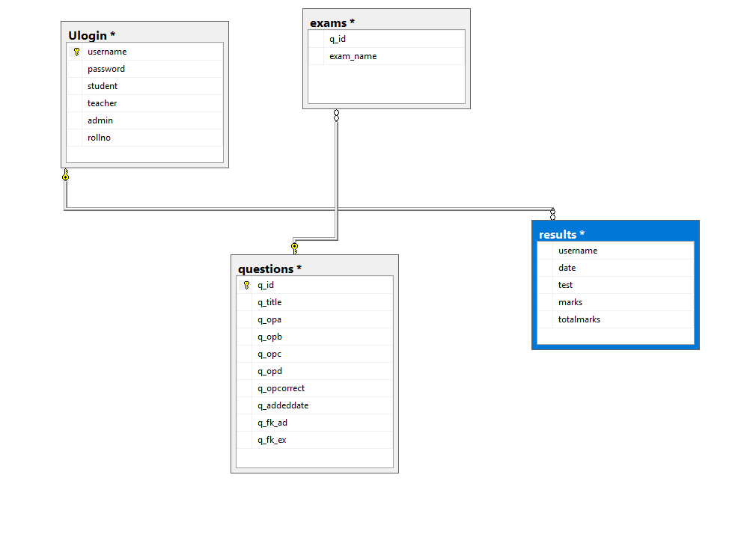

Figure (3.2): Entity_Relation Diagram of Online Exam management system

Here has 4 table (Ulogin , questions , results , exams ).

In here we have 4 tables and their relationships are shown. The 4 tables are given below

Table 3.1 User_login Table

|  |  |  |  |
| --- | --- | --- | --- |
| **Serial No.** | **Field Name** | **Field Type** | **Field Description** |
| **1.** | **username** | **varchar(50)** | **User’s Name** |
| **2.** | **password** | **varchar(100)** | **User’s Password** |
| **3.** | **student** | **nvarchar(50)** | **Permission of Student** |
| **4.** | **teacher** | **nvarchar(50)** | **Permission of teacher** |
| **5.** | **admin** | **nvarchar(50)** | **Permission of admin** |
| **6.** | **rollno** | **int** | **User’s serial Number** |

Table 3.2 Question Table

|  |  |  |  |
| --- | --- | --- | --- |
| **Serial No.** | **Field Name** | **Field Type** | **Field Description** |
| **1.** | **qid** | **numeric(18, 0)** | **Question id number** |
| **2.** | **question** | **nvarchar(MAX)** | **Question** |
| **3.** | **settype** | **varchar(50)** | **Subject Name** |
| **4.** | **choicea** | **nvarchar(50)** | **Option of question a** |
| **5.** | **choiceb** | **nvarchar(50)** | **Option of question b** |
| **6.** | **choicec** | **nvarchar(50)** | **Option of question c** |
| **7.** | **choiced** | **nvarchar(50)** | **Option of question d** |
| **8.** | **ans** | **numeric(18, 0)** | **Answer of question** |

Table 3.3 Result Table

|  |  |  |  |
| --- | --- | --- | --- |
| **Serial No.** | **Field Name** | **Field Type** | **Field Description** |
| **1.** | **username** | **nvarchar(MAX)** | **User Name** |
| **2.** | **date** | **nvarchar(50)** | **Exam holding date in which student give exam** |
| **3.** | **test** | **nvarchar(50)** | **Subject Name** |
| **4.** | **marks** | **numeric(18, 0)** | **Marks obtained by student in exam** |
| **5.** | **totalmarks** | **numeric(18, 0)** | **Total marks in the exam** |

Table 3.4 Exam Table

|  |  |  |  |
| --- | --- | --- | --- |
| **Serial No.** | **Field Name** | **Field Type** | **Field Description** |
| **1.** | **ex_id** | **int** | **Id Number** |
| **2.** | **exam_name** | **nvarchar(20)** | **Name of exam** |

**3.4 Use Case Diagram**

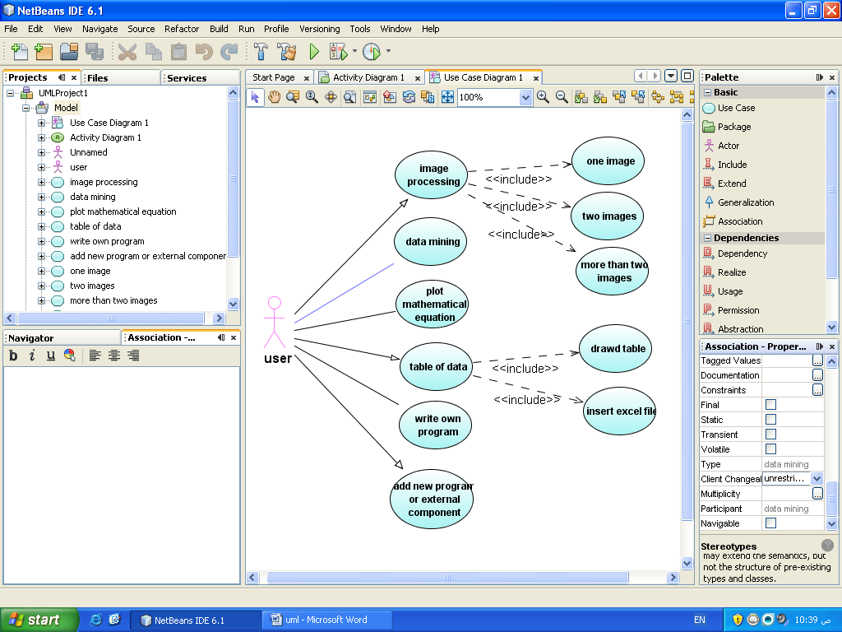

Administrator



Teacher



Student

Figure 3.3: Use case diagram

**Administrator**

An administrator can view reports and do all registration process.

**Teacher**

A teacher can Insert/delete/Update Questions paper, view reports.

**Student**

Student cangive Exam, View Correct answer, View Result.

**3.5 Dataflow Diagram**

User Table

User

Reg Table

Result

Figure 3.4: Data flow diagram

# Chapter IV

# System Design and Implementation

Design is the abstraction of a solution; it is a general description of the solution to a problem without the details. Design is view patterns seen in the analysis phase to be a pattern in a design phase. After design phase we can reduce the time required to create the implementation.

**4.1 Software System Attributes**

**Usability:**

The links are provided for each form. The user is facilitated to view and make entries in the forms. Validations are provided in each field to avoid inconsistent or invalid entry in the databases. Some forms consists Hyper Links, which provides further details. Reports screen contains text boxes and drop down lists, so that reports can be produced.

**Security:**

Application will allow only valid users to access the system. Access to any application resource will depend upon user’s designation. There are three types of users namely Administrator and Teachers and Students. Security is based upon the individual user ID and Password.

**Maintainability:**

The installation and operation manual of examination management system will be provided to the user.

**Availability:**

System will be available around the clock except for the time required for the backup of data.

**Portability:**

The application is developed in ASP.NET. It would be portable to other operating system provided .NET Framework is available for the OS. As the database is made in Microsoft SQL Server 2012, porting the database to another database server would require some development effort.

**4.2 Technologies Used**

**Front end as**

HTML, CSS

**Back end as**

C#, JavaScript

**Server**

Asp.Net

**Database**

Microsoft SQL Server 2012

**Querying language**

SQL

**4.3 User Interface Design**

Here I display the UI design sequentially given below:

**4.3.1 Login**

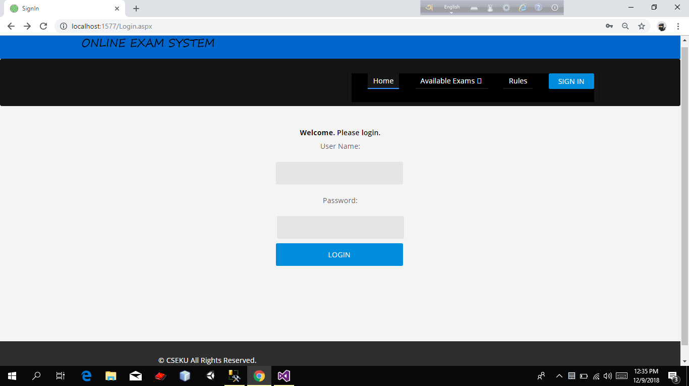

Figure 4.1 : Login Page

It is login Page. Where a user give his\her user Name and Password in the related field. If User give his\her use Name and password rightly then user can login the system otherwise User can not login the system and user show a massage “Invalid username or password. Please try again”.

**4.3.2 Admin Activities**

**Admin Panel**

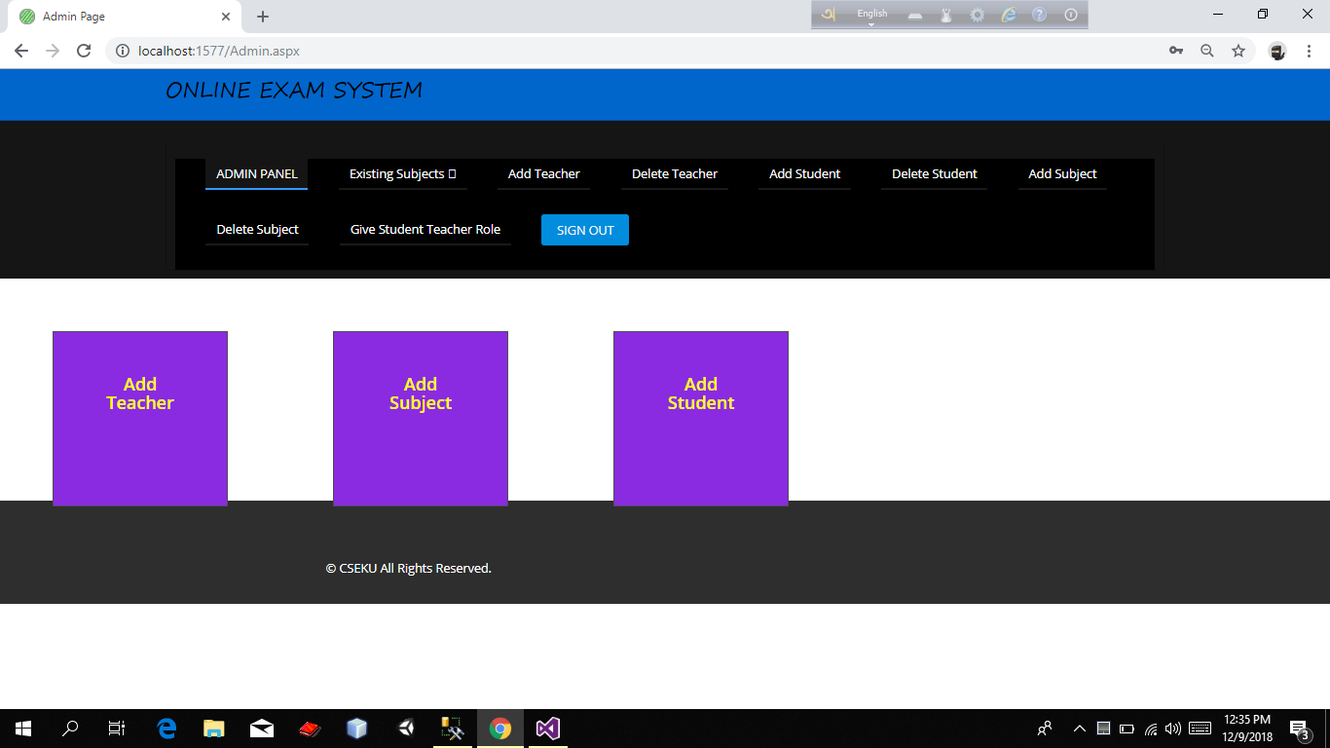

Figure 4.2 : Admin Panel

It is admin panel**.** When admin login he can see this page.

**Show Existing Subject** **Page**

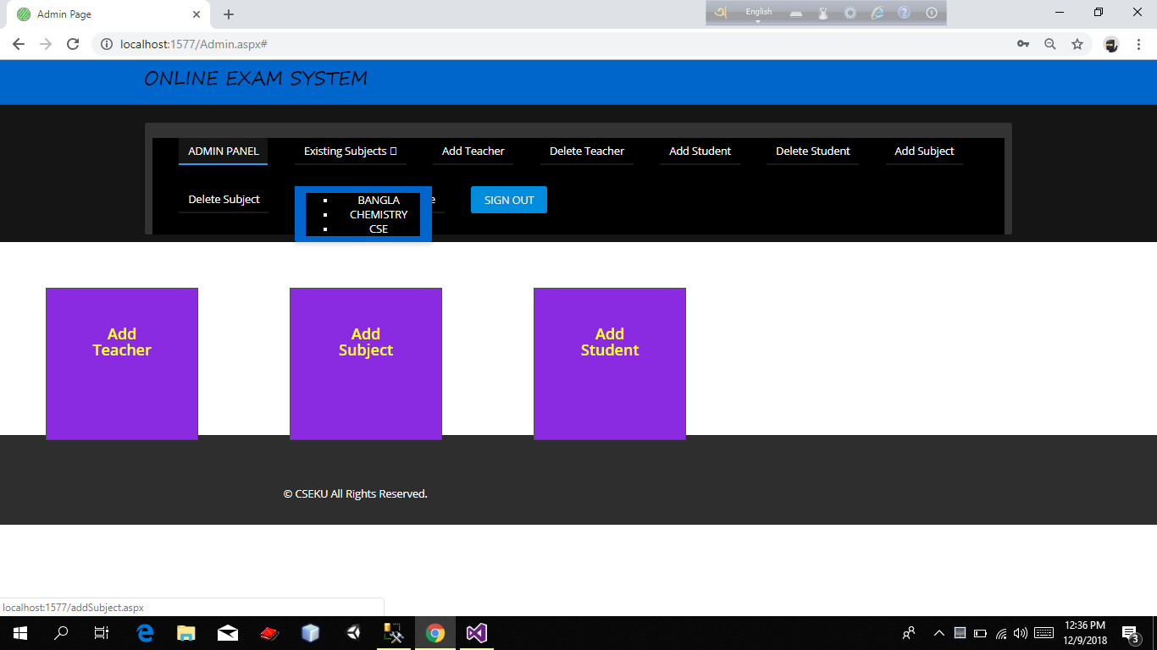

Figure 4.3 : Admin Panel (Show Existing Subject Page)

It is admin panel**.** In this page admin show the existing subject.

**Register Teacher** **Page**

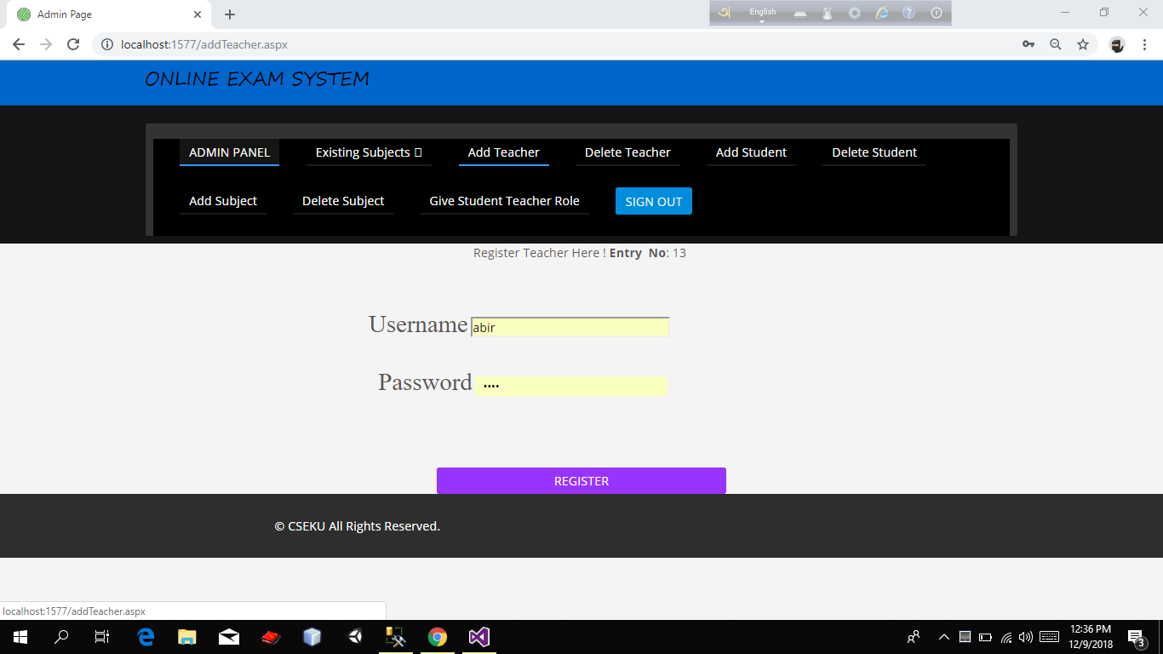

Figure 4.4 : Admin Panel (Register Teacher Page).

It is admin Panel. Where admin register a user as teacher.

**Delete Teacher** **Page**

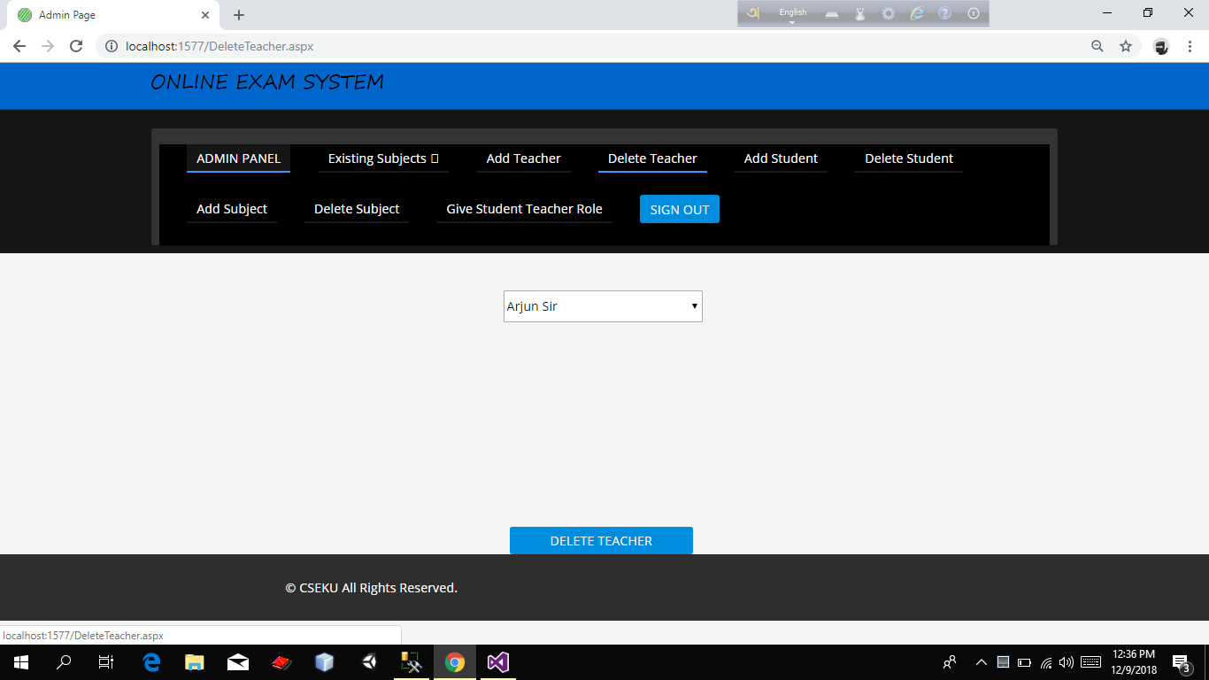

Figure 4.5 : Admin Panel (Delete Teacher Page).

It is Admin Panel. In this page admin can see the existing all teacher name who are permitted to access the software. Admin can delete the teacher’s permission in this page.

**Register Student** **Page**

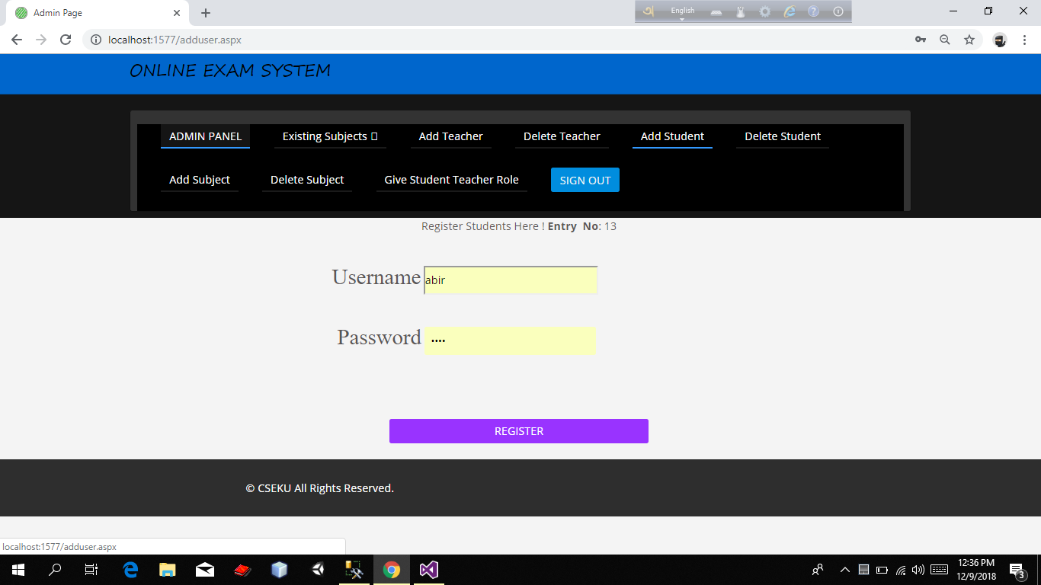

Figure 4.6 : Admin Panel (Register Student Page).

It is admin Panel. Where admin register a user as student.

**Student Delete Page**

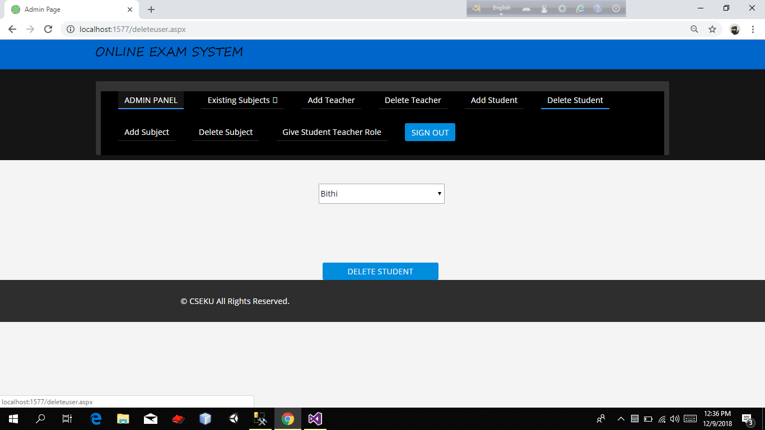

Figure 4.7 : Admin Panel (Student Delete Page).

.

It is Admin Panel. In this page admin can see the existing all Student name who are permitted to access the software. Admin can delete the student’s permission in this page.

**Add Subject Page**

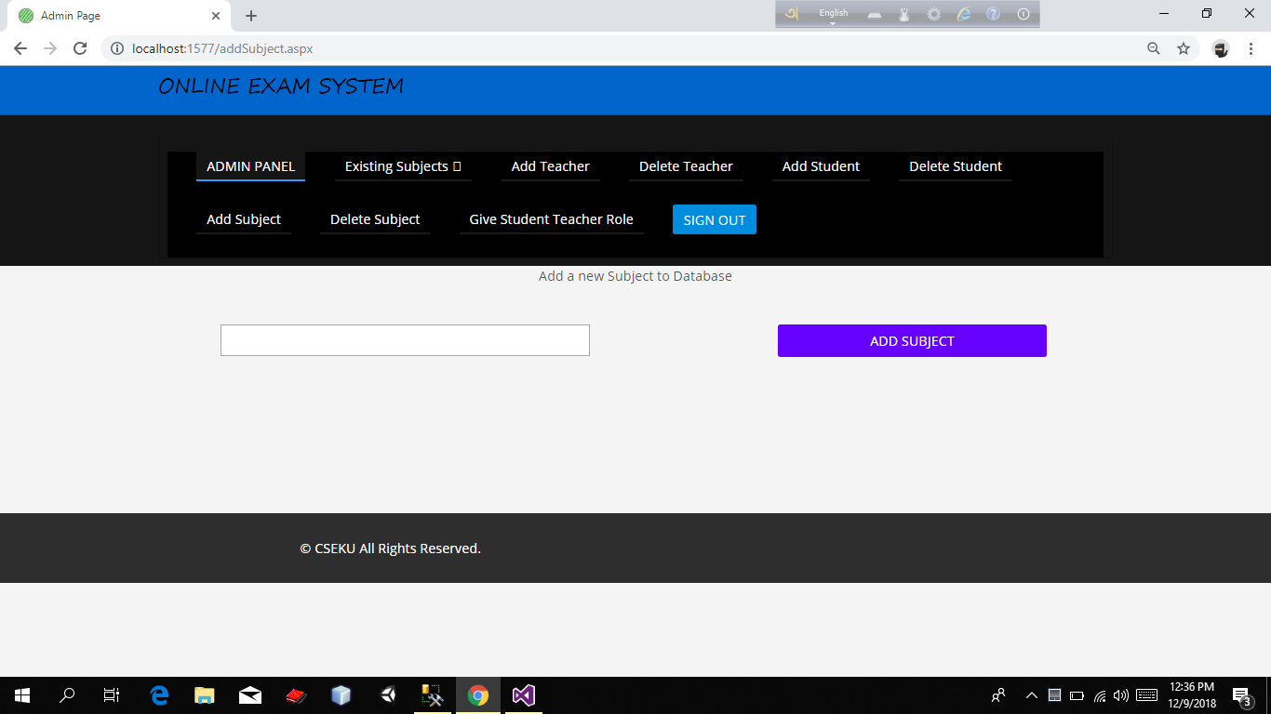

Figure 4.8 : Admin Panel (Add Subject Page).

It is admin Panel. Where admin can add subject Name in this page.

**Delete Subject Page**

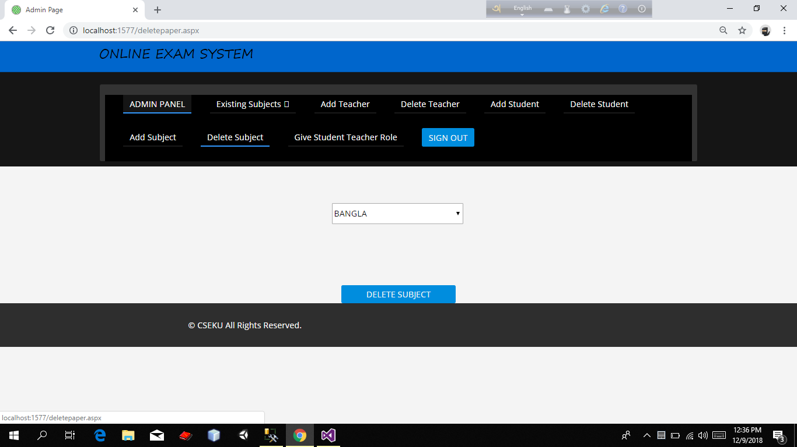

Figure 4.9 : Admin Panel (Delete Subject Page).

It is Admin Panel. In this page admin can see the existing all Subject name in the software. Admin can delete the Subject name in this page.

**Assign Teacher Page**

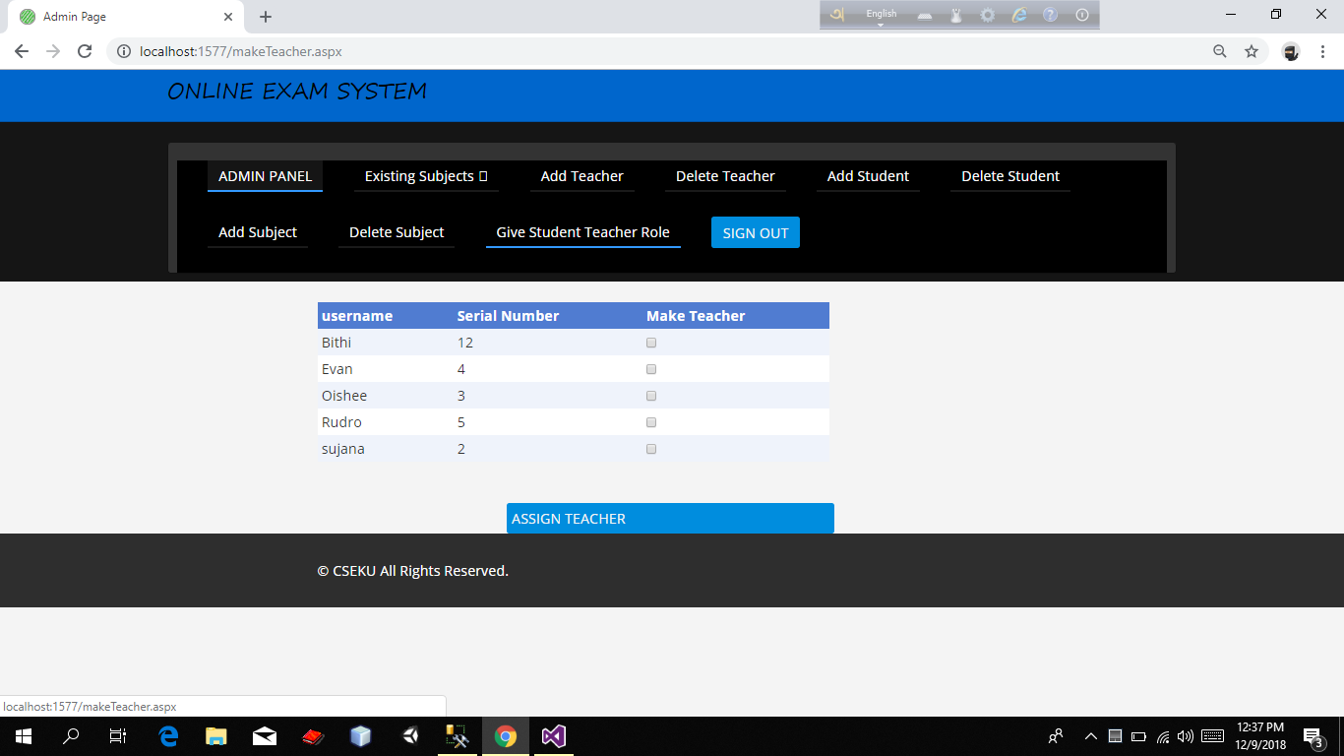

Figure 4.10: Admin Panel (Assign Teacher Page).

It is Admin Panel. If admin want to give permission of a user (who is already exist as a student) as a teacher he can do this in this page.

**4.3.3 Teacher Activities:**

**Teacher Panel**

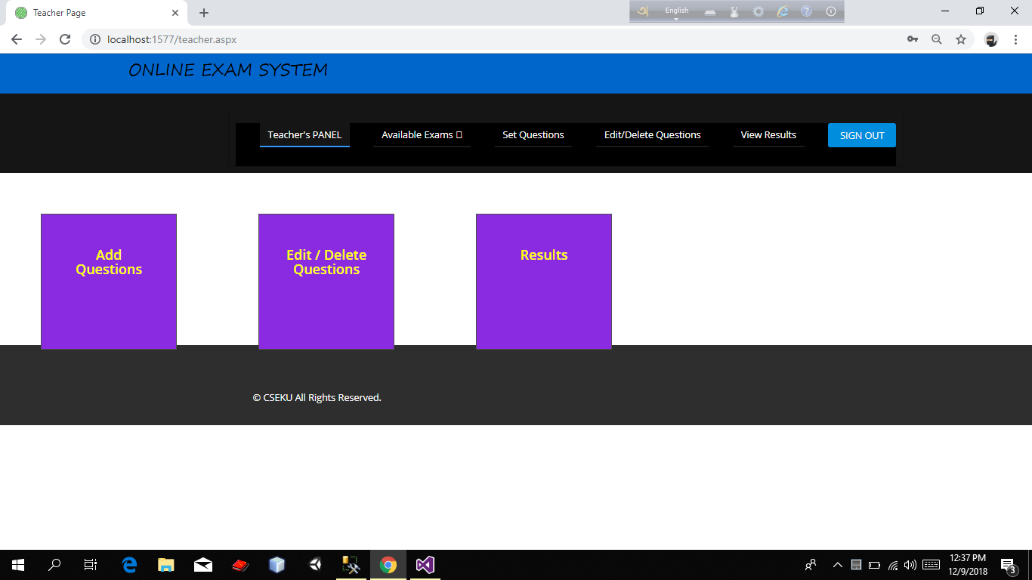

Figure 4.11 : Teacher Panel .

It is teacher Panel.When teacher login he can see this page.

**Set Question** **Page**

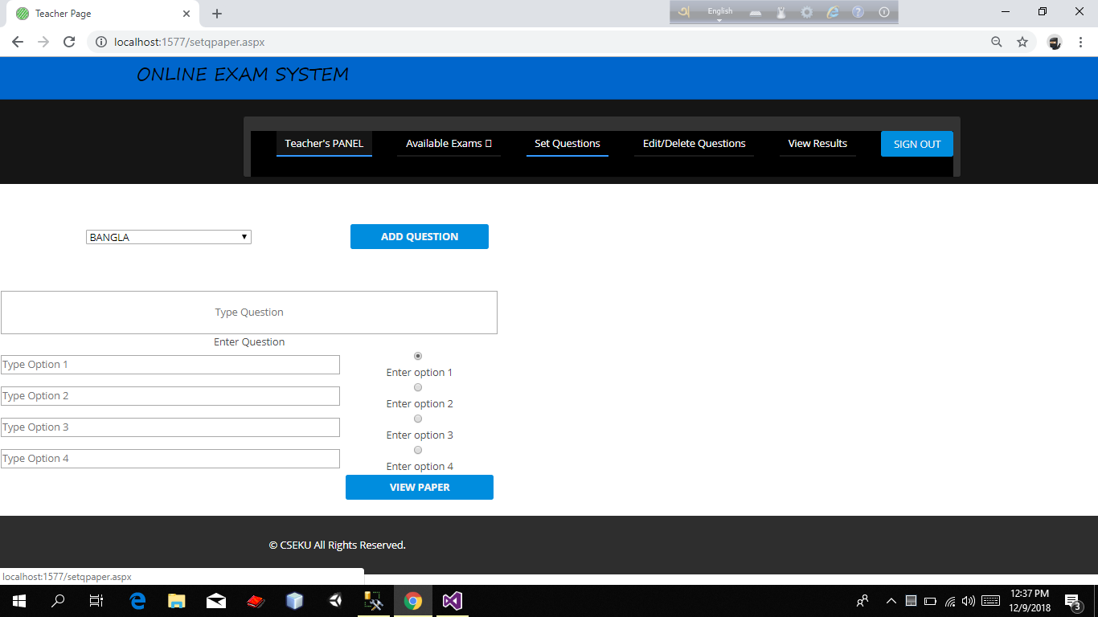

Figure 4.12 : Teacher Panel( Set Question Page).

It is teacher Panel.Where teacher can set question.For this reason teacher at first select the subject name .There after he write the question name and give 4 options of answer of the question.He also set the right answer by clicking the radio button.After doing all this he press the “ADD QUESTION” button to add the question.

**Question Edit and Delete Page**

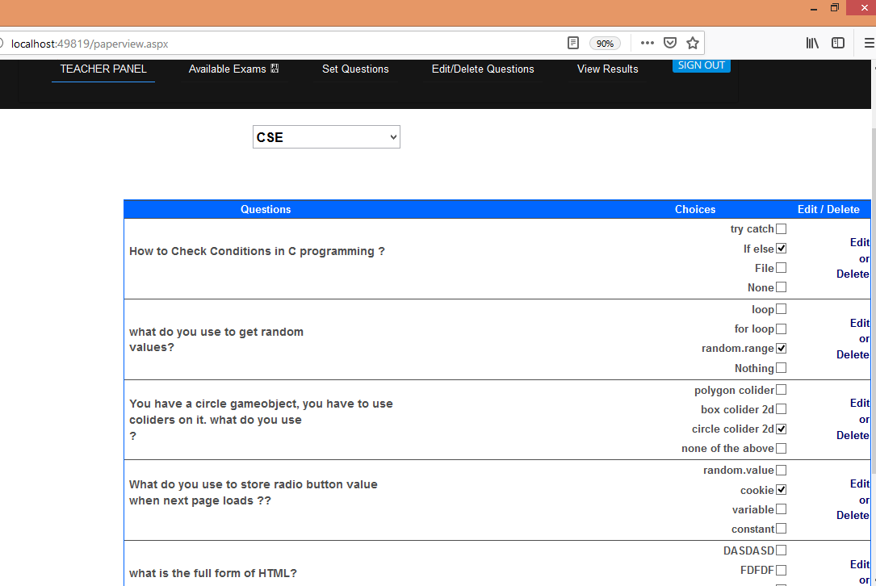

Figure 4.13 : Teacher Panel(Question Edit and Delete Page).

It is Teacher Panel.Teacher can view the previous question in this page.If he wish he can edit or delete any question.

**Student Result Page**

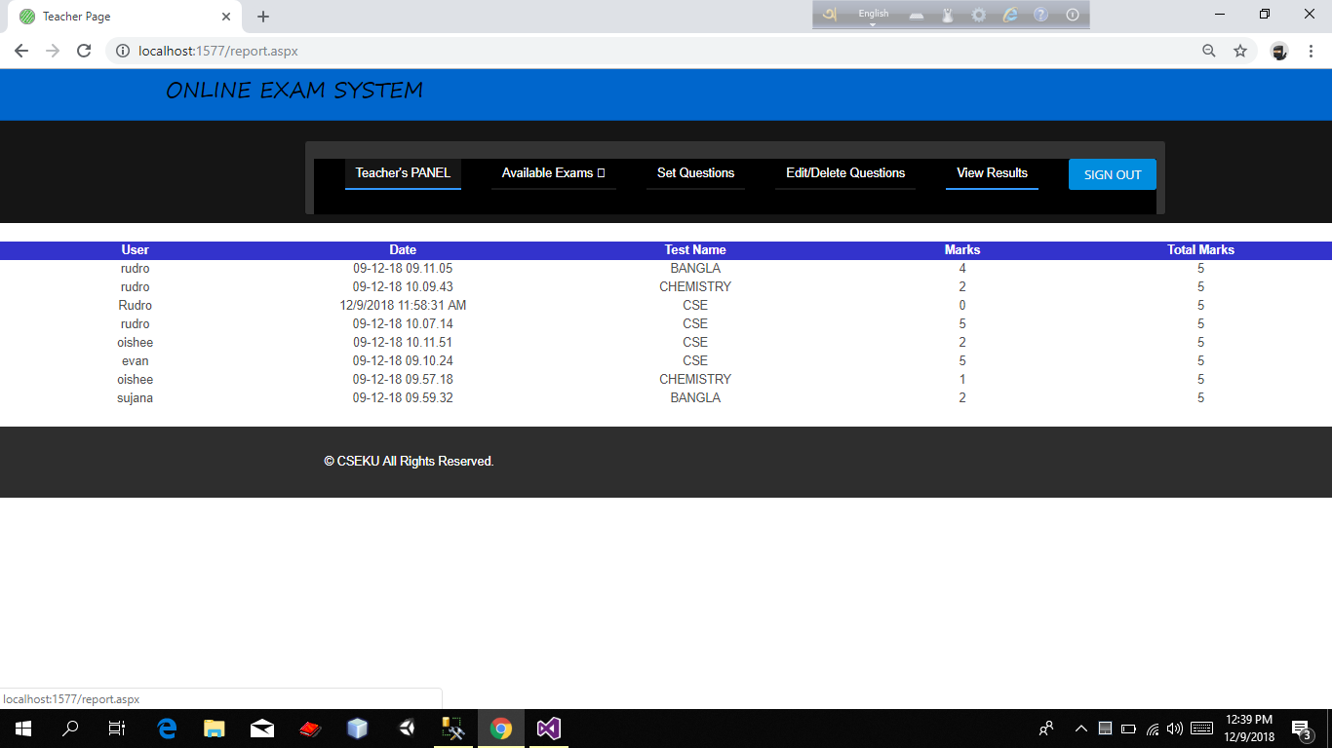

Figure 4.14 : Teacher Panel(Student Result Page).

It is Teacher Panel.In this page teacher can show the student’s result.

**4.3.4 Student Activates**

**Student Exam Rule Page**

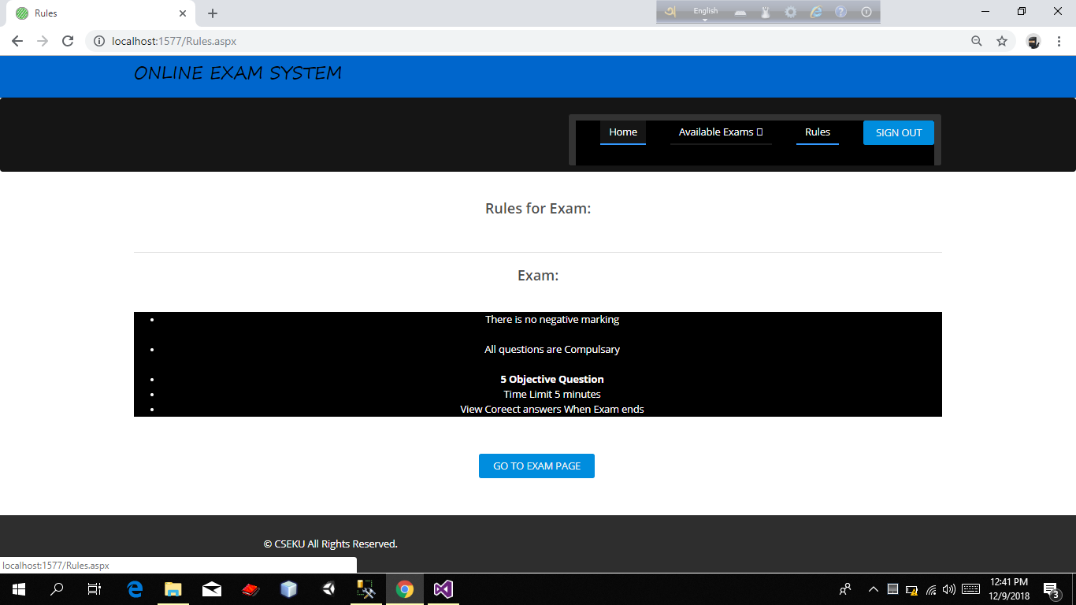

Figure 4.15 : Student Panel(Student Exam Rule Page).

It is Student Panel.In this page Student can show the exam’s rule.

**Exam Subject Selection Page**

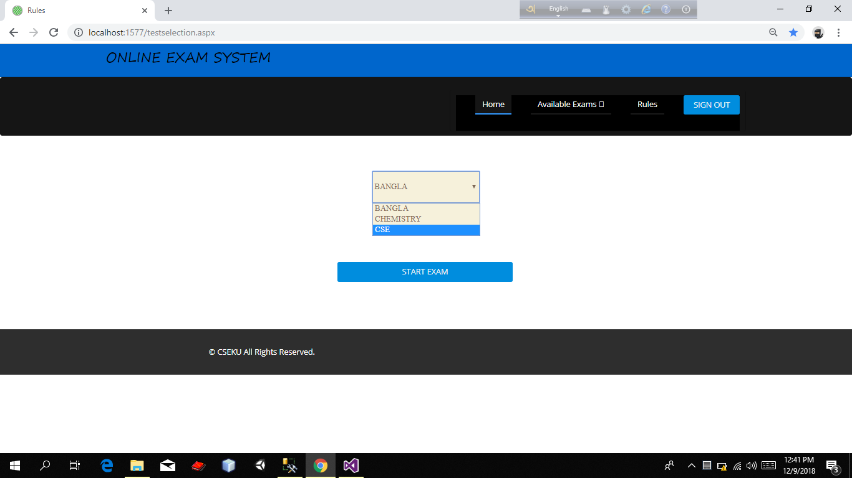

Figure 4.16 : Student Panel(Exam Subject Selection Page).

It is Student Panel.In this page Student select the subject which he give exam.

**Exam Page**

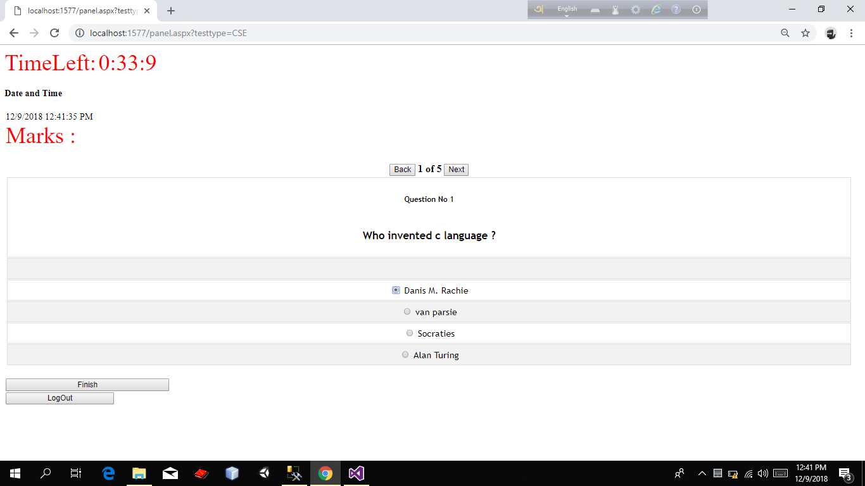

Figure 4.17: Student Panel(Exam Page).

It is Student Panel.In this page Student give exam.Student have to give exam within a time limit.After giving the answer of questions student press “Finish” button.

**Show obtained Marks Page**

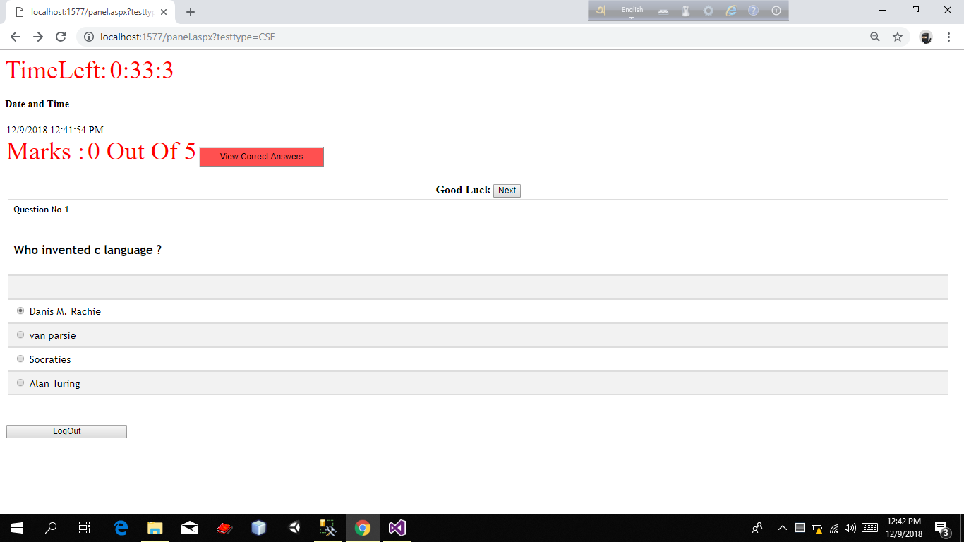

Figure 4.18 : Student Panel (Show obtained Marks Page).

It is Student Panel.In this page Student can see their obtained marks after finishing exam.

**View correct answer Page**

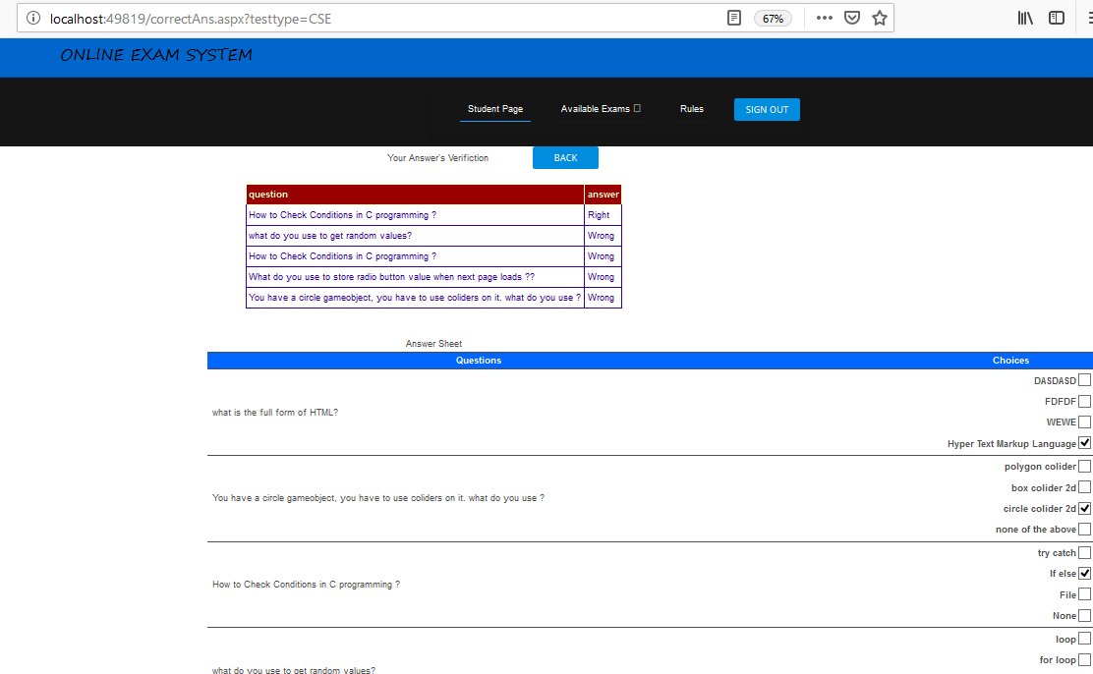

Figure 4.19: Student Panel(View correct answer Page).

It is Student Panel.In this page Student can show the correct answer.Student can see the page after clicking the “View Correct Answer” button On “Show obtained Marks Page”.

**4.4 Limitation of Proposed System:**

No software can solve all requirements of the user at a glance. This software is developed for a part of Exam system of KU specially faculty of CSE faculty .It is possible to update and implement this software for others faculty. This proposed system only suitable for MCQ ,True/ false Question.

1. We have to keep in mind that students will take the exam on their own device in their own time with nobody to check up on them, so we have to alter our questions to provide for this situation .We have to ask questions which are not easily to be retrieved from books or the internet. Or we can add a timer to each question so their is no time to search for the answer.
2. Open text questions are possible, but they don't auto-grade, so we have to check them ourselves.
3. An online exam system is a little bit more susceptible for fraud. So we have to keep that in mind if we setup our exam. Do we want to share the results immediately after the result? In that case we can setup a question bank to solve the issue of fraud. Handing out all questions & answers of a question bank to students is ok. Because they have to learn all the questions & answers by heart. And when they're done they master the material. Read more about proctored exams.
4. If the internet connection is not available then student can’t give exam.

# Chapter V

**Conclusion and future work**

The Exam system is one of the most complex and important part of a university. The university is a large field where many students study here. To manage the exam system manually is a difficult job. If we manage the exam system by Online Exam System it will more easy and more secure than manual system. The system has reached a steady state where all bugs have been eliminated. The system is operated at a high level of efficiency and all the teachers and students understands its advantage. Our aim is to convert the manual exam system of educational institution to Online Exam System. In this system the teachers and students will be great benefited. Texting is vital to success of the system. System testing makes a logical assumption that if all the parts of the system are correct ,the goal will successfully achieved .We text our software using various input and get required result.

No software can solve all requirement of the user at a glance .In future I will integrate more features like random question selection, random questions distribution, complete result making system . The system only suitable for MCQ ,True/ false type question. But in future I will develop the system so that the system will suitable for all type of question.

.

**References**

[1] A. Trivedi, “A Relevant Online Examination System”, Proceedings of the 1st IEEE International Conference on Technology for Education (IEEE T4E), Mumbai, India, pp. 32-35, July 2010.

[2] C. Xiangjun and W. Fangsheng, “Web-based General Examination System Development”, Proceedings of the 2nd International Conference on Computer Engineering and Technology (ICCET), Chengdu, China , Vol. 3, No. 4, pp. 457-461, April 2010.

[3] M. A. Sarrayrih and M. Ilyas, “Challenges of Online Exam, Performances and Problems for Online University Exam”, International Journal of Computer Science Issues (IJCSI), Vol. 10, No. 1, pp. 439-443, January 2013.

[4] D. Kochakornjarupong, “Web-based System Design for Enhancing Learning Problem Solving in Artificial Intelligence”, International Journal of the Computer, the Internet and Management (IJCIM), Vol. 18, No. 1, pp. 42.1-42.6, December 2010.

[5] J. McGough, J. Mortensen, J. Johnson, and S. Fadali, “A Web-Based Testing System with Dynamic Question Generation”, Proceedings of the ASEE/IEEE International Conference on Frontiers in Education, Renu, Nevada, USA, Vol. 3, pp. 23-28, October 2001.

[6] K. Henke, “Web-Based Test, Examination and Assessment System”, Advanced Technology for Learning, Vol. 4, No. 3, pp. 140-145, June 2007.

[7] M. Z. Rashad, M. S. Kandil, A. E. Hassan, and M. A. Zaher, “An Arabic Web-Based Exam Management System”, International Journal of Electrical and Computer Sciences (IJECS-IJENS), Vol. 10, No. 1, pp. 35-41, February 2010.

[8] S. Vasupongayya, T. Kamolphiwong, S. Kamolphiwong and S. Sae-Wong, “Interactive Examination Management System”, Proceedings of the 2nd IEEE/IACSIT International Conference on Education Technology and Computer (ICETC), Shanghai, China, Vol. 2, pp. 55-59, June 2010. International Journal of Computing Academic Research (IJCAR), Volume 4, Number 2, April 2015

[9] R. Sheshadri, T. C. Reddy, and N. A. kumar, “Web-Based-Secure Online Non-Choice-Based Examination System (WONES) using Cryptography”, International Journal on Computer Science and Engineering (IJCSE), Vol. 3, No. 10, pp. 3383-3393, October 2011.

[10] P. G. Raj, P. Kumar, S. Sengupta, K. Vats, and P. R. Gupta, “An Architectural Insight into the National Online Examination System”, International Journal of e-Education, e-Business, eManagement and e-Learning, Vol. 2, No. 2, pp. 126-131, April 2012.

[11] H. Satav, T. Nanekar, S. Pingale, and Nupur, “SQL Based Paperless Examination System”, Journal of Information Engineering and Applications (JIEA), Vol. 2, No. 2, pp. 30-33, 2012.

[12] M. Z. Islam, M. M. Rahman, and M. K. Islam, “Online Examination System in Bangladesh Context”, International Journal of Science, Environment and Technology (IJSET), Vol. 2, No. 3, pp. 351-359, June 2013.

Appendix –A

**Source Code :**

https: //github.com/mkazi078/onlineexam