1. A = units frisky pup produced/sold

B = units husky hound produced/sold

Production Cost of Frisky Pup = (1A)\*1 + (1.5A)\*2 = 4

Production Cost of Husky Hound = (2B)\*1 + (1B)\*2 = 4

Profit for Frisky Pup = (7-4-1.4)A = 1.6A

Profit for Husky Hound = (6-4-.6)B = 1.4B

Total Profit = 1.6A + 1.4B

Objective: Max(1.6A + 1.4B)

Constraints:

0 <= A <= 110,000 (max of 110,000 units of Frisky Pup packaged/month)

0 <= B

A + 2B <= 240,000 (240,000 pounds cereal available)

1.5A + B <= 180,000 (180,000 pounds meat available)

2. x1 = units tomato, x2 = units lettuce, x3 = units spinach, x4 = units carrots,

x5 = units oil

nutrient content:

calories = x1\*21 + x2\*17 + x3\*370+x4\*345 + x5\*883

protein = x1\*.85 + x2\*1.63 + x3\*12.79 + x4\*8.38 + x5\*0.00

fat = x1\*0.33 + x2\*0.2 + x3\*1.58 + x4\*1.39 + x5\*100

carbs = x1\*4.65 + x2\*2.37 + x3\*73.68 + x4\*80.70 + x5\*0

sodium = x1\*9 + x2\*8 + x3\*7 + x4\*506.4 + x5\*0

constraints

x1, x2, x3, x4, x5 >= 0 (all amounts >= 0)

x1\*.85 + x2\*1.63 + x3\*12.79 + x4\*8.38 + x5\*0.00 >= 15 (at least 15 protein)

x1\*0.33 + x2\*0.2 + x3\*1.58 + x4\*1.39 + x5\*100 >= 2 (at least 2 fat)

x1\*0.33 + x2\*0.2 + x3\*1.58 + x4\*1.39 + x5\*100 <= 6 (at most 6 fat)

x1\*4.65 + x2\*2.37 + x3\*73.68 + x4\*80.70 + x5\*0>= 4 (at least 4 carbs)

x1\*9 + x2\*8 + x3\*7 + x4\*506.4 + x5\*0 <= 100 (at most 100 sodium)

x2 + x3 - x1 - x4 - x5 <= 0 (less than 50% greens)

objective: minimize (x1\*21 + x2\*17 + x3\*370+x4\*345 + x5\*883)

Solution: 588.4 grams tomato, 584.8 grams lettuce, 3.6 grams spinach, 0 grams carrot, 0 grams oil;

236.5 calories, 15 grams protein, 3.17 grams fat, 43 grams carbohydrates, 100 milligrams sodium

Solved with glpsol (GLPK):

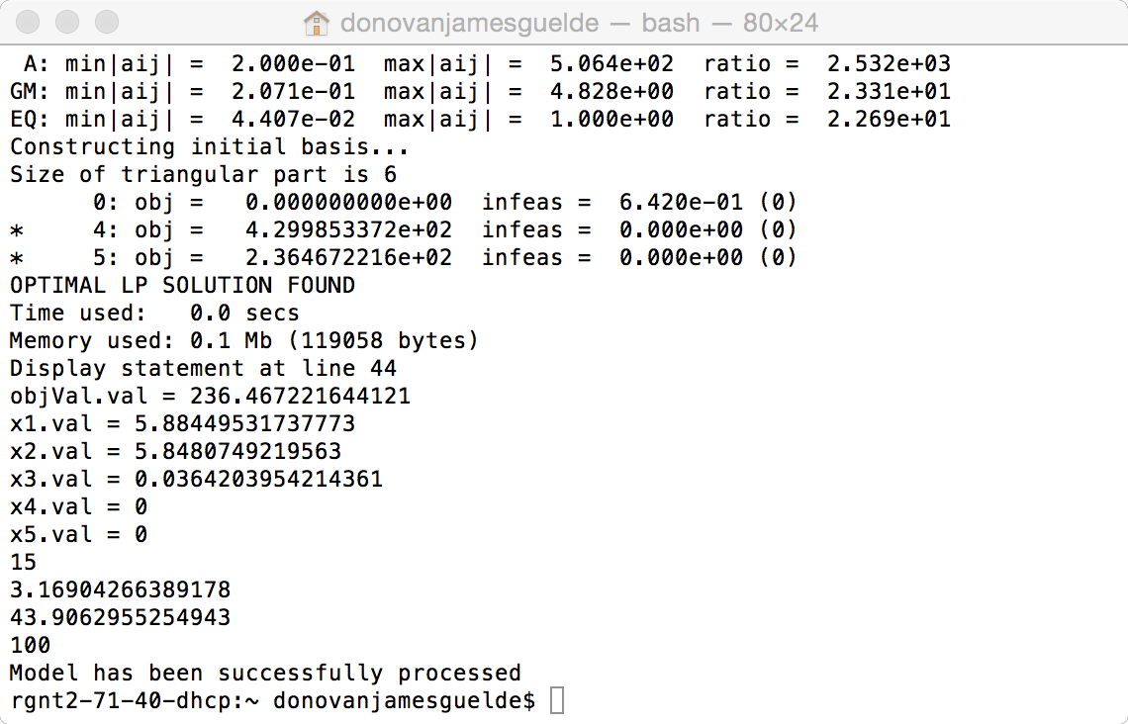

3.