1. c1 = 5x5 kernel, 32 filters

maxPool1 = 2x2

c2 = 5x5 kernel, 64 filters

maxPool2 = 2x2

connected layer = 1024 nodes

output layer = 10 nodes

no augmentation, dropout, etc. Simple cnn

AdamOptimizer

validation accuracy .6475

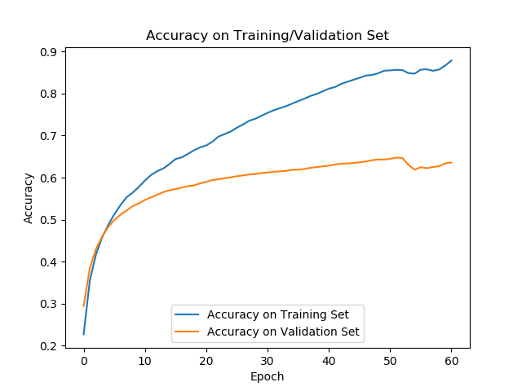

c1 = 5x5 kernel, 32 filters

maxPool1 = 2x2

c2 = 5x5 kernel, 64 filters

maxPool2 = 2x2

connected layer = 512 nodes (to reduce overfitting)

output layer = 10 nodes

no augmentation, dropout, etc. Simple cnn

AdamOptimizer

validation accuracy .6389

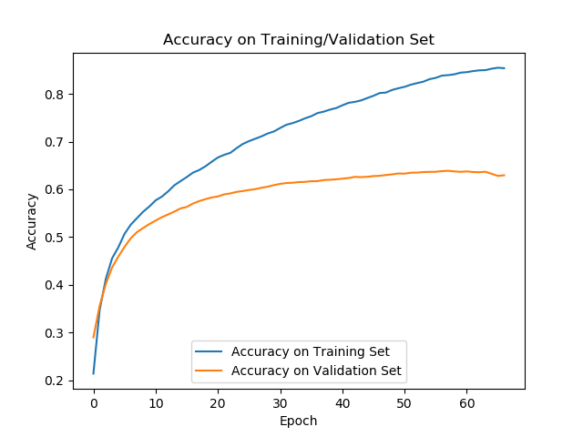

c1 = 5x5 kernel, 32 filters

maxPool1 = 2x2

c2 = 5x5 kernel, 64 filters

maxPool2 = 2x2

connected layer = 256 nodes (to reduce overfitting)

output layer = 10 nodes

no augmentation, dropout, etc. Simple cnn

AdamOptimizer

validation accuracy .6553

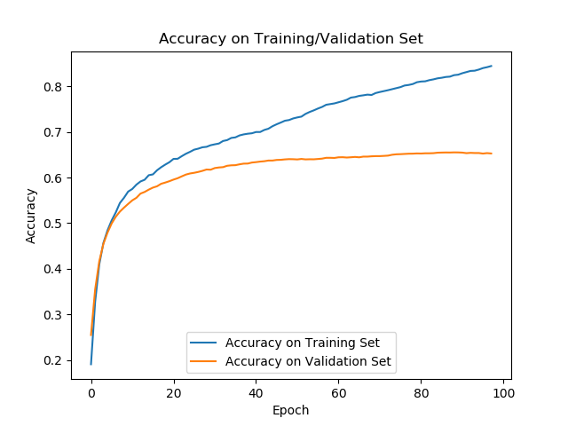

c1 = 5x5 kernel, 32 filters

maxPool1 = 2x2

c2 = 5x5 kernel, 64 filters

maxPool2 = 2x2

connected layer = 128 nodes (to reduce overfitting)

output layer = 10 nodes

no augmentation, dropout, etc. Simple cnn

AdamOptimizer

validation accuracy .6566

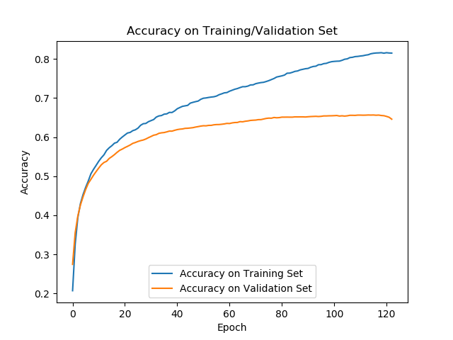

c1 = 5x5 kernel, 32 filters

maxPool1 = 2x2

c2 = 5x5 kernel, 64 filters

maxPool2 = 2x2

connected layer = 64 nodes (to reduce overfitting)

output layer = 10 nodes

no augmentation, dropout, etc. Simple cnn

AdamOptimizer

validation accuracy .6640

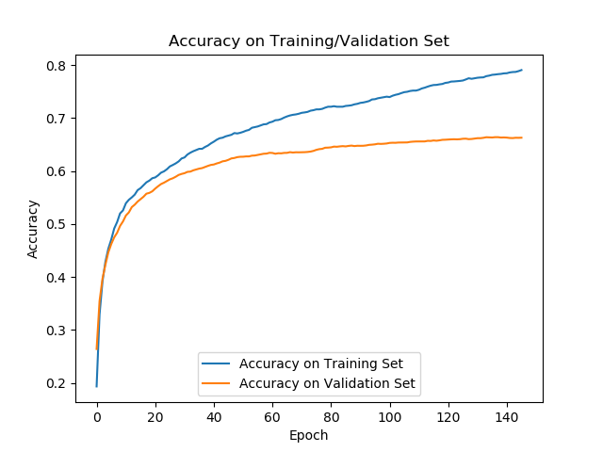

c1 = 5x5 kernel, 32 filters

maxPool1 = 2x2

c2 = 5x5 kernel, 64 filters

maxPool2 = 2x2

connected layer = 32 nodes (to reduce overfitting)

output layer = 10 nodes

no augmentation, dropout, etc. Simple cnn

AdamOptimizer

validation accuracy .6690

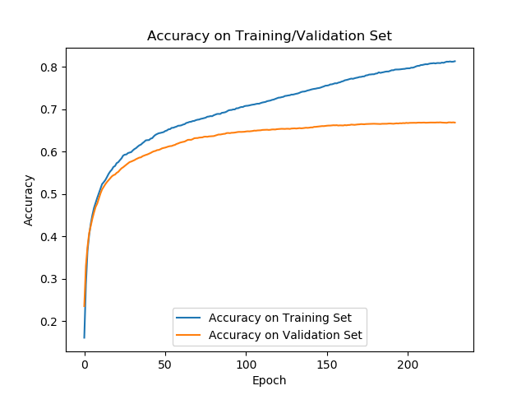

c1 = 5x5 kernel, 32 filters

maxPool1 = 2x2

c2 = 5x5 kernel, 64 filters

maxPool2 = 2x2

connected layer = 16 nodes (to reduce overfitting)

output layer = 10 nodes

no augmentation, dropout, etc. Simple cnn

AdamOptimizer

validation accuracy .6772

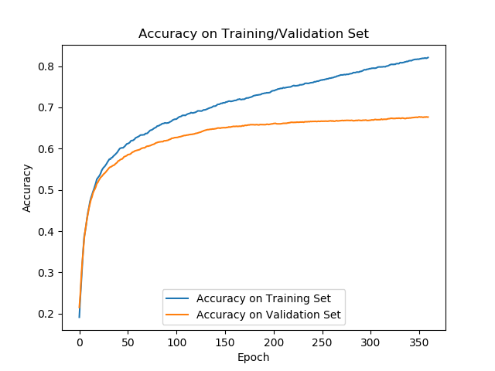

c1 = 5x5 kernel, 32 filters

maxPool1 = 2x2

c2 = 5x5 kernel, 64 filters

maxPool2 = 2x2

connected layer = 8 nodes (to reduce overfitting)

output layer = 10 nodes

no augmentation, dropout, etc. Simple cnn

AdamOptimizer

validation accuracy .6469

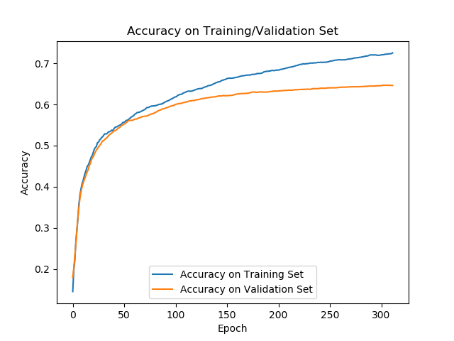

c1 = 5x5 kernel, 32 filters

maxPool1 = 2x2

c2 = 5x5 kernel, 64 filters

maxPool2 = 2x2

connected layer = 4 nodes (to reduce overfitting)

output layer = 10 nodes

no augmentation, dropout, etc. Simple cnn

AdamOptimizer

validation accuracy .4051

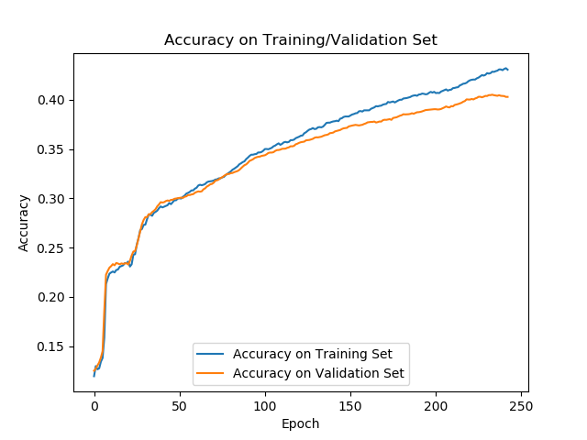

c1 = 5x5 kernel, 32 filters

maxPool1 = 2x2

c2 = 5x5 kernel, 64 filters

maxPool2 = 2x2

connected layer 1 = 8 nodes (to reduce overfitting)

connected layer 2 = 16 nodes

output layer = 10 nodes

no augmentation, dropout, etc. Simple cnn

AdamOptimizer

validation accuracy .6092

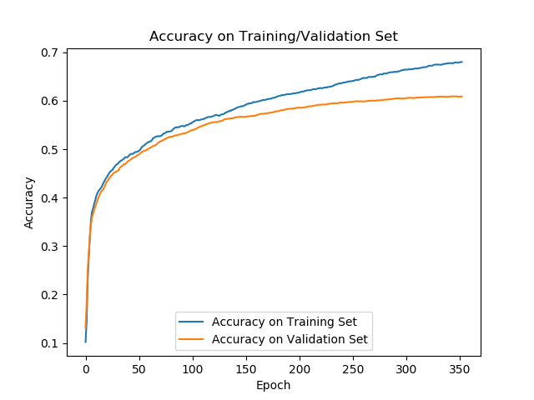

c1 = 5x5 kernel, 32 filters

maxPool1 = 2x2

c2 = 5x5 kernel, 64 filters

maxPool2 = 2x2

connected layer 1 = 16 nodes (to reduce overfitting)

connected layer 2 = 32 nodes

output layer = 10 nodes

no augmentation, dropout, etc. Simple cnn

AdamOptimizer

validation accuracy .6580

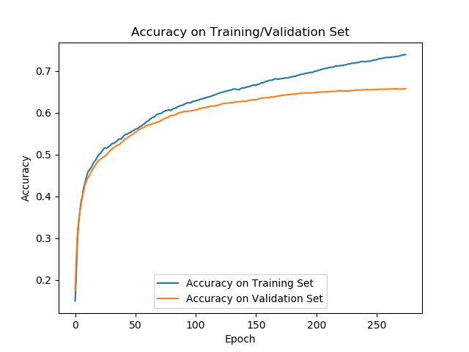

c1 = 5x5 kernel, 32 filters

maxPool1 = 2x2

c2 = 5x5 kernel, 64 filters

maxPool2 = 2x2

connected layer 1 = 16 nodes (to reduce overfitting)

connected layer 2 = 64 nodes

output layer = 10 nodes

no augmentation, dropout, etc. Simple cnn

AdamOptimizer

validation accuracy .6541

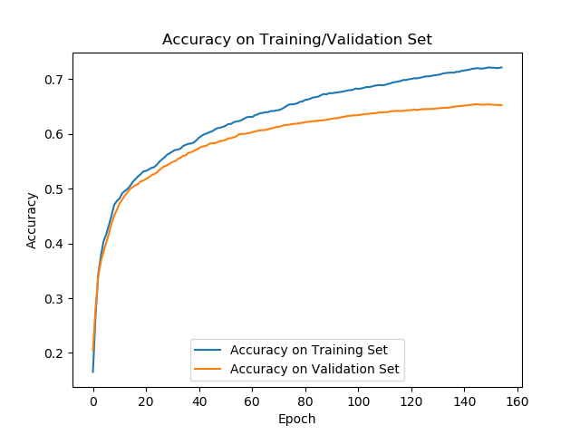

c1 = 5x5 kernel, 32 filters

c2 = 5x5 kernel, 64 filters

maxPool1 = 2x2

maxPool2 = 2x2

connected layer 1 = 16 nodes

connected layer 2 = 64 nodes

output layer = 10 nodes

no augmentation, dropout, etc. Simple cnn

AdamOptimizer

validation accuracy .6747

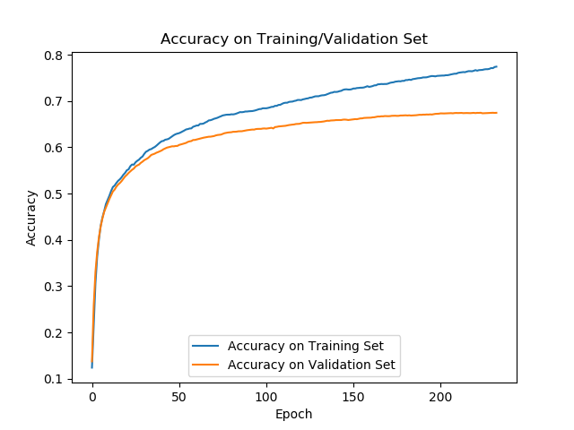

c1 = 3x3 kernel, 32 filters

c2 = 3x3 kernel, 64 filters

c3 = 3x3 kernel, 64 filters

maxPool1 = 2x2

maxPool2 = 2x2

connected layer 1 = 64 nodes

output layer = 10 nodes

no augmentation, dropout, etc. Simple cnn

AdamOptimizer

validation accuracy .6875

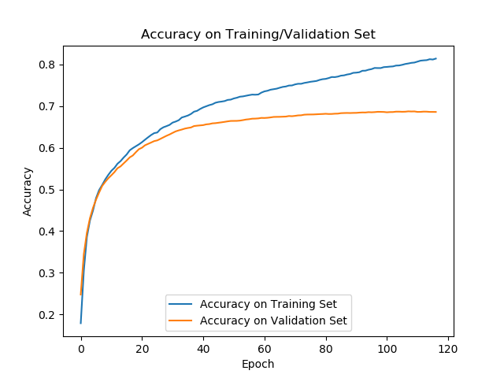

c1 = 3x3 kernel, 32 filters

c2 = 3x3 kernel, 64 filters

c3 = 3x3 kernel, 64 filters

c4 = 3x3 kernel, 64 filters

maxPool1 = 2x2

maxPool2 = 2x2

maxPool3 = 2x2

connected layer 1 = 64 nodes

output layer = 10 nodes

no augmentation, dropout, etc. Simple cnn

AdamOptimizer

validation accuracy .6844

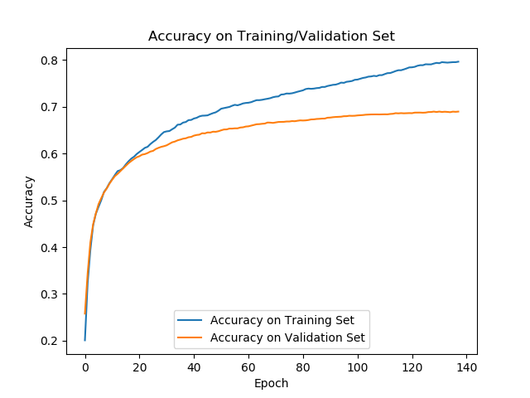

c1 = 3x3 kernel, 32 filters

c2 = 3x3 kernel, 64 filters

c3 = 3x3 kernel, 64 filters

c4 = 3x3 kernel, 64 filters

c5 = 3x3 kernel, 64 filters

maxPool1 = 2x2

maxPool2 = 2x2

maxPool3 = 2x2

connected layer 1 = 64 nodes

output layer = 10 nodes

no augmentation, dropout, etc. Simple cnn

AdamOptimizer

validation accuracy .6844

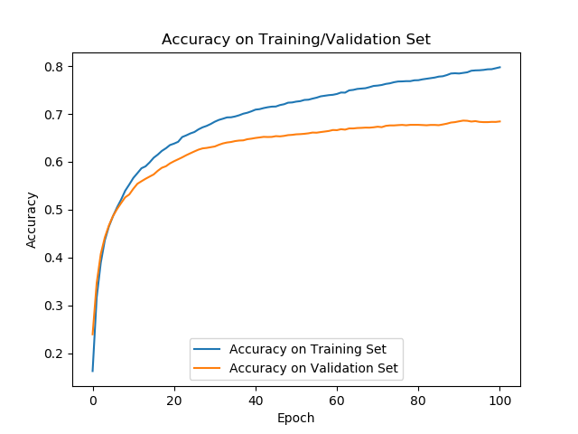

c1 = 3x3 kernel, 32 filters

c2 = 3x3 kernel, 64 filters

c3 = 3x3 kernel, 64 filters

c4 = 3x3 kernel, 64 filters

c5 = 3x3 kernel, 64 filters

maxPool1 = 2x2

maxPool2 = 2x2

connected layer 1 = 64 nodes

output layer = 10 nodes

no augmentation, dropout, etc. Simple cnn

AdamOptimizer

validation accuracy .6844