**CROSS-SECTIONAL ECONOMIC ANALYSIS OF UNEMPLOYEMNT RATES – DA2**

**Data Source:** [**https://data.worldbank.org/indicator?tab=all**](https://data.worldbank.org/indicator?tab=all) **Year: 2017** – no major economic shock

**Dependent / Y variable:**

1. [**Unemployment, total (% of total labor force) (modeled ILO estimate)**](https://data.worldbank.org/indicator/SL.UEM.TOTL.ZS)

**Independent / X variables:**

*Economic Variables:*

1. [GDP growth (annual %)](https://data.worldbank.org/indicator/NY.GDP.MKTP.KD.ZG)
2. [General government final consumption expenditure (% of GDP)](https://data.worldbank.org/indicator/NE.CON.GOVT.ZS)
3. [**Inflation, GDP deflator (annual %)**](https://data.worldbank.org/indicator/NY.GDP.DEFL.KD.ZG)
4. [Broad money (% of GDP)](https://data.worldbank.org/indicator/FM.LBL.BMNY.GD.ZS)
5. [Gross savings (% of GDP)](https://data.worldbank.org/indicator/NY.GNS.ICTR.ZS)

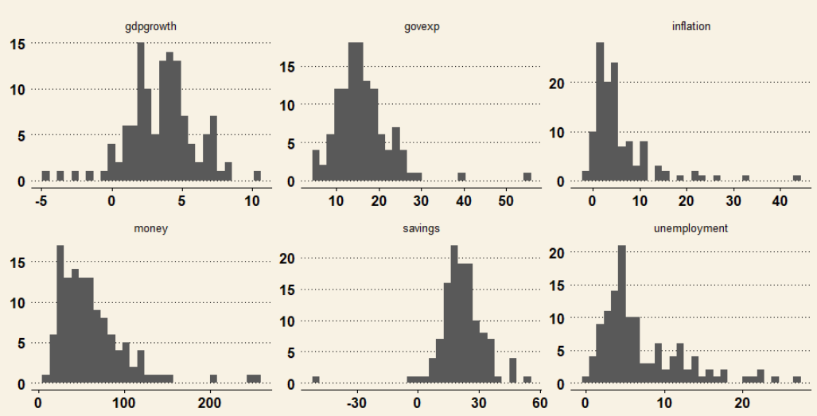

**Research Intention:***CASUAL ANALYSIS BETWEEN UNEMPLOYMENT AND INFLATION*

Use cross-sectional data on 122 countries (filtered for data completeness but not yet for extreme values) to discover whether there is a causal relationship between unemployment and inflation. (Note: In contrast to the Philips Curve, I would like to use the unemployment rate as the y variable.) My control variables are GDP growth, General government final consumption expenditure, Broad money, Gross savings. Taking into consideration that is advisable to have at least 20 observations / variables, I plan to discard the least significant explanatory variable after proper examination of the model.