Data Structures and Variables
The files used in my solution are:
Personal detail – persondetail: table
Training information – traininginformation: table
Ranking information – ranking: table
These are all random access files.
I also created an array containing one element, which stores the admin’s password.
Admin password – adminpassword: table

Database design & sample data
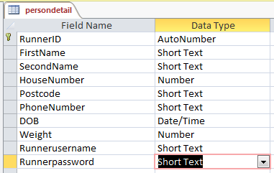

Person detail
RunnerID | FirstName | SecondName | HouseNumber | Postcode | PhoneNumber | DOB | Weight | Runnerusername | Runnerpassword
304 | Tulsi | Patell | 175 | rm24 6df | 07898345767 | 24/02/1995 | 75 | Tulsi | Patel
305 | Will | Baker | 177 | RM4 6JV | 07441332148 | 08/07/1998 | 50 | WRB | Boss
317 | Ricky | Fisher | 1 | XX3 4XX | 01708222222 | 14/12/1992 | 50 | Rixterz | :3:3
318 | David | Guo | 9 | AB1 2CD | 07123456789 | 16/01/1998 | 75 | faithfulstride1997 | faithfulstride1997
This table is used to hold the records of each runner’s personal details.
Screens that get data from this table:
User profile: every runner is able to see or edit his own profile/details.
Admin Runners detail page: the admin is able to view all the runners’ details, and also delete a selected record/runner’s profile. The admin can also search for a runner’s details by surname or Runner ID.
Queries:
SELECT * FROM persondetail
"SELECT * FROM persondetail where RunnerID =" & textbox search.Text
"SELECT * FROM persondetail where SecondName ='" & textbox search.Text & "'"

Sign in: after the user presses the sign in button, the system will check whether the username exists in the table and, if it does, whether it matches the password.

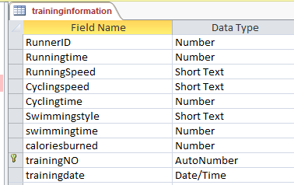

Training information
RunnerID | RunningSpeed | runningtime | Cyclingspeed | Cyclingtime | Swimmingstyle | swimmingtime | caloriesburned | trainingNO | trainingdate
318 | 6 mph (10 minute mile) | 0.1 | 7 mph (8.5 minute mile) | 0.1 | Freestyle, fast | 0.1 | 138.2813 | 2 | 02/03/2015
318 | 7 mph (8.5 minute mile) | 0.1 | 6 mph (10 minute mile) | 0.1 | Freestyle, fast | 0.1 | 152.1563 | 11 | 02/03/2015
318 |  | 0 |  | 0 |  | 0 | 0 | 12 | 02/03/2015
318 |  | 0 | 6 mph (10 minute mile) | 0.1 |  | 0 | 33.1875 | 23 | 31/03/2015
318 | 6 mph (10 minute mile) | 0.1 | 6 mph (10 minute mile) | 0.1 | Freestyle, slow | 0.1 | 143.8125 | 24 | 03/03/2015
The table will hold the records of every runner’s training information.
Screens that get data from this table:
Runner’s training information page: every runner is able to view, add and delete his own training information.
Queries:
"SELECT * FROM traininginformation where RunnerID =" & runner ID
Runner’s compare training page: the user will be able to see all the runners’ training performance based on one or more exercises.
- Running:
SELECT RunnerID, Runningtime, RunningSpeed, trainingdate FROM traininginformation where not (Runningtime = 0)
- Cycling:
SELECT RunnerID, Cyclingspeed, Cyclingtime, trainingdate FROM traininginformation where not (Cyclingtime = 0)
- Swimming:
SELECT RunnerID, Swimmingstyle, swimmingtime, trainingdate FROM traininginformation where not (swimmingtime = 0)
- All activities:
SELECT * FROM traininginformation

Admin’s training information page: the admin will be able to see all the runners’ training information.
SELECT * FROM traininginformation

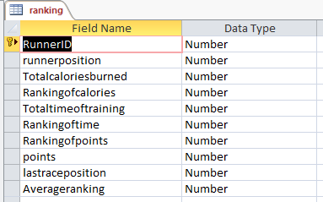

Ranking
RunnerID | position | Totalcaloriesburned | Rankingofcalories | Totaltimeoftraining | Rankingoftime | Rankingofpoints | points | Averageranking | lastraceposition
304 | 2 | 3242134 | 4 | 3214 | 3 | 6 | 76 | 4.33 | 6
305 | 1 | 532523214 | 2 | 2134 | 4 | 5 | 89 | 3.66 | 1
317 | 5 | 25322134 | 3 | 3424 | 1 | 11 | 24 | 5 | 5
318 | 11 | 9712.96875 | 12 | 16 | 11 | 7 | 65 | 10 | 7
The table will hold the records of every runner’s rankings in different aspects.

Screens that get data from this table:
Race and select team page: the admin is able to view all the runners’ rankings and also sort them in the order of any one of the fields.
Queries:
SELECT * FROM ranking

Relationship between the tables:

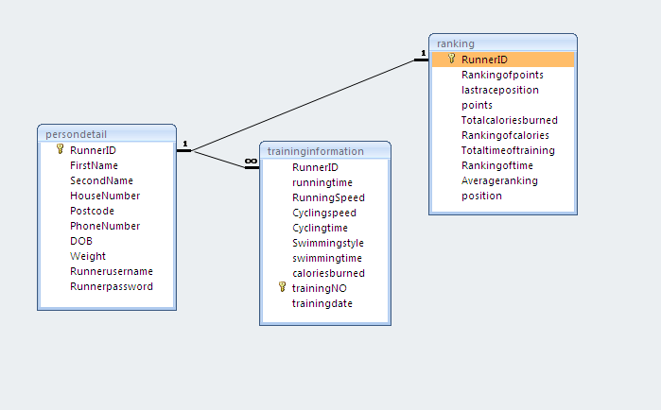

Variables:

Sign in page:

Variable | Data type | purpose
dblo | String | The location of the database
Currentposition | String | The current position of the runner that corresponds to the username
pw | String | To check whether the runner’s password matches the one in the database
runnerid | String | Retrieve the runner’s ID that corresponds to the username
adminpassword | String | Retrieve the admin’s password from the database and use it to check whether the password input is correct
np | String | Used to check whether the new password is valid.

Sign up page:

Variable | Data type | purpose
dblo | String | The location of the database
id | Integer | Add the new runner’s ID to another table (the ranking table)
em | String | The error message that is shown after the user inputs invalid data.

Runner profile:
Variable | Data type | purpose
dblo | String | The location of the database
runnerid | String | The runner’s ID from the sign in page
viewonly | Boolean | Set the ‘view only’ property of all the buttons to true or false
em | String | The error message that is shown after the user inputs invalid data.

Training information(R)
Variable | Data type | purpose
dblo | String | The location of the database
runnerid | String | The runner’s ID from the sign in page
closingform | Boolean | Decide whether to close or hide the form when the user goes to another form
Rt | Single/real | Total running time
ct | Single/real | Total cycling time
St | Single/real | Total swimming time
tc | Single/real | Total calories burned
tt | Single/real | Total training time

Add a new training
Variable | Data type | purpose
dblo | String | The location of the database
Weight | integer | The runner’s weight
Ratio | single | The ratio of the runner’s weight to 80 kg, used to calculate the calories burned.
m | string | The error message when a required textbox is empty

Compare training page
Variable | Data type | purpose
dblo | String | The location of the database
i | integer | The number of repetitions of a section of code (hides all the runner’s training information records if they are empty).

Runners’ detail
Variable | Data type | purpose
dblo | String | The location of the database
Id | Integer | The runner’s ID that corresponds to the selected record.
Index | Integer | The index of the selected runner’s details in the data grid view.

Adding new race page
Variable | Data type | purpose
dblo | String | The location of the database
I | Integer | The number of repetitions of a section of code (works out the points to add to the runner’s total points).
Position | integer | Used to work out the runner’s position
c | Integer | The number of runners who attended the last race.
pi | integer | The number of repetitions of a section of code (stores the runner’s position).

