User interface:

Menu structure:
Sign in

Sign up a new account

Runner home page
Runner’s detail
Training information
Calories calculator
Personal detail
Adding new training

Admin home page

Training information
Race & select team

Compare training
Add new race

Sign up page

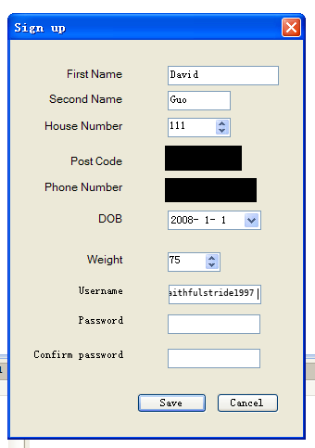
Use number picker can make sure users input digit, also it can have range which ensure user input sensible data.
Use date time picker can make sure the users input correct time format data.
Sizes of the textboxes are based on associated length of input text.
The similar objects are lined up which give the user a clear view

The labels are used for displaying the text

Login page:

Using tab pages can help user to quick access another tab, and it save time to create another form with similar content

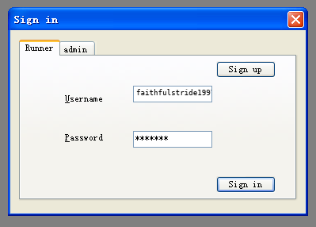

The button that more likely to be clicked will have a thicker outline, so user can access the button by pressing Enter key.

The “U” is underlined which tell the user the username textbox can be accessed by pressing Alt + U

The text in password textboxes is shown as same character which make it secure.

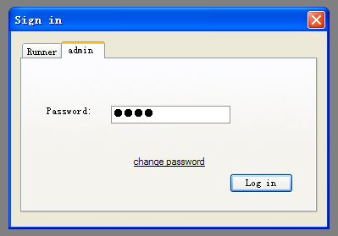

I underline the option change password because it appears like this in many popular program and website.

Runner homepage
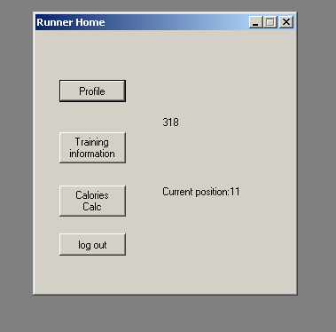
The texts on the button show the form thatwill open if the button is clicked.
The text in the label shows the most important information from database.

Runner profile
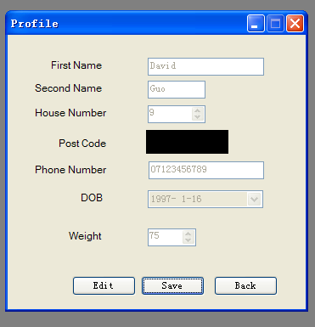

The texts are shown as grey coloured as they are not editable unless edit button is clicked which avoid unexpected change.

Training information(R)

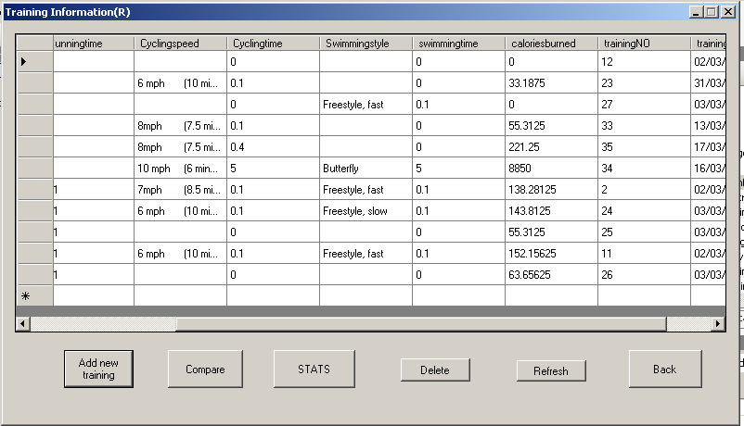
Using data grid view can display data from database on the page.

Add a new training
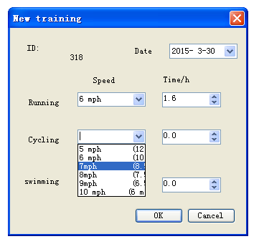
Using combo box can help user quicker input data and avoid spelling error.

Compare training page

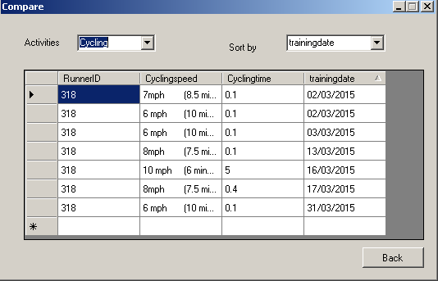

Calories Calculator
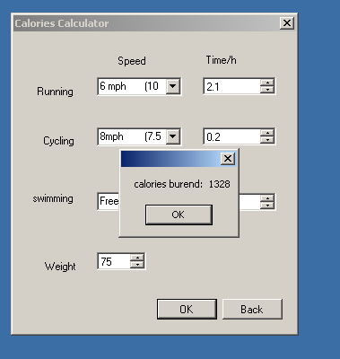
I used a message instead of new form which can give a user a straight report.

Admin home page
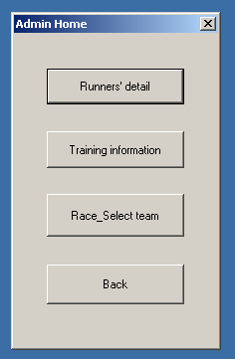

Runners’ detail

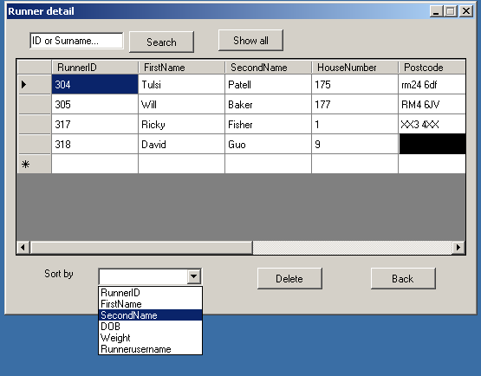

Texts in the textbox tells the data user need to input, and it’ll be cleared once the textbox is clicked.

Training information (A)

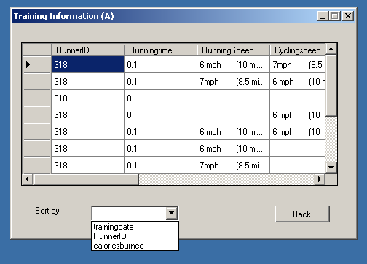

Race& select team

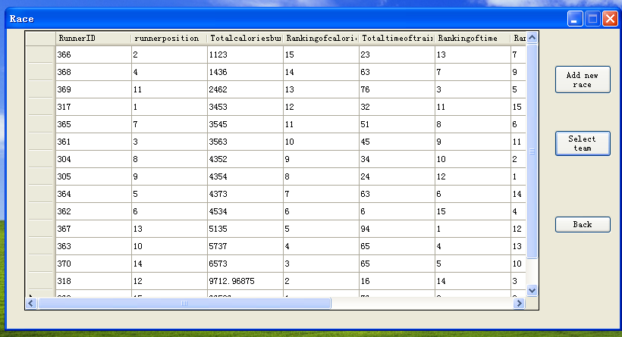
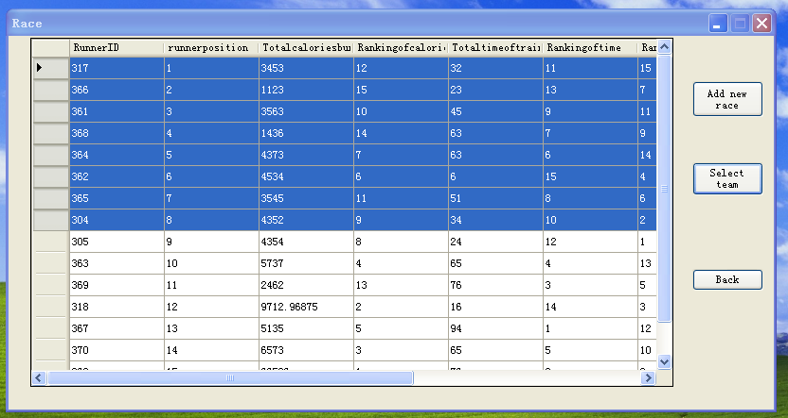
When the select team button is clicked the table will be sorted in the order of the points and the best eight runner will be highlighted which can show the report clearly to the user.

Adding new race page
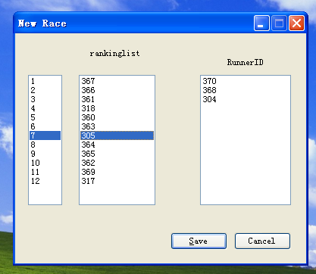
The list box is good to display a list of items or a 1D array.
When the item from either of the list box is selected, the corresponding item will also be selected /highlighted in the other list box, which can tell the index of the item /position of the runner clearly.

