Actual Test Runs
Test | Result | Evidence | Action
1 | Performed as predicted. | See heading ‘Test 1’ | None
1.1 | Performed as predicted. | See heading ‘Test 1’ | None
2 | Performed as predicted. | See heading ‘Test 2’ | None
3 | Performed as predicted. | See heading ‘Test 3’ | None
4 | Performed as predicted. | See heading ‘Test 4’ | None
4.1 | Performed as predicted. | See heading ‘Test 4’ | None
5 | Performed as predicted. | See heading ‘Test 5’ | None
6 | Performed as predicted. | See heading ‘Test 6’ | None
6.1 | Performed as predicted. | See heading ‘Test 6’ | None
7 | Performed as predicted. | See heading ‘Test 7’ | None
8 | The first name and surname validation allowed digits in names. | See heading ‘Test 8’ | Change the name validations so that digits in the textbox are detected.
8.1 | Performed as predicted. | See heading ‘Test 8’ | None
8.2 | Performed as predicted. | See heading ‘Test 8’ | None
8.3 | Performed as predicted. | See heading ‘Test 8’ | None
8.4 | Performed as predicted. | See heading ‘Test 8’ | None
9 | Performed as predicted. | See heading ‘Test 9’ | None
10 | An error message appeared in the code. | See heading ‘Test 10’ | Change the code to eliminate the error.
10.1 | Performed as predicted. | See heading ‘Test 10’ | None
11 | Performed as predicted. | See heading ‘Test 11’ | None
12 | Performed as predicted. | See heading ‘Test 12’ | None
13 | Performed as predicted. | See heading ‘Test 13’ | None
14 | Performed as predicted. | See heading ‘Test 14’ | None
15 | - Items in the combo box were miscopied.  - A variable name was misspelt. | See heading ‘Test 15’ | - Copy the items again.  - Correct the spelling.
16 | Performed as predicted. | See heading ‘Test 16’ | None
16.1 | Performed as predicted. | See heading ‘Test 16’ | None
17 | Performed as predicted. | See heading ‘Test 17’ | None
17.1 | Performed as predicted. | See heading ‘Test 17’ | None
17.2 | Performed as predicted. | See heading ‘Test 17’ | None
18 | - An error message appeared because I used a reserved word as a field name in the database. | See heading ‘Test 18’ | - Rename that field.
19 | Performed as predicted. | See heading ‘Test 19’ | None
20 | Performed as predicted. | See heading ‘Test 20’ | None
21 | Performed as predicted. | See heading ‘Test 21’ | None
22 | Performed as predicted. | See heading ‘Test 22' | None
23 | Performed as predicted. | See heading ‘Test23' | None
24 | Performed as predicted. | See heading ‘Test 24' | None
25 | Performed as predicted. | See heading ‘Test 25' | None
26 | Performed as predicted. | See heading ‘Test 26' | None
27 | Performed as predicted. | See heading ‘Test 27' | None
28 | Performed as predicted. | See heading ‘Test 28' | None
29 | Performed as predicted. | See heading ‘Test 29' | None
29.1 | Performed as predicted. | See heading ‘Test 29' | None
29.2 | Performed as predicted. | See heading ‘Test 29' | None
*Headings can be accessed from ‘View > Document Map/Navigation pane’

Test 1
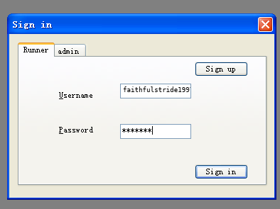

This is an existing username in database with correct password

The system showed the runner homepage.

(Test 1.1)
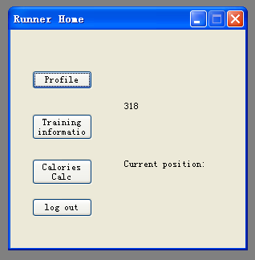

Test 2
As the username didn’t exist, an error message showed up.

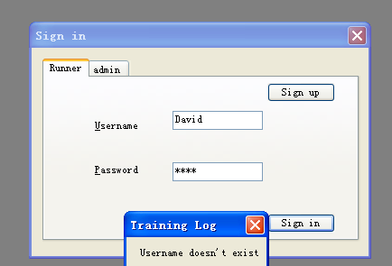

Test 3
As the username existed and the password was incorrect, a message box showed this information.

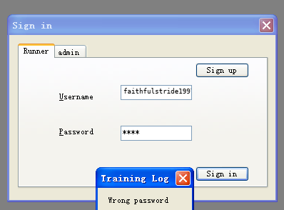

Test 4
As the correct admin password was entered, the admin homepage was shown.
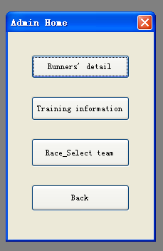
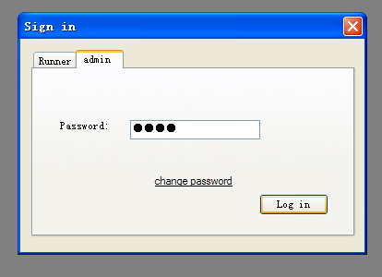

The admin’s password is saved in the database.

(Test 4.1)

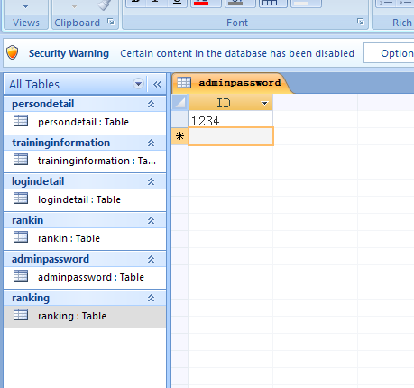
Admin password

Test 5
As the wrong password was entered, the error message was shown.
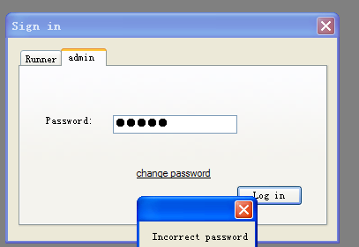

Test 6
This is when a user signs up for a new account. As all the data was valid, the data will be saved into the database and the sign in page will be shown.
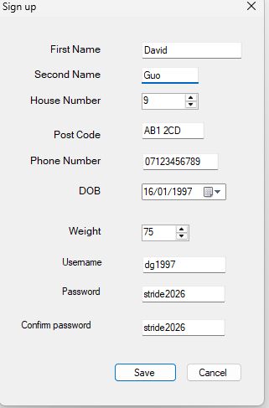
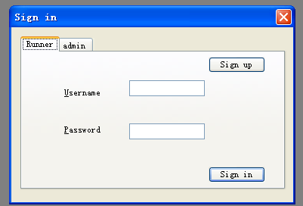

(Test 6.1)

A new record was added at the end of the database.

Test 7
This data may not seem correct, but the system will still accept it as it passed all the validation, so a new record will be added to the database.

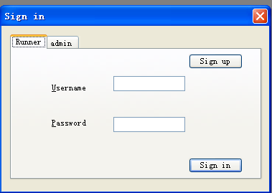
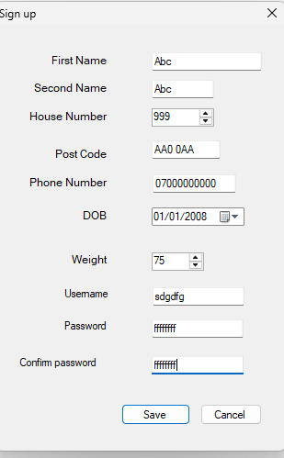

Test 8
When the data entered was invalid, a message box was shown to tell the user all the invalid data that they need to correct.

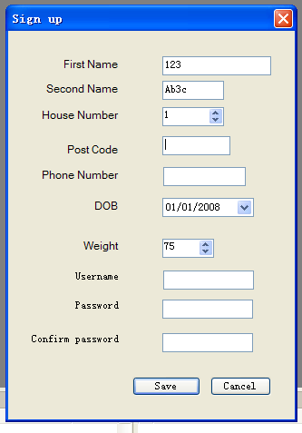
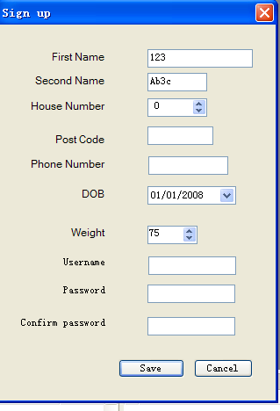

As the number picker is able to have a limit, so if the data the user enters is outside the range, it will auto-correct to its default value.

This is the invalid data I input:
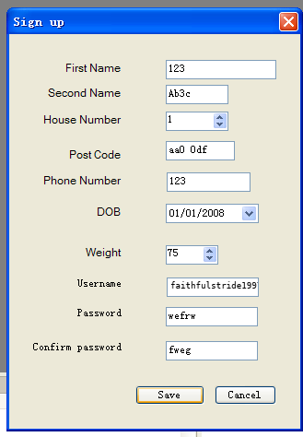

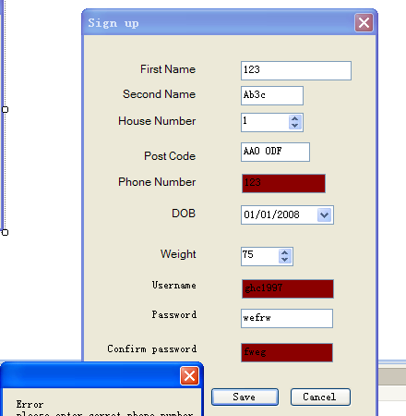
The postcode was changed to upper case.
The data validations didn’t work as I expected, because the first name and second name textboxes should not allow the user to have digits in them, so I found the code for the validation of the first name.

'First name verfication
If fntb.Text.Contains("#") Or fntb.Text.Length < 2 Then
'name should not contain digits or be less than three charaters
em = em & vbNewLine &"please enter corret first name"
'error message will add to the string if data entered is not valid
fntb.BackColor = Color.DarkRed
' and the textbox colour will change to red
EndIf

This is the first name verification, and it’s similar to the second name verification. I think a name shouldn’t contain any numbers, so my code indicates that the text shouldn’t contain ‘#’, which I thought stands for a number in Visual Basic. However, what the verification code did was check whether the text contains a ‘#’ symbol, so I had to find and use different code to do the verification I wanted.

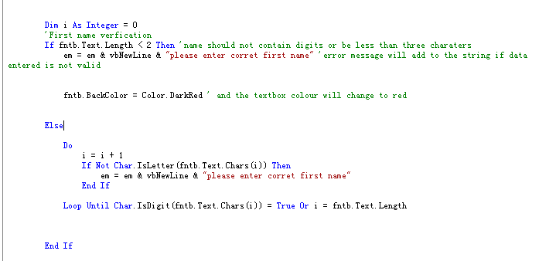

This is the new code I made. I created a loop that checks every single character in the text to see whether it’s a letter; it stops when a digit is found or when every character has been checked.

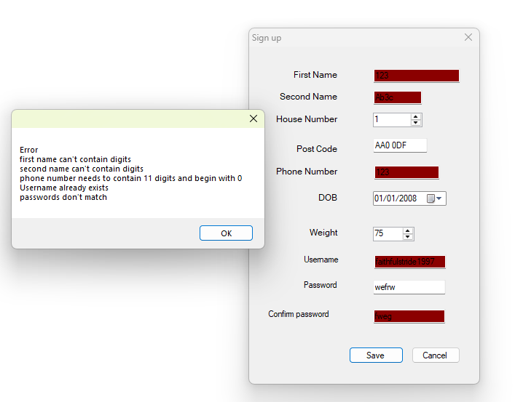

I think the code did work, because when I entered the same invalid data, the error message was shown, and the background colour of the first and second name textboxes turned red.

Test 8.1
I input valid details except for the first name.

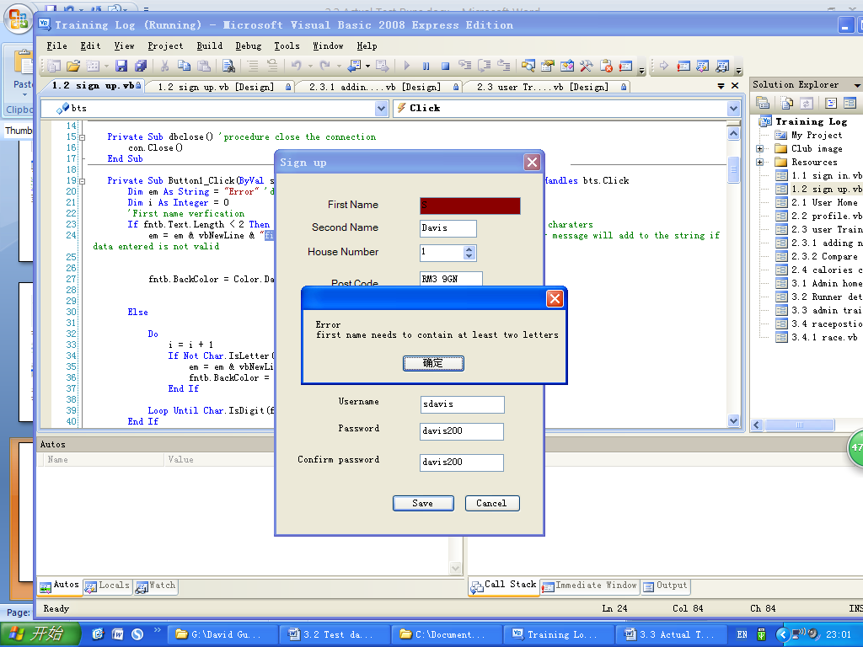

The message only told the user about the first name validation, and the background colour of the first name textbox changed to red, because only the first name was incorrect.

Test 8.2
Again, I input valid details except for the postcode, and the message box only told the user that the postcode input was incorrect.

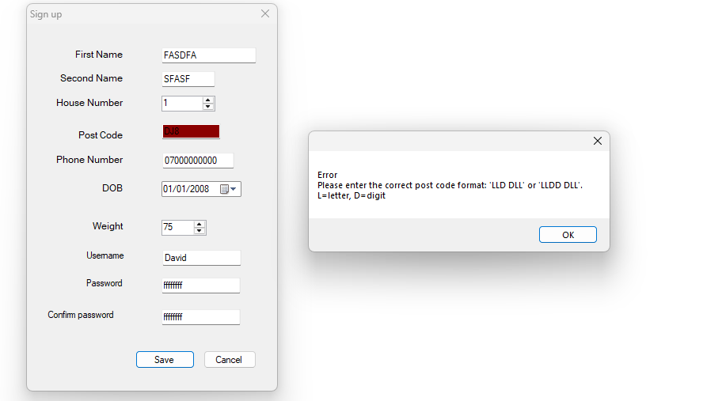

Test 8.3
As passwords need to contain at least four characters for security purposes, an error message will be shown if the user inputs a password with fewer than four characters.
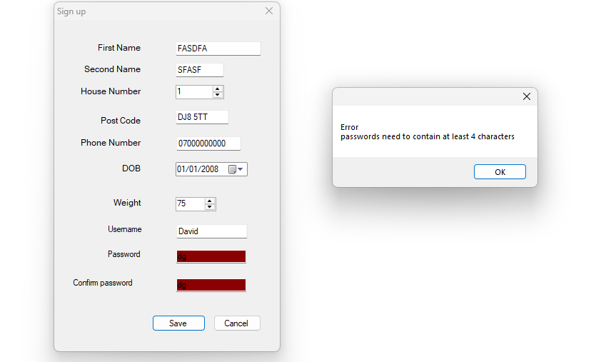

Test 8.4

As phone numbers start with 0, an error message will be shown when the user inputs a number that doesn’t begin with 0.

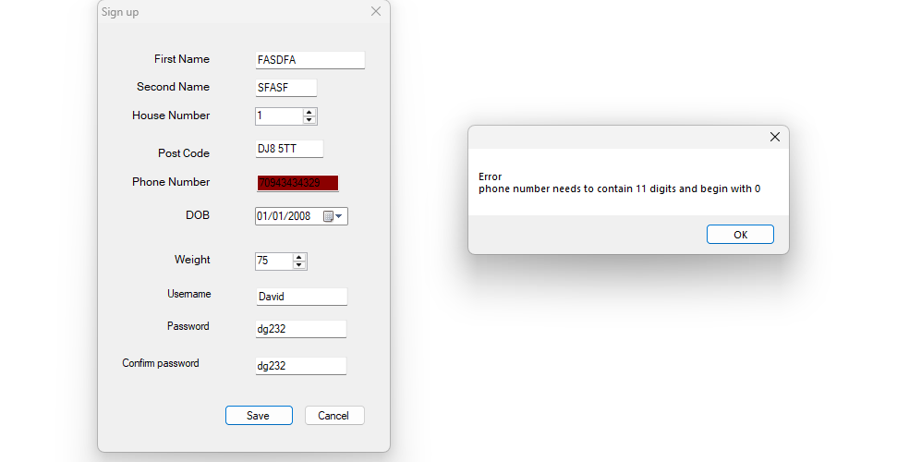

These sub-tests showed that the error messages would still be shown even when there is only one invalid piece of data.

Test 9
Same input as test 8.2 (only the postcode is invalid), after the save button is pressed: the postcode textbox has a red background colour; when its text is changed to a valid postcode, the colour changes to white.

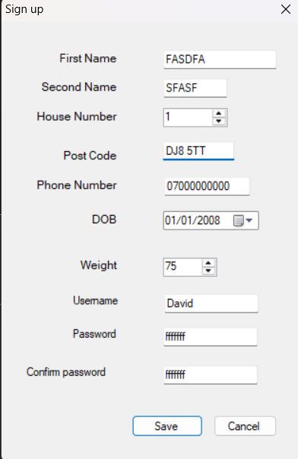
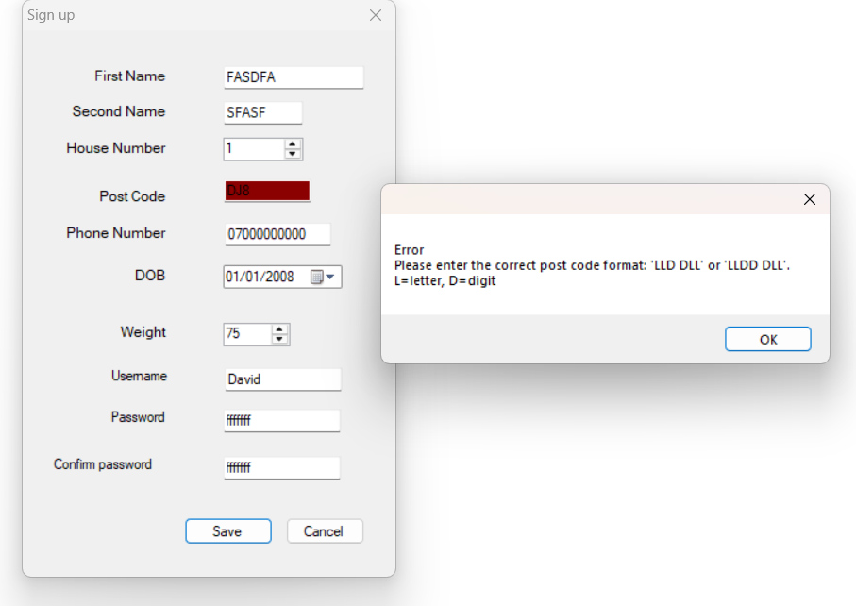

Test 10

The runner profile page has similar validation code to the sign up page, as both are used for checking the runner’s details. But it didn’t work as I expected, and the code with the error was the name verification, which I corrected in test 8. (The data I input was valid data, the same as in Test 6.)

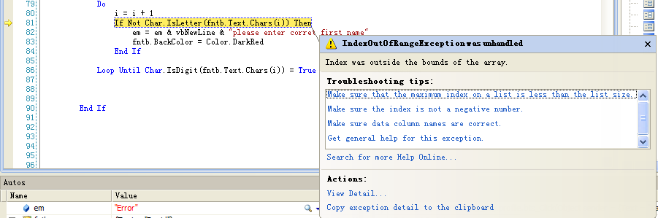

I found that the error occurred because the length of a text (e.g. the length of David is 5) is one greater than its last index number (e.g. the last index number of David is 4) in Visual Basic. So I changed the code so the loop will stop after it has repeated the length of the text minus 1 times.

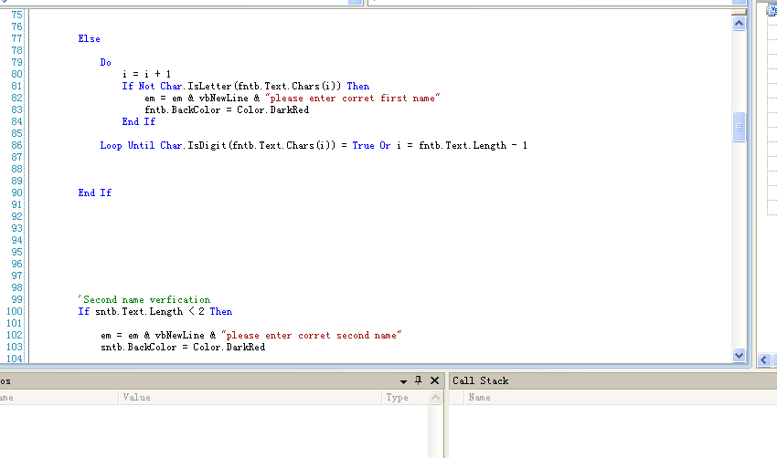
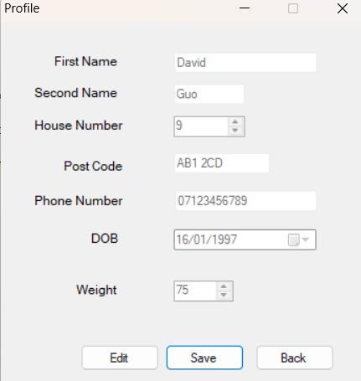
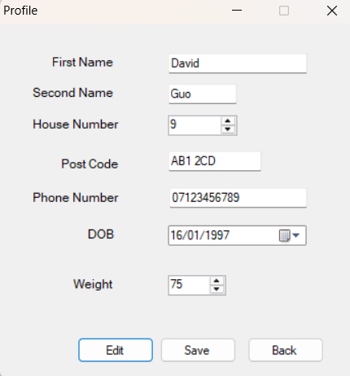

After the correction, the code worked fine and the error message didn’t show; all the textboxes were disabled when the save button was pressed.

Test 10.1
When the back button was clicked, the runner homepage was shown.

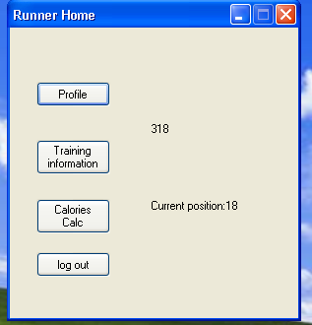

Test 11
The user selected a record.

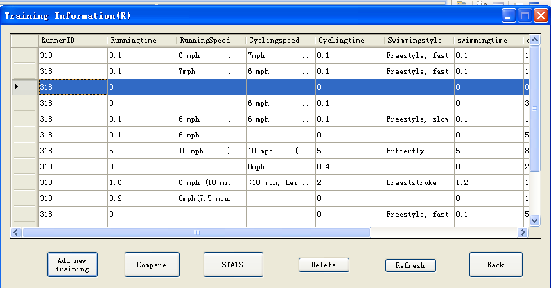

A message box popped up for confirmation.

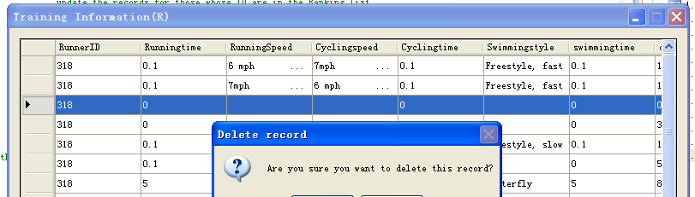

The user clicked ‘no’ and the record didn’t get deleted.
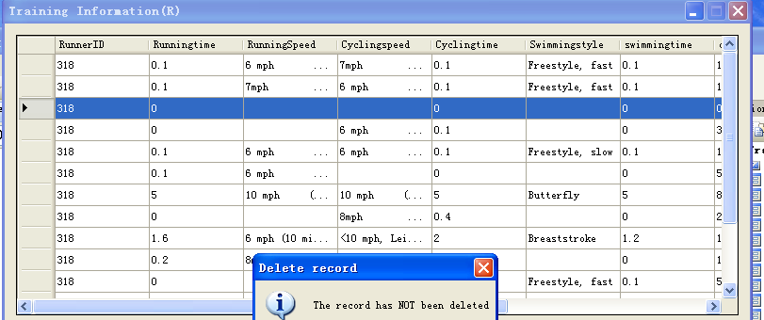

After the same procedure, the user clicked ‘yes’ and the record was deleted.
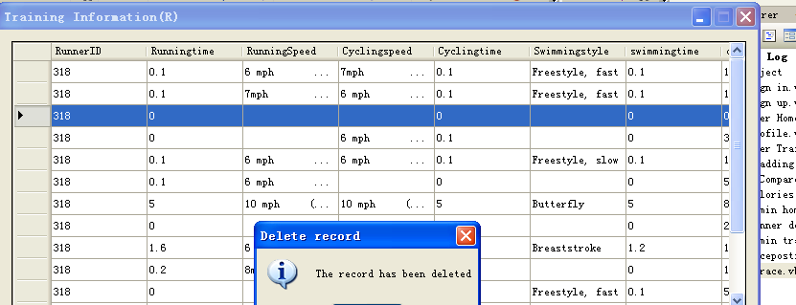

The record is removed from the grid view.
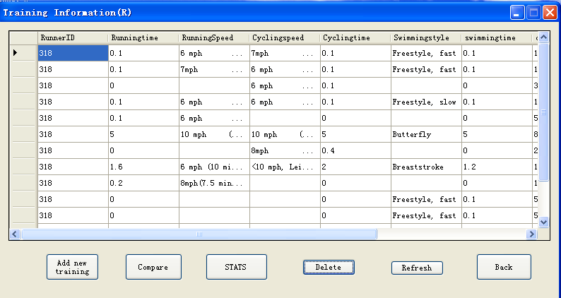

Test 12
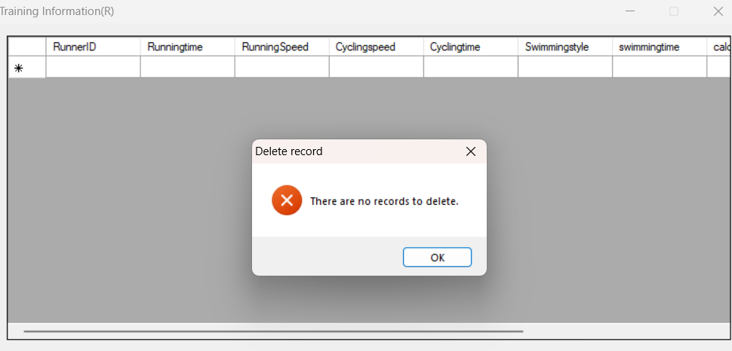
When there is no record in the database and the user clicks the ‘delete’ button, an error message will be shown.

Test 13
When the stats button is clicked, a message box came up to show the statistics of the training.
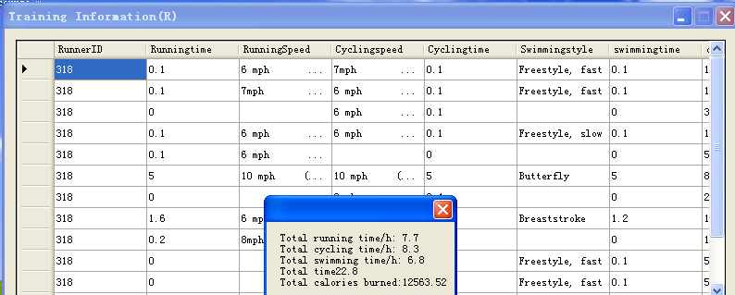

Test 14
When the header of the running time column is clicked, the data is sorted in the order of the running time.
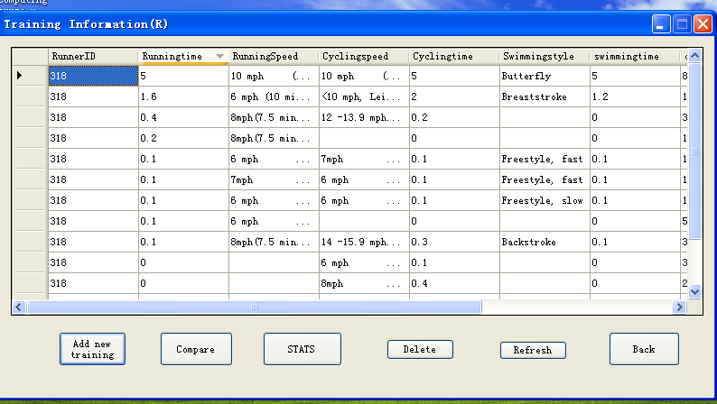

Test 15
When I tried to select the cycling speed, I couldn’t find the one I wanted. I think I miscopied the speed options for cycling, so I copied them again to make sure they were correct.

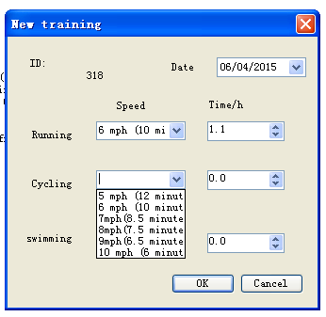

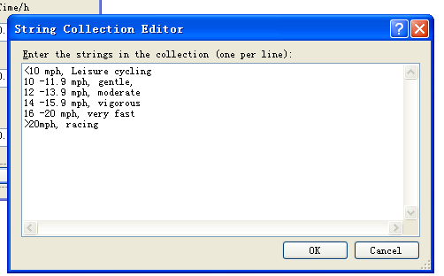

I entered the data after the items in the cycling speed combo box had been corrected.

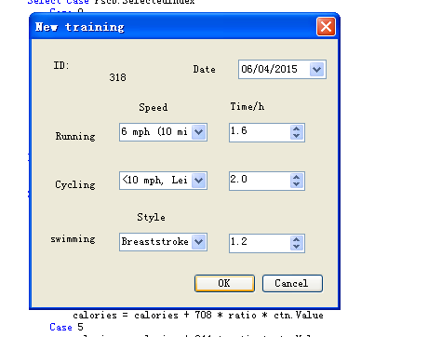

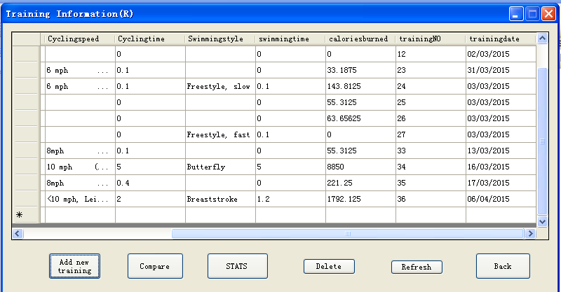

I calculated that total calories burned should be 1991.25.

The training information report was not the same as I expected, so I checked the code and found that there was a misspelt variable name.

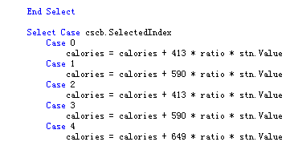

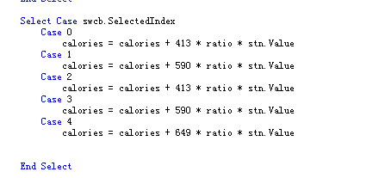

So I corrected the spelling, and the system did produce the correct report I expected.

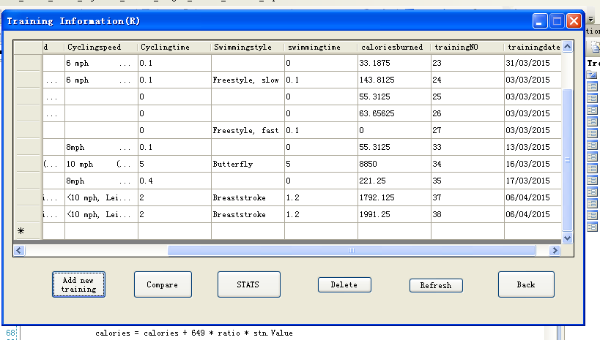

Test 16
I pressed the OK button after I entered the running time but not the running speed, and an error message showed up, so it worked as I expected. The corresponding speed needs to be input when the time is input.
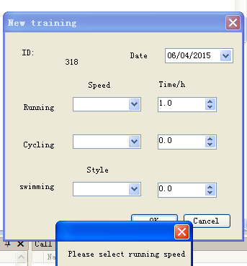

Test 16.1
As the user shouldn’t add a new record that is empty, this error message will be shown if the total training time is 0.
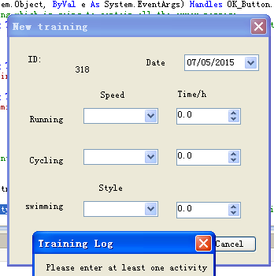

Test 17
When cycling was selected, all the cycling training information was shown (and the empty records were all hidden), so it did what I expected.
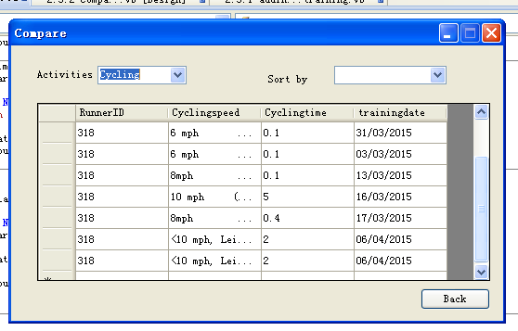

Test 17.1
The user can sort the data in the data grid view by selecting the order they want from the combo box. If the training date is selected, the data will be sorted in the order of the training date.

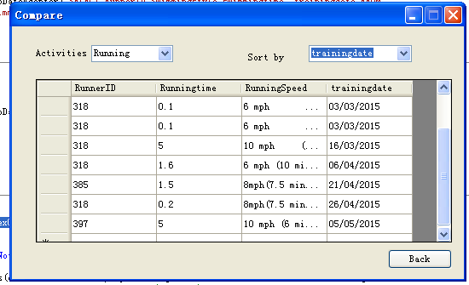
I selected training data on the ‘sort by’ combo box

Test 17.2

When the back button is clicked (as on any other screen), the current form will be closed and the previous form will be shown.

When I pressed the back button on the comparing training page, the training information page was shown, as it was the page that the comparing training page was opened from.

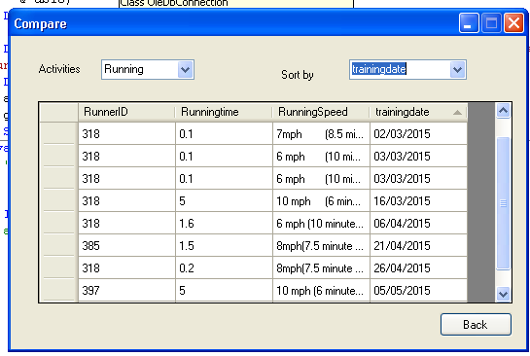

The training information page was shown successfully.

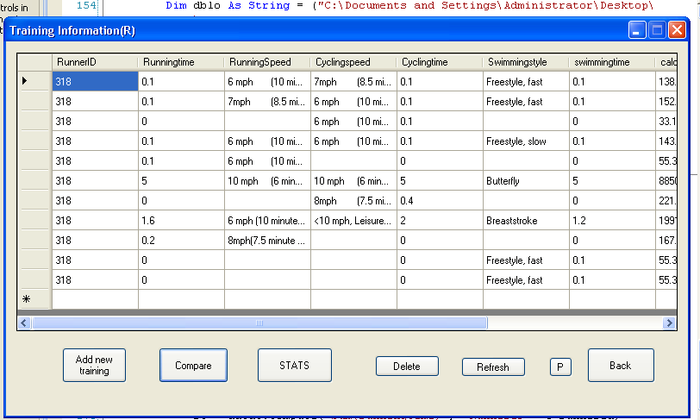

Test 18
When I tried to open the race & select team form, an error message showed up saying there was a syntax error in the UPDATE statement.
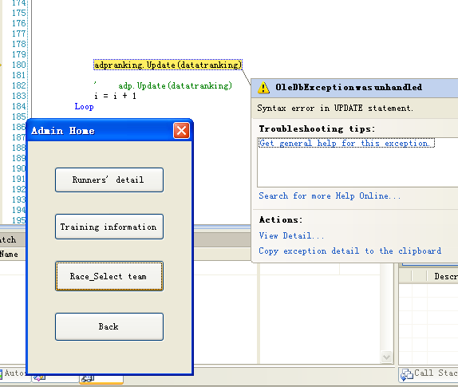

I found that the problem was caused by Access’s reserved-word rules: ‘position’ is a reserved word in Access, and I couldn’t access the field from Visual Basic because of it. So I changed ‘position’ to ‘runnerposition’. It was easy to change, but it took me quite a lot of time to find the problem.
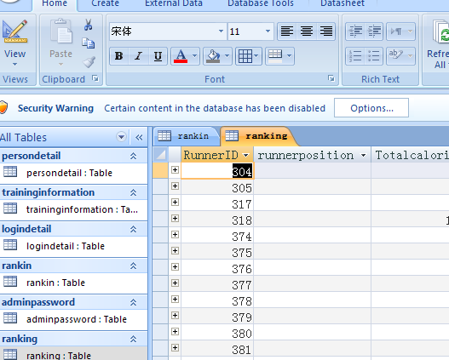

After the correction, the system did what I wanted: the fields were all ranked.

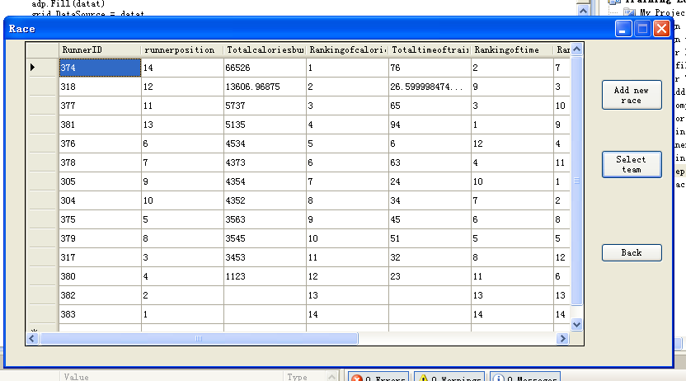

Test 19
The runners were ordered, and the best 8 runners were highlighted/selected.

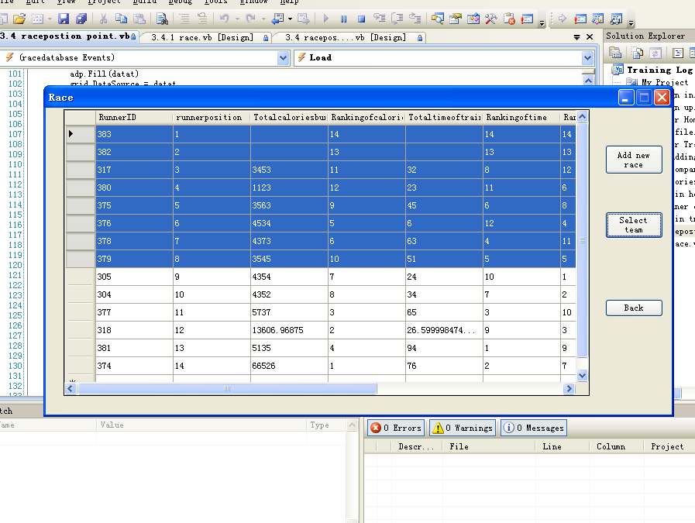

Test 20
I deleted some records from the database to carry out this test. As there were fewer than 8 runners, an error message was shown to tell the user that a team of 8 runners can’t be selected.
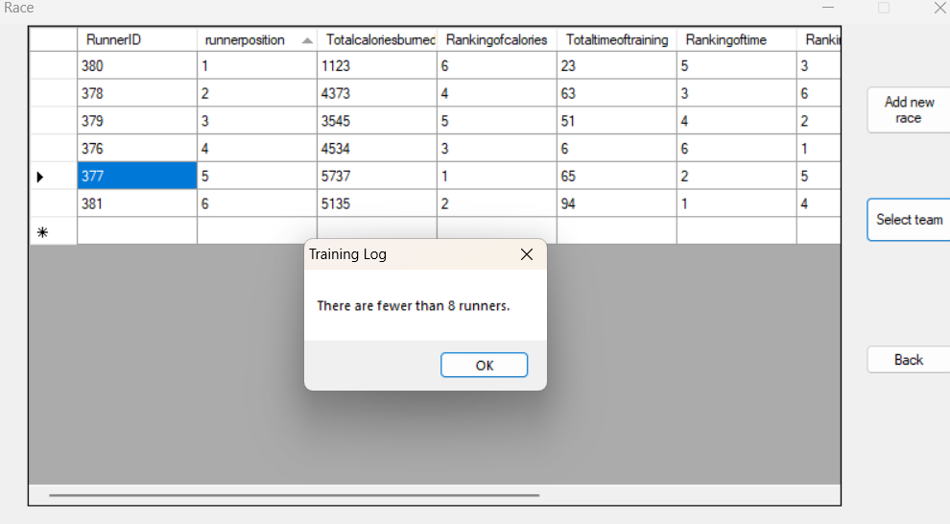

Test 21

Button for the user to add a new race

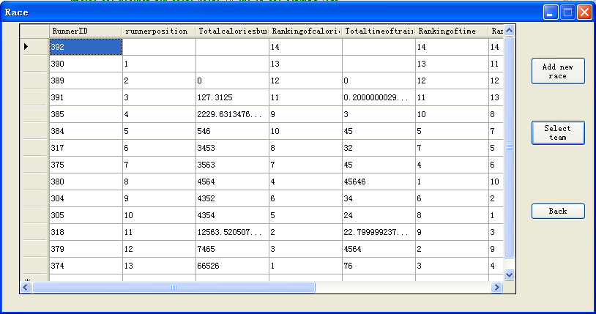

Form for adding a new race
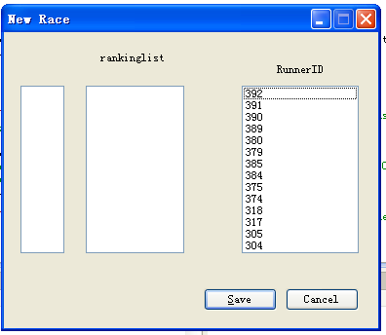

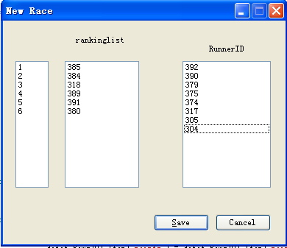

The admin can click the item (Runner ID) on the runner ID list, which will remove from the list and add to the ranking list.

The correct points were added to the database.

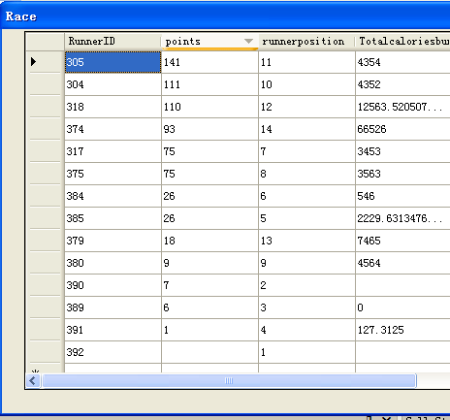

+6
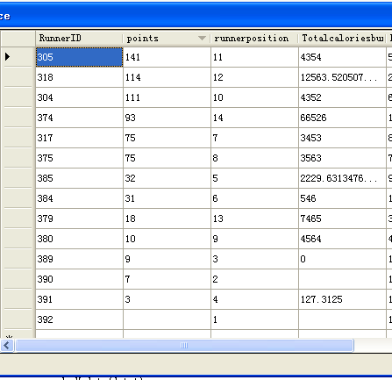

+1

Test 22
The record with the runner ID of 318, which was in the textbox, was shown.

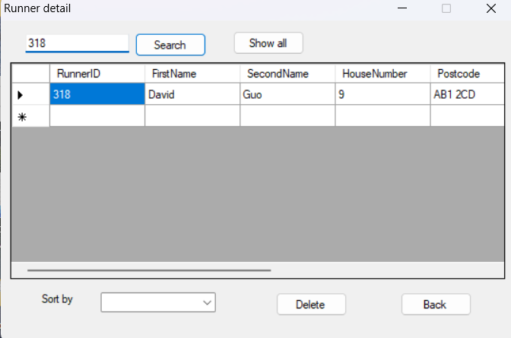

Test 23
As the text entered is not a valid ID number or surname, an error message showed up and no records were shown.
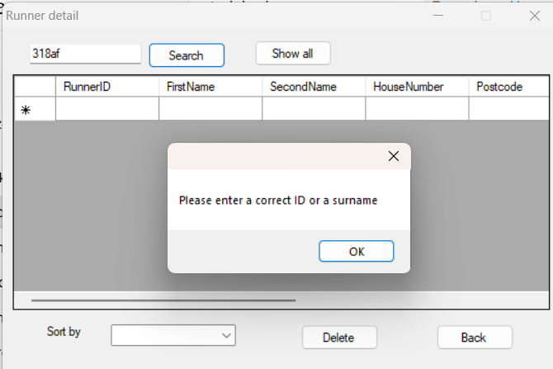

Test 24
Because there were two records with the same surname, both of them were shown. (One of them was saved in the database initially; the other was created in Test 6.)
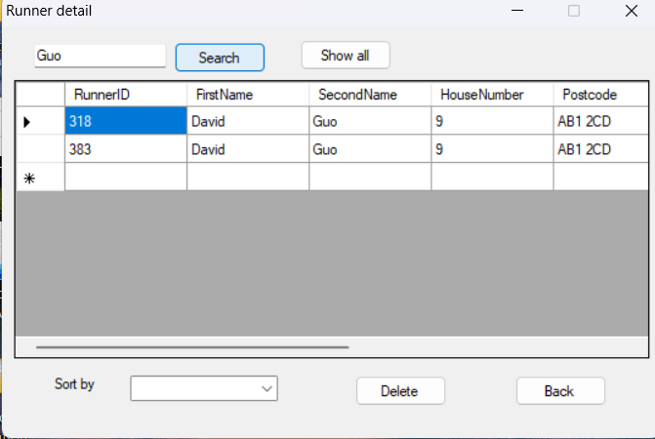

Test 25
I selected ID 399 from the runner ID list view (this screenshot was taken while holding the mouse button; otherwise the ID would have been removed).
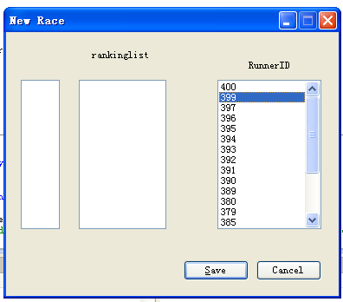

Then Runner ID 399 was added to the ranking list and removed from the Runner ID list (after the mouse was released).
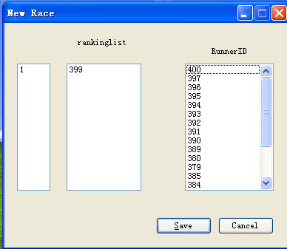

Test 26
When the user clicks an ID on the ranking list, the position of the runner (the index of the item) is shown.

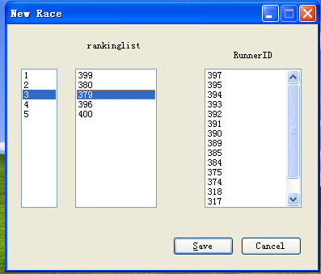

Test 27
When the user clicks the position of a runner, the corresponding runner ID on the ranking list is shown (this screenshot was also taken while holding the mouse button, so the runner ID won’t be highlighted until the mouse is released).

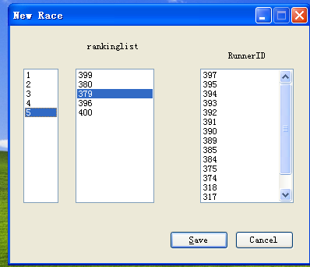

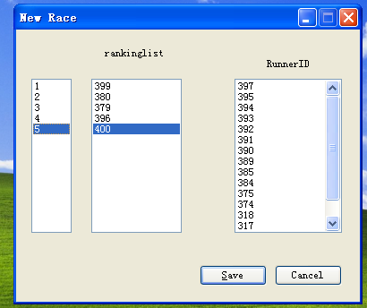

.

Test 28
A race should normally consist of two or more runners, so if the user tries to save the data when there is only one runner, an error message will be shown.
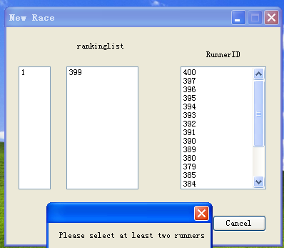

Test 29
When the user clicks the save button, a message is shown asking the user to confirm saving the new race to the database.
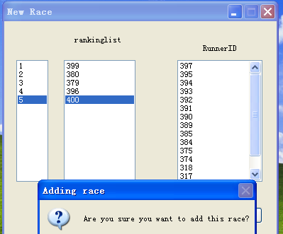

Test 29.1 &29.2
If the user clicks the ‘Yes’ button, the ‘Selecting team and race’ form is shown and the new race information is added to the database.

